Status of Pacific ocean perch (*Sebastes*

*alutus*) along the US west coast in 2017

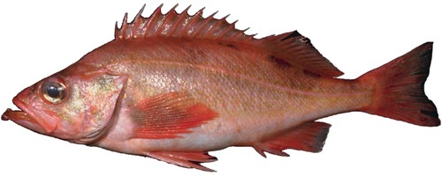

Chantel R. Wetzel1 Lee Cronin-Fine2 Kelli F. Johnson1,2

1Northwest Fisheries Science Center, U.S. Department of Commerce, National Oceanic and Atmospheric Administration, National Marine Fisheries Service, 2725 Montlake Boulevard East, Seattle, Washington 98112

2University of Washington, School of Aquatic and Fishery Sciences

Please cite as:

Wetzel, C.R., Cronin-Fine, L., and Johnson, K.F. 2017. Status of Pacific ocean perch (*Sebastes alutus*) along the US west coast in 2017. Pacific Fishery Management Council, 7700 Ambassador Place NE, Suite 200, Portland, OR 97220.

Status of Pacific ocean perch (*Sebastes alutus*) along the US west coast in 2017

**Contents**

**Executive Summary** **i**

Stock . . . . . . . . . . . . . . . . . . . . . . . . . . . . . . . . . . . . . . . . . . . i

Landings . . . . . . . . . . . . . . . . . . . . . . . . . . . . . . . . . . . . . . . . . i

Data and Assessment iii

Stock Biomass iv

Recruitment vii

Exploitation Status ix

Ecosystem Considerations xii

Reference Points xii

Management Performance xiii

Unresolved Problems and Major Uncertainties xiv

Decision Table xv

Research and Data Needs xvii

1 Introduction 1

1.1 Distribution and Stock Structure . . . . . . . . . . . . . . . . . . . . . . . . 1

1.2 Historical and Current Fishery . . . . . . . . . . . . . . . . . . . . . . . . . . 1

* 1. Summary of Management History and Performance . . . . . . . . . . . . . . 2
  2. Fisheries off Canada and Alaska . . . . . . . . . . . . . . . . . . . . . . . . . 2

1. Data 3

2.1 Fishery-Independent Data . . . . . . . . . . . . . . . . . . . . . . . . . . . . 3

* + 1. Northwest Fisheries Science Center (NWFSC) Shelf-Slope Survey . . 4
    2. Northwest Fisheries Science Center (NWFSC) Slope Survey . . . . . 5
    3. Alaska Fisheries Science Center (AFSC) Slope Survey . . . . . . . . . 6

2.1.4 Pacific Ocean Perch Survey . . . . . . . . . . . . . . . . . . . . . . . 6

2.1.5 Fishery Independent Data Not Included in the Base Model . . . . . . 7

2.1.5.1 Triennial Shelf Survey . . . . . . . . . . . . . . . . . . . . . 7

2.1.5.2 Washington Research Lengths . . . . . . . . . . . . . . . . . 8 2.2 Fishery-Dependent Data . . . . . . . . . . . . . . . . . . . . . . . . . . . . . 8

2.2.1 Commercial Fishery Landings . . . . . . . . . . . . . . . . . . . . . . 8 2.2.2 Discards . . . . . . . . . . . . . . . . . . . . . . . . . . . . . . . . . . 9

* + 1. Fishery Length and Age Data 10
       1. Commercial Fishery 10
       2. At-Sea Hake Fishery 11
    2. Fishery Data Not Included in the Base Model 11
       1. Historical Commercial Catch-Per-Unit Effort 11
       2. Oregon Special Projects Length and Age Data 11
  1. Biological Data 12
     1. Natural Mortality 12
     2. Sex Ratio, Maturation, and Fecundity 13
     3. Length-Weight Relationship 13
     4. Growth (Length-at-Age) 13
     5. Ageing Precision and Bias 14
  2. History of Modeling Approaches Used for This Stock 14
     1. Previous Assessments 14

1. **Assessment** **15**
   1. General Model Specifications and Assumptions 15
      1. Changes Between the 2011 Assessment Model and Current Model . . 15
      2. Summary of Fleets and Areas 16
      3. Other Specifications 17
      4. Modeling Software 18
      5. Priors 18
      6. Data Weighting 19
      7. Estimated and Fixed Parameters 19
   2. Model Selection and Evaluation 20
      1. Key Assumptions and Structural Choices 20
      2. Bridging Analysis and Alternate Models Considered 20
      3. Convergence 21
   3. STAR Panel Review and Recommendations 22
   4. Response to the 2011 STAR Panel Recommendations 22
   5. Response to the 2017 STAR Panel Requests 23
   6. Base Model Results 24
      1. Parameter Estimates 25
      2. Fits to the Data 26
      3. Population Trajectory 28
      4. Uncertainty and Sensitivity Analyses 29
      5. Retrospective Analysis 30
      6. Historical Analysis 30
      7. Likelihood Profiles 31
      8. Reference Points 31

### Harvest Projections and Decision Tables 32

### Regional Management Considerations 32

### Research Needs 32

### Acknowledgments 33

### Tables 35

### Figures 69

### Appendix A. Detailed Fit to Length Composition Data 157

### Appendix B. Detailed Fit to Age Composition Data 168

### Appendix C. Description of CPUE and Triennial Data 174

### Appendix D. SSC Groundfish Subcommittee Discussion Regarding Steep- ness 182

### Appendix E. List of Auxiliary Files Available 185

1. **References**

**Executive Summary**

**Stock**

This assessment reports the status of the Pacific ocean perch rockfish (*Sebastes alutus*) off the US west coast from Northern California to the Canadian border using data through 2016. Pacific ocean perch are most abundant in the Gulf of Alaska and have been observed off of Japan, in the Bering Sea, and south to Baja California, though they are sparse south of Oregon and rare in southern California. Although neither catches nor other data from north of the US-Canada border were included in this assessment, the connectivity of these populations and the contribution to the biomass possibly through adult migration and/or larval dispersion is not certain. To date, no significant genetic differences have been found in the range covered by this assessment.

**Landings**

Harvest of Pacific ocean perch first exceeded 1 mt off the US west coast in 1918. Catches ramped up in the 1940s with large removals in Washington waters. During the 1950s the removals primary occurred in Oregon waters with catches from Washington declining following the 1940s. The largest removals, occurring between 1966-1968, were largely a result of harvest by foreign vessels. The fishery proceeded with more moderate removals ranging between 1165 to 2619 metric tons (mt) per year between 1969 and 1980. Removals generally declined from 1981 to 1994 to between 1031 and 1617 mt per year. Pacific ocean perch was declared overfished in 1999, resulting in large reductions in harvest in years since the declaration. Since 2000, annual landings of Pacific ocean perch have ranged between 54-270 mt, with landings in 2016 totaling 68 mt.

Pacific ocean perch are a desirable market species and discarding has historically been low. However, management restrictions (e.g. trip limits) resulted in increased discarding starting in the early 1990s. During the 2000s discarding increased for Pacific ocean perch due to harvest restrictions imposed to allow rebuilding, with estimated discard rates from the fishery peaking in 2009 and 2010 to approximately 50%, prior to implementation of catch shares in 2011. Since 2011, discarding of Pacific ocean perch has been estimated to be less than 3.5%.

Table a: Landings (mt) for the past 10 years for Pacific ocean perch by source.

|  |  |  |  |  |  |  |
| --- | --- | --- | --- | --- | --- | --- |
| Year | California | Oregon | Washington | At-sea  hake | Survey | Total  Landings |
| 2007 | 0.15 | 83.65 | 45.12 | 4.05 | 0.58 | 133.55 |
| 2008 | 0.39 | 58.64 | 16.61 | 15.93 | 0.80 | 92.36 |
| 2009 | 0.92 | 58.74 | 33.22 | 1.56 | 2.72 | 97.17 |
| 2010 | 0.14 | 58.00 | 22.29 | 16.87 | 1.68 | 98.98 |
| 2011 | 0.12 | 30.26 | 19.66 | 9.17 | 1.94 | 61.14 |
| 2012 | 0.18 | 30.41 | 21.79 | 4.52 | 1.62 | 58.51 |
| 2013 | 0.08 | 34.86 | 14.83 | 5.41 | 1.71 | 56.89 |
| 2014 | 0.18 | 33.91 | 15.82 | 3.92 | 0.57 | 54.40 |
| 2015 | 0.12 | 38.05 | 11.41 | 8.71 | 1.59 | 59.88 |
| 2016 | 0.23 | 40.81 | 13.12 | 10.30 | 3.10 | 67.56 |

15000

10000

Landings (mt)

5000

0

1918 1938 1958 1978 1998

Year

Fishery

California Oregon Washington At−sea hake Foreign Survey

|  |  |  |  |  |  |  |  |  |  |  |  |
| --- | --- | --- | --- | --- | --- | --- | --- | --- | --- | --- | --- |
|  |  |  |  |  |  |  |  |  |  |  |  |
|  |  |  |  |  |  |  |  |  |  |  |  |
|  |  |  |  |  |  |  |  |  |  |  |  |
|  |  |  |  |  |  |  |  |  |  |  |  |
|  |  |  |  |  |  |  |  |  |  |  |  |
|  |  |  |  |  |  |  |  |  |  |  |  |
|  |  |  |  |  |  |  |  |  |  |  |  |
|  |  |  |  |  |  |  |  |  |  |  |  |
|  |  |  |  |  |  |  |  |  |  |  |  |

Figure a: Landings of Pacific ocean perch for California, Oregon, Washington, the foreign fishery (1966-1976), at-sea hake fishery, and fishery-independent surveys.

## Data and Assessment

This a new full assessment for Pacific ocean perch, which was last assessed in 2011. In this assessment, aspects of the model including landings, data, and modelling assumptions were re-evaluated. The assessment was conducted using the length- and age-structured modeling software Stock Synthesis (version 3.30.03.05). The coastwide population was modeled allowing separate growth and mortality parameters for each sex (a two-sex model) from 1918 to 2017 and forecasted beyond 2017.

All of the data sources included in the base model for Pacific ocean perch have been re- evaluated for 2017. Changes of varying degrees have occurred in the data from those used in previous assessments. The landings history has been updated and extended back to 1918. Harvest was negligible prior to that year. Survey data from the Alaska and Northwest Fisheries Science Centers have been used to construct indices of abundance analyzed using a spatio-temporal delta-model. Length, marginal age or conditional age-at-length compositions were also created for each fishery-dependent and -independent data source.

The definition of fishing fleets have changed from those in the 2011 assessment. Three fishing fleets were specified within the model: 1) a combined bottom trawl, mid-water trawl, and fixed gear fleet, where only a small fraction of Pacific ocean perch were captured by fixed gear (termed the fishery fleet), 2) the historical foreign fleet, and 3) the at-sea hake fishery. The fleet grouping was based on discarding practices. The fishery fleet estimated a retention curve based on discarding data and known management restrictions. However, very little if any discarding is assumed to have occurred by the foreign fleet and the catch reported by the at-sea hake fishery accounts for both discarded and landed fish and hence, no additional discard mortality was estimated for each of these fleets.

The assessment uses landings data and discard-fraction estimates; survey indices of abundance; length- or age-composition data for each year and fishery or survey (with conditional age- at-length compositional data for the NWFSC shelf-slope survey); information on weight- at-length, maturity-at-length, and fecundity-at-length; information on natural mortality and the steepness of the Beverton-Holt stock-recruitment relationship; and estimates of ageing error. Recruitment at “equilibrium spawning output”, length-based selectivity of the fisheries and surveys, retention of the fishery, catchability of the surveys, growth, the time-series of spawning output, age and size structure, and current and projected future stock status are outputs of the model. Natural mortality (0.054 yr-1) and steepness (0.50) were fixed in the final model. This was done due to relatively flat likelihood surfaces, such that fixing parameters and then varying them in sensitivity analyses was deemed the best way to characterize uncertainty.

Although this assessment uses many types of data since the 1980s, there is little information about steepness and natural mortality. Estimates of steepness are uncertain partly because of highly variable recruitment. Uncertainty in natural mortality is common in many fish stock assessments even when length and age data are available.

A number of sources of uncertainty are explicitly included in this assessment. This assessment includes gender differences in growth, a non-linear relationship between individual spawner biomass and effective spawning output, and an updated relationship between length and maturity, based upon non-published information (Melissa Head, personal communication, NOAA, NWFSC). As is always the case, overall uncertainty is greater than that predicted by a single model specification. Among other sources of uncertainty that are not included in the current model are the degree of connectivity between the stocks of Pacific ocean perch off of Vancouver Island, British Columbia and those in US waters, and the effect of climatic variables on recruitment, growth and survival.

A base model was selected that best captures the central tendency for those sources of uncertainty considered in the model.

## Stock Biomass

The predicted spawning output from the base model generally showed a slight decline prior to 1966 when fishing by the foreign fleet commenced. A short, but sharp decline occurred between 1966 and 1970, followed by a period of the spawning output stabilizing or with a minimal decline until the late 1990s. The stock showed increases in stock size following the year 2000 due to a combination of strong recruitment and low catches. The 2017 estimated spawning output relative to unfished equilibrium spawning output is above the target of 40% of unfished spawning output at 76.6% ( 95% asymptotic interval: 55.6%-97.7%). Approximate confidence intervals based on the asymptotic variance estimates show that the uncertainty in the estimated spawning output is high.

∼ ±

Table b: Recent trend in estimated spawning output (million eggs) and estimated relative spawning output (depletion).

|  |  |  |  |  |
| --- | --- | --- | --- | --- |
| Year | Spawning Output  (million eggs) | ˜ 95%  Confidence Interval | Estimated  Depletion | ˜ 95%  Confidence Interval |
| 2008 | 3745 | 1620 - 5870 | 0.544 | 0.380 - 0.708 |
| 2009 | 3885 | 1688 - 6083 | 0.564 | 0.395 - 0.733 |
| 2010 | 3976 | 1731 - 6221 | 0.577 | 0.405 - 0.749 |
| 2011 | 4032 | 1759 - 6305 | 0.585 | 0.412 - 0.759 |
| 2012 | 4067 | 1780 - 6354 | 0.590 | 0.416 - 0.764 |
| 2013 | 4091 | 1797 - 6384 | 0.594 | 0.420 - 0.768 |
| 2014 | 4197 | 1857 - 6538 | 0.609 | 0.433 - 0.785 |
| 2015 | 4516 | 2021 - 7011 | 0.656 | 0.470 - 0.841 |
| 2016 | 4931 | 2231 - 7630 | 0.716 | 0.517 - 0.914 |
| 2017 | 5280 | 2407 - 8153 | 0.766 | 0.556 - 0.977 |

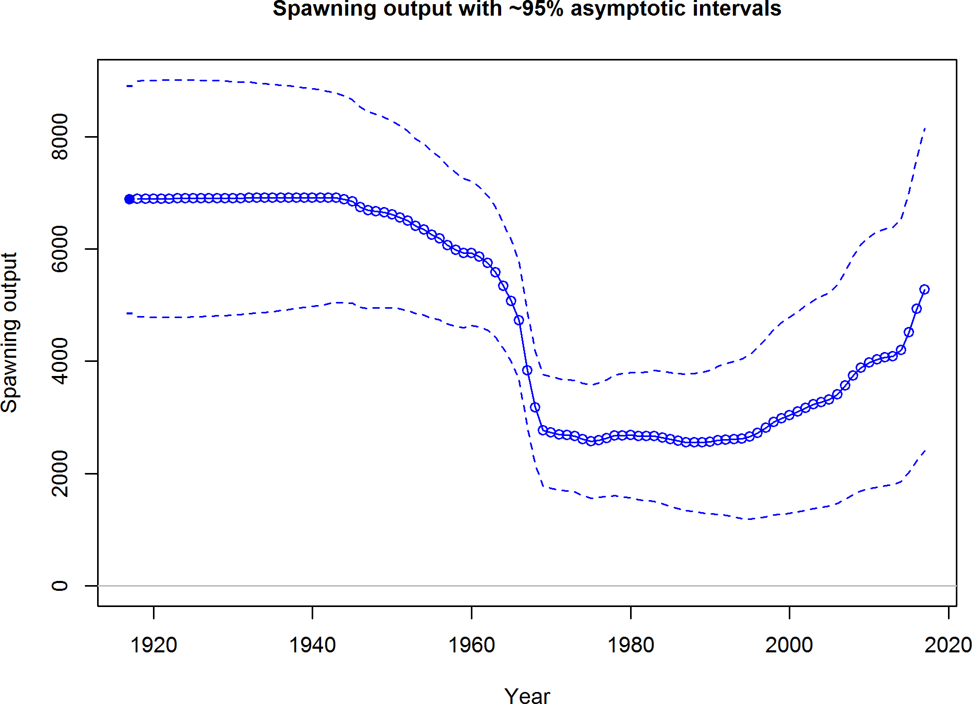

Figure b: Estimated time-series of spawning output trajectory (circles and line: median; light broken lines: 95% credibility intervals) for the base assessment model.

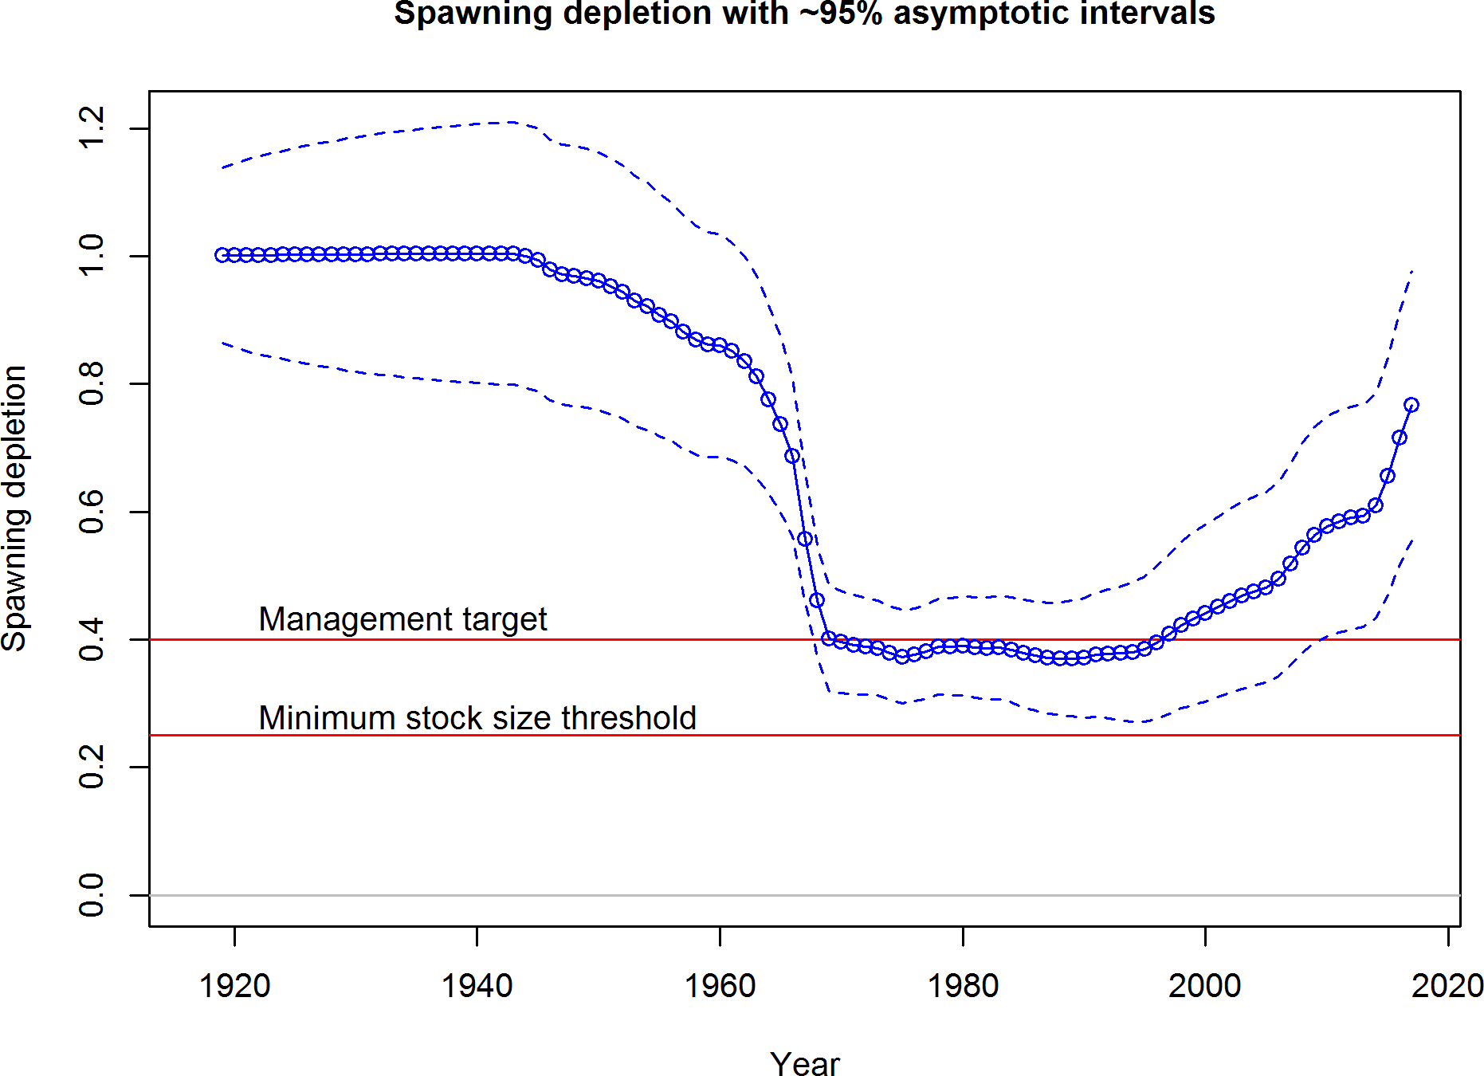

Figure c: Estimated time-series of relative spawning output (depletion) (circles and line: median; light broken lines: 95% credibility intervals) for the base assessment model.

## Recruitment

Recruitment deviations were estimated for the entire assessment period. There is little information regarding recruitment prior to 1965, and the uncertainty in these estimates is expressed in the model. Past assessments estimated large recruitments in 1999 and 2000. In recent years, a recruitment of unprecedented size is estimated to have occurred in 2008. Additionally, there is early evidence of a strong recruitment in 2013. The four lowest recruitments estimated within the model (in ascending order) occurred in 2012, 2003, 2005, and 2007.

Table c: Recent estimated trend in recruitment and estimated recruitment deviations deter- mined from the base model. The recruitment deviations for 2016 and 2017 were fixed at zero within the model.

|  |  |  |  |  |
| --- | --- | --- | --- | --- |
| Year | Estimated  Recruitment | ˜ 95% Confidence  Interval | Estimated  Recruitment Devs. | ˜ 95% Confidence  Interval |
| 2008 | 116128 | 66566 - 202591 | 2.623 | 2.323 - 2.923 |
| 2009 | 4731 | 2047 - 10932 | -0.592 | -1.347 - 0.163 |
| 2010 | 7499 | 3650 - 15404 | -0.140 | -0.732 - 0.453 |
| 2011 | 15198 | 7730 - 29880 | 0.562 | 0.031 - 1.093 |
| 2012 | 2101 | 879 - 5026 | -1.420 | -2.237 - -0.603 |
| 2013 | 29027 | 13826 - 60941 | 1.118 | 0.482 - 1.754 |
| 2014 | 4630 | 1629 - 13160 | -0.813 | -1.863 - 0.238 |
| 2015 | 10661 | 2987 - 38052 | -0.004 | -1.372 - 1.364 |
| 2016 | 11016 | 3082 - 39382 | 0.000 | -1.372 - 1.372 |
| 2017 | 11253 | 3151 - 40194 | 0.000 | -1.372 - 1.372 |

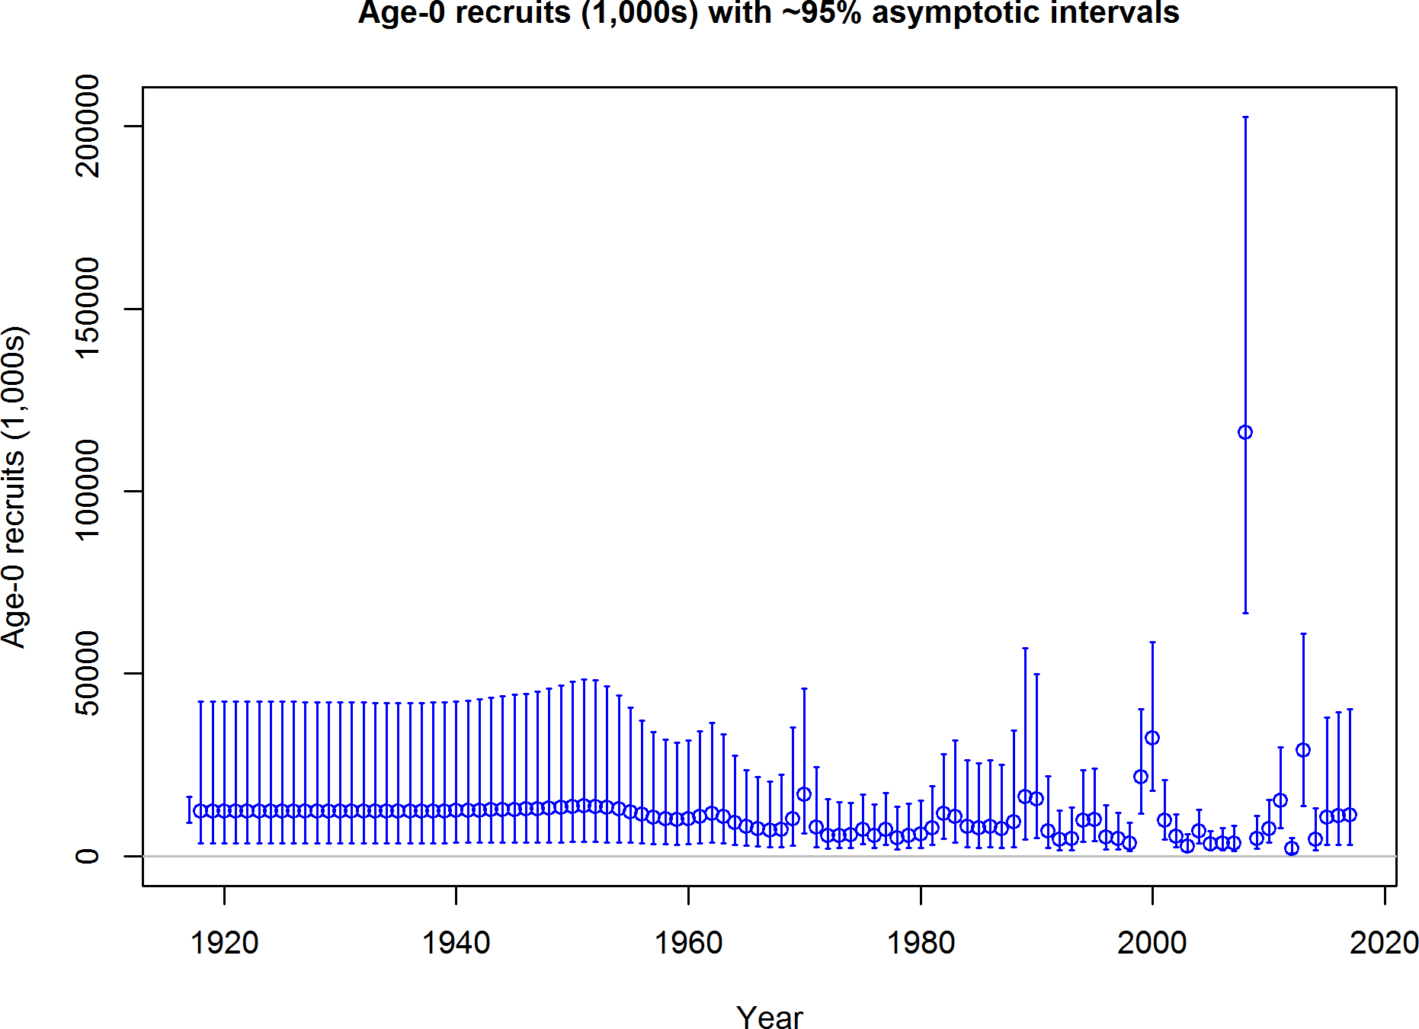

Figure d: Time-series of estimated Pacific ocean perch recruitments for the base model with 95% confidence or credibility intervals.

## Exploitation Status

The spawning output of Pacific ocean perch reached a low in 1989. Landings for Pacific ocean perch decreased significantly in 2000 compared to previous years. The estimated relative depletion was possibly below the target biomass level between the 1970s and 1990s, but has likely remained above the target otherwise, and currently is significantly greater than the 40% unfished spawning output target. Throughout the late 1960s and the early 1970s the exploitation rate and values of relative spawning potential ((1-SPR)/(1-SPR50%)) were mostly above target levels. Recent exploitation rates on Pacific ocean perch were predicted to be significantly below target levels.

Table d: Recent trend in spawning potential ratio (1-SPR)/(1-SPR50) and summary exploita- tion rate for age 3+ biomass for Pacific ocean perch.

|  |  |  |  |  |
| --- | --- | --- | --- | --- |
| Year | (1-SPR)/  (1-SPR50%) | ˜ 95%  Confidence Interval | Exploitation  Rate | ˜ 95%  Confidence Interval |
| 2007 | 0.087 | 0.039 - 0.134 | 0.002 | 0.001 - 0.003 |
| 2008 | 0.072 | 0.031 - 0.113 | 0.002 | 0.001 - 0.002 |
| 2009 | 0.097 | 0.040 - 0.153 | 0.002 | 0.001 - 0.004 |
| 2010 | 0.092 | 0.039 - 0.145 | 0.002 | 0.001 - 0.003 |
| 2011 | 0.032 | 0.014 - 0.050 | 0.001 | 0.000 - 0.001 |
| 2012 | 0.031 | 0.014 - 0.048 | 0.001 | 0.000 - 0.001 |
| 2013 | 0.030 | 0.013 - 0.046 | 0.001 | 0.000 - 0.001 |
| 2014 | 0.026 | 0.012 - 0.040 | 0.000 | 0.000 - 0.001 |
| 2015 | 0.026 | 0.012 - 0.040 | 0.001 | 0.000 - 0.001 |
| 2016 | 0.027 | 0.012 - 0.041 | 0.001 | 0.000 - 0.001 |

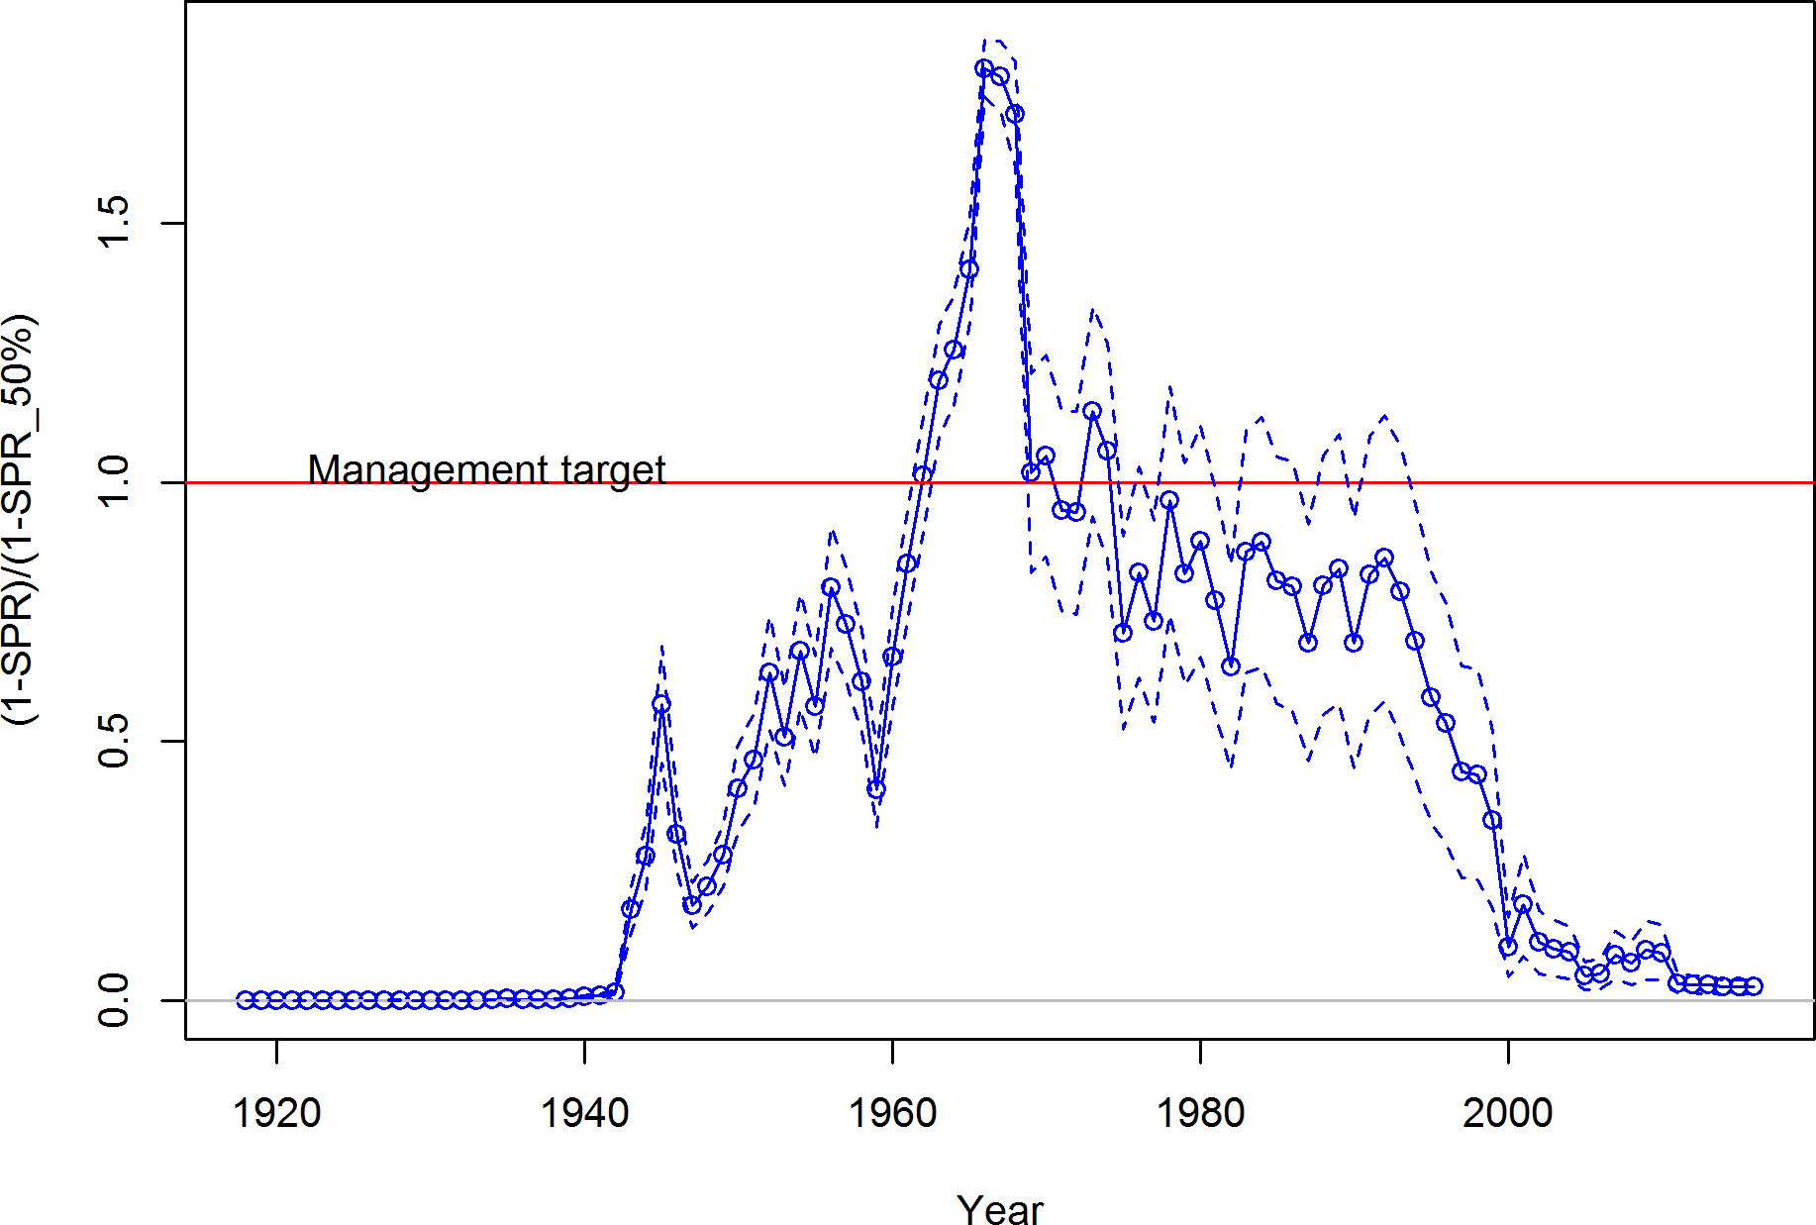

Figure e: Estimated relative spawning potential ratio (1-SPR)/(1-SPR50%) for the base model. One minus SPR is plotted so that higher exploitation rates occur on the upper portion of the y-axis. The management target is plotted as a red horizontal line and values above this reflect harvests in excess of the overfishing proxy based on the SPR50% harvest rate. The last year in the time-series is 2016.

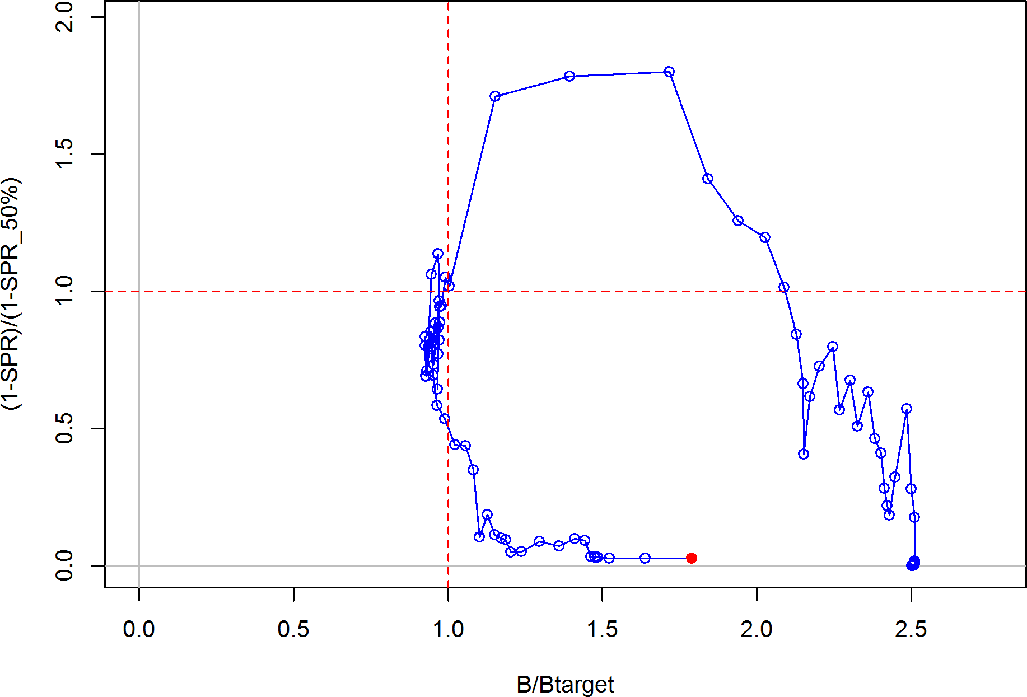

Figure f: Phase plot of estimated (1-SPR)/(1-SPR50%) vs. depletion (B/Btarget) for the base case model. The red circle indicates 2016 estimated status and exploitation for Pacific ocean perch.

## Ecosystem Considerations

Rockfish are an important component of the California Current ecosystem along the US west coast, with more than sixty five species filling various niches in both soft and hard bottom habitats from the nearshore to the continental slope, as well as near bottom and pelagic zones. Pacific ocean perch are generally considered to be semi-demersal, but there can, at times, be a significant pelagic component to their distribution.

Recruitment is one mechanism by which the ecosystem may directly impact the population dynamics of Pacific ocean perch. The 1999 cohort for many species of rockfish was large – sometimes significantly so. Long-term averages suggest that environmental conditions may influence the spawning success and survival of larvae and juvenile rockfish. Pacific ocean perch showed above average recruitment deviations in 1999 and 2000. The specific pathways through which environmental conditions exert influence on Pacific ocean perch dynamics are unclear; however, changes in water temperature and currents, distribution of prey and predators, and the amount and timing of upwelling are all possible linkages. Changes in the environment may also result in changes in length-at-maturity, fecundity, growth, and survival which can affect the status of the stock and its susceptibility to fishing. Unfortunately, there are few data available for Pacific ocean perch that provide insights into these effects.

Fishing has effects on both the age-structure of a population, as well as the habitat with which the target species is associated. Fishing often targets larger, older fish and years of fishing mortality results in a truncated age-structure when compared to unfished conditions. Rockfish are often associated with habitats containing living structure such as sponges and corals, and fishing may alter that habitat to a less productive state. This assessment provides a look at the effects of fishing on age structure, and recent studies on essential fish habitat are beginning to characterize important locations for rockfish throughout their life history; however, there is little current information available to evaluate the specific effects of fishing on the ecosystem issues specific to Pacific ocean perch.

## Reference Points

This stock assessment estimates that the spawning output of Pacific ocean perch is above the management target. Due to reduced landing and the large 2008 year-class, an increasing trend in spawning output was estimated in the base model. The estimated depletion in 2017 is 76.6% ( 95% asymptotic interval: 55.6%-97.7%), corresponding to an unfished spawning output of 5,280 million eggs ( 95% asymptotic interval: 2,407-8,153 million eggs). Unfished age 3+ biomass was estimated to be 147,286 mt in the base model. The target spawning output based on the biomass target (*𝑆𝐵*40%) is 2,755.7 million eggs, with an equilibrium catch of 1,808.3 mt. Equilibrium yield at the proxy *𝐹𝑀𝑆𝑌* harvest rate corresponding to *𝑆𝑃 𝑅*50% is 1,822.5 mt. Estimated MSY catch is at a 1,825.3 spawning output of 2,425 million eggs (35.2% depletion)

∼

∼ ±

Table e: Summary of reference points and management quantities for the base case.

|  |  |  |
| --- | --- | --- |
| **Quantity** | **Estimate** | ∼**95%**  **Interval** |
| Unfished spawning output (million eggs) | 6889.2 | 4860.7 - 8917.6 |
| Unfished age 3+ biomass (mt) | 147286 | 104000.8 - 190571.2 |
| Unfished recruitment (R0, thousands) | 12110.2 | 9046.1 - 16212.1 |
| Spawning output(2017 million eggs) | 5280.4 | 2407.4 - 8153.3 |
| Relative spawning output (depletion) (2017) | 0.766 | 0.556 - 0.977 |
| **Reference points based on SB40**%  Proxy spawning output (*𝐵*40%) | 2755.7 | 1944.3 - 3567 |
| SPR resulting in *𝐵*40% (*𝑆𝑃 𝑅𝐵*40%) | 0.55 | 0.55 - 0.55 |
| Exploitation rate resulting in *𝐵*40% | 0.028 | 0.028 - 0.029 |
| Yield with *𝑆𝑃 𝑅𝐵*40% at *𝐵*40% (mt)  ***Reference points based on SPR proxy for MSY*** | 1808.3 | 1278.2 - 2338.4 |
| Spawning output | 2296.4 | 1620.2 - 2972.5 |
| *𝑆𝑃 𝑅�����* | 0.5 |  |
| Exploitation rate corresponding to *𝑆𝑃 𝑅�����* | 0.033 | 0.033 - 0.034 |
| Yield with *𝑆𝑃 𝑅�����* at *𝑆𝐵𝑆𝑃𝑅* (mt)  ***Reference points based on estimated MSY values*** | 1822.5 | 1288.5 - 2356.5 |
| Spawning output at *𝑀𝑆𝑌* (*𝑆𝐵𝑀𝑆𝑌* ) | 2425 | 1708.1 - 3141.8 |
| *𝑆𝑃 𝑅𝑀𝑆𝑌* | 0.514 | 0.512 - 0.516 |
| Exploitation rate at *𝑀𝑆𝑌* | 0.032 | 0.031 - 0.032 |
| *𝑀𝑆𝑌* (mt) | 1825.3 | 1290.4 - 2360.2 |

**Confidence**

## Management Performance

Exploitation rates on Pacific ocean perch exceeded MSY proxy target harvest rates during the 1960s and 1970s, resulting in sharp declines in the spawning output. Exploitation rates subsequently declined to rates at or below the management target in the late 1970s. Management restrictions imposed in the 1990s further reduced exploitation rates. An overfished declaration for Pacific ocean perch resulted in very low exploitation rates since 2001 with Annual Catch Limits (ACLs) being set far below the Overfishing Limit (OFL) and Acceptable Biological Catch (ABC) values.

Table f: Recent trend in total catch and landings (mt) relative to the management guidelines. Estimated total catch reflect the landings plus the model estimated discarded biomass based on discard rate data.

|  |  |  |  |  |  |
| --- | --- | --- | --- | --- | --- |
| Year | OFL (mt; ABC  prior to 2011) | ABC (mt) | ACL (mt; OY  prior to 2011) | Total Landings  (mt) | Estimated  Total Catch |
|  |  |  |  |  | (mt) |
| 2007 | 900 |  | 150 | 134 | 159 |
| 2008 | 911 |  | 150 | 92 | 135 |
| 2009 | 1,160 |  | 189 | 97 | 194 |
| 2010 | 1,173 |  | 200 | 99 | 183 |
| 2011 | 1,026 | 981 | 180 | 61 | 62 |
| 2012 | 1,007 | 962 | 183 | 59 | 60 |
| 2013 | 844 | 807 | 150 | 57 | 58 |
| 2014 | 838 | 801 | 153 | 54 | 56 |
| 2015 | 842 | 805 | 158 | 60 | 61 |
| 2016 | 850 | 813 | 164 | 68 | 68 |

## Unresolved Problems and Major Uncertainties

1. The current data for Pacific ocean perch weighted according to the Francis weighting approach do not contain information regarding steepness. The estimated final status is highly dependent upon the assumed steepness value, as is typical for most US west coast groundfish assessments. The data available and the modeling approach applied in 2011 supported a steepness value of 0.40. However, the current data no longer support this value. Models that used the mean to the 2017 steepness prior (0.72) resulted in stock size estimates near unfished conditions leading to low survey catchability for the NWFSC shelf-slope survey that the Scientific and Statistical Committee (SSC) deemed implausible. A steepness value for the final model was determined by a form of model averaging. Spawning output was calculated across a range of steepness values (0.25- 0.95) which were considered equally likely. The expected (i.e. arithmetic mean) ending spawning output was calculated and the steepness value most closely associated with the expected value was identified, a value of 0.50. Additional research for alternative approaches for determining steepness values when traditional approaches do not seem appropriate should be identified.
2. Pacific ocean perch off the US west coast may be a fraction of a much large population extending into Canada or even Alaska. Modelling only a part of the total population might contribute to the lack of correspondence between the survey indices and other data sources, as seen in the ln(*𝑅*0) profiles and age-structured production model diagnostics as well as some of the lack of fit to the observations. It is important to recognize that stock structure could potentially be a major source of uncertainty regarding the assessment results.
3. The indices of abundance used in the final base model provide almost no information on population scale, as demonstrated in the ln(*𝑅*0) profiles examined during the review.

The Triennial survey was the only index that provided signal with respect to population scale. However, this survey was removed in the final base model due to concerns about the quality of the survey and conflicts with other data.

1. Use of conditional-age-at-length composition data provides information on parameters beyond those of the length-at-age relationship. The conditional-age-at-length data are robust to length-based processes (Piner et al. 2016), however they are also influenced by age-based processes (Lee et al. 2017). No age-based processes were used in the assessment model as a link to the data, meaning that the conditional-age-at-length data were assumed to be unbiased with respect to the population. The conditional-age- at-length data were shown to be very influential on the estimated dynamics beyond growth estimates. More theoretical work in this area is needed to understand how to best the use this type of information and what potential systems or observation model processes could invalidate the assumption of randomness at length.

## Decision Table

Model uncertainty has been described by the estimated uncertainty within the base model and by the sensitivities to different model structure. The results from the final base model were sensitive to both the assumed steepness or natural mortality values. The STAT team and the STAR panel agreed to select natural mortality (*𝑀* ) as the main axis for uncertainty when projecting the population under alternative harvest strategies. The 12.5% and 87.5% quantiles based on spawning output uncertainty were used to determine the low and high values for *𝑀* of 0.04725 and 0.0595 yr-1.

Due to the sensitivity associated with the assessment given the assumed steepness value the assessment is classified as a Category 2 stock assessment, with a default sigma of 0.72. This default sigma is used to determine the catch reduction to account for scientific uncertainty because the estimated sigma for current spawning biomass in the assessment is smaller (0.27).

Table g: Projections of potential OFL (mt) and ABC (mt) and the estimated spawning output and relative depletion based on ABC removals. The 2017 and 2018 removals are set at the harvest limits currently set by management of 281 mt per year.

|  |  |  |  |  |
| --- | --- | --- | --- | --- |
| Year | OFL | ABC | Spawning Output  (million eggs) | Relative  Depletion (%) |
| 2019 | 4753 | 4340 | 5741 | 83 |
| 2020 | 4632 | 4229 | 5745 | 83 |
| 2021 | 4499 | 4108 | 5723 | 83 |
| 2022 | 4364 | 3984 | 5666 | 82 |
| 2023 | 4230 | 3862 | 5586 | 81 |
| 2024 | 4105 | 3748 | 5494 | 80 |
| 2025 | 3991 | 3644 | 5395 | 78 |
| 2026 | 3889 | 3551 | 5292 | 77 |
| 2027 | 3797 | 3467 | 5188 | 75 |
| 2028 | 3712 | 3389 | 5084 | 74 |

Table h: Decision table summary of 10-year projections beginning in 2019 for alternate states of nature based on an axis of uncertainty for the base model. The removals in 2017 and 2018 were set at the defined management specification of 281 mt for each year assuming full attainment. The range of natural mortality values corresponded to the 12.5 and 87.5th quantile from the uncertainty around final spawning biomass. Columns range over low, mid, and high states of nature, and rows range over different assumptions of catch levels. The SPR50 catch stream is based on the equilibrium yield applying the SPR50 harvest rate.

**States of nature**

M = 0.04725 M = 0.054 M = 0.0595

|  |  |  |  |  |  |  |  |  |  |
| --- | --- | --- | --- | --- | --- | --- | --- | --- | --- |
|  | Year | Catch | Spawning  Output | Depletion (%) | Spawning  Output | Depletion (%) | Spawning  Output | Depletion | (%) |
|  | 2019 | 4340 | 3944 | 62.9 | 5741 | 83.3 | 7505 | 96.8 | |
|  | 2020 | 4229 | 3909 | 62.4 | 5745 | 83.4 | 7542 | 97.3 | |
|  | 2021 | 4108 | 3858 | 61.6 | 5723 | 83.1 | 7546 | 97.3 | |
| ABC | 2022 | 3984 | 3784 | 60.4 | 5666 | 82.2 | 7503 | 96.8 | |
|  | 2023 | 3862 | 3695 | 59.0 | 5586 | 81.1 | 7427 | 95.8 | |
|  | 2024 | 3748 | 3600 | 57.4 | 5494 | 79.7 | 7332 | 94.6 | |
|  | 2025 | 3644 | 3502 | 55.9 | 5395 | 78.3 | 7226 | 93.2 | |
|  | 2026 | 3551 | 3404 | 54.3 | 5292 | 76.8 | 7113 | 91.8 | |
|  | 2027 | 3467 | 3308 | 52.8 | 5188 | 75.3 | 6996 | 90.3 | |
|  | 2028 | 3389 | 3213 | 51.3 | 5084 | 73.8 | 6879 | 88.7 | |
|  | 2019 | 1822 | 3944 | 62.9 | 5741 | 83.3 | 7505 | 96.8 | |
|  | 2020 | 1822 | 4022 | 64.2 | 5857 | 85.0 | 7654 | 98.7 | |
|  | 2021 | 1822 | 4083 | 65.1 | 5946 | 86.3 | 7768 | 100.2 | |
| SPR50 | 2022 | 1822 | 4117 | 65.7 | 5996 | 87.0 | 7830 | 101.0 | |
|  | 2023 | 1822 | 4131 | 65.9 | 6016 | 87.3 | 7852 | 101.3 | |
|  | 2024 | 1822 | 4133 | 65.9 | 6017 | 87.3 | 7848 | 101.2 | |
|  | 2025 | 1822 | 4125 | 65.8 | 6004 | 87.1 | 7824 | 100.9 | |
|  | 2026 | 1822 | 4110 | 65.6 | 5979 | 86.8 | 7786 | 100.4 | |
|  | 2027 | 1822 | 4090 | 65.3 | 5947 | 86.3 | 7736 | 99.8 | |
|  | 2028 | 1822 | 4067 | 64.9 | 5908 | 85.8 | 7679 | 99.1 | |

## Research and Data Needs

There are many areas of research that could be undertaken to benefit the understanding and assessment of Pacific ocean perch. Below, are issues that are considered of importance.

1. **Natural mortality**: Uncertainty in natural mortality translates into uncertain esti- mates of status and sustainable fishing levels for Pacific ocean perch. The collection of additional age data, re-reading of older age samples, reading old age samples that are unread, and improved understanding of the life history of Pacific ocean perch may reduce that uncertainty.
2. **Steepness**: The amount of stock resilience, steepness, dictates the rate at which a stock can rebuild from low stock sizes. Improved understanding regarding the steepness parameter for US west coast Pacific ocean perch will reduce our uncertainty regarding current stock status.
3. **Basin-wide understanding of stock structure, biology, connectivity, and dis- tribution:** This is a stock assessment for Pacific ocean perch off of the west coast of the US and does not consider data from British Columbia or Alaska. Further investigating and comparing the data and predictions from British Columbia and Alaska to determine if there are similarities with the US west coast observations would help to define the connectivity between Pacific ocean perch north and south of the US-Canada border.

xviii

Table i: Base model results summary.

|  |  |  |  |  |  |  |  |  |  |  |
| --- | --- | --- | --- | --- | --- | --- | --- | --- | --- | --- |
| Quantity | 2008 | 2009 | 2010 | 2011 | 2012 | 2013 | 2014 | 2015 | 2016 | 2017 |
| OFL (mt) | 911 | 1,160 | 1,173 | 1,026 | 1,007 | 844 | 838 | 842 | 850 | 964 |
| ACL (mt) | 150 | 189 | 200 | 180 | 183 | 150 | 153 | 158 | 164 | 281 |
| Landings (mt) | 92 | 97 | 99 | 61 | 59 | 57 | 54 | 60 | 68 |  |
| Total Est. Catch (mt) | 135 | 194 | 183 | 62 | 60 | 58 | 56 | 61 | 68 |  |
| (1-*𝑆𝑃 𝑅*)(1-*𝑆𝑃 𝑅*50%) | 0.072 | 0.097 | 0.092 | 0.032 | 0.031 | 0.030 | 0.026 | 0.026 | 0.027 |  |
| Exploitation rate | 0.002 | 0.002 | 0.002 | 0.001 | 0.001 | 0.001 | 0.000 | 0.001 | 0.001 |  |
| Age 3+ biomass (mt) | 86308.1 | 86803.2 | 86769.2 | 98173.2 | 103709.0 | 109254.0 | 115075.0 | 119187.0 | 124995.0 | 128529.0 |
| Spawning Output | 3745 | 3885 | 3976 | 4032 | 4067 | 4091 | 4197 | 4516 | 4931 | 5280 |
| 95% CI | 1620 - 5870 | 1688 - 6083 | 1731 - 6221 | 1759 - 6305 | 1780 - 6354 | 1797 - 6384 | 1857 - 6538 | 2021 - 7011 | 2231 - 7630 | 2407 - 8153 |
| Relative Depletion | 0.544 | 0.564 | 0.577 | 0.585 | 0.590 | 0.594 | 0.609 | 0.656 | 0.716 | 0.766 |
| 95% CI | 0.380 - 0.708 | 0.395 - 0.733 | 0.405 - 0.749 | 0.412 - 0.759 | 0.416 - 0.764 | 0.420 - 0.768 | 0.433 - 0.785 | 0.470 - 0.841 | 0.517 - 0.914 | 0.556 - 0.977 |
| Recruits | 116128 | 4731 | 7499 | 15198 | 2101 | 29027 | 4630 | 10661 | 11016 | 11253 |
| 95% CI | 66566 - 202591 | 2047 - 10932 | 3650 - 15404 | 7730 - 29880 | 879 - 5026 | 13826 - 60941 | 1629 - 13160 | 2987 - 38052 | 3082 - 39382 | 3151 - 40194 |

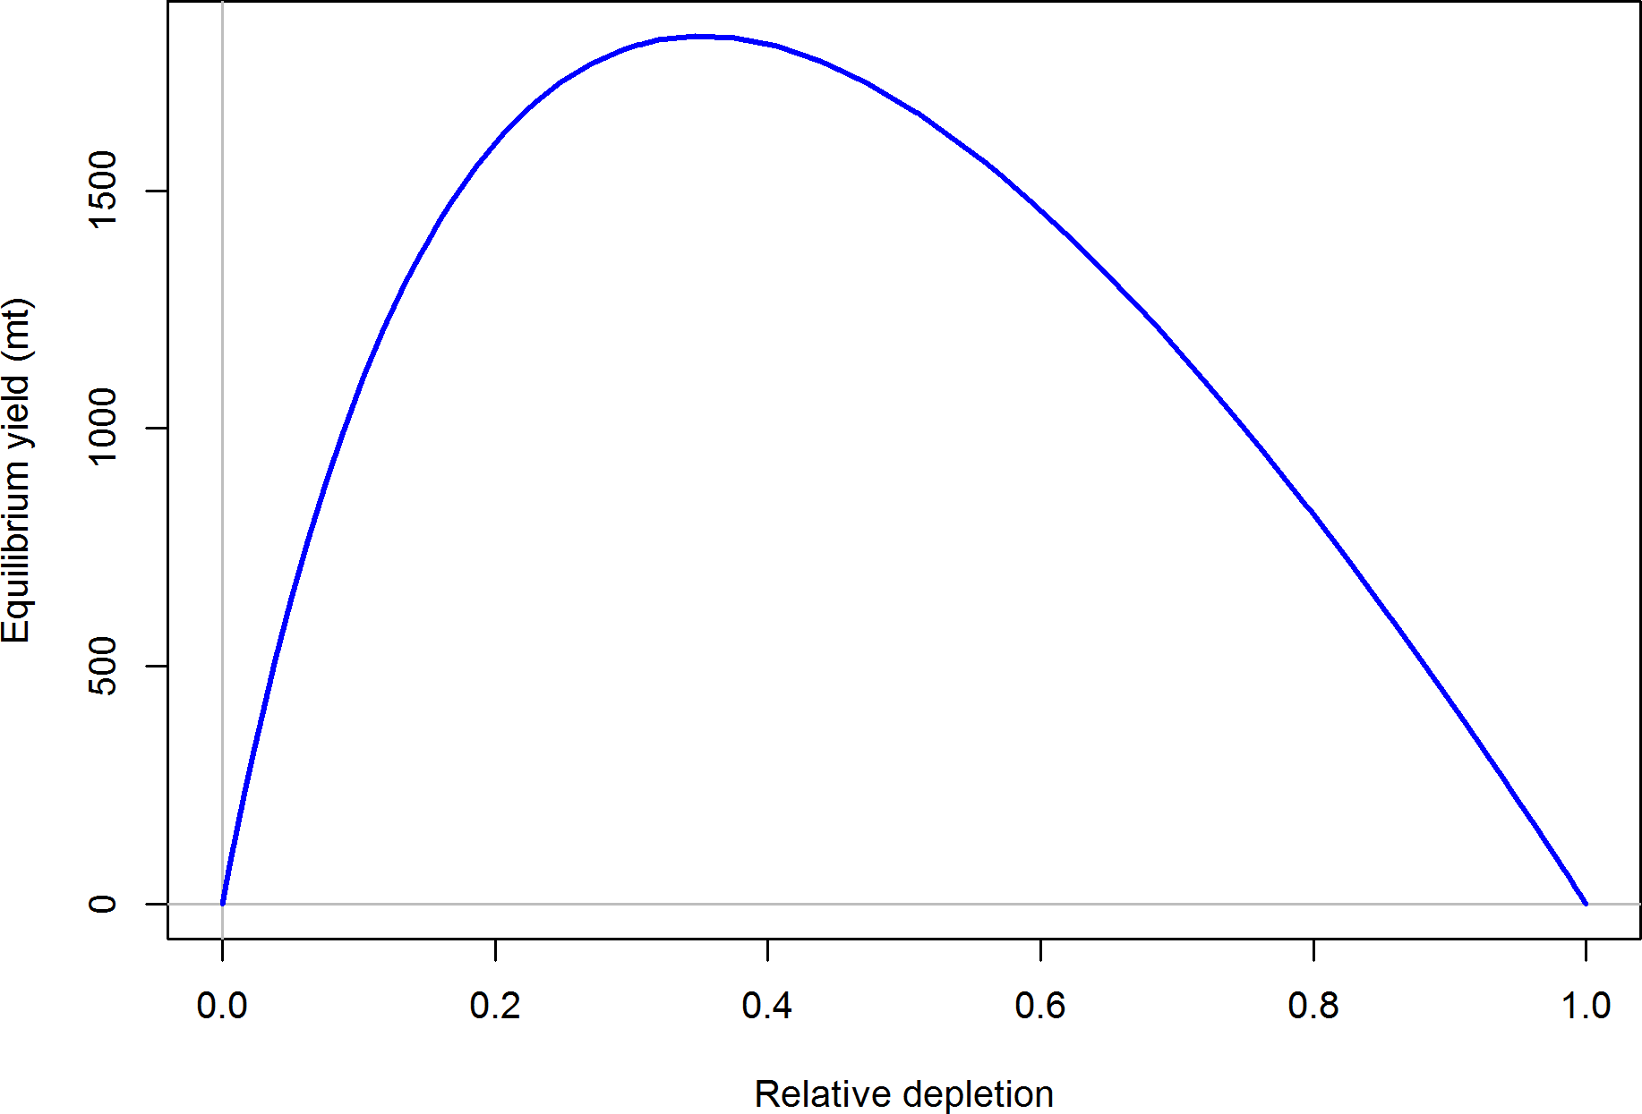

Figure g: Equilibrium yield curve for the base case model. Values are based on the 2016 fishery selectivity and with steepness fixed at 0.50.

# Introduction

## Distribution and Stock Structure

Pacific ocean perch (*Sebastes alutus*) are most abundant in the Gulf of Alaska and have been observed off of Japan, in the Bering Sea, and south to Baja California, although they are sparse south of Oregon and rare in southern California. While genetic studies have found three populations of Pacific ocean perch off of British Columbia related to unique geography and oceanic conditions (Seeb and Gunderson 1988, Withler et al. 2001) with, notably, a separate stock off of Vancouver Island, no significant genetic differences have been found in the range covered by this assessment. However, studies looking for genetic difference in the range of this assessment are limited. Pacific ocean perch show dimorphic growth, with females reaching a slightly larger size than males. Males and females are equally abundant on rearing grounds at age 1.5.

The Pacific ocean perch population has been modeled as a single stock off of the US west coast (essentially northern California to the Canadian border, since Pacific ocean perch are seen extremely rarely in central and southern California). Good recruitments show up in size-composition data throughout all portions of this area, which supports the single stock hypothesis. This assessment includes landings and catch data for Pacific ocean perch from the states of Washington, Oregon and California, along with records from foreign fisheries, the at-sea hake fleet, and fishery-independent surveys.

## Historical and Current Fishery

Prior to 1966, the Pacific ocean perch resource off of the northern portion of the US west coast was harvested almost entirely by Canadian and US vessels. Harvest was negligible prior to 1940, reached 1,367 mt in 1950, 3,243 mt in 1961 and 7,636 mt in 1965. Catches increased dramatically after 1965, with the introduction of large distant-water fishing fleets from the Soviet Union and Japan. Both nations employed large factory stern trawlers as their primary method for harvesting Pacific ocean perch. Peak removals are estimated at 18,883 mt in 1966 and 14,591 mt in 1967. These numbers are based upon a re-analysis of the foreign catch data (Rogers 2003), which focused on deriving a more realistic species composition for catches previously identified only as Pacific ocean perch. Catches declined rapidly following these peak years, and Pacific ocean perch stocks were considered to be severely depleted throughout the Oregon-Vancouver Island region by 1969 (Gunderson 1977, Gunderson et al. 1977). Landed harvest averaged 1,381 mt over the period 1977-94. Landings have continued to decline since 1994, primarily due to more restrictive management (Table 1 and Figure 1).

## Summary of Management History and Performance

Prior to 1977, Pacific ocean perch in the northeast Pacific were managed by the Canadian Government in its waters and by the individual states in waters off of the US. With the implementation of the Magnuson Fishery Conservation and Management Act (MFCMA) in 1977, US territorial waters were extended to 200 nautical miles from shore and primary responsibility for management of the groundfish stocks off Washington, Oregon, and California shifted from the states to the Pacific Fishery Management Council (PFMC) and the National Marine Fisheries Service (NMFS). At that time, however, a Fishery Management Plan for the West Coast groundfish stocks had not yet been approved. In the interim, the state agencies worked with the PFMC to address conservation issues. In 1981, the PFMC adopted a management strategy to rebuild the depleted Pacific ocean perch stocks to levels that would produce Maximum Sustainable Yield (MSY) within 20 years. On the basis of cohort analysis (Gunderson 1978), the PFMC set Acceptable Biological Catch (ABC) levels at 600 mt for the US portion of the Vancouver International North Pacific Fishery Commission (INPFC) area and 950 mt for the Columbia INPFC area. To implement this strategy, the states of Oregon and Washington each established landing limits for Pacific ocean perch. Trawl trip limits of various forms remained in effect through 2016 (Table 2).

The landings of Pacific ocean perch have been historically governed by harvest guidelines and trip limits, while recently management has imposed total catch harvest limits in the form of overfishing limits (OFLs), acceptable biological catches (ABCs), and annual catch limits (ACLs). A trawl rationalization program, consisting of an individual fishing quota (IFQ) catch shares system was implemented in 2011 for the limited entry trawl fleet targeting non- whiting groundfish, including Pacific ocean perch and the trawl fleet targeting and delivering whiting to shore-based processors. The limited entry at-sea trawl sectors (motherships and catch-processors) that target whiting and process at-sea are managed in a system of harvest cooperatives.

Limits on Pacific ocean perch were first established in 1983 (Table 2). These were implemented as area closures, trip limits, and cumulative landing limits. In 1999, Pacific ocean perch was declared overfished with the assessment estimating the spawning output below the management limit (25% of virgin biomass or output). In reaction to the overfished declaration, harvest limits were reduced relative to previous years and a rebuilding plan was implemented in 2001 with recent ACLs being set well below the estimated OFLs (Table 3).

## Fisheries off Canada and Alaska

Pacific ocean perch can be found in waters off the US west coast and northward through Alaskan waters. In contrast to the Pacific ocean perch stock off the US west coast, each assessed portion of the stock in Canadian and Alaskan waters have historically been estimated to be above management targets. The subset of the stock off the US west coast represents the tail of the species distribution with little to no Pacific ocean perch being encountered south

of northern California. The most recent updated assessments for the Bering Sea and the Gulf of Alaska stocks determined that neither stock is in an overfished state and recommended acceptable biological catches of 43,723 mt and 23,918 mt, respectively, for 2017.

In Canadian waters Pacific ocean perch has the largest single-species quota, accounting for approximately 25% of all rockfish landings by weight in the bottom trawl fleet. The Canadian Pacific ocean perch stock is broken into three separate areas that are individually assessed. The status of the stock within each area is above Canadian management targets. The Canadian portion of the stock off the coast of British Columbia (PMFC management areas 3C and 3D) was assessed in 2013 to be at 41% of unfished virgin biomass (Edwards et al. 2014). Removals averaged 530 mt for the management area between 2006-2012. The removal history peaked during the foreign fishery years of the 1960s and have declined to lower levels in more recent years. Both natural mortality and steepness were estimated using priors within the British Columbia assessment. Natural mortality was estimated at 0.069yr-1 for females and 0.072yr-1 for males. Steepness was estimated to be 0.70.

# Data

Data used in the Pacific ocean perch assessment are summarized in Figure 2. A description of each data source is provided below.

## Fishery-Independent Data

Research surveys have been used to provide fishery-independent information about the abundance, distribution, and biological characteristics of Pacific ocean perch. A coast-wide survey was conducted in 1977 (Gunderson and Sample 1980) and repeated every three years through 2004 (referred to as the ‘Triennial shelf survey’). The NMFS coordinated a cooperative research survey of the Pacific ocean perch stocks off Washington and Oregon with the Washington Department of Fish and Wildlife (WDFW) and the Oregon Department of Fish and Wildlife (ODFW) in March-May 1979 (Wilkins and Golden 1983). This survey was repeated in 1985 (referred to as the Pacific ocean perch survey). Two slope surveys have been conducted off the West Coast in recent years, one using the research vessel Miller Freeman, which ended in 2001 (referred to as the ‘AFSC slope survey’), and another ongoing cooperative survey using commercial fishing vessels which began in 1998 as a DTS (Dover sole, thornyhead, and sablefish) survey and was expanded to other groundfish in 1999 (referred to as the ‘NWFSC slope survey’). In 2003, this survey was expanded spatially to include the shelf. This last survey, conducted by the NWFSC, continues to cover depths from 30-700 fathoms (55-1280 meters) on an annual basis (referred to as the ‘NWFSC shelf-slope survey’).

Age estimates for Pacific ocean perch prior to the 1980s were made via surface ageing of otoliths, which misses the very tight annuli at the edge of the otolith once the fish reaches

near maximum size. Ages are highly biased by age 14, and maximum age was estimated to be in the 20s, which lead to an overestimate of the natural mortality rate and the productivity of the stock. Using break and burn methods, Pacific ocean perch have been aged to over 100 years. Otoliths from fishery-independent and -dependent sources that were only surface age reads were excluded from this assessment due to the bias associated with these age reads. The previous assessment also excluded the surface read otoliths.

### 2.1.1 Northwest Fisheries Science Center (NWFSC) Shelf-Slope Survey

The NWFSC shelf-slope survey is based on a random-grid design; covering the coastal waters from a depth of 55 m to 1,280 m (Bradburn et al. 2011). This design uses four chartered industry vessels in most years, assigned to a roughly equal number of randomly selected grid cells. The survey, which has been conducted from late-May to early-October each year, is divided into two 2-vessel passes off the coast, which are executed from north to south. This design therefore incorporates both vessel-to-vessel differences in catchability as well as variance associated with selecting a relatively small number (approximately 700) of cells from a very large population of possible cells (greater than 11,000) distributed from the Mexican to the Canadian border.

The data from the NWFSC shelf-slope survey was analyzed using a spatio-temporal delta- model (Thorson et al. 2015), implemented as an R package, VAST (Thorson and Barnett 2017), which is publicly available online (<https://github.com/James-Thorson/VAST>). Spatial and spatio-temporal variation is specifically included in both encounter probability and positive catch rates, a logit-link for encounter probability and a log-link for positive catch rates. Vessel-year effects were included for each unique combination of vessel and year in the data to account for the random selection of commercial vessels used during sampling (Helser et al. 2004, Thorson and Ward 2014). Spatial variation was approximated using 1,000 knots, and the model used the bias-correction algorithm (Thorson and Kristensen 2016) in Template Model Builder (Kristensen et al. 2016). Further details regarding model structure are available in the user manual ([https://github.com/James-Thorson/VAST/blob/](https://github.com/James-Thorson/VAST/blob/master/examples/VAST_user_manual.pdf) [master/examples/VAST user manual.pdf](https://github.com/James-Thorson/VAST/blob/master/examples/VAST_user_manual.pdf)). The stratification and modeling configuration are provided in Table 4.

The smallest Pacific ocean perch tend to occur in the shallower depths (*<* 200 m) with only larger individuals occurring at depths deeper than 300 m. Data collected by the NWFSC

shelf-slope survey between depths of 55 - 549 m and north of 42∘ and south of 49∘ were used to generate an index of abundance from 2003-2016. The estimated index of abundance is

shown in Table 5. For contrast, the design based values are shown in Table 6. The lognormal distribution with random strata-year and vessel effects had the lowest AIC and was chosen as the final model. The Q-Q plot does not show any departures from the assumed distribution (Figure 4). The indices for the NWFSC shelf-slope survey show a tentative decline in the population between 2003 and 2009, with an increasing trend in biomass between the 2009 and 2016 median point estimates.

Length compositions were expanded based upon the stratification and the age data was used as conditional age-at-length data. The number of tows with length data ranged from 33 in 2006 to 69 in 2015 (Table 7), where ages were collected for Pacific ocean perch in nearly every tow length data were collected (Table 8). The expanded length frequencies from this survey show an increase in small fish starting in 2010 (Figure 5). The age frequencies provide clear evidence of large year-classes moving through the population from the 1999, 2000, and 2008 recruitments; with early indications of a large 2013 recruitment (Figure 6).

The input sample sizes for length and marginal age-composition data for all fishery- independent surveys were calculated according to Stewart and Hamel (2014), which determined that the approximate realized sample size for shelf/slope rockfish species was

2*.*43 *𝑁*tow. The effective sample size of conditional-age-at-length data was set at the number

*

of fish at each length by sex and by year. The conditional-age-at-length data were not expanded and were binned by according to length, age, sex, and year.

Fish with ages also have an associated length and each type of data have been used in the model. Age data from the NWFSC shelf-slope survey were used as conditional-age-at-length data within the model, which avoids double of the length and age data by explicitly stating the length associatted with each aged fish. Hence, the length and conditional-age-at-length data from the NWFSC shelf-slope survey were given full weight in likelihood calculations when model fitting.

### Northwest Fisheries Science Center (NWFSC) Slope Survey

The NWFSC slope survey covered waters throughout the summer from 183 m to 1,280 m north of 34∘30′ S, which is near Point Conception, from 1999 and 2002. Tows conducted between the depths of 183 and 549 m were used to create an index of abundance using a

bayesian delta-GLMM model. The VAST delta-GLMM model was also explored but due to poor diagnostics this modeling approach was not used to create the final index. The estimated index of abundance is shown in Table 5. The stratification and modeling configuration are provided in Table 4. Based on the diagnostics of the bayesian delta-GLMM, which does not account for spatial effects, a gamma distribution allowing for additional probability of extreme catch events with year-vessel random effects was selected as the final model. The Q-Q plot does show a minimal departure from the assumed distribution (Figure 7), but was determined to be acceptable based on the alternative model distributions. The trend of abundance across the four surveys years was generally flat with high estimated annual variance. Sensitivities (not shown) were done evaluating the excluding of this index within the base model or using the VAST estimated index and neither approach was found to be influential on the model estimates.

Length and age compositions were available for 2001 and 2002 and were expanded based upon the survey stratification (Tables 9 and 10). The expanded length frequencies from this survey shows that primarily only large fish were captured both years (Figure 8). The majority of fish observed by this survey were aged at greater than 10 years (Figure 9).

The input sample sizes for length and marginal age-composition data were calculated according to Stewart and Hamel (2014) described in Section 2.1.1.

Fish with ages also have an associated length and each type of data have been used in the model. To avoid double use of the length and age data from individual fish, the length and age data sources were each given 0.50 weight in the likelihood calculations when model fitting.

### Alaska Fisheries Science Center (AFSC) Slope Survey

The AFSC slope survey operated during autumn (October-November) aboard the R/V Miller Freeman. Partial survey coverage of the US west coast occurred during 1988-96 and complete coverage (north of 34∘30′ S) during 1997, 1999, 2000, and 2001. Only the four years of

consistent and complete surveys (1997, 1999, 2000, and 2001) plus 1996, which surveyed north of 43∘ N latitude to the US-Canada border, were used in this assessment. These same data years were used in the last assessment. The number of tows with length data ranged from 19

in 2000 to 48 in 1996 (Table 11). Because a large number of positive tows occurred in 1996, it was decided to include that year, which surveyed from 43∘ N latitude to the US-Canada border. Therefore, only tows from 43∘ N latitude to the US-Canada border were used across all years to create and index of abundance.

An index of abundance was estimated based on the data using the VAST delta-GLMM model. The estimated index of abundance is shown in Table 5. The stratification and modeling configuration are provided in Table 4. The lognormal distribution with random strata-year had the lowest AIC and was chosen as the final model. The Q-Q plot does not show any departures from the assumed distribution (Figure 10). The trend in the indices was generally flat over time.

Length compositions were available for each year the survey was conducted. No age data were available from this survey. The expanded length frequencies from this survey were generally of larger fish ( *>* 30 cm), except for 1997 where the highest frequency of fish were between 20 and 30 cm for both females and males (Figure 11).

The input sample sizes for length and marginal age composition data were calculated according to Stewart and Hamel (2014) described above in Section 2.1.1.

### Pacific Ocean Perch Survey

A survey designed to sample Pacific ocean perch was conducted in 1979 and again in 1985 (for a detailed description see Ianelli et al. (1992)). An index of abundance was estimated based on the data using the VAST delta-GLMM model. The estimated index of abundance is shown in Table 5. The stratification and modeling configuration are provided in Table 4. The lognormal distribution with random strata-year had the lowest AIC and was chosen as

the final model. The Q-Q plot does not show any departures from the assumed distribution (Figure 12). The index shows a clear decline in abundance between the two survey years.

Length and age compositions were expanded based on the survey stratification. The survey had 125 and 126 Pacific ocean perch tows (Table 12) and break-and-burn ages were available for 1985 (Table 13). Only surface reads, considered to be biased, were available for the 1979 data. The length frequencies for both years are highest between the 30-45 cm range (Figure

13) with ages in 1985 having a large number of fish age 40 and greater (Figure 14).

The input sample sizes for length and marginal age-composition data were calculated according to Stewart and Hamel (2014) described above in Section 2.1.1. To avoid double use of the length and age data from individual fish, the length and age data sources were each given

0.50 weight in the likelihood calculations when model fitting.

### Fishery Independent Data Not Included in the Base Model

The follow datasets were evaluated but not included in the base model.

### Triennial Shelf Survey

The Triennial shelf survey was first conducted by the AFSC in 1977 and spanned the time- frame from 1977-2004. The survey’s design and sampling methods are most recently described in Weinberg et al. (2002). Its basic design was a series of equally-spaced transects from which searches for tows in a specific depth range were initiated. The survey design has changed slightly over the period of time. In general, all of the surveys were conducted in the mid-summer through early fall: the 1977 survey was conducted from early July through late September; the surveys from 1980 through 1989 ran from mid-July to late September; the 1992 survey spanned from mid-July through early October; the 1995 survey was conducted from early June to late August; the 1998 survey ran from early June through early August; and the 2001 and 2004 surveys were conducted in May-July.

Haul depths ranged from 91-457 m during the 1977 survey with no hauls shallower than 91 m. The surveys in 1980, 1983, and 1986 covered the West Coast south to 36*.*8∘ N latitude and a depth range of 55-366 m. The surveys in 1989 and 1992 covered the same depth range but extended the southern range to 34*.*5∘ N (near Point Conception). From 1995 through 2004, the surveys covered the depth range 55-500 m and surveyed south to 34*.*5∘ N. In the final

year of the Triennial series, 2004, the NWFSC’s Fishery Resource and Monitoring division

(FRAM) conducted the survey and followed very similar protocols as the AFSC.

Although the Triennial shelf survey was used in the 2011 assessment, it was not used in the final base model for the current assessment for a number of reasons. First, there were concerns regarding the varying sampling and targeting of specific species by year across the

time-series. Secondly, the Triennial shelf survey targeted the shelf of the West Coast and would not be expected to sample well slope species such as Pacific ocean perch. There were limited observations of Pacific ocean perch relative to other surveys (e.g. NWFSC shelf-slope survey) and the length and age distributions varied in such a manner that would indicate either poor sampling of Pacific ocean perch or inconsistent sampling of the population.

Information regarding the Triennial shelf survey index of abundance and the number of samples available and plots of the composition data are available in Appendix C, section 12.

* + - 1. **Washington Research Lengths**

Research length and ages were provided by WDFW. However, the information regarding the nature of the research cruise and collection methods have been lost to time. The data set includes lengths and ages that were collected between 1967-1972 and in 1979. The distribution of lengths across years collected were consistent with primarily only larger Pacific ocean perch, 35-40 cm, being selected. All age data were based upon surface reads which unfortunately are highly biased at relatively young ages for Pacific ocean perch. Due to the lack of information regarding the collection of these data, they were not selected to be a part of the base model but a sensitivity was conducted which evaluated the impact of these data.

* 1. **Fishery-Dependent Data**
     1. **Commercial Fishery Landings Washington**

Historical commercial fishery landings of Pacific ocean perch in Washington for the years 1908-2016 were obtained from Theresa Tsou (WDFW) and Phillip Weyland (WDFW). This assessment is the first Pacific ocean perch assessment to include a historical catch reconstruction provided by Washington state and, hence, the historical catches for Washington differ from those used in the 2011 assessment. WDFW also provided catches for the 1981-2016 period to include re-distribution of the “URCK” landings in the PacFIN database. These data are currently not available from PacFIN.

**Oregon**

Historical commercial fishery landings of Pacific ocean perch in Oregon for the years 1892- 1986 were obtained from Alison Whitman (ODFW). A description of the methods can be found in Karnowski et al. (2014). Recent landings (1987-2016) were obtained from PacFIN (retrieval dated May 2, 2017, Pacific States Marine Fisheries Commission, Portland, Oregon; www.psmfc.org). The catch data from the POP and POP2 categories contained within PacFIN for Pacific ocean perch were used for this assessment. Additional catches from

1987-1999 for Pacific ocean perch under the URCK category not yet available in PacFIN were received directly from the state and combined with the landings data available for that period within PacFIN (Patrick Mirrick, personal communication, ODFW).

**California**

Historical commercial fishery landings of Pacific ocean perch were obtained directly from John Field at the SWFSC due to database issues for the historical period for the California Coop- erative Groundfish Survey data system, also known as CALCOM Database (128.114.3.187) for the years 1916-1980. The catches received included revisions in the catch history from 1948-1960 based on fish that were caught north of the California-Oregon border and landed in northern California which were not included in the original reconstruction. A description of the historical reconstruction methods can be found in Ralston et al. (2010). Recent landings (1981-2016) were obtained from PacFIN (retrieval dated May 2, 2017, Pacific States Marine Fisheries Commission, Portland, Oregon; www.psmfc.org).

**At-Sea Hake Fishery**

Catches of Pacific ocean perch are monitored aboard the vessel by observers in the at-sea hake Observer program (ASHOP) and were available for the years of 1975-2016. Observers use a spatial sample design, based on weight, to randomly choose a portion of the haul to sample for species composition. For the last decade, this is typically 30-50% of the total weight. The total weight of the sample is determined by all catch passing over a flow scale. All species other than hake are removed and weighed by species on a motion compensated flatbed scale. Observers record the weights of all non-hake species. Non-hake species total weights are expanded in the database by using the proportion of the haul sampled to the total weight of the haul. The catches of non-hake species in unsampled hauls is determined using bycatch rates determined from sampled hauls. Since 2001, more than 97% of the hauls have been observed and sampled.

**Foreign Catches**

From the 1960s through the early 1970s, foreign trawling enterprises harvested considerable amounts of rockfish off Washington and Oregon, and along with the domestic trawling fleet, landed large quantities of Pacific ocean perch. Foreign catches of individual species were estimated by Rogers (2003) and attributed to INPFC areas for the years of 1966-1976 for Pacific ocean perch. The foreign catches were combined across areas for a coastwide removal total.

* + 1. **Discards**

Data on discards of Pacific ocean perch are available from two different data sources. The earliest source is referred to as the Pikitch data and comes from a study organized by Ellen

Pikitch that collected trawl discards from 1985-1987 (Pikitch et al. 1988). The northern and southern boundaries of the study were 48∘42′ N latitude and 42∘60′ N latitude respectively, which is primarily within the Columbia INPFC area (Pikitch et al. 1988, Rogers and Pikitch

1992). Participation in the study was voluntary and included vessels using bottom, midwater, and shrimp trawl gears. Observers of normal fishing operations on commercial vessels collected the data, estimated the total weight of the catch by tow, and recorded the weight of species retained and discarded in the sample. Results of the Pikitch data were obtained from John Wallace (personal communication, NWFSC, NOAA) in the form of ratios of discard weight to retained weight of Pacific ocean perch and sex-specific length frequencies. Discard estimates are shown in Table 14.

The second source is from the West Coast Groundfish Observer Program (WCGOP). This program is part of the NWFSC and has been recording discard observations since 2003. Table 14 shows the discard ratios (discarded/(discarded + retained)) of Pacific ocean perch from WCGOP. Since 2011, when the trawl rationalization program was implemented, observer coverage rates increased to nearly 100% for all the limited entry trawl vessels in the program and discard rates declined compared to pre-2011 rates. Discard rates were obtained for both the catch-share and the non-catch share sector for Pacific ocean perch. A single discard rate was calculated by weighting discard rates based on the commercial landings by each sector. Coefficient of variations were calculated for the non-catch shares sector and pre-catch share years by bootstrapping vessels within ports because the observer program randomly chooses vessels within ports to be observed. Post-ITQ, all catch-share vessels have 100% observer coverage and discarding is assumed to be known. Discard length composition for the trawl fleet varied by year, with larger fish being discarded prior to 2011 (Figure 15).

* + 1. **Fishery Length and Age Data**
       1. **Commercial Fishery**

Biological data from commercial fisheries that caught Pacific ocean perch were extracted from PacFIN on May 4, 2017. Lengths taken during port sampling in Oregon and Washington were used to calculate length and age compositions. There were no biological data from California for Pacific ocean perch available within PacFIN or CALCOM databases. The overwhelming majority of these data were collected from the mid-water and bottom trawl gear, but additional biological data were collected from non-trawl gear which was grouped together with trawl gear data. Tables 15 and 16 show the number of trips and fish sampled, along with the calculated sample sizes. Length and age data were acquired at the trip level and then aggregated to the state level. The input sample sizes were calculated via the Stewart method (Ian Stewart, personal communication, IPHC):

Input effN = *𝑁*trips + 0*.*138 * *𝑁*fish if *𝑁*fish*/𝑁*trips is *<* 44 Input effN = 7*.*06 * *𝑁*trips if *𝑁*fish*/𝑁*trips is ≥ 44

The fishery fleet observed Pacific ocean perch that were generally greater than 30 cm across all years of available data (Figure 16). The fishery fleet age data has clear patterns showing two large cohorts moving through the population near the end of the time-series (Figure 17). Lengths and ages were also available for the at-sea hake fishery and are shown in Figures 18 and 19.

To avoid double use of the length and age data from individual fish, the length and age data sources were each given 0.50 weight in the likelihood calculations when model fitting.

* + - 1. **At-Sea Hake Fishery**

Available biological data from the at-sea hake fishery were included in the assessment. Length data were available from 2003-2016 (Table 17) with annual sample sizes ranging from a low of 63 in 2009 to a high of 470 in 2007. Age data were available from 2003, 2006, 2007, and 2014 (Table 18). Sample sizes were calculated based on the equation described above in Section 2.2.3.1. To avoid double use of the length and age data from individual fish, the length and age data sources were each given 0.50 weight in the likelihood calculations when model fitting.

* + 1. **Fishery Data Not Included in the Base Model**

Several datasets available from the fishery were explored but not used in the final assessment.

* + - 1. **Historical Commercial Catch-Per-Unit Effort**

Data on catch-per-unit-effort (CPUE) in mt/hr from the domestic fishery were combined for the INPFC Vancouver and Columbia areas from Gunderson (1977). Although these data reflect catch rates for the US fleet, the highest catch rates coincided with the beginning of removals by the foreign fleet. This suggests that, barring unaccounted changes in fishing efficiency during this period, the level of abundance was high at that time. Unfortunately, the original data and the analysis methods used to create this CPUE series have been lost to time precluding a re-analysis of these data. Due to the inability to examine the assumptions made during the original analysis or the data used this time-series has been excluded from the base model. These data were included in the previous assessment but were deemed not influential in the model estimates. Information regarding the fishery CPUE are available in Appendix C, section 12.

* + - 1. **Oregon Special Projects Length and Age Data**

Oregon special project data were provided by ODFW. These data represent samples made at either the dock or at processing plants from fishery landings. Length data were collected

primarily from 1970-1986, with limited samples from more recent years. Age data were primarily available from 1981-1984. These data were collected for special projects and may not have been sampled randomly from the fishery landings. Due to these concerns, these data were not included in the base model but were included in a model sensitivity. This was the first time these data were explored for consideration in the assessment.

* 1. **Biological Data**
     1. **Natural Mortality**

Historical Pacific ocean perch ages determined using scales and surface reading methods of otoliths resulted in estimates of natural mortality (*𝑀*) between 0.10 and 0.20 yr-1 with a longevity less than 30 years (Gunderson 1977). Based on the break-and-burn method of age determination using otoliths, the maximum age of Pacific ocean perch was revised to be 90 years (Chilton and Beamish 1982). The updated understanding concerning Pacific ocean perch longevity reduced the estimate of natural mortality based on Hoenig’s (1983) relationship to 0.059 yr-1. The previous assessment applied a prior distribution on natural mortality based upon multiple life-history correlates (including Hoenig’s method, Gunderson (1997) gonadosomatic index, and McCoy and Gillooly’s (2008) theoretical relationship) developed separately for female and male Pacific ocean perch.

Hamel (2015) developed a method for combining meta-analytic approaches relating the *𝑀* rate to other life-history parameters such as longevity, size, growth rate, and reproductive effort to provide a prior on *𝑀*. In that same issue of *ICES Journal of Marine Science*, Then et al. (2015) provided an updated data set of estimates of *𝑀* and related life history parameters across a large number of fish species from which to develop an *𝑀* estimator for fish species in general. They concluded by recommending *𝑀* estimates be based on maximum

age alone, based on an updated Hoenig non-linear least squares estimator *𝑀* = 4*.*899*𝐴*−0*.*916. The approach of basing *𝑀* priors on maximum age alone was one that was already being used

*�𝑎�*

for West Coast rockfish assessments. However, in fitting the alternative model forms relating

*𝑀* to *𝐴*max, Then et al. (2015) did not consistently apply their transformation. In particular, in real space, one would expect substantial heteroscedasticity in both the observation and process error associated with the observed relationship of *𝑀* to *𝐴*max. Therefore, it would be reasonable to fit all models under a log transformation. This was not done. Re-evaluating the data used in Then et al. (2015) by fitting the one-parameter *𝐴*max model under a log-log transformation (such that the slope is forced to be -1 in the transformed space (Hamel 2015)), the point estimate for *𝑀* is:

*𝑀* = 5*.*4

*𝐴*

max

The above is also the median of the prior. The prior is defined as a lognormal distribution with mean *��*(5*.*4*/𝐴*max) and SE = 0.438. Using a maximum age of 100, the point estimate and median of the prior is 0.054 yr-1. The maximum age was selected based on available age

data from all West Coast data sources. The oldest aged rockfish was 120 years, captured by the commercial fishery in 2007. However, age data are subject to ageing error which could impact this estimate of longevity. The selection of 100 years was based on the range of other ages available with multiple observations of fish between 90 and 102 years of age.

* + 1. **Sex Ratio, Maturation, and Fecundity**

Examining all biological data sources, the sex ratio of young fish are within 5% of 1:1 by length until larger sizes which are dominated by females who reach a larger maximum size relative to males (Figure 20), with the sex ratio being approximately equal across ages (Figure 21), and hence this assessment assumed the sex ratio at birth was 1:1. This assessment assumed a logistic maturity-at-length curve based on analysis of 537 fish maturity samples collected from the NWFSC shelf-slope survey. This is revised from the previous assessment that assumed maturity-at-age based on the work of Hannah and Parker (2007). Additionally, the new maturity-at-length curve is based on the estimate of functional maturity, an approach that classifies rockfish maturity with developing oocytes as mature or immature based on the proportion of vitellogenin in the cytoplasm and the measured frequency of atretic cells (Melissa Head, personal communication, NWFSC, NOAA). The 50% size-at-maturity was estimated at 32.1 cm with maturity asymptoting to 1.0 for larger fish (Figure 22). Comparison between the maturity-at-age used in the previous assessment and the updated functional maturity-at-length is shown in Figure 23 showing that the new maturity curve has fish reaching 50% maturity at older ages relative to the maturity-at-age used in the 2011 assessment.

The fecundity-at-length has also been updated from the previous assessment based on new research. Dick et al. (2017) estimated new fecundity relationships for select West Coast stocks where fecundity for Pacific ocean perch was estimated equal to 8.66e-10*𝐿*4.98 in millions of eggs where *𝐿* is length in cm. Fecundity-at-length is shown in Figure 24.

* + 1. **Length-Weight Relationship**

The length-weight relationship for Pacific ocean perch was estimated outside the model using all biological data available from fishery-dependent and -independent data sources, where the female weight-at-length in grams was estimated at 1.003e-05*𝐿*3.1 and males at 9.881e-06*𝐿*3.1 where *𝐿* is length in cm (Figures 25 and 26).

* + 1. **Growth (Length-at-Age)**

The length-at-age was estimated for male and female Pacific ocean perch using data collected from both fishery-dependent and -independent data sources that were collected from 1981- 2016. Figure 27 shows the lengths and ages for all years and all data as well as predicted

von Bertalanffy fits to the data. Females grow larger than males and sex-specific growth parameters were estimated at the following values:

Females *𝐿*∞ = 42.32; *�* = 0.169; *�*0 = -1.466 Males *𝐿*∞ = 39.03; *�* = 0.212; *�*0 = -1.02

These values were used as starting parameter values within the base model prior to estimating each parameter for male and female Pacific ocean perch.

* + 1. **Ageing Precision and Bias**

Uncertainty surrounding the age-reading error process for Pacific ocean perch was incorporated by estimating ageing error by age. Age-composition data used in the model were from break- and-burn otolith reads aged by the Cooperative Ageing Project (CAP) in Newport, Oregon. Break-and-burn double reads of more than 1500 otoliths were provided by the CAP lab. An ageing-error estimate was made based on these double reads using a computational tool specifically developed for estimating ageing error (Punt et al. 2008) and using release 1.0.0 of the R package nwfscAgeingError (Thorson et al. 2012) for input and output diagnostics, publicly available at: <https://github.com/nwfsc-assess/nwfscAgeingError>. A non-linear standard error was estimated by age, where there is more variability in the age of older fish (Table 19 and Figure 28). The 2011 assessment assumed a linear ageing error vector and is shown in Figure 28 for comparison with the updated ageing error applied in the current assessment.

**2.4 History of Modeling Approaches Used for This Stock**

**2.4.1 Previous Assessments**

The status of Pacific ocean perch off British Columbia, Washington, and Oregon have been periodically assessed since the intensive exploitation that occurred in the 1960s. Concerns regarding Pacific ocean perch status off the coast the US west coast were raised in the late 1970s (Gunderson 1978, 1981) and in 1981 the PFMC adopted a 20-year plan to rebuild the stock.

The 1992 assessment determined that Pacific ocean perch remained at low levels relative to the population size in 1960 (Ianelli et al. 1992) and recommended additional harvest restrictions to allow for stock rebuilding. The 1998 assessment (Ianelli and Zimmermann 1998) estimated that the stock was 13% of the unfished level, leading the National Marine Fishery Service (NMFS) to declare the stock overfished in 1999. A formal rebuilding plan was implemented in 2001. The rebuilding plan reduced the SPR harvest rate used to determine

catches to 0.864 (in contrast to the default harvest rate of 0.50). The last full assessment of Pacific ocean perch was conducted in 2011 (Hamel and Ono 2011), which concluded that the stock was still well below the target biomass of 40%*𝑆𝐵*0, estimating the relative stock status at 19.1%.

1. **Assessment**
   1. **General Model Specifications and Assumptions**

Stock Synthesis version 3.30.03.05 was used to estimate the parameters in the model. R4SS, version 1.27.0, along with R version 3.3.2 were used to investigate and plot model fits. A summary of the data sources used in the model (details discussed above) is shown in Figure 2.

* + 1. **Changes Between the 2011 Assessment Model and Current Model**

The current model for Pacific ocean perch has many similar assumptions as the 2011 assessment but differs in some key ways. In this assessment, fleets were disaggregated into a trawl/other gear, at-sea hake, historical foreign fleet, and research fleets. The previous assessment implemented a single fleet where removals from all sources were aggregated together. The separating of fleets applied in this assessment allowed for differing assumptions regarding current and historical discarding practices. Although there are no compositional data available from the foreign fleet, it is assumed that very little to no discarding of fish occurred. Additionally, the at-sea hake fishery removals represent both discarded and retained fish and hence an additional discard rate would not be appropriate. Similar logic was applied in regard to survey removals.

The historical landings used in the model differ from those used in 2011. This assessment includes the first state provided historical reconstruction landings for Washington. The historical reconstruction has removals starting in 1908 and has larger removals in the 1940s relative to those used in the 2011 assessment (Figure 30). The starting year for modeling the stock was revised to 1918, the first year Pacific ocean perch landings exceeded 1 mt, rather than 1940 as modeled in the previous assessment, given the new information regarding historical removals prior to 1940. Explorations were conducted relative to the model starting year and no differences were found between the 1918 start year compared to starting the model in 1892, which is the first year there is any record of landings of Pacific ocean perch between California, Oregon, and Washington.

Selectivity in this model is assumed to be length-based and is modeled using double-normal selectivity for all fleets, except the Pacific ocean perch survey which retained the assumption

used in previous assessment of logistic selectivity. The previous assessment mirrored selectivity among the Pacific ocean perch and both slope surveys (AFSC and NWFSC). This assessment allows for survey-specific selectivity.

All fishery-independent indices have been re-evaluated for this assessment using a spatial- temporal delta generalized linear mixed model (VAST delta-GLMM) which is an updated approach from that used in 2011, which did not incorporate spatial autocorrelation effects. This assessment opted to not include the fishery CPUE and the Triennial shelf index and composition data based upon discussions during the STAR panel. The data used to create the CPUE index were not available for reanalysis and hence were excluded from this assessment due to questions regarding this index that could not be addressed. In regards to the Triennial survey, Pacific ocean perch is considered a slope species off the US west coast and this survey did not sample the prime habitat for Pacific ocean perch and had limited observations relative to the other surveys. It was concluded during the STAR panel that this data set was not a good source of information regarding this species and would not be included in the base model.

Maturity and fecundity were updated for this assessment based upon new research. Fecundity for Pacific ocean perch used in this assessment was based on a re-evaluation of the fecundity of West Coast rockfish by Dick et al. (2017), updating the previous fecundity estimates used in the 2011 assessment (Dick 2009) (Figure 24). Maturity in this assessment was based on examination of 537 fish samples which were used to estimate functional maturity, an approach that classifies rockfish maturity with developing oocytes as mature or immature based on the proportion of vitellogenin in the cytoplasm and the measured frequency of atretic cells (Melissa Head, personal communication, NWFSC, NOAA). The updated maturity curve was based on maturity-at-length where the previous estimates used in 2011 were based on maturity-at-age (Figure 23).

In this assessment, the beta prior developed from a meta-analysis of West Coast groundfish was updated to the 2017 value (James Thorson, personal communication, NWFSC, NOAA) in preliminary models, with steepness fixed at an alternative value in the final base model. The estimated spawning output, relative stock status, and model diagnostics in preliminary models using the steepness prior were deemed unrealistic (e.g. estimated near unfished conditions with low catchability by the NWFSC shelf-slope survey). Steepness was fixed in the base model at the value corresponding to the median spawning output resulting from steepness values ranging from 0.25 - 0.95. Additionally, the prior for natural mortality was updated based on an analysis conducted by Owen Hamel (personal communication, NWFSC, NOAA), where female and male natural mortality were fixed at the median of the prior (0.054 yr-1).

* + 1. **Summary of Fleets and Areas**

Pacific ocean perch are most frequently observed in Oregon and Washington waters in survey and fishery observations. Multiple fisheries encounter Pacific ocean perch. Bottom trawl,

mid-water trawl, fixed gear, and the at-sea (mid-water) hake fisheries account for the majority of the current Pacific ocean perch landings.

The majority of removals of Pacific ocean perch are attributable to trawl gears with fixed gear accounting for a small fraction of the catches available within PacFIN. Trawl and fixed gears were combined into a coast-wide fleet. For the period from 1918 to the early 1990s, prior to the introduction of trip limits for rockfish, limited discarding of Pacific ocean perch was assumed. Observations of Pacific ocean perch in the Pikitch et al. (1988) data (1986-1987) allowed for a formal analysis of discard rates that were applied to the historical period of the fishery. Foreign trawl catches (1966-1976) were modeled as a single fleet. The at-sea hake fishery operates as a mid-water fishery targeting Pacific whiting but encounters Pacific ocean perch as a bycatch species. This fleet was also modeled as a single fleet.

* + 1. **Other Specifications**

The specifications of the assessment are listed in Table 20. The model is a two-sex, age- structured model starting in 1918 with an accumulated age group at 60 years. Growth and natural mortality were assumed time invariant with a constant growth estimated and natural mortality fixed at the median of the prior. The lengths in the population were tracked by 1 cm intervals and the length data were binned into 1 cm intervals. A curvilinear ageing imprecision relationship was estimated and used to model ageing error. Fecundity-at-length was fixed at the values from Dick et al. (2017) for Pacific ocean perch and spawning output was defined in millions of eggs.

Age data for the commercial and at-sea hake fisheries, as well as the Pacific ocean perch, the NWFSC slope, and the NWFSC shelf-slope surveys were used in this assessment. The ages from the NWFSC shelf-slope survey were entered into the model as conditional age-at-length. The assessment used length-frequencies collected by the fishery fleet, the at-sea hake fishery, and Pacific ocean perch, AFSC slope, NWFSC slope, and the NWFSC shelf-slope surveys.

The specification of when to estimate recruitment deviations is an assumption that likely affects model uncertainty. Recruitment deviations were estimated from 1900-2014 to appropriately quantify uncertainty. The earliest length-composition data occur in 1966 and the earliest age data were in 1981. The most informed years for estimating recruitment deviations were from about the mid-1970s to 2013. The period from 1900-1974 was fit using an early series with little or no bias adjustment, the main period of recruitment deviates occurred from 1975-2014 with an upward and downward ramping of bias adjustment (Figure 29), and 2015 onward were fit using forecast recruitment deviates with no bias adjustment. Methot and Taylor (2011) summarize the reasoning behind varying levels of bias adjustment based on the information available to estimate the deviates. The standard deviation of recruitment variability was assumed to be 0.70 based on the estimated variation in recruitment from the base model.

The recommended selectivity in Stock Synthesis is the double-normal parameterization and it was used in this assessment for the all fleets, except the Pacific ocean perch survey, which was assumed logistic based on the length-composition data. Changes in retention curves were estimated for the fishery fleet.

Time blocks for the fishery fleet are provided in Table 20. Fishery selectivity and retention has changed over the modeled period due to management changes. The time block for fishery selectivity was set from 1918-1999 and 2000-2017 based on changes in selectivity arising from the overfished declaration. The time blocks on the retention curves for the fishery were set from 1918-1991, 1992-2001, 2002-2007, 2008, 2009-2010, 2011-2016 based on available

discarding data and changes in trip limits that likely resulted in changes to discarding patterns of Pacific ocean perch. No discarding was assumed in the at-sea hake and the foreign fisheries. The length data are not available from the foreign fleet. The selectivity from this fleet was mirrored to the main fishery fleet.

The following distributions were assumed for data fitting: survey indices were lognormal, total discards were lognormal, and the compositional data had a multinomial error structure.

* + 1. **Modeling Software**

The STAT team used Stock Synthesis version 3.30.03.05 developed by Dr. Richard Methot at the NWFSC (Methot and Wetzel 2013). This most recent version was used because it included improvements and corrections to older versions. The previous assessment of Pacific ocean perch also used Stock Synthesis but an earlier version, 3.24; model bridging was performed between both versions of Stock Synthesis and are shown in Figure 31.

* + 1. **Priors**

A prior distribution was developed for natural mortality (*𝑀* ) from an analysis based on an assumed maximum age of 100 years. The analysis was performed by Owen Hamel (personal communications, NWFSC, NOAA) and used data from Then et al. (2015) to provide a lognormal distribution for natural mortality. The lognormal prior has a median of 0.054 and a standard error of 0.438.

The prior for steepness (*ℎ*) assumed a beta distribution with parameters based on an update of the Thorson-Dorn rockfish prior (commonly used in past West Coast rockfish assessments) conducted by James Thorson (personal communication, NWFSC, NOAA) which was reviewed and endorsed by the Scientific and Statistical Committee (SSC) in 2017. The prior is a beta distribution with *𝜇*=0.72 and *𝜎*=0.15. However, fixing steepness at 0.72 within the model resulted in a catchability coefficient for the NWFSC shelf-slope survey that was deemed to be implausibly low. The Groundfish Subcommittee of the SSC (GFSC) recommended determining a fixed value for steepness by a process of model averaging (see Appendix D,

section 13 for GFSC comments). Spawning output was calculated across a range of steepness values (0.25-0.95) which were considered equally likely. The expected (i.e. arithmetic mean) ending spawning output was calculated and the steepness value most closely associated with the expected value was identified. The steepness value of 0.50 most closely corresponded with the expected spawning output and was used in the final base model. The previous assessment fixed steepness equal to 0.40 based on a likelihood profile that had a minimum near 0.40. The current data and model structure are not informative regarding steepness. This change in perception is likely due to the observation of large recruitment events in this assessment, updated data weighting approaches, and varying model specifications between the 2011 and the current model.

* + 1. **Data Weighting**

Length and age-at-length compositions from the NWFSC shelf-slope survey were fit along with length and marginal age compositions from the fishery and other survey fleets. Length data started with a sample size determined from the equation listed in Sections 2.1.1 (survey data) and 2.2.3 (fishery data). It was assumed for age-at-length data that each age was a random sample within the length bin and the model started with a sample size equal to the number of fish in that length bin.

One extra variability parameter was estimated and added to the input variance for the NWFSC shelf-slope survey index. Estimating additional variance for the other surveys was explored and determined to not be required. WCGOP data were bootstrapped to provide uncertainty of the total discards (Table 14).

The base assessment model was weighted using the “Francis method”, which was based on equation TA1.8 in Francis (2011). This formulation looks at the mean length or age and the variance of the mean to determine if across years, the variability is explained by the model. If the variability around the mean does not encompass the model predictions, then that data source should be down-weighted. This method accounts for correlation in the data (i.e., the multinomial distribution) as opposed to the McAllister and Ianelli (1997) method (Harmonic Mean weighting) of looking at the difference between individual observations and predictions. A sensitivity was performed examining the difference between the weighting approaches. The weights applied to each length and age data set for the base model are shown in Table 21.

* + 1. **Estimated and Fixed Parameters**

There were 163 estimated parameters in the base model. These included one parameter for

*𝑅*0, 8 parameters for growth, 1 parameters for extra variability for the NWFSC shelf-slope survey index, 24 parameters for selectivity, retention, and time blocking of the fleets and the surveys, 117 recruitment deviations, and 12 forecast recruitment deviations (Table 22).

Fixed parameters in the model were as follows. Steepness was fixed at 0.50. A sensitivity analysis and a likelihood profile were performed for steepness. Natural mortality was fixed at

0.054 yr-1 for females and males, which is the median of the prior. The standard deviation

of recruitment deviates was fixed at 0.70. Maturity-at-length was fixed as described above in Section 2.3.2. Length-weight parameters were fixed at estimates using all length-weight observations (Figure 26).

Dome-shaped selectivity was explored for all fleets within the model. Older Pacific ocean perch are often found in deeper waters and may move into areas that limit their availability to fishing gear, especially trawl gear. The final base model estimated dome-shaped selectivity for only the fishery. The selectivties for the the at-sea hake fishery and all surveys were estimated asymptotic.

* 1. **Model Selection and Evaluation**

The base assessment model for Pacific ocean perch was developed to balance parsimony and realism, and the goal was to estimate a spawning output trajectory for the population of Pacific ocean perch off the west coast of the US. The model contains many assumptions to achieve parsimony and uses many different sources of data to estimate reality. A series of investigative model runs were done to achieve the final base model.

* + 1. **Key Assumptions and Structural Choices**

The key assumptions in the model were that the assessed population is a single stock with biological parameters characterizing the entire coast; natural mortality, maturity-at-length, length-at-age, and weight-at-length have remained constant over the period modeled; the standard deviation in recruitment deviation is 0.70; and steepness is 0.50. These are simplifying assumptions that unfortunately cannot be verified or disproved. Sensitivity analyses were conducted for most of these assumptions to determine their effect on the results.

Structurally, the model assumed that the landings from each fleet were representative of the coastwide population, instead of specific areas, and fishing mortality prior to 1918 was negligible. It also assumed that discards were low prior to 1992.

* + 1. **Bridging Analysis and Alternate Models Considered**

The exploration of models began by bridging from the 2011 assessment to Stock Synthesis version 3.30.03.05, which produced no discernible difference (Figure 31). The updated landings data and discard rates added to the 2011 assessment produced insignificant differences in the relative scale of the population although the updated historical removals resulted in an

increase in the estimate of unfished spawning output (Figures 32 and 33). Updating the survey indices produced small differences in the relative scale of the population. Adding age and length data each resulted in less of a population decline from the 1970s to pre-2000, resulting in an increase in the estimated 2017 final stock status. However, the addition of new data resulted in an early pattern within recruitment, indicating that the assumptions within the previous model may not represent the best fit to the current data.

This assessment estimated discards in the model, so time was spent investigating time blocks for changes in selectivity and retention to match the discard data as best as possible. Using major changes in management and observed changes in landings, a set of blocks for retention were determined for the fishery fleet. In the spirit of parsimony, as few blocks as possible were used by only allowing blocks during time periods with data or when we felt they were justified by changes in management.

Natural mortality was also investigated and a new prior was developed assuming a maximum age of 100 years for females and males. The previous assessment estimated male natural mortality as an offset from a fixed female natural mortality. Profiles over natural mortality indicated that the data provided little to no information on this parameter; hence natural mortality was fixed for both sexes to 0.054 within the base model. The model estimated very little difference in male natural mortality relative to females (*<* 0.002).

Finally, multiple models were investigated where steepness was either estimated, fixed at the prior, or at an alternate value. The assessment in 2011 determined that there was sufficient information concerning steepness where the parameter was estimated and then fixed at the estimated value of 0.40. Based upon likelihood profiles performed on the current model, there was no longer support for a steepness value of 0.40. The likelihood profile was flat across various levels of steepness with a very small improvement in likelihood (*<*0.50 log likelihood units) at the lowest steepness values. Estimating steepness starting at the mean of the “type C” prior, the meta-analysis prior evaluated omitting information from Pacific ocean perch, of

0.76 resulted in very little if any movement from the mean value due to the flat likelihood surface across values for this parameter with the final relative stock status for 2017 being estimated to be *>* 100% of unfished spawning output. The base model with a fixed steepness at 0.50 was developed during the October 2017 SSC Groundfish subcommittee meeting with steepness determined by calculating current ending spawning output for steepness values ranging from 0.25 to 0.95 in increments of 0.05 and assuming each value to be equally plausible. The expected (i.e arithmetic mean) spawning output was identified and the most closely corresponding steepness of 0.50 was selected for use in the final base model. Model sensitivities are provided when steepness was fixed at the 2011 value of 0.40 or when fixed at the mean of the current prior of 0.72.

**3.2.3 Convergence**

Proper convergence was determined by starting the minimization process from dispersed values of the maximum likelihood estimates to determine if the model found a better minimum.

Starting parameters were jittered by 10%. This was repeated 50 times and a better minimum was not found (Table 23). The model did not experience convergence issues when provided reasonable starting values. Through the jittering done as explained above and likelihood profiles, we are confident that the base model as presented represents the best fit to the data given the assumptions made. There were no difficulties in inverting the Hessian to obtain estimates of variability, although much of the early model investigation was done without attempting to estimate a Hessian.

* 1. **STAR Panel Review and Recommendations**
  2. **Response to the 2011 STAR Panel Recommendations**

Recommendation: Considering trans-boundary stock effects should be pursued. In particular, the consequences of having spawning contributions from external stock components should be evaluated relative to the steepness estimates obtained in the present assessment.

*STAT response: The STAT team agrees that this should be an ongoing area of research and collaboration between the US and Canada. This assessment presents a sensitivity where the inclusion of Canadian data are included within the model.*

Recommendation: The benefits of adopting the complex model used this year should be evaluated relative to simpler assumptions and models. While the transition from the simpler old model to Stock Synthesis was shown to be similar for the historical period, the depletion estimates in the most recent years were different enough to warrant further investigation.

*STAT response: This assessment was performed in Stock Synthesis, an integrated model, which can be modified to either simple or complex structural forms based upon the available data and the processes being modeled. There were not addtional explorations of alternative modeling platforms.*

Recommendation: Discard estimates from observer programs should be presented, reviewed (similar to the catch reconstructions), and be made available to the assessment process.

*STAT response: This assessment uses discard rates and discard lengths collected by the WCGOP from 2003-2015.*

Recommendation: The ability to allow different “plus groups” for specific data types should be evaluated (and implemented in Stock Synthesis). For example, this would provide the ability to use the biased surface-aged data in an appropriate way.

*STAT response: The STAT team agrees that this should be explored, but additional research needs to completed which evaluates the amount of bias and imprecision in surface-read ages. Evaluating available surface-read ages within the PacFIN database fish of lengths between*

*23-44 cm can be aged at 10 years old. This large range of lengths at the same age indicates considerable bias in ages for fish surface-read younger aged fish.*

Recommendation: Historical catch reconstruction estimates should be formally reviewed prior to being used in assessments and should be coordinated so that interactions between stocks are appropriately treated. The relative reliability of the catch estimates over time could provide an axis of uncertainty in future assessments.

*STAT response: California and Oregon have undergone extensive work to create historical catch reconstructions. This is the first assessment for Pacific ocean perch which includes a Washington historical catch reconstruction. The data used in this assessment represent Washington state’s current best estimate for historical catches. An historical catch reconstruc- tion meeting was held in November of 2016 where states discussed methods and approaches to improve historical catch estimates. Additionally, both California and Washington are conducting research to estimate uncertainty surrounding historical catches which could be used to propegate uncertainty within the assessment.*

* 1. **Response to the 2017 STAR Panel Requests**

The stock assessment review (STAR) panel for this assessment was held at the NWFSC in Seattle, WA from June 26-30, 2017. David Sampson was the chair, while Norman Hall, Kevin Piner, and Yiota Apostolaki were invited reviewers. It was a productive and busy review that thoroughly reviewed many facets of the assessments. As mentioned above, changes to the data used in this assessment were made during the panel.

Recommendation: Further investigation of Pacific ocean perch stock structure is recommended. One approach would be to look for correlations of US west coast recruitment deviations and survey biomass estimates with corresponding results from Pacific ocean perch assessments in Canada and Gulf of Alaska.

*STAT response: We agree. A preliminary analysis using a subset of Canadian data was provided as a sensitivity, but further investigations should be conducted.*

STAR Recommendation: The next iteration of this assessment could be an update assessment.

GFSC Recommendation: Given the considerable uncertainty associated with the assessment, the GFSC recommends that the next assessment be a full assessment.

*STAT response: We agree with the GFSC recommmendation.*

Additionally, a number of general recommendations were made for all West Coast assessments:

Recommendation: Comprehensively evaluate the appropriateness of using the Triennial survey in assessments for other rockfish species and whether the survey should be split into early

and late segments. The lingcod assessment reviewed during this STAR split the Triennial survey into separate early and late surveys, whereas the draft Pacific ocean perch assessment brought to the STAR had a single Triennial survey.

*STAT response: We agree. As a whole this dataset should be evaluated to determine which West Coast species were well sampled. However, the treatment of keeping the data set as a single time-series or splitting into early or late periods may need to be considered on a species specific level. Changes in sampling range and timing may not impact or may have differing levels of impact for West Coast species.*

Recommendation: Explore the assumption that conditional age-at-length data are random samples of the age-composition.

*STAT response: We agree. The conditional age-at-length data are highly influential in the model. Some explorations were conducted during the STAR panel examining the impact of these data and to determine if the underlying assumptions of the data were violated based on age-based processes. Further research should be conducted examining the assumptions of these data.*

Recommendation: A standard approach for combining conditional age-at-length sample data into annual conditional-age-at-length compositions should be developed and reviewed. If age data are not selected in proportion to the available lengths, simple aggregation of the ages by length-bin may provide biased views of the overall age-composition and year-class strength.

*STAT response: We agree.*

Recommendation: Further explore the VAST approach for constructing relative abundance indices. The upcoming workshop at the Center for the Advancement of Population Assessment Methodology (CAPAM) will address this issue.

*STAT response: The trend of the indices created using VAST and the Bayesian delta-glmm which did not explicitly account for spatial dynamics were consistent with each other. However, assessments in general will benefit, from continued research regarding the best way to generate indices of abundance for fishery and non-fishery data.*

* 1. **Base Model Results**

The base model parameter estimates along with approximate asymptotic standard errors are shown in Table 22 and the likelihood components are shown in Table 24. Estimates of derived reference points and approximate 95% asymptotic confidence intervals are shown in Table 25. Estimates of stock size over time are shown in Table 26.

* + 1. **Parameter Estimates**

The estimates of maximum length and the von Bertanlaffy growth coefficient, *�*, were less than the the external estimates for males and female but were well within the 95% confidence interval given the estimated uncertainty (Table 22, Figures 34 and 35). The majority of growth for female and male Pacific ocean perch growth occurs at younger ages, reaching near maximum length by age 20, with female Pacific ocean perch reaching larger maximum lengths.

Selectivity curves were estimated for the fishery and survey fleets. The estimated selectivities for all fleets within the model are shown in Figure 36. The fishery selectivity was estimated to be dome shaped, reaching maximum selectivity for fish between 35 and 40 cm. A shift in selectivity for the final asymptotic selectivity was estimated for the fishery for prior to the overfished declaration and post (1918-1999 and 2000-2016). The at-sea hake fishery was estimated to have little selectivity for smaller Pacific ocean perch reaching full selectivity at the largest sizes. The foreign fleet for which only catch data are available was assumed to be identical to the main fishery, although a sensitivity was performed (not shown) that mirrored the foreign selectivity to that of the Pacific ocean perch survey selectivity resulting in a negligible difference in stock status. Survey selectivities were estimated to be asymptotic during model explorations with the final selectivity forced to be asymptotic in the final base model.

Retention curves were estimated for the fishery fleet only and were allowed to vary based upon discard data within the model over time (Figure 37). Historical retention was estimated to be high and declined over time due to management restriction on landings of Pacific ocean perch with the lowest retention occurring in 2009 and 2010 prior to the implementation of ITQs. Post-2011 retention was estimated to be nearly 100% for the fishery fleet.

Additional survey variability (process error added directly to each year’s input variability) for the NWFSC shelf-slope survey was estimated within the model. The model estimated a small added variance for the NWFSC shelf-slope survey of 0.018. Preliminary models explored estimating added variance for each of the other indices, but resulted in no added variance being estimated and hence the added variance parameters were not estimated in the base model.

Estimates of recruitment suggest that the Pacific ocean perch population is characterized by variable recruitment with occasional strong recruitments and periods of low recruitment (Figures 38 and 39). There is little information regarding recruitment prior to 1970 and the uncertainty in those estimates is expressed in the model. The four lowest recruitments (in ascending order) occurred in 2012, 2003, 2005, and 2007. There are very large, but uncertain, estimates of recruitment in 2008, 2013, 2000, and 1999. The 2008 recruitment event supported by both the fishery and the NWFSC shelf-slope composition data is estimated to be larger by an order of magnitude compared to other recruitments estimated in the model. The uncertainty interval around the number of recruits is large based on the uncertainty surrounding the

spawning output in that year. However, the uncertainty around the recruitment deviation estimated is low.

* + 1. **Fits to the Data**

There are numerous types of data for which the fits are discussed: survey abundance indices, discard data (biomass and length compositions), length-composition data for the fisheries and surveys, marginal age compositions for the fisheries and surveys, and conditional age-at-length observations for the NWFSC shelf-slope survey.

The fits to the survey indices are shown in Figure 40. Extra standard error was estimated for the NWFSC shelf-slope survey. The Pacific ocean perch survey index were fit well by the model. Both the AFSC and NWFSC slope survey indices were generally flat and fit well by the model. The recent NWFSC shelf-slope survey showed a variable trend over the time period with the 2016 data point being the highest estimate of the series and given the uncertainty around each data point (input and model estimated added variance) the model fit fell within the uncertainty interval for all years.

Fits to the total observed discards required time blocks (Figure 41). Fits to the trawl discards from the Pikitch data in 1985-1987 were quite good. The change in the discard rate modeled over 1992-2001 was based on management restrictions, which were assumed to have increased discarding practices in the fishery fleet. The next required time block was based on the WCGOP data from 2002-2007 and were fit well by the model. Discarding increased prior to the implementation of ITQs requiring blocks for 2008 and the 2009-2010 periods. The model fit the very low post-ITQ discard rates based on the WCGOP data well. The total estimated discard amount over time is shown in Figure 42.

Fits to the length data are shown based on the proportions of lengths observed by year and the Pearson residuals-at-length for all fleets. Detailed fits to the length data by year and fleet are provided in Appendix A, section 10. Aggregate fits by fleet are shown in Figure 43. There are a few things that stand out when examining the aggregated length composition data. First, the sexed discard lengths appear to be poorly fit by the model but this is related to small sample sizes. The NWFSC slope survey lengths were under estimated by the model, but these data only represent two years.

Discard lengths from WCGOP were fit well by the model and show no obvious pattern in the residuals (Figure 44). The residuals to the fishery lengths clearly showed the growth differential between males and females where the majority of positive residuals at larger sizes were from female fish (Figure 45). The fishery showed large positive residuals for smaller fish for 2013-2016 which were attributed to the strong 2008 year class moving through the fishery. The at-sea hake fishery did not show an obvious pattern in residuals but clearly showed the selectivity of larger fish (Figure 46). The residuals for each of the surveys are shown in Figures 47, 48, 49, and 50. The Pearson residuals from the NWFSC shelf-slope survey clearly showed the strong year classes moving through the population.

Length data were weighted according to the Francis weights that adjust the weight given to a data set based on the fit to the mean lengths by year. The mean lengths from the fishery were consistent across the sampled period, showing only a decline in the mean length in 2013-2015 likely due to the large 2008 cohort (Figure 51). The at-sea hake fishery showed an increase in the mean length of fish observed to 2009 and then fluctuated at larger mean lengths thereafter (Figure 52). The mean lengths were consistent across the two sample years of the Pacific ocean perch survey (Figure 53). However, the model expected a decline in mean length over the period. The trend in the mean lengths observed by the AFSC slope survey was generally flat excluding the samples from 1997 which were smaller fish (Figure 54). The NWFSC slope length data from 2001 and 2002 were highly variable with differing mean lengths between the years which were not fit well by the model (Figure 55). The mean length for the NWFSC shelf-slope survey declined in 2012 and 2016 due to observations of young, small fish by the survey (Figure 56).

Age data were fitted to as marginal age compositions for the main fishery fleet, the at-sea hake fishery, the Pacific ocean perch survey, and the NWFSC slope survey. The NWFSC shelf-slope ages were treated as conditional age-at-length data to facilitate the estimation of growth within the model. The aggregated fits to the marginal age data are shown in Figure

57. The aggregated age data were fit well for the fishery fleet which had the largest sample of ages. The at-sea hake fishery and the surveys had significantly lower sample sizes that resulted in spiky patterns in the aggregated data. However, the model generally captured the pattern of the data. Detailed fits to the age data by year and fleet are provided in Appendix B, section 11.

The Pearson residuals for the main fishery fleet are shown in Figure 58. There are diagonal patterns in the residuals across years, which likely are cohorts moving through the fishery. The at-sea hake fishery only had age data for four non-consecutive years, combined with the tendency of this fleet to select older fish, preventing general conclusions regarding fits to the data and cohort strength over time (Figure 59). The Pacific ocean perch survey only had one year of age data (the 1979 were all surface reads), but both sexes had a larger observed number of older fish relative to the model estimates (Figure 60). The Pearson residuals for the two years of age data from NWFSC slope survey are shown in Figure 61. The residual pattern differs between the years and by sex with positive residuals of male fish across ages in the 2001 data.

The observed and expected conditional age-at-length fits are shown in Figures 62, 63, 64, 65, and 66 for the NWFSC shelf-slope survey observations. The fits generally match the observations. Some outliers are apparent with large residuals. The 2016 data varies from previous years, where larger fish across all ages have higher observations compared to the model expectations.

The age data were also weighted according to Francis weighting which adjusted the weight given to a data set based on the fit to the mean age by year. The mean ages from the fishery appear to have declined in recent years which could be due to incoming cohorts (Figure 67). The at-sea hake fishery mean ages are similar for 2006 and 2007, but both 2003 and 2014

have lower average ages in the samples (Figure 68). The NWFSC slope had a decline in the mean age between the two data years (Figure 69). The mean age for the NWFSC shelf-slope survey generally showed a declining trend over the time-series excluding 2013 and 2016 which sampled older fish relative to the other years (Figure 70).

* + 1. **Population Trajectory**

The predicted spawning output (in millions of eggs) is given in Table 26 and plotted in Figure

71. The predicted spawning output from the base model generally showed a slight decline over the time-series until when the foreign fleet began. A short, but sharp decline occurred during the period of the foreign fishery in the late 1960s. The stock continued to decline minimally until 1989 (37%), at which point the stock size remained relatively flat, until 2000, when a combination of strong recruitment and low catches resulted in an increase in spawning output at the end of the time-series. The recent increase is even faster for total biomass (Figure 72) because not all fish from the 2008 recruitment are mature (Figure 23) with the model estimating the final year total biomass higher than unfished conditions. The 2017 spawning output relative to unfished equilibrium spawning output is above the target of 40% of unfished spawning output (76.6%) (Figure 73). Approximate confidence intervals based on the asymptotic variance estimates show that the uncertainty in the estimated spawning output is high, especially in the early years. The standard deviation of the log of the spawning output in 2017 is 0.27.

Recruitment deviations were estimated for the entire time-series that was modeled (Figure 38 and discussed in Section 3.6.1) and provide a realistic portrayal of uncertainty. Recruitment predictions from the mid-1970s and early 1980s were mostly below average, with the 1999, 2000, 2008, and 2013 cohorts being the strongest over the modeled period. Many other stock assessments of rockfish along the west coast of the US have estimated a large recruitment event in 1999 (e.g., greenstriped rockfish (Hicks et al. 2009), chilipepper rockfish (Field 2007), darkblotched rockfish (Gertseva et al. 2015)). The 2008 year class was estimated as the strongest year class measured to date for Pacific ocean perch. This year has been estimated to have very strong year classes for other West Coast stocks (e.g., darkblotched rockfish (Gertseva et al. 2015), widow rockfish (Hicks and Wetzel 2015)). It may be worthwhile to investigate the periods of strong and weak year classes further to see if it is an artifact of the data, a consistent autocorrelation, or a result of the environment.

The stock-recruit curve resulting from a value of steepness fixed at 0.50 is shown in Figure 74 with estimated recruitments also shown. The stock is predicted to have never fallen to low enough levels that the effects of steepness are obvious. However, the lowest levels of predicted spawning output showed some of the smallest recruitments and very few above average recruitments. Steepness was not estimated in this model, but a sensitivity to an alternative value of steepness is discussed below.

* + 1. **Uncertainty and Sensitivity Analyses**

A number of sensitivity analyses were conducted. Each of the sensitivities conducted were single explorations from the base model assumptions and data and were not performed in a cumulative fashion.

* + - 1. Data weighting according to the harmonic mean (McAllister, and Ianelli, 1997). The data weights used in this sensitivity are showing in Table 29 and can be compared to the weights used in the base model shown in Table 21.
      2. Fixed steepness at the value assumed in the 2011 assessment of 0.40.
      3. Fixed steepness at the mean of the 2017 steepness prior of 0.72.
      4. Maturity relationship used in the previous assessment.
      5. Fecundity relationship used in the previous assessment.
      6. Remove the influence of the large 2008 year-class by setting the 2008 recruitment deviation to zero (estimated straight from the stock recruitment curve)
      7. Include Triennial shelf survey (1980-2004) and composition data.
      8. Remove all other surveys and associated length and age data, except for the Triennial shelf survey. Fishery length and ages were retained.
      9. Include the historical commercial CPUE index.
      10. Inclusion of available Canadian fishery and survey data (does not constitute all data used in Canadian assessments). This sensitivity includes Canadian fishery landings (1997-2016 with landings ranging from 260-400 mt by year) and survey removals (2004, 2006, 2008, 2010, 2012, 2014, 2016), no fishery or survey index of abundance, but length- and age-composition data from both the fishery and survey. Fleet specific selectivity curves were estimated for the Canadian fishery and the survey.
      11. Inclusion of historical Washington research lengths. A separate selectivity was estimated for this fleet.
      12. Inclusion of Oregon special projects length and age data, which are sampled at the dockside or processing facilities. The selectivity was mirrored to the fishery fleet since these data were collected from fishery samples.

Likelihood values and estimates of key parameters from each sensitivity are available in Tables 27 and 28. Plots of the estimated time-series of spawning output and relative depletion are shown in Figures 75, 76, 77, and 78.

The sensitivities that explored steepness and using only Triennial survey data exhibited the largest changes in estimated stock status relative to the base model. The sensitivities that explored alternative steepness values differed the greatest from the base model. Assuming a the lower steepness value of 0.40 resulted in the final stock status being above the management target but having historically declined below the target. Using only the Triennial shelf survey data resulted in a reduction in stock size and status relative to the base model. The model estimated extended positive recruitments in the early period of the model in order to create an population age-structure that was consistent with the composition data resulting in an increase in biomass prior to the start of the foreign fishing fleet, indicating that potential model misspecification in the absence of the other survey data.

Weighting the data according to the harmonic means resulted in a decrease in the estimated stock status relative to the base model with the stock being estimated at 60% of unfished spawning output.

The sensitivity that removed the large 2008 year-class resulted in a large change in estimated stock status relative to the base model. Assuming a recruitment even straight from the stock recruitment curve resulted in an estimated stock status of 59%.

Including additional data from either Canada, Washington research lengths, and or Oregon special projects data resulted in minimal reduction in the stock status relative to the base model.

The sensitivities that explored the inclusion of the CPUE index, the 2011 maturity, or fecundity relationship had little impact relative to the base model estimated stock status.

* + 1. **Retrospective Analysis**

A 5-year retrospective analysis was conducted by running the model using data only through 2011, 2012, 2013, 2014, and 2015, progressively (Figure 79 and 80). The initial scale of the spawning population was basically unchanged for all of these retrospectives. The estimation of the 2008 recruitment deviation decreased as more data were removed. Overall, no alarming patterns were present in the retrospective analysis. However, the retrospective pattern reflects the influential nature of the 2016 data which increases initial stock size and the increase in biomass in recent years.

* + 1. **Historical Analysis**

The estimated 3+ summary biomass from previous assessments since 2000 is shown in Figure

81. The current assessment estimated an increase in initial summary biomass compared to previous assessments. Additionally, the composition data included in the 2017 assessment showing strong 2008 and 2013 year classes drives a sharp increase of biomass at the end of the time-series.

* + 1. **Likelihood Profiles**

Likelihood profiles were conducted for *𝑅*0, steepness, and natural mortality values separately. These likelihood profiles were conducted by fixing the parameter at specific values and estimated the remaining parameters based on the fixed parameter value.

For steepness, the negative log-likelihood was essentially flat between values of 0.40 - 0.80 (Figure 82). Likelihood components by data source show that the fishery length and age data support a low steepness value, but the NWFSC shelf-slope age data support a higher value for steepness. The surveys generally do not provide information concerning steepness. The relative depletion for Pacific ocean perch has a wide range across different assumed values of steepness (Figure 83).

The negative log-likelihood was minimized at a natural mortality value of 0.06, but the 95% confidence interval extends over values ranging from 0.035 - 0.08. Male natural mortality was fixed to equal female natural mortality in the likelihood profile. The age and length data likelihood contribution was minimized at natural morality values ranging from 0.055-0.06 (Figure 84). The relative depletion for Pacific ocean perch widely varied across alternative values of natural mortality (Figure 85).

In regards to values of *𝑅*0, the negative log-likelihood was minimized at approximately log(*𝑅*0) of 9.4 (Figure 86). The fishery and survey composition data were in opposition regarding values of *𝑅*0 where the fishery length and age data indicated lower values of *𝑅*0 while the survey ages from the Pacific ocean perch and the NWFSC shelf-slope surveys indicated a higher value. The survey indices were uninformative concerning *𝑅*0, an issue that was explored and discussed in depth during the week of the STAR panel.

* + 1. **Reference Points**

Reference points were calculated using the estimated selectivities and catch distributions among fleets in the most recent year of the model (2016). Sustainable total yields (landings plus discards) were 1,822.5 mt when using an *𝑆𝑃 𝑅*50% reference harvest rate and with a 95% confidence interval of 1,288.5 - 2,356.5 mt based on estimates of uncertainty. The spawning output equivalent to 40% of the unfished spawning output (*𝑆𝐵*40%) was 2,755.7 millions of eggs. The recent catches (landings plus discards) have been below the point estimate of potential long-term yields calculated using an *𝑆𝑃 𝑅*50% reference point and the population has been increasing sharply over the last 15 years.

The predicted spawning output from the base model generally showed a sharp decline during the 1960s followed by less of a decline until 1989 (Figure 71). Since 2001, the spawning output has been rapidly increasing due to small catches, and recently, above average recruitment. The

2017 spawning output relative to unfished equilibrium spawning output is above the target of 40% of unfished spawning output (Figure 73). The fishing intensity, (1 − *𝑆𝑃 𝑅*)*/*(1 − *𝑆𝑃 𝑅*50%),

exceeded the current estimates of the harvest rate limit (*𝑆𝑃 𝑅*50%) throughout the 1960s as seen in Figure 87. Recent exploitation rates on Pacific ocean perch were predicted to be much less than target levels. In recent years, the stock has experienced exploitation rates that have been below the target level while the spawning output level has remained above the target level.

Table 25 shows the full suite of estimated reference points for the base model and Figure 88 shows the equilibrium curve based on a steepness value fixed at 0.50.

1. **Harvest Projections and Decision Tables**

A ten year projection of the base model with catches equal to the estimated ACL for years 2019-2028 and a catch allocation equal to the percentages for each fleet over the period of 2014-2016 predicts an increase in the spawning output due to the large 2008 cohort, with a slight downturn beginning in 2023 (Table 30). The removals in 2018 and 2019 were set at the defined management specification of 281 mt for each year assuming full attainment. Additional projections with the current ACL or the SPR50 MSY using the low and high states of nature are provided in Table 31 and show the spawning output remaining well above the management target for either catch level.

1. **Regional Management Considerations**

The distribution of Pacific ocean perch occur primarily in the US west coast waters of Washington, Oregon, and northern California and is currently managed to a species level

with harvest limits set for the stock north of the 40∘10′ latitude. The population within this area is treated as a single stock due to the lack of biological and genetic data indicating the

presence of multiple stocks. Analysis conducted within this assessment did not find support for regional management within the area that Pacific ocean perch occur.

1. **Research Needs**

There are many areas of research that could be improved to benefit the understanding and assessment of Pacific ocean perch. Below, are issues that are considered of importance.

1. **Natural mortality**: Uncertainty in natural mortality translates into uncertain esti- mates of status and sustainable fishing levels for Pacific ocean perch. The collection

of additional age data, re-reading of older age samples, reading old age samples that are unread, and improved understanding of the life history of Pacific ocean perch may reduce that uncertainty.

1. **Steepness**: The amount of stock resilience, steepness, dictates the rate at which a stock can rebuild from low stock sizes. Improved understanding regarding the steepness of US west coast Pacific ocean perch will reduce our uncertainty regarding current stock status.
2. **Basin-wide understanding of stock structure, biology, connectivity, and dis- tribution:** This is a stock assessment for Pacific ocean perch off of the west coast of the US and does not consider data from British Columbia or Alaska. Further investigating and comparing the data and predictions from British Columbia and Alaska to determine if there are similarities with the US west coast observations would help to define the connectivity between Pacific ocean perch north and south of the U.S.-Canada border.
3. **Acknowledgments**

Many people were instrumental in the successful completion of this assessment and their contribution is greatly appreciated. Jason Cope (NWFSC), Ian Taylor (NWFSC), and Owen Hamel (NWFSC), contributed greatly with discussions about data, modeling, and SS. Allan Hicks (IPHC) provided guidance on model approaches and data exploration. We are grateful to Theresa Tsou (WDFW) and Phillip Wyland (WDFW) who provided research data and the first historical reconstruction of catch for Washington state. Alison Whitman (ODFW), Patrick Mirrick (ODFW), and Ted Calavan (ODFW) provided Oregon composition data, historical catches, corrected PacFIN catches, and quickly uploaded age data that were critical to this assessment. We appreciate Vanessa Tuttle’s patience and responsiveness to providing data. John Field (SWFSC) provided historical catch information and Don Pearson (SWFSC) compiled the extensive management changes for Pacific ocean perch which were critical in understanding and modeling fishery behavior. John Wallace provided multiple last minute PacFIN extractions and analyzed historical discard rates for use in the assessment.

We are very grateful to Patrick McDonald and the team of agers at CAP for their hard work reading numerous otoliths and availability to answer questions when needed. Beth Horness was always eager to help, quick to supply survey extractions, and answered numerous questions we had. Jason Jannot and Kayleigh Sommers assisted with data from the WCGOP and entertained our many questions. We appreciate Melissa Head’s effort to produce updated maturity estimates for the assessment. We would like to acknowledge our survey team and their dedication to improving the assessments we do. The assessment was greatly improved through the many discussions within the Population Ecology team in the FRAM division at the NWFSC.

The reviews of the STAR panel (Norman Hall, Kevin Piner, and Yiota Apostolaki) and STAR panel chair (David Sampson), the GMT representative (Lynn Mattes), and the

GAP representative (Louie Zimm) are greatly appreciated for their patience, advice, focus, understanding, and comments during and after the STAR panel meeting. John Devore was an indispensable resource of the past, current, and future management as well as a great organizer and representative of the Pacific Fishery Management Council.

1. **Tables**

Table 1: Landings for each state (all gears combined), the at-sea hake fishery, the foreign fleet, and surveys for the modeled years.

|  |  |  |  |  |  |  |
| --- | --- | --- | --- | --- | --- | --- |
| Year | California | Oregon | Washington | At-Sea Hake | Foreign | Survey |
| 1918 | 0.1 | 0.0 | 1.1 | 0.0 | 0 | 0.0 |
| 1919 | 0.0 | 0.0 | 0.4 | 0.0 | 0 | 0.0 |
| 1920 | 0.0 | 0.0 | 0.3 | 0.0 | 0 | 0.0 |
| 1921 | 0.0 | 0.0 | 0.3 | 0.0 | 0 | 0.0 |
| 1922 | 0.0 | 0.0 | 0.1 | 0.0 | 0 | 0.0 |
| 1923 | 0.0 | 0.0 | 0.2 | 0.0 | 0 | 0.0 |
| 1924 | 0.1 | 0.0 | 0.5 | 0.0 | 0 | 0.0 |
| 1925 | 0.1 | 0.0 | 0.6 | 0.0 | 0 | 0.0 |
| 1926 | 0.1 | 0.0 | 1.0 | 0.0 | 0 | 0.0 |
| 1927 | 0.1 | 0.0 | 1.4 | 0.0 | 0 | 0.0 |
| 1928 | 0.1 | 0.1 | 1.2 | 0.0 | 0 | 0.0 |
| 1929 | 0.3 | 0.1 | 0.7 | 0.0 | 0 | 0.0 |
| 1930 | 0.2 | 0.1 | 0.9 | 0.0 | 0 | 0.0 |
| 1931 | 0.4 | 0.1 | 0.4 | 0.0 | 0 | 0.0 |
| 1932 | 0.3 | 0.1 | 0.4 | 0.0 | 0 | 0.0 |
| 1933 | 0.6 | 0.1 | 0.5 | 0.0 | 0 | 0.0 |
| 1934 | 0.4 | 0.0 | 2.3 | 0.0 | 0 | 0.0 |
| 1935 | 0.4 | 0.1 | 7.7 | 0.0 | 0 | 0.0 |
| 1936 | 0.2 | 0.2 | 1.6 | 0.0 | 0 | 0.0 |
| 1937 | 0.5 | 0.4 | 2.0 | 0.0 | 0 | 0.0 |
| 1938 | 0.6 | 0.1 | 5.1 | 0.0 | 0 | 0.0 |
| 1939 | 0.9 | 0.4 | 8.7 | 0.0 | 0 | 0.0 |
| 1940 | 0.9 | 9.1 | 12.2 | 0.0 | 0 | 0.0 |
| 1941 | 1.3 | 14.0 | 13.6 | 0.0 | 0 | 0.0 |
| 1942 | 0.4 | 26.6 | 18.6 | 0.0 | 0 | 0.0 |
| 1943 | 1.0 | 94.3 | 453.6 | 0.0 | 0 | 0.0 |
| 1944 | 2.8 | 164.5 | 739.3 | 0.0 | 0 | 0.0 |
| 1945 | 6.7 | 247.1 | 1887.1 | 0.0 | 0 | 0.0 |
| 1946 | 7.3 | 193.2 | 845.9 | 0.0 | 0 | 0.0 |
| 1947 | 2.6 | 167.2 | 385.3 | 0.0 | 0 | 0.0 |
| 1948 | 4.2 | 177.8 | 491.1 | 0.0 | 0 | 0.0 |
| 1949 | 2.2 | 472.9 | 409.5 | 0.0 | 0 | 0.0 |
| 1950 | 1.5 | 690.1 | 675.7 | 0.0 | 0 | 0.0 |
| 1951 | 4.3 | 840.1 | 735.1 | 0.0 | 0 | 0.0 |
| 1952 | 3.1 | 2030.5 | 305.6 | 0.0 | 0 | 0.0 |
| 1953 | 146.4 | 1223.5 | 361.6 | 0.0 | 0 | 0.0 |
| 1954 | 123.6 | 1837.5 | 538.8 | 0.0 | 0 | 0.0 |
| 1955 | 50.6 | 1346.4 | 555.6 | 0.0 | 0 | 0.0 |
| 1956 | 4.1 | 2563.8 | 548.2 | 0.0 | 0 | 0.0 |

|  |  |  |  |  |  |  |
| --- | --- | --- | --- | --- | --- | --- |
| Year | California | Oregon | Washington | At-Sea Hake | Foreign | Survey |
| 1957 | 1.7 | 2128.1 | 538.5 | 0.0 | 0 | 0.0 |
| 1958 | 3.1 | 1564.9 | 530.4 | 0.0 | 0 | 0.0 |
| 1959 | 1.6 | 892.6 | 337.0 | 0.0 | 0 | 0.0 |
| 1960 | 20.9 | 1358.8 | 928.1 | 0.0 | 0 | 0.0 |
| 1961 | 1.2 | 2061.9 | 1179.8 | 0.0 | 0 | 0.0 |
| 1962 | 0.6 | 2584.9 | 1725.2 | 0.0 | 0 | 0.0 |
| 1963 | 33.1 | 3693.9 | 2006.0 | 0.0 | 0 | 0.0 |
| 1964 | 47.1 | 4261.6 | 1770.7 | 0.0 | 0 | 0.0 |
| 1965 | 36.3 | 5627.8 | 1972.1 | 0.0 | 0 | 0.0 |
| 1966 | 5.3 | 1591.2 | 1725.5 | 0.0 | 15561 | 0.0 |
| 1967 | 18.1 | 354.7 | 1861.0 | 0.0 | 12357 | 0.0 |
| 1968 | 22.3 | 466.4 | 2501.2 | 0.0 | 6639 | 0.0 |
| 1969 | 8.4 | 422.3 | 1236.0 | 0.0 | 469 | 0.0 |
| 1970 | 8.7 | 507.4 | 1293.3 | 0.0 | 441 | 0.0 |
| 1971 | 12.2 | 290.4 | 673.6 | 0.0 | 902 | 0.0 |
| 1972 | 11.4 | 105.3 | 796.5 | 0.0 | 950 | 0.0 |
| 1973 | 11.9 | 121.2 | 713.1 | 0.0 | 1773 | 0.0 |
| 1974 | 15.7 | 136.7 | 641.8 | 0.0 | 1457 | 0.0 |
| 1975 | 11.4 | 181.3 | 413.9 | 62.3 | 496 | 0.0 |
| 1976 | 17.1 | 663.7 | 521.1 | 31.9 | 239 | 0.0 |
| 1977 | 16.7 | 457.1 | 752.0 | 3.8 | 0 | 11.9 |
| 1978 | 42.5 | 498.7 | 1391.5 | 15.4 | 0 | 0.0 |
| 1979 | 136.7 | 735.9 | 581.4 | 15.1 | 0 | 34.5 |
| 1980 | 19.2 | 948.6 | 666.2 | 47.0 | 0 | 4.6 |
| 1981 | 10.8 | 929.7 | 390.3 | 15.4 | 0 | 0.0 |
| 1982 | 145.9 | 584.0 | 273.0 | 28.3 | 0 | 0.0 |
| 1983 | 102.0 | 1032.7 | 437.7 | 10.9 | 0 | 4.4 |
| 1984 | 47.6 | 750.4 | 815.7 | 2.3 | 0 | 0.9 |
| 1985 | 70.9 | 789.5 | 503.2 | 11.4 | 0 | 13.6 |
| 1986 | 52.8 | 676.5 | 588.9 | 19.8 | 0 | 1.4 |
| 1987 | 120.9 | 550.0 | 399.4 | 5.4 | 0 | 0.0 |
| 1988 | 75.4 | 749.8 | 509.8 | 4.5 | 0 | 0.5 |
| 1989 | 29.5 | 927.8 | 466.2 | 4.3 | 0 | 4.2 |
| 1990 | 18.3 | 567.8 | 427.2 | 80.9 | 0 | 0.0 |
| 1991 | 8.4 | 853.2 | 530.1 | 46.1 | 0 | 0.0 |
| 1992 | 15.3 | 623.4 | 435.2 | 373.3 | 0 | 4.9 |
| 1993 | 11.0 | 797.8 | 464.7 | 0.9 | 0 | 0.2 |
| 1994 | 6.7 | 626.4 | 352.0 | 83.8 | 0 | 0.0 |
| 1995 | 9.2 | 515.0 | 289.8 | 46.6 | 0 | 2.8 |
| 1996 | 18.4 | 531.1 | 236.7 | 6.3 | 0 | 1.2 |
| 1997 | 15.8 | 439.1 | 184.9 | 6.4 | 0 | 0.1 |
| 1998 | 21.6 | 436.7 | 172.4 | 22.3 | 0 | 3.8 |
| 1999 | 19.8 | 326.8 | 145.8 | 16.5 | 0 | 1.4 |

|  |  |  |  |  |  |  |
| --- | --- | --- | --- | --- | --- | --- |
| Year | California | Oregon | Washington | At-Sea Hake | Foreign | Survey |
| 2000 | 6.8 | 95.1 | 33.0 | 10.1 | 0 | 0.6 |
| 2001 | 0.5 | 193.4 | 51.8 | 21.0 | 0 | 2.8 |
| 2002 | 0.8 | 107.0 | 39.5 | 3.9 | 0 | 0.3 |
| 2003 | 0.2 | 94.6 | 30.2 | 6.3 | 0 | 3.6 |
| 2004 | 2.1 | 97.7 | 22.3 | 1.1 | 0 | 2.5 |
| 2005 | 0.1 | 51.2 | 10.4 | 1.7 | 0 | 1.8 |
| 2006 | 0.2 | 52.2 | 15.8 | 3.1 | 0 | 1.2 |
| 2007 | 0.2 | 83.7 | 45.1 | 4.0 | 0 | 0.6 |
| 2008 | 0.4 | 58.6 | 16.6 | 15.9 | 0 | 0.8 |
| 2009 | 0.9 | 58.7 | 33.2 | 1.6 | 0 | 2.7 |
| 2010 | 0.1 | 58.0 | 22.3 | 16.9 | 0 | 1.7 |
| 2011 | 0.1 | 30.3 | 19.7 | 9.2 | 0 | 1.9 |
| 2012 | 0.2 | 30.4 | 21.8 | 4.5 | 0 | 1.6 |
| 2013 | 0.1 | 34.9 | 14.8 | 5.4 | 0 | 1.7 |
| 2014 | 0.2 | 33.9 | 15.8 | 3.9 | 0 | 0.6 |
| 2015 | 0.1 | 38.1 | 11.4 | 8.7 | 0 | 1.6 |
| 2016 | 0.2 | 40.8 | 13.1 | 10.3 | 0 | 3.1 |

Table 2: West Coast history of regulations.

|  |  |  |
| --- | --- | --- |
| Date | Area | Regulation |
| 11/10/1983 | Columbia | Closed Columbia area to Pacific ocean perch fishing until the end of the |
|  |  | year, as 950 mt OY for this species has been reached; |
| 11/10/1983 | Vancouver | retained 5,000-pound trip limit or 10% of total trip weight on landings of |
|  |  | Pacific ocean perch in the Vancouver area. |
| 1/1/1984 | ALL | Continued 5,000-pound trip limit or 10% of total trip weight on Pacific |
|  |  | ocean perch as specified in FMP. Fishery to close when area OYs are |
|  |  | reached (see action effective November 10, 1983 above). |
| 8/1/1984 | Vancouver | Reduced trip limit for Pacific ocean perch in the Vancouver and Columbia |
|  | Columbia | areas to 20% by weight of all fish on board, not to exceed 5,000 pounds |
|  |  | per vessel per trip. |
| 8/16/1984 | Columbia | Commercial fishing for Pacific ocean perch in the Columbia area closed for |
|  |  | remainder of the year. |
| 1/10/1985 | Vancouver | Established Vancouver and Columbia areas Pacific ocean perch trip limit |
|  | Columbia | of 20% by weight of all fish on board (no 5,000-pound limit as specified in |
|  |  | last half of 1984). |
| 4/28/1985 | Vancouver | Reduced the Vancouver and Columbia areas Pacific ocean perch trip limit |
|  | Columbia | to 5,000 pounds or 20% by weight of all fish on board, whichever is less. |
| 4/28/1985 | ALL | Landings of Pacific ocean perch less than 1,000 pounds will be unrestricted. |
|  |  | The fishery for this species will close when the OY in each area is reached. |
| 6/10/1985 | ALL | Landings of Pacific ocean perch up to 1,000 pounds per trip will be |
|  |  | unrestricted regardless of the percentage of these fish on board. |
| 1/1/1986 | Cape Blanco | Established the Pacific ocean perch trip limit north of Cape Blanco (4250) |
|  | North | at 20% (by weight) of all fish on board or 10,000 pounds whichever is less; |
| 1/1/1986 | ALL | landings of Pacific ocean perch unrestricted if less than 1,000 pounds |
|  |  | regardless of percentage on board; Vancouver area OY = 600 mt; |
|  |  | Columbia area OY =950 mt. |
| 12/1/1986 | Vancouver | OY quota for Pacific ocean perch reached in the Vancouver area; fishery |
|  |  | closed until January 1, 1987. |
| 1/1/1987 | ALL | Established coastwide Pacific ocean perch limit at 20% of all legal fish on |
|  |  | board or 5,000 pounds whichever is less (in round weight); landings of |
|  |  | Pacific ocean perch unrestricted if less than 1,000 pounds regardless of |
|  |  | percentage on board; Vancouver area OY =500 mt; Columbia area OY = |
|  |  | 800 mt. |
| 1/1/1988 | ALL | Established the coastwide Pacific ocean perch trip limit at 20% (by |
|  |  | weight) of all fish on board or 5,000 pounds, whichever is less; landings of |
|  |  | Pacific ocean perch unrestricted if less than 1,000 pounds regardless of |
|  |  | percentage on board; |
| 1/1/1989 | ALL | Established the coastwide Pacific ocean perch trip limit at 20% (by |
|  |  | weight) of all fish on board or 5,000 pounds whichever is less; |
| 1/1/1989 | ALL | landings of Pacific ocean perch unrestricted if less than 1,000 pounds |
|  |  | regardless of percentage on board (Vancouver area OY =500 mt; Columbia |
|  |  | area OY =800 mt). |
| 7/26/1989 | ALL | Reduced the coastwide trip limit for Pacific ocean perch to 2,000 pounds |
|  |  | or 20% of all fish on board, whichever is less, with no trip frequency |
|  |  | restriction. |
| 12/13/1989 | Columbia | Closed the Pacific ocean perch fishery in the Columbia area because 1,040 |
|  |  | mt OY reached. |
| 1/1/1990 | ALL | Established the coastwide Pacific ocean perch trip limit at 20% (by |
|  |  | weight) of all fish on board or 3,000 pounds whichever is less; landings of |
|  |  | Pacific ocean perch be unrestricted if less than 1,000 pounds regardless of |
|  |  | percentage on board. (Vancouver area OY = 500 mt; Columbia area OY = |
|  |  | 1,040 mt). |
| 1/1/1991 | ALL | Established the coastwide Pacific ocean perch trip limit at 20% (by |
|  |  | weight) of all groundfish on board or 3,000 pounds whichever is less; |
|  |  | landings of Pacific ocean perch be unrestricted if less than 1,000 pounds |
|  |  | regardless of percentage on board (harvest guideline for combined |
|  |  | Vancouver and Columbia areas = 1,000 mt). |
| 1/1/1992 | ALL | For Pacific ocean perch, established the coastwide trip limit at 20% (by |
|  |  | weight) of all groundfish on board or 3,000 pounds whichever is less; |
|  |  | landings of Pacific ocean perch be unrestricted if less than 1,000 pounds |
|  |  | regardless of percentage on board (harvest guideline for combined |
|  |  | Vancouver and Columbia areas = 1,550 mt). |

|  |  |  |
| --- | --- | --- |
| Date | Area | Regulation |
| 1/1/1993 | Cape | For Pacific ocean perch, continued the coastwide trip limit at 20% (by |
|  | Mendocino | weight) of all groundfish on board or 3,000 pounds whichever is less; |
|  | Coos Bay | landings of Pacific ocean perch unrestricted if less than 1,000 pounds |
|  |  | regardless of percentage on board (harvest guideline for combined |
|  |  | Vancouver and Columbia areas = 1,550 mt). |
| 1/1/1994 | ALL | Pacific Ocean Perch trip limit of 3,000 pounds or 20% of all fish on board, |
|  |  | whichever is less, in landings of Pacific ocean perch above 1,000 pounds. |
| 1/1/1995 | ALL | For Pacific Ocean Perch, established a cumulative trip limit of 6,000 pounds |
|  |  | per month |
| 1/1/1996 | ALL | Pacific Ocean Perch cumulative trip limit of 10,000 pounds per two-month |
|  |  | period. |
| 7/1/1996 | 4030 North | Reduced the cumulative 2-month limit for Pacific ocean perch to 8,000 |
|  |  | pounds, and established the cumulative 2-month limit for Dover sole north |
|  |  | of Cape Mendocino at 38,000 pounds |
| 1/1/1997 | ALL | Pacific Ocean Perch limited entry fishery cumulative trip limit of 8,000 |
|  |  | pounds per two-month period |
| 1/1/1998 | ALL | Pacific Ocean Perch: limited entry fishery Cumulative trip limit of 8,000 |
|  |  | pounds per two-month period. |
| 7/1/1998 | ALL | Open Access Rockfish: removed overall rockfish monthly limit and replaced |
|  |  | it with limits for component rockfish species: for Sebastes complex, |
|  |  | monthly cumulative limit is 33,000 pounds, for widow rockfish, monthly |
|  |  | cumulative trip limit is 3,000 pounds, for Pacific Ocean Perch, monthly |
|  |  | cumulative trip limit is 4,000 pounds. |
| 1/1/1999 | ALL | for the limited entry fishery A new three phase cumulative limit period |
|  |  | system is introduced for 1999. Phase 1 is a single cumulative limit period |
|  |  | that is 3months long, from January 1 - March 31. Phase 2 has 3 separate 2 |
|  |  | month cumulative limit periods of April 1 - May 31, June 1 - July 31, and |
|  |  | August 1 - September 30. Phase 3 has 3 separate 1 month cumulative limit |
|  |  | periods of October 1-31, November 1-30, and December 1-31. For all |
|  |  | species except Pacific ocean perch and Bocaccio, there will be no monthly |
|  |  | limit within the cumulative landings limit periods. An option to apply |
|  |  | cumulative trip limits lagged by 2 weeks (from the 16th to the 15th) was |
|  |  | made available to limited entry trawl vessels when their permits were |
|  |  | renewed for 1999. Vessels that are authorized to operate in this ”B” |
|  |  | platoon may take and retain, but may not land, groundfish during January |
|  |  | 1-15, 1999. |
| 1/1/1999 | ALL | for the limited entry fishery Pacific Ocean Perch: cumulative limit, Phase 1: |
|  |  | 4,000 pounds per month; Phase 2: 4,000 pounds per month; Phase 3: |
|  |  | 4,000pounds per month. |
| 1/1/1999 | ALL | for open access gear: Pacific Ocean Perch: coastwide, 100 pounds per |
|  |  | month. |
| 1/1/2000 | ALL | Limited entry trawl, Pacific Ocean Perch, 500 lbs per month |
| 1/1/2000 | ALL | Pacific Ocean Perch, Open Access gear except exempted trawl, 100 lbs per |
|  |  | month |
| 1/1/2000 | ALL | Pacific Ocean Perch, limited entry fixed gear, 500 lbs per month |
| 5/1/2000 | ALL | Limited entry trawl, Pacific Ocean Perch, 2500 lbs per 2 months |
| 5/1/2000 | ALL | Pacific Ocean Perch, limited entry fixed gear, 2500 lbs per month |
| 11/1/2000 | ALL | Limited entry trawl, Pacific Ocean Perch, 500 lbs per month |
| 11/1/2000 | ALL | Pacific Ocean Perch, limited entry fixed gear, 500 lbs per month |
| 1/1/2001 | 3600 North | Pacific Ocean Perch, open access, 100 lbs per month |
| 1/1/2001 | 4010 North | Pacific Ocean Perch, limited entry trawl, 1500 lbs per mont |
| 1/1/2001 | ALL | Pacific Ocean Perch, limited entry fixed gear, 1500 lbs per month |
| 5/1/2001 | 4010 North | Pacific Ocean Perch, limited entry trawl, 2500 lbs per month |
| 5/1/2001 | ALL | Pacific Ocean Perch, limited entry fixed gear, 2500 lbs per month |
| 10/1/2001 | 4010 North | Pacific Ocean Perch, limited entry trawl, 1500 lbs per month |
| 11/1/2001 | ALL | Pacific Ocean Perch, limited entry fixed gear, 1500 lbs per month |
| 1/1/2002 | 4010 North | Pacific Ocean Perch, open access, 100 lbs per month |
| 1/1/2002 | 4010 North | Pacific Ocean Perch, limited entry fixed gear, 2000 lbs per month |
| 1/1/2002 | 4010 North | Pacific Ocean Perch, limited entry trawl, 2000 lbs per month |
| 4/1/2002 | 4010 North | Pacific Ocean Perch, limited entry fixed gear, 4000 lbs per month |
| 5/1/2002 | 4010 North | Pacific Ocean Perch, limited entry trawl, 4000 lbs per month |
| 11/1/2002 | 4010 North | Pacific Ocean Perch, limited entry fixed gear, 2000 lbs per month |
| 11/1/2002 | 4010 North | Pacific Ocean Perch, limited entry trawl, 2000 lbs per month |
| 1/1/2003 | 3800 South | minor slope rockfish south including pacific ocean perch, open access gear, |
|  |  | 10000 lbs per 2 months |

|  |  |  |
| --- | --- | --- |
| Date | Area | Regulation |
| 1/1/2003 | 3800 South | Minor slope rockfish south including Pacific ocean perch, limited entry fixed |
|  |  | gear, 30000 lbs per 2 months |
| 1/1/2003 | 3800 South | Minor slope rockfish south including Pacific ocean perch , limited entry |
|  |  | trawl, 30000 lbs per 2 months |
| 1/1/2003 | 3800 4010 | minor slope rockfish south including pacific ocean perch, open access gear, |
|  |  | per trip no more than 25% (by weight) of sablefish landed |
| 1/1/2003 | 3800 4010 | Minor slope rockfish south including Pacific ocean perch, limited entry fixed |
|  |  | gear, 1800 lbs per 2 months |
| 1/1/2003 | 3800 4010 | Minor slope rockfish south including Pacific ocean perch , limited entry |
|  |  | trawl, 1800 lbs per 2 months |
| 1/1/2003 | 4010 North | pacific ocean perch, open access gears, 100 lbs per month |
| 1/1/2003 | 4010 North | pacific ocean perch, limited entry fixed gear, 1800 lbs per 2 months |
| 1/1/2003 | 4010 North | Pacific Ocean Perch, Limited entry trawl gear, 3000 lbs per 2 months |
| 3/1/2003 | 3800 4010 | Minor slope rockfish south including Pacific ocean perch, limited entry fixed |
|  |  | gear, no more than 25% of the weight of sablefish landed per trip |
| 11/1/2003 | 3800 4010 | Minor slope rockfish south including Pacific ocean perch, limited entry fixed |
|  |  | gear, 1800 lbs per 2 months |
| 1/1/2004 | 3800 South | Minor slope rockfish south including Pacific ocean perch, open access gear, |
|  |  | 10000 lbs per 2 months |
| 1/1/2004 | 3800 South | minor slope rockfish south inclding pacific ocean perch, limited entry fixed |
|  |  | gear, 40000 lbs per 2 months |
| 1/1/2004 | 3800 South | minor slope rockfish south including pacific ocean perch, limited entry |
|  |  | trawl, 40000 lbs per 2 months |
| 1/1/2004 | 3800 4010 | Minor slope rockfish south including Pacific ocean perch, open access gear, |
|  |  | per trip no more than 25% of the weight of sablefish landed |
| 1/1/2004 | 3800 4010 | minor slope rockfish south including pacific ocean perch, limited entry fixed |
|  |  | gear, 7000 lbs per 2 months |
| 1/1/2004 | 3800 4010 | minor slope rockfish south including pacific ocean perch, limited entry |
|  |  | trawl, 7000 lbs per 2 months |
| 1/1/2004 | 4010 North | pacific ocean perch, open access gear, 100 lbs per month |
| 1/1/2004 | 4010 North | pacific ocean perch, limited entry fixed gear, 1800 lbs per 2 months |
| 1/1/2004 | 4010 North | pacific ocean perch, limited entry trawl, 3000 lbs per 2 months |
| 5/1/2004 | 3800 South | minor slope rockfish south inclding pacific ocean perch, limited entry fixed |
|  |  | gear, 50000 lbs per 2 months |
| 5/1/2004 | 3800 South | minor slope rockfish south including pacific ocean perch, limited entry |
|  |  | trawl, 50000 lbs per 2 months |
| 5/1/2004 | 3800 4010 | minor slope rockfish south including pacific ocean perch, limited entry fixed |
|  |  | gear, 50000 lbs per 2 months |
| 5/1/2004 | 3800 4010 | minor slope rockfish south including pacific ocean perch, limited entry |
|  |  | trawl, 50000 lbs per 2 months |
| 11/1/2004 | 3800 South | minor slope rockfish south inclding pacific ocean perch, limited entry fixed |
|  |  | gear, 50000 lbs per 2 months |
| 11/1/2004 | 3800 South | minor slope rockfish south including pacific ocean perch, limited entry |
|  |  | trawl, 50000 lbs per 2 months |
| 11/1/2004 | 3800 4010 | minor slope rockfish south including pacific ocean perch, limited entry fixed |
|  |  | gear, 10000 lbs per 2 months |
| 11/1/2004 | 3800 4010 | minor slope rockfish south including pacific ocean perch, limited entry |
|  |  | trawl, 10000 lbs per 2 months |
| 1/1/2005 | 3800 South | minor slope rockfish south including darkblotched and pacific ocean perch, |
|  |  | open access gear, 10000 lbs per 2 months |
| 1/1/2005 | 3800 South | minor slope rockfish south including darkblotched rockfish and pacific |
|  |  | ocean perch, limited entry trawl, closed |
| 1/1/2005 | 3800 4010 | minor slope rockfish south including darkblotched and pacific ocean perch, |
|  |  | open access gear, per trip no more than 25% of weight of sablefish onboard |
| 1/1/2005 | 3800 4010 | minor slope rockfish south including darkblotched rockfish and pacific |
|  |  | ocean perch, limited entry trawl, 4000 lbs per 2 months |
| 1/1/2005 | 4010 North | pacific ocean perch, open access gears, 100 lbs per month |
| 1/1/2005 | 4010 North | pacific ocean perch, limited entry trawl gear, 3000 lbs per 2 months |
| 1/1/2005 | 4010 North | pacific ocean perch, limited entry fixed gear, 1800 lbs per 2 months |
| 1/1/2005 | 4010 South | minor slope rockfish south including darkblotched and pacific ocean perch, |
|  |  | limited entry fixed gear, 40000 lbs per 2 months |
| 5/1/2005 | 3800 4010 | minor slope rockfish south including darkblotched rockfish and pacific |
|  |  | ocean perch, limited entry trawl, 8000 lbs per 2 months |

|  |  |  |
| --- | --- | --- |
| Date | Area | Regulation |
| 1/1/2008 | 3800 4010 | minor slope rockfish south including pacific ocean perch and darkblotched |
|  |  | rockfish, limited entry trawl, 15000 lbs per 2 months |
| 1/1/2008 | 4010 North | pacific ocean perch, limited entry trawl, 1500 lbs per 2 months |
| 1/1/2009 | 4010 North | pacific ocean perch, limited entry fixed gear, 1800 lbs per 2 months |
| 1/1/2009 | 4010 South | minor slope rockfish south including pacific ocean perch and darkblotched, |
|  |  | limited entry fixed gear, 40000 lbs per 2 months |
| 1/1/2009 | 3800 South | minor slope rockfish south including pacific ocean perch and darkblotched |
|  |  | rockfish, open access gear, 10000 lbs per 2 months |
| 1/1/2009 | 3800 4010 | minor slope rockfish south including pacific ocean perch and darkblotched |
|  |  | rockfish, open access gear, per trip no more than 25% (by weight) of |
|  |  | sablefish landed |
| 1/1/2009 | 4010 North | pacific ocean perch, open access gears, 100 lbs per month |
| 1/1/2009 | 3800 South | minor slope rockfish southincluding pacific ocean perch and darkblotched |
|  |  | rockfish, limited entry trawl, 55000 lbs per 2 months |
| 1/1/2009 | 3800 4010 | minor slope rockfish south including pacific ocean perch and darkblotched |
|  |  | rockfish, limited entry trawl, 15000 lbs per 2 months |
| 1/1/2009 | 4010 North | pacific ocean perch, limited entry trawl, 1500 lbs per 2 months |
| 7/1/2009 | 3800 4010 | minor slope rockfish south including pacific ocean perch and darkblotched |
|  |  | rockfish, limited entry trawl, 10000 lbs per 2 months |
| 11/1/2009 | 3800 4010 | minor slope rockfish south including pacific ocean perch and darkblotched |
|  |  | rockfish, limited entry trawl, 15000 lbs per 2 months |
| 1/1/2010 | 4010 North | pacific ocean perch, limited entry fixed gear, 1800 lbs per 2 months |
| 1/1/2010 | 4010 South | minor slope rockfish south including pacific ocean perch and |
|  |  | darkblotched,limited entry fixed gear, 40000 lbs per 2 months |
| 1/1/2010 | 3800 South | minor slope rockfish south including pacific ocean perch and darkblotched |
|  |  | rockfish, open access gear, 10000 lbs per 2 months |
| 1/1/2010 | 3800 4010 | minor slope rockfish south including pacific ocean perch and darkblotched |
|  |  | rockfish, open access gear, per trip no more than 25% (by weight) of |
|  |  | sablefish landed |
| 1/1/2010 | 4010 North | pacific ocean perch, open access gears, 100 lbs per month |
| 1/1/2010 | 3800 South | minor slope rockfish south including pacific ocean perch and darkblotched |
|  |  | rockfish, limited entry trawl, 55000 lbs per 2 months |
| 1/1/2010 | 3800 4010 | minor slope rockfish south including pacific ocean perch and darkblotched |
|  |  | rockfish, limited entry trawl, 15000 lbs per 2 months |
| 1/1/2010 | 4010 North | pacific ocean perch, limited entry trawl, 1500 lbs per 2 months |
| 1/1/2011 | 4010 North | pacific ocean perch, limited entry fixed gear, 1800 lbs per 2 months |
| 1/1/2011 | 4010 South | minor slope rockfish south including pacific ocean perch and darkblotched, |
|  |  | limited entry fixed gear, 40000 lbs per 2 months |
| 1/1/2011 | 3800 South | minor slope rockfish south including pacific ocean perch and darkblotched |
|  |  | rockfish, open access gear, 10000 lbs per 2 months |
| 1/1/2011 | 3800 4010 | minor slope rockfish south including pacific ocean perch and darkblotched |
|  |  | rockfish, open access gear, per trip no more than 25% (by weight) of |
|  |  | sablefish landed |
| 1/1/2011 | 4010 North | pacific ocean perch, open access gears, 100 lbs per month |
| 1/1/2011 | ALL | Pacific Ocean Perch managed in part by IFQ |
| 1/1/2012 | 4010 North | pacific ocean perch, limited entry fixed gear, 1800 lbs per 2 months |
| 1/1/2012 | 4010 South | minor slope rockfish southincluding pacific ocean perch and darkblotched, |
|  |  | limited entry fixed gear, 40000 lbs per 2 months |
| 1/1/2012 | 3800 South | minor slope rockfish south including pacific ocean perch and darkblotched |
|  |  | rockfish, open access gear, 10000 lbs per 2 months |
| 1/1/2012 | 3800 4010 | minor slope rockfish south including pacific ocean perch and darkblotched |
|  |  | rockfish, open access gear, per trip no more than 25% (by weight) of |
|  |  | sablefish landed |
| 1/1/2012 | 4010 North | pacific ocean perch, open access gears, 100 lbs per month |
| 1/1/2013 | 4010 North | pacific ocean perch, open access gears, 100 lbs per month |
| 1/1/2013 | 4010 North | pacific ocean perch, limited entry fixed gear, 1800 lbs per 2 months |
| 1/1/2013 | 4010 South | minor slope rockfish south including pacific ocean perch and darkblotched, |
|  |  | limited entry fixed gear, 40000 lbs per 2 months no more than 1375 lbs may |
|  |  | be blackgill |
| 1/1/2013 | 4010 South | minor slope rockfish south including pacific ocean perch and darkblotched |
|  |  | rockfish, open access gear, 10000 lbs per 2 months no more than 475 lbs of |
|  |  | which may be blackgill rockfish |
| 1/1/2014 | 4010 North | non-trawl, limited entry, pacific ocean perch, 1800 lbs per 2 months |
| 1/1/2014 | 4010 South | non-trawl, limited entry, minor slope rockfish and darkblotched rockfish |
|  |  | and pacific ocean perch, 40000 lbs per 2 months of which no more than |
|  |  | 1375 lbs may be blackgill rockfish |

|  |  |  |
| --- | --- | --- |
| Date | Area | Regulation |
| 1/1/2014 | 4010 North | non-trawl, open access, pacific ocean perch, 100 lbs per month |
| 1/1/2014 | 4010 South | non-trawl, open access, minor slope rockfish including darkblotched |
|  |  | rockfishand pacific ocean perch, 10000 lbs per 2 months of which no more |
|  |  | than 475 lbs may be blackgill rockfish |
| 1/1/2015 | 4010 North | non-trawl, limited entry, pacific ocean perch, 1800 lbs per 2 months |
| 1/1/2015 | 4010 South | non-trawl, limited entry, minor slope rockfish and darkblotched rockfish |
|  |  | and pacific ocean perch, 40000 lbs per 2 months of which no more than |
|  |  | 1375 lbs may be blackgill rockfish |
| 1/1/2015 | 4010 North | non-trawl, open access, pacific ocean perch, 100 lbs per month |
| 1/1/2015 | 4010 South | non-trawl, open access, minor slope rockfish including darkblotched |
|  |  | rockfishand pacific ocean perch, 10000 lbs per 2 months of which no more |
|  |  | than 475 lbs may be blackgill rockfish |
| 7/1/2015 | 4010 South | non-trawl, limited entry, minor slope rockfish and darkblotched rockfish |
|  |  | and pacific ocean perch, 40000 lbs per 2 months of which no more than |
|  |  | 1600 lbs may be blackgill rockfish |
| 7/1/2015 | 4010 South | non-trawl, open access, minor slope rockfish including darkblotched |
|  |  | rockfishand pacific ocean perch, 10000 lbs per 2 months of which no more |
|  |  | than 550 lbs may be blackgill rockfish |
| 1/1/2016 | 4010 North | non-trawl, limited entry, pacific ocean perch, 1800 lbs per 2 months |
| 1/1/2016 | 4010 North | non-trawl, open access, pacific ocean perch, 100 lbs per month |
| 1/1/2016 | 4010 South | non-trawl, open access, minor slope rockfish including darkblotched |
|  |  | rockfishand pacific ocean perch, 10000 lbs per 2 months of which no more |
|  |  | than 475 lbs may be blackgill rockfish |
| 7/1/2016 | 4010 South | non-trawl, open access, minor slope rockfish including darkblotched |
|  |  | rockfishand pacific ocean perch, 10000 lbs per 2 months of which no more |
|  |  | than 550 lbs may be blackgill rockfish |

Table 3: Recent trend in estimated total catch relative to management guidelines. The estimated total catch includes the total landings plus the model estimated discard mortality based upon discard rate data.

|  |  |  |  |  |  |
| --- | --- | --- | --- | --- | --- |
| Year | OFL (mt;  ABC prior to | ABC (mt) | ACL (mt; OY  prior to 2011) | Total landings  (mt) | Estimated total  catch (mt) |
|  | 2011) |  |  |  |  |
| 2007 | 900 |  | 150 | 134 | 159 |
| 2008 | 911 |  | 150 | 92 | 135 |
| 2009 | 1,160 |  | 189 | 97 | 194 |
| 2010 | 1,173 |  | 200 | 99 | 183 |
| 2011 | 1,026 | 981 | 180 | 61 | 62 |
| 2012 | 1,007 | 962 | 183 | 59 | 60 |
| 2013 | 844 | 807 | 150 | 57 | 58 |
| 2014 | 838 | 801 | 153 | 54 | 56 |
| 2015 | 842 | 805 | 158 | 60 | 61 |
| 2016 | 850 | 813 | 164 | 68 | 68 |

Table 4: Description of the data used to create the indices, the modeling platform used to generate the estimates, and the model configuration.

|  |  |  |  |  |
| --- | --- | --- | --- | --- |
|  | Pacific ocean  perch | AFSC Slope | NWFSC Slope | NWFS  Shelf-Slope |
| Depth | 155-500 | 183-549 | 183-549 | 55-549 |
| Latitude | 44-48.5 | 42-49 | 42-49 | 42-49 |
| Model | VAST | VAST | Bayesian Delta | VAST |
|  |  |  | GLMM |  |
| Error Structure | Lognormal | Lognormal | Gamma | Lognormal |
| Knots | 1000 | 1000 | - | 1000 |
| Spatial | Y | Y | N | Y |
| Temporal | Y | Y | N | Y |
| Vessel-Year | N | N | Y | Y |

Table 5: Summary of the fishery-independent biomass/abundance time-series used in the stock assessment. The standard error includes the input annual standard error and model estimated added variance.

POP AFSC Slope NWFSC Slope NWFSC Shelf-Slope

|  |  |  |  |  |  |  |  |  |
| --- | --- | --- | --- | --- | --- | --- | --- | --- |
| Year | Obs | SE | Obs | SE | Obs | SE | Obs | SE |
| 1979 | 56461 | 0.27 | - | - | - | - | - | - |
| 1985 | 34645 | 0.29 | - | - | - | - | - | - |
| 1996 | - | - | 7621 | 0.51 | - | - | - | - |
| 1997 | - | - | 3807 | 0.51 | - | - | - | - |
| 1999 | - | - | 4694 | 0.50 | 3643 | 0.63 | - | - |
| 2000 | - | - | 4243 | 0.53 | 4120 | 0.58 | - | - |
| 2001 | - | - | 4187 | 0.49 | 2325 | 0.59 | - | - |
| 2002 | - | - | - | - | 1903 | 0.60 | - | - |
| 2003 | - | - | - | - | - | - | 9646 | 0.36 |
| 2004 | - | - | - | - | - | - | 5284 | 0.39 |
| 2005 | - | - | - | - | - | - | 7528 | 0.39 |
| 2006 | - | - | - | - | - | - | 6010 | 0.41 |
| 2007 | - | - | - | - | - | - | 6268 | 0.36 |
| 2008 | - | - | - | - | - | - | 3867 | 0.39 |
| 2009 | - | - | - | - | - | - | 2745 | 0.36 |
| 2010 | - | - | - | - | - | - | 5404 | 0.34 |
| 2011 | - | - | - | - | - | - | 7533 | 0.34 |
| 2012 | - | - | - | - | - | - | 9289 | 0.34 |
| 2013 | - | - | - | - | - | - | 8093 | 0.34 |
| 2014 | - | - | - | - | - | - | 4914 | 0.34 |
| 2015 | - | - | - | - | - | - | 5752 | 0.31 |
| 2016 | - | - | - | - | - | - | 11770 | 0.36 |

Table 6: Summary of the design-based estimates of fishery-independent biomass/abundance time-series.

POP AFSC Slope NWFSC Slope NWFSC Shelf-Slope

|  |  |  |  |  |  |  |  |  |
| --- | --- | --- | --- | --- | --- | --- | --- | --- |
| Year | Obs | SE | Obs | SE | Obs | SE | Obs | SE |
| 1979 | 34135 | 0.25 | - | - | - | - | - | - |
| 1985 | 16675 | 0.18 | - | - | - | - | - | - |
| 1996 | - | - | 6472 | 0.29 | - | - | - | - |
| 1997 | - | - | 2965 | 0.43 | - | - | - | - |
| 1999 | - | - | 19063 | 0.48 | 6472 | 0.45 | - | - |
| 2000 | - | - | 4438 | 0.50 | 2965 | 0.48 | - | - |
| 2001 | - | - | 14570 | 0.69 | 19063 | 0.40 | - | - |
| 2002 | - | - | - | - | 4438 | 0.45 | - | - |
| 2003 | - | - | - | - | - | - | 21055 | 0.36 |
| 2004 | - | - | - | - | - | - | 4623 | 0.55 |
| 2005 | - | - | - | - | - | - | 9674 | 0.60 |
| 2006 | - | - | - | - | - | - | 9609 | 0.53 |
| 2007 | - | - | - | - | - | - | 3769 | 0.57 |
| 2008 | - | - | - | - | - | - | 5723 | 0.59 |
| 2009 | - | - | - | - | - | - | 14790 | 0.78 |
| 2010 | - | - | - | - | - | - | 11133 | 0.47 |
| 2011 | - | - | - | - | - | - | 6186 | 0.46 |
| 2012 | - | - | - | - | - | - | 10208 | 0.46 |
| 2013 | - | - | - | - | - | - | 14306 | 0.58 |
| 2014 | - | - | - | - | - | - | 4040 | 0.29 |
| 2015 | - | - | - | - | - | - | 9766 | 0.56 |
| 2016 | - | - | - | - | - | - | 19859 | 0.52 |

Table 7: Summary of NWFSC shelf-slope survey length samples used in the stock assessment. The sample sizes were calculated according to Stewart and Hamel (2014), which determined that the approximate realized sample size for shelf/slope rockfish species was 2.43 fish per tow.

|  |  |  |  |
| --- | --- | --- | --- |
| Year | Tows | Fish | Sample Size |
| 2003 | 46 | 1426 | 111 |
| 2004 | 34 | 565 | 82 |
| 2005 | 38 | 526 | 92 |
| 2006 | 33 | 659 | 80 |
| 2007 | 50 | 628 | 121 |
| 2008 | 39 | 539 | 94 |
| 2009 | 46 | 471 | 111 |
| 2010 | 53 | 907 | 128 |
| 2011 | 53 | 921 | 128 |
| 2012 | 50 | 1175 | 121 |
| 2013 | 45 | 732 | 109 |
| 2014 | 52 | 991 | 126 |
| 2015 | 69 | 1165 | 167 |
| 2016 | 50 | 1150 | 121 |

Table 8: Summary of NWFSC shelf-slope survey age samples used in the stock assessment. The sample sizes were calculated according to Stewart and Hamel (2014), which determined that the approximate realized sample size for shelf/slope rockfish species was 2.43 fish per tow.

|  |  |  |  |
| --- | --- | --- | --- |
| Year | Tows | Fish | Sample Size |
| 2003 | 45 | 432 | 109 |
| 2004 | 34 | 219 | 82 |
| 2005 | 38 | 257 | 92 |
| 2006 | 33 | 254 | 80 |
| 2007 | 50 | 439 | 121 |
| 2008 | 39 | 328 | 94 |
| 2009 | 45 | 331 | 109 |
| 2010 | 53 | 579 | 128 |
| 2011 | 53 | 674 | 128 |
| 2012 | 49 | 699 | 119 |
| 2013 | 44 | 553 | 106 |
| 2014 | 52 | 626 | 126 |
| 2015 | 68 | 840 | 165 |
| 2016 | 44 | 703 | 106 |

Table 9: Summary of NWFSC slope survey length samples used in the stock assessment. The sample sizes were calculated according to Stewart and Hamel (2014), which determined that the approximate realized sample size for shelf/slope rockfish species was 2.43 fish per tow.

|  |  |  |  |
| --- | --- | --- | --- |
| Year | Tows | Fish | Sample Size |
| 2001 | 18 | 173 | 43 |
| 2002 | 24 | 368 | 58 |

Table 10: Summary of NWFSC slope survey age samples used in the stock assessment. The sample sizes were calculated according to Stewart and Hamel (2014), which determined that the approximate realized sample size for shelf/slope rockfish species was 2.43 fish per tow.

|  |  |  |  |
| --- | --- | --- | --- |
| Year | Tows | Fish | Sample Size |
| 2001 | 17 | 172 | 41 |
| 2002 | 24 | 359 | 58 |

Table 11: Summary of AFSC slope survey length samples used in the stock assessment. The sample sizes were calculated according to Stewart and Hamel (2014), which determined that the approximate realized sample size for shelf/slope rockfish species was 2.43 fish per tow.

|  |  |  |  |
| --- | --- | --- | --- |
| Year | Tows | Fish | Sample Size |
| 1996 | 48 | 1396 | 116 |
| 1997 | 21 | 347 | 51 |
| 1999 | 21 | 562 | 51 |
| 2000 | 19 | 353 | 46 |
| 2001 | 23 | 390 | 55 |

Table 12: Summary of Pacific ocean perch survey length samples used in the stock assessment. The sample sizes were calculated according to Stewart and Hamel (2014), which determined that the approximate realized sample size for shelf/slope rockfish species was 2.43 fish per tow.

|  |  |  |  |
| --- | --- | --- | --- |
| Year | Tows | Fish | Sample Size |
| 1979 | 125 | 2375 | 303 |
| 1985 | 126 | 2558 | 306 |

Table 13: Summary of Pacific ocean perch survey age samples used in the stock assessment. The sample sizes were calculated according to Stewart and Hamel (2014), which determined that the approximate realized sample size for shelf/slope rockfish species was 2.43 fish per tow.

|  |  |  |  |
| --- | --- | --- | --- |
| Year | Tows | Fish | Sample Size |
| 1985 | 29 | 1635 | 70 |

Table 14: Summary of discard rates used in the model by each data source. The 1992 value was based on management restrictions that are assumed to have resulted in increased discarding relative to the earlier years with data.

|  |  |  |  |
| --- | --- | --- | --- |
| Year | Source | Discard | Standard Error |
| 1985 | Pikitch | 0.027 | 0.068 |
| 1986 | Pikitch | 0.024 | 0.063 |
| 1987 | Pikitch | 0.039 | 0.083 |
| 1992 | Management | 0.100 | 0.300 |
|  | Restrictions |  |  |
| 2002 | WCGOP | 0.150 | 0.164 |
| 2003 | WCGOP | 0.183 | 0.268 |
| 2004 | WCGOP | 0.203 | 0.206 |
| 2005 | WCGOP | 0.175 | 0.346 |
| 2006 | WCGOP | 0.148 | 0.243 |
| 2007 | WCGOP | 0.171 | 0.261 |
| 2008 | WCGOP | 0.362 | 0.172 |
| 2009 | WCGOP | 0.504 | 0.153 |
| 2010 | WCGOP | 0.487 | 0.195 |
| 2011 | WCGOP | 0.015 | 0.053 |
| 2012 | WCGOP | 0.028 | 0.054 |
| 2013 | WCGOP | 0.027 | 0.054 |
| 2014 | WCGOP | 0.035 | 0.050 |
| 2015 | WCGOP | 0.010 | 0.053 |

Table 15: Summary of commercial fishery length samples used in the stock assessment (continued on next page). Sample sizes were calculated according to method described above in Section 2.2.3.

|  |  |  |  |
| --- | --- | --- | --- |
| Year | Trips | Fish | Sample Size |
| 1966 | 1 | 238 | 7 |
| 1967 | 5 | 1020 | 35 |
| 1968 | 3 | 912 | 21 |
| 1969 | 4 | 1213 | 28 |
| 1970 | 13 | 1830 | 92 |
| 1971 | 22 | 4698 | 155 |
| 1972 | 23 | 4561 | 162 |
| 1973 | 17 | 4134 | 120 |
| 1974 | 20 | 4806 | 141 |
| 1975 | 19 | 3637 | 134 |
| 1976 | 21 | 3677 | 148 |
| 1977 | 32 | 4846 | 226 |
| 1978 | 52 | 7715 | 367 |
| 1979 | 34 | 3414 | 240 |
| 1980 | 55 | 5425 | 388 |
| 1981 | 40 | 3921 | 282 |
| 1982 | 48 | 4824 | 339 |
| 1983 | 39 | 3944 | 275 |
| 1984 | 31 | 3102 | 219 |
| 1985 | 45 | 4508 | 318 |
| 1986 | 40 | 4002 | 282 |
| 1987 | 43 | 3053 | 304 |
| 1988 | 9 | 601 | 64 |
| 1989 | 16 | 798 | 113 |
| 1990 | 12 | 599 | 85 |
| 1991 | 8 | 216 | 38 |
| 1994 | 43 | 2608 | 304 |
| 1995 | 49 | 3161 | 346 |
| 1996 | 64 | 3085 | 452 |
| 1997 | 76 | 3570 | 537 |
| 1998 | 56 | 3450 | 395 |
| 1999 | 58 | 2812 | 409 |
| 2000 | 49 | 2004 | 326 |
| 2001 | 59 | 1696 | 293 |
| 2002 | 50 | 1666 | 280 |

|  |  |  |  |
| --- | --- | --- | --- |
| Year | Trips | Fish | Sample Size |
| 2003 | 67 | 1661 | 296 |
| 2004 | 53 | 1202 | 219 |
| 2005 | 51 | 1277 | 227 |
| 2006 | 59 | 1486 | 264 |
| 2007 | 81 | 2248 | 391 |
| 2008 | 101 | 3058 | 523 |
| 2009 | 107 | 3207 | 550 |
| 2010 | 134 | 2872 | 530 |
| 2011 | 100 | 1943 | 368 |
| 2012 | 97 | 1873 | 355 |
| 2013 | 117 | 2167 | 416 |
| 2014 | 140 | 2850 | 533 |
| 2015 | 110 | 2504 | 456 |
| 2016 | 131 | 2158 | 429 |

Table 16: Summary of commercial fishery age samples used in the stock assessment. Sample sizes were calculated according to method described above in Section 2.2.3.

|  |  |  |  |
| --- | --- | --- | --- |
| Year | Trips | Fish | Sample Size |
| 1981 | 20 | 1901 | 141 |
| 1982 | 40 | 2776 | 282 |
| 1983 | 33 | 3317 | 233 |
| 1984 | 27 | 2625 | 191 |
| 1985 | 21 | 2096 | 148 |
| 1986 | 17 | 1693 | 120 |
| 1987 | 24 | 1193 | 169 |
| 1988 | 4 | 199 | 28 |
| 1994 | 8 | 238 | 41 |
| 1999 | 18 | 863 | 127 |
| 2000 | 14 | 677 | 99 |
| 2001 | 40 | 1349 | 226 |
| 2002 | 38 | 1414 | 233 |
| 2003 | 40 | 1309 | 221 |
| 2004 | 30 | 854 | 148 |
| 2005 | 37 | 1018 | 177 |
| 2006 | 49 | 1258 | 223 |
| 2007 | 63 | 1825 | 315 |
| 2008 | 44 | 1129 | 200 |
| 2009 | 75 | 1548 | 289 |
| 2010 | 54 | 1264 | 228 |
| 2011 | 85 | 1230 | 255 |
| 2012 | 7 | 331 | 49 |
| 2013 | 10 | 265 | 47 |
| 2014 | 91 | 587 | 172 |
| 2015 | 78 | 513 | 149 |
| 2016 | 21 | 254 | 56 |

Table 17: Summary of at-sea hake fishery length samples used in the stock assessment. Sample sizes were calculated according to method described above in Section 2.2.3.

|  |  |  |  |
| --- | --- | --- | --- |
| Year | Trips | Fish | Sample Size |
| 2003 | 153 | 805 | 263 |
| 2004 | 128 | 329 | 172 |
| 2005 | 221 | 734 | 321 |
| 2006 | 210 | 751 | 312 |
| 2007 | 319 | 1119 | 470 |
| 2008 | 26 | 2491 | 162 |
| 2009 | 12 | 366 | 63 |
| 2010 | 22 | 1794 | 155 |
| 2011 | 36 | 1748 | 226 |
| 2012 | 26 | 881 | 148 |
| 2013 | 26 | 834 | 140 |
| 2014 | 31 | 532 | 103 |
| 2015 | 23 | 925 | 150 |
| 2016 | 35 | 1947 | 240 |

Table 18: Summary of at-sea hake fishery age samples used in the stock assessment. Sample sizes were calculated according to method described above in Section 2.2.3.

|  |  |  |  |
| --- | --- | --- | --- |
| Year | Trips | Fish | Sample Size |
| 2003 | 142 | 378 | 194 |
| 2006 | 198 | 410 | 255 |
| 2007 | 297 | 620 | 383 |
| 2014 | 22 | 101 | 36 |

Table 19: Estimated ageing error from the CAPS lab used in the assessment model

|  |  |  |  |
| --- | --- | --- | --- |
| True Age (yr) | SD of Observed | True Age (yr) | SD of Observed |
|  | Age (yr) |  | Age (yr) |
| 0.5 | 0.156 | 31.5 | 2.772 |
| 1.5 | 0.156 | 32.5 | 2.854 |
| 2.5 | 0.249 | 33.5 | 2.935 |
| 3.5 | 0.341 | 34.5 | 3.016 |
| 4.5 | 0.433 | 35.5 | 3.097 |
| 5.5 | 0.524 | 36.5 | 3.177 |
| 6.5 | 0.615 | 37.5 | 3.257 |
| 7.5 | 0.706 | 38.5 | 3.337 |
| 8.5 | 0.796 | 39.5 | 3.416 |
| 9.5 | 0.886 | 40.5 | 3.495 |
| 10.5 | 0.976 | 41.5 | 3.574 |
| 11.5 | 1.065 | 42.5 | 3.652 |
| 12.5 | 1.154 | 43.5 | 3.73 |
| 13.5 | 1.242 | 44.5 | 3.808 |
| 14.5 | 1.33 | 45.5 | 3.885 |
| 15.5 | 1.418 | 46.5 | 3.962 |
| 16.5 | 1.505 | 47.5 | 4.039 |
| 17.5 | 1.592 | 48.5 | 4.115 |
| 18.5 | 1.679 | 49.5 | 4.191 |
| 19.5 | 1.765 | 50.5 | 4.267 |
| 20.5 | 1.851 | 51.5 | 4.342 |
| 21.5 | 1.937 | 52.5 | 4.417 |
| 22.5 | 2.022 | 53.5 | 4.492 |
| 23.5 | 2.107 | 54.5 | 4.566 |
| 24.5 | 2.191 | 55.5 | 4.641 |
| 25.5 | 2.275 | 56.5 | 4.714 |
| 26.5 | 2.359 | 57.5 | 4.788 |
| 27.5 | 2.442 | 58.5 | 4.861 |
| 28.5 | 2.525 | 59.5 | 4.934 |
| 29.5 | 2.608 | 60.5 | 5.007 |
| 30.5 | 2.69 |  |  |

Table 20: Specifications of the base model for Pacific ocean perch.

Model Specification Base Model

Starting year 1918

Population characteristics

Maximum age 60

Gender 2

Population lengths 5-50 cm by 1 cm bins Summary biomass (mt) Age 3+

Data characteristics

Data lengths 11-47 cm by 1 cm bins Data ages 1-40 ages

Minimun age for growth calculations 3

Maximum age for growth calculations 20

First mature age 0

Starting year of estimated recruitment 1940

Fishery characteristics

Fishing mortality method Discrete Maximum F 0.9

Catchability Analytical estimate

Fishery selectivity Double Normal

At-Sea Hake selectivity Double Normal POP survey selectivity Logistic

Triennial survey Double Normal

AFSC slope survey Double Normal

NWFSC slope survey Double Normal

NWFSC shelf-slope survey Double Normal

Fishery time blocks

Fishery selectivity 1918-1999, 2000-2016

Fishery retention 1918-1991, 1992-2001,

2002-2007, 2008, 2009-2010,

2011-2016

Table 21: Data weights applied when using Francis data weighting in the base model. The data weights were aquired after a single model weighting iteration.

|  |  |  |
| --- | --- | --- |
| Fleet | Lengths | Ages |
| Fishery | 0.096 | 0.217 |
| At-sea hake | 0.104 | 0.032 |
| Pacific ocean perch survey | 1.000 | 1 |
| AFSC slope survey | 0.077 | - |
| NWFSC slope survey | 0.565 | 0.304 |
| NWFSC shelf-slope survey | 0.031 | 0.363 |

56

Table 22: List of parameters used in the base model, including estimated values and standard deviations (SD), bounds (minimum and maximum), estimation phase (negative values indicate not estimated), status (indicates if parameters are near bounds, and prior type information (mean, SD).

Parameter Value Phase Bounds Status SD Prior (Exp.Val, SD)

NatM p 1 Fem GP 1 0.054 -5 (0.02, 0.1) Log Norm (-2.92, 0.44)

L at Amin Fem GP 1 20.7538 3 (15, 25) OK 0.14 None

L at Amax Fem GP 1 41.6011 2 (35, 45) OK 0.14 None

VonBert K Fem GP 1 0.166779 3 (0.1, 0.4) OK 0.00 None

SD young Fem GP 1 1.34872 4 (0.03, 5) OK 0.06 None

SD old Fem GP 1 2.56049 4 (0.03, 5) OK 0.12 None

Wtlen 1 Fem 1.003e-05 -99 (0, 3) None

Wtlen 2 Fem 3.1026 -99 (2, 4) None

Mat50% Fem 32.1 -99 (20, 40) None

Mat slope Fem -1 -99 (-2, 4) None

Eggs scalar Fem 8.66e-10 -99 (0, 6) None

Eggs exp len Fem 4.9767 -99 (-3, 5) None

NatM p 1 Mal GP 1 0.054 -5 (0, 0.3) Normal (0.05, 0.1)

L at Amin Mal GP 1 20.7538 -2 (6, 68) None

L at Amax Mal GP 1 38.9253 2 (13, 122) OK 0.00 None

VonBert K Mal GP 1 0.198 3 (0.04, 1.09) OK 0.03 None

SD young Mal GP 1 1.34872 -5 (0, 742.07) None

SD old Mal GP 1 2.28 5 (0, 742.07) OK 0.06 None

Wtlen 1 Mal 9.881e-06 -99 (0, 3) None

Wtlen 2 Mal 3.1039 -99 (2, 4) None

CohortGrowDev 1 -1 (1, 1) None

FracFemale GP 1 0.5 -99 (0.01, 0.99) None

SR LN(R0) 9.4018 1 (5, 20) OK 0.15 None

SR BH steep 0.5 -2 (0.2, 1) Full Beta (0.72, 0.15)

SR sigmaR 0.7 -6 (0.5, 1.2) None

SR regime 0 -99 (-5, 5) None

57

Table 22: List of parameters used in the base model, including estimated values and standard deviations (SD), bounds (minimum and maximum), estimation phase (negative values indicate not estimated), status (indicates if parameters are near bounds, and prior type information (mean, SD).

Parameter Value Phase Bounds Status SD Prior (Exp.Val, SD)

SR autocorr 0 -99 (0, 2) None

Early InitAge 18 0.00265625 3 (-6, 6) act 0.70 dev (NA, NA)

Early InitAge 17 0.00279222 3 (-6, 6) act 0.70 dev (NA, NA)

Early InitAge 16 0.00293308 3 (-6, 6) act 0.70 dev (NA, NA)

Early InitAge 15 0.00307856 3 (-6, 6) act 0.70 dev (NA, NA)

Early InitAge 14 0.00322832 3 (-6, 6) act 0.70 dev (NA, NA)

Early InitAge 13 0.00338192 3 (-6, 6) act 0.70 dev (NA, NA)

Early InitAge 12 0.00353873 3 (-6, 6) act 0.70 dev (NA, NA)

Early InitAge 11 0.00369798 3 (-6, 6) act 0.70 dev (NA, NA)

Early InitAge 10 0.0038583 3 (-6, 6) act 0.70 dev (NA, NA)

Early InitAge 9 0.00401862 3 (-6, 6) act 0.70 dev (NA, NA)

Early InitAge 8 0.00417628 3 (-6, 6) act 0.70 dev (NA, NA)

Early InitAge 7 0.00432953 3 (-6, 6) act 0.70 dev (NA, NA)

Early InitAge 6 0.00448031 3 (-6, 6) act 0.70 dev (NA, NA)

Early InitAge 5 0.00463308 3 (-6, 6) act 0.70 dev (NA, NA)

Early InitAge 4 0.00479034 3 (-6, 6) act 0.70 dev (NA, NA)

Early InitAge 3 0.00495221 3 (-6, 6) act 0.70 dev (NA, NA)

Early InitAge 2 0.00511809 3 (-6, 6) act 0.70 dev (NA, NA)

Early InitAge 1 0.00528801 3 (-6, 6) act 0.70 dev (NA, NA)

LnQ base POP(4) -0.217115 -1 (-15, 15) None

LnQ base AFSCSlope(6) -2.67499 -1 (-15, 15) None

LnQ base NWFSCSlope(7) -3.04717 -1 (-15, 15) None

LnQ base NWFSCcombo(8) -2.73349 -1 (-15, 15) None

Q extraSD NWFSCcombo(8) 0.01779 2 (0, 0.5) OK 0.07 None

SizeSel P1 Fishery(1) 37.0908 1 (20, 45) OK 0.13 None

SizeSel P2 Fishery(1) -5 -2 (-6, 4) None

58

Table 22: List of parameters used in the base model, including estimated values and standard deviations (SD), bounds (minimum and maximum), estimation phase (negative values indicate not estimated), status (indicates if parameters are near bounds, and prior type information (mean, SD).

Parameter Value Phase Bounds Status SD Prior (Exp.Val, SD)

SizeSel P3 Fishery(1) 3.47683 3 (-1, 9) OK 0.13 None

SizeSel P4 Fishery(1) -1.65 -3 (-9, 9) None

SizeSel P5 Fishery(1) -3.2223 4 (-5, 9) OK 0.20 None

SizeSel P6 Fishery(1) 0.00856061 4 (-5, 9) OK 0.28 None

Retain P1 Fishery(1) 28.4526 1 (15, 45) OK 0.36 None

Retain P2 Fishery(1) 0.985719 1 (0.1, 10) OK 0.13 None

Retain P3 Fishery(1) 7.11797 1 (-10, 10) OK 1.72 None

Retain P4 Fishery(1) 0 -3 (0, 0) None

SizeSel P1 ASHOP(2) 49.4956 1 (20, 49.5) HI 0.14 None

SizeSel P2 ASHOP(2) -5 -2 (-6, 4) None

SizeSel P3 ASHOP(2) 5.15704 3 (-1, 9) OK 0.18 None

SizeSel P4 ASHOP(2) 1 -3 (-1, 9) None

SizeSel P5 ASHOP(2) -4.35 -4 (-9, 9) None

SizeSel P6 ASHOP(2) 999 -2 (-5, 999) None

SizeSel P1 POP(4) 25.1237 1 (20, 70) OK 2.28 None

SizeSel P2 POP(4) 11.654 3 (0.001, 50) OK 4.14 None

SizeSel P1 AFSCSlope(6) 21.5056 1 (20, 45) OK 6.26 None

SizeSel P2 AFSCSlope(6) -5 -2 (-6, 4) None

SizeSel P3 AFSCSlope(6) 1.14059 3 (-1, 9) OK 6.75 None

SizeSel P4 AFSCSlope(6) 1 -3 (-1, 9) None

SizeSel P5 AFSCSlope(6) -9 -4 (-9, 9) None

SizeSel P6 AFSCSlope(6) 999 -2 (-5, 999) None

SizeSel P1 NWFSCSlope(7) 35.9371 1 (20, 45) OK 2.36 None

SizeSel P2 NWFSCSlope(7) -5 -2 (-6, 4) None

SizeSel P3 NWFSCSlope(7) 1.84591 3 (-1, 9) OK 1.93 None

SizeSel P4 NWFSCSlope(7) 1 -3 (-1, 9) None

59

Table 22: List of parameters used in the base model, including estimated values and standard deviations (SD), bounds (minimum and maximum), estimation phase (negative values indicate not estimated), status (indicates if parameters are near bounds, and prior type information (mean, SD).

Parameter Value Phase Bounds Status SD Prior (Exp.Val, SD)

SizeSel P5 NWFSCSlope(7) -9 -4 (-9, 9) None

SizeSel P6 NWFSCSlope(7) 999 -2 (-5, 999) None

SizeSel P1 NWFSCcombo(8) 21.1613 1 (18, 49.5) OK 4.09 None

SizeSel P2 NWFSCcombo(8) -5 -2 (-6, 4) None

SizeSel P3 NWFSCcombo(8) 3.02794 3 (-1, 9) OK 2.21 None

SizeSel P4 NWFSCcombo(8) 1 -3 (-1, 9) None

SizeSel P5 NWFSCcombo(8) -9 -4 (-9, 9) None

SizeSel P6 NWFSCcombo(8) 999 -2 (-5, 999) None

SizeSel P6 Fishery(1) BLK4repl 1918 1.50688 2 (-5, 9) OK 0.69 None

Retain P2 Fishery(1) BLK2add 1918 1.26058 2 (0.1, 10) OK 0.13 None

Retain P3 Fishery(1) BLK1repl 1918 9.58287 4 (-10, 10) OK 11.06 None

Retain P3 Fishery(1) BLK1repl 1992 2.58069 4 (-10, 10) OK 0.48 None

Retain P3 Fishery(1) BLK1repl 2002 1.91825 4 (-10, 10) OK 0.15 None

Retain P3 Fishery(1) BLK1repl 2008 0.689664 4 (-10, 10) OK 0.29 None

Retain P3 Fishery(1) BLK1repl 2009 0.0280968 4 (-10, 10) OK 0.24 None

Table 23: Results from 50 jitters from the base model.

|  |  |
| --- | --- |
| Status | Base.Model |
| Returned to base case | 27 |
| Found local minimum | 23 |
| Found better solution | 0 |
| Total | 50 |

Table 24: Likelihood components from the base model

|  |  |
| --- | --- |
| Likelihood Component | Value |
| Total | 1639.13 |
| Survey | -13.51 |
| Discard | -34.57 |
| Length-frequency data | 143.5 |
| Age-frequency data | 1531.08 |
| Recruitment | 11.62 |
| Forecast Recruitment | 0 |
| Parameter Priors | 1 |

Table 25: Summary of reference points and management quantities for the base case.

|  |  |  |
| --- | --- | --- |
| **Quantity** | **Estimate** | **˜95% Confidence**  **Interval** |
| Unfished spawning output (million eggs) | 6889.2 | 4860.7 - 8917.6 |
| Unfished age 3+ biomass (mt) | 147286 | 104000.8 - 190571.2 |
| Unfished recruitment (R0, thousands) | 12110.2 | 9046.1 - 16212.1 |
| Spawning output(2017 million eggs) | 5280.4 | 2407.4 - 8153.3 |
| Depletion (2017) | 0.766 | 0.556 - 0.977 |
| **Reference points based on SB40**%  Proxy spawning output (*𝐵*40%) | 2755.7 | 1944.3 - 3567 |
| SPR resulting in *𝐵*40% (*𝑆𝑃 𝑅𝐵*40%) | 0.55 | 0.55 - 0.55 |
| Exploitation rate resulting in *𝐵*40% | 0.028 | 0.028 - 0.029 |
| Yield with *𝑆𝑃 𝑅𝐵*40% at *𝐵*40% (mt)  ***Reference points based on SPR proxy for MSY*** | 1808.3 | 1278.2 - 2338.4 |
| Spawning output | 2296.4 | 1620.2 - 2972.5 |
| *𝑆𝑃 𝑅�����* | 0.5 |  |
| Exploitation rate corresponding to *𝑆𝑃 𝑅�����* | 0.033 | 0.033 - 0.034 |
| Yield with *𝑆𝑃 𝑅�����* at *𝑆𝐵𝑆𝑃𝑅* (mt)  ***Reference points based on estimated MSY values*** | 1822.5 | 1288.5 - 2356.5 |
| Spawning output at *𝑀𝑆𝑌* (*𝑆𝐵𝑀𝑆𝑌* ) | 2425 | 1708.1 - 3141.8 |
| *𝑆𝑃 𝑅𝑀𝑆𝑌* | 0.514 | 0.512 - 0.516 |
| Exploitation rate at *𝑀𝑆𝑌* | 0.032 | 0.031 - 0.032 |
| *𝑀𝑆𝑌* (mt) | 1825.3 | 1290.4 - 2360.2 |

Table 26: Time-series of population estimates from the base model.

Year Total

Spawning

Summary

Relative

Age-0

Estimated

1-SPR Exploit. rate

|  |  |  |  |  |  |  |  |  |
| --- | --- | --- | --- | --- | --- | --- | --- | --- |
|  | biomass  (mt) | output  (million eggs) | biomass  3+ | biomass | recruits | total  catch (mt) |  | |
| 1918 | 147,517 | 6,896 | 146,768 | 1.00 | 12,180 | 1 | 0 | 0 |
| 1919 | 147,536 | 6,897 | 146,788 | 1.00 | 12,182 | 0 | 0 | 0 |
| 1920 | 147,557 | 6,898 | 146,808 | 1.00 | 12,185 | 0 | 0 | 0 |
| 1921 | 147,578 | 6,899 | 146,829 | 1.00 | 12,188 | 0 | 0 | 0 |
| 1922 | 147,600 | 6,900 | 146,851 | 1.00 | 12,190 | 0 | 0 | 0 |
| 1923 | 147,622 | 6,901 | 146,873 | 1.00 | 12,193 | 0 | 0 | 0 |
| 1924 | 147,645 | 6,902 | 146,896 | 1.00 | 12,195 | 1 | 0 | 0 |
| 1925 | 147,668 | 6,903 | 146,918 | 1.00 | 12,197 | 1 | 0 | 0 |
| 1926 | 147,691 | 6,904 | 146,941 | 1.00 | 12,200 | 1 | 0 | 0 |
| 1927 | 147,714 | 6,905 | 146,964 | 1.00 | 12,202 | 1 | 0 | 0 |
| 1928 | 147,737 | 6,906 | 146,987 | 1.00 | 12,203 | 1 | 0 | 0 |
| 1929 | 147,761 | 6,907 | 147,011 | 1.00 | 12,205 | 1 | 0 | 0 |
| 1930 | 147,785 | 6,908 | 147,035 | 1.00 | 12,206 | 1 | 0 | 0 |
| 1931 | 147,809 | 6,909 | 147,059 | 1.00 | 12,207 | 1 | 0 | 0 |
| 1932 | 147,834 | 6,910 | 147,084 | 1.00 | 12,208 | 1 | 0 | 0 |
| 1933 | 147,859 | 6,911 | 147,109 | 1.00 | 12,209 | 1 | 0 | 0 |
| 1934 | 147,883 | 6,913 | 147,133 | 1.00 | 12,212 | 3 | 0 | 0 |
| 1935 | 147,906 | 6,914 | 147,155 | 1.00 | 12,216 | 8 | 0 | 0 |
| 1936 | 147,923 | 6,914 | 147,172 | 1.00 | 12,225 | 2 | 0 | 0 |

Table 26: Time-series of population estimates from the base model.

|  |  |  |  |  |  |  |  |  |
| --- | --- | --- | --- | --- | --- | --- | --- | --- |
| Year | Total  biomass (mt) | Spawning  output (million eggs) | Summary  biomass 3+ | Relative  biomass | Age-0  recruits | Estimated  total catch (mt) | 1-SPR | Exploit. rate |
| 1937 | 147,946 | 6,916 | 147,195 | 1.00 | 12,239 | 3 | 0 | 0 |
| 1938 | 147,969 | 6,917 | 147,218 | 1.00 | 12,263 | 6 | 0 | 0 |
| 1939 | 147,991 | 6,918 | 147,238 | 1.00 | 12,297 | 10 | 0 | 0 |
| 1940 | 148,011 | 6,918 | 147,256 | 1.00 | 12,394 | 23 | 0.005 | 0 |
| 1941 | 148,023 | 6,918 | 147,265 | 1.00 | 12,454 | 30 | 0.005 | 0 |
| 1942 | 148,037 | 6,918 | 147,274 | 1.00 | 12,526 | 47 | 0.01 | 0 |
| 1943 | 148,047 | 6,917 | 147,281 | 1.00 | 12,609 | 561 | 0.09 | 0.004 |
| 1944 | 147,567 | 6,891 | 146,796 | 1.00 | 12,689 | 927 | 0.14 | 0.006 |
| 1945 | 146,760 | 6,847 | 145,984 | 0.99 | 12,772 | 2188 | 0.285 | 0.015 |
| 1946 | 144,758 | 6,743 | 143,977 | 0.98 | 12,839 | 1070 | 0.16 | 0.007 |
| 1947 | 143,949 | 6,695 | 143,163 | 0.97 | 12,960 | 568 | 0.09 | 0.004 |
| 1948 | 143,701 | 6,675 | 142,910 | 0.97 | 13,128 | 688 | 0.11 | 0.005 |
| 1949 | 143,387 | 6,651 | 142,588 | 0.96 | 13,323 | 905 | 0.14 | 0.006 |
| 1950 | 142,922 | 6,619 | 142,112 | 0.96 | 13,520 | 1399 | 0.205 | 0.01 |
| 1951 | 142,041 | 6,565 | 141,219 | 0.95 | 13,651 | 1616 | 0.23 | 0.011 |
| 1952 | 141,037 | 6,504 | 140,204 | 0.94 | 13,628 | 2394 | 0.315 | 0.017 |
| 1953 | 139,363 | 6,408 | 138,525 | 0.93 | 13,345 | 1772 | 0.255 | 0.013 |
| 1954 | 138,415 | 6,346 | 137,584 | 0.92 | 12,835 | 2559 | 0.335 | 0.019 |
| 1955 | 136,769 | 6,251 | 135,959 | 0.91 | 12,144 | 2000 | 0.285 | 0.015 |
| 1956 | 135,740 | 6,188 | 134,964 | 0.90 | 11,352 | 3192 | 0.4 | 0.024 |
| 1957 | 133,540 | 6,072 | 132,809 | 0.88 | 10,644 | 2734 | 0.365 | 0.021 |
| 1958 | 131,783 | 5,985 | 131,099 | 0.87 | 10,134 | 2151 | 0.31 | 0.016 |
| 1959 | 130,539 | 5,932 | 129,894 | 0.86 | 9,914 | 1262 | 0.205 | 0.01 |
| 1960 | 130,066 | 5,925 | 129,446 | 0.86 | 10,125 | 2364 | 0.33 | 0.018 |
| 1961 | 128,365 | 5,864 | 127,751 | 0.85 | 10,850 | 3321 | 0.42 | 0.026 |
| 1962 | 125,624 | 5,755 | 124,989 | 0.83 | 11,567 | 4414 | 0.505 | 0.035 |
| 1963 | 121,776 | 5,588 | 121,100 | 0.81 | 10,839 | 5869 | 0.6 | 0.048 |
| 1964 | 116,537 | 5,343 | 115,843 | 0.77 | 9,191 | 6223 | 0.63 | 0.054 |
| 1965 | 111,044 | 5,076 | 110,409 | 0.74 | 8,103 | 7818 | 0.705 | 0.071 |
| 1966 | 104,043 | 4,729 | 103,498 | 0.69 | 7,551 | 18964 | 0.9 | 0.183 |
| 1967 | 86,087 | 3,840 | 85,602 | 0.56 | 7,055 | 14650 | 0.89 | 0.171 |
| 1968 | 72,717 | 3,175 | 72,263 | 0.46 | 7,372 | 9717 | 0.855 | 0.134 |
| 1969 | 64,452 | 2,766 | 64,009 | 0.40 | 10,218 | 2188 | 0.51 | 0.034 |
| 1970 | 63,791 | 2,732 | 63,276 | 0.40 | 16,959 | 2307 | 0.525 | 0.036 |
| 1971 | 63,133 | 2,698 | 62,420 | 0.39 | 7,817 | 1909 | 0.475 | 0.031 |
| 1972 | 63,119 | 2,683 | 62,231 | 0.39 | 5,659 | 1892 | 0.47 | 0.03 |
| 1973 | 63,334 | 2,665 | 62,888 | 0.39 | 5,700 | 2646 | 0.57 | 0.042 |
| 1974 | 62,677 | 2,608 | 62,329 | 0.38 | 5,770 | 2277 | 0.53 | 0.037 |
| 1975 | 62,265 | 2,569 | 61,910 | 0.37 | 7,357 | 1185 | 0.355 | 0.019 |
| 1976 | 62,796 | 2,595 | 62,421 | 0.38 | 5,666 | 1514 | 0.415 | 0.024 |
| 1977 | 62,849 | 2,629 | 62,421 | 0.38 | 7,200 | 1282 | 0.365 | 0.021 |
| 1978 | 62,998 | 2,678 | 62,631 | 0.39 | 5,072 | 2008 | 0.48 | 0.032 |
| 1979 | 62,265 | 2,680 | 61,856 | 0.39 | 5,649 | 1546 | 0.41 | 0.025 |
| 1980 | 61,874 | 2,684 | 61,553 | 0.39 | 5,969 | 1731 | 0.445 | 0.028 |
| 1981 | 61,152 | 2,668 | 60,796 | 0.39 | 7,753 | 1382 | 0.385 | 0.023 |
| 1982 | 60,714 | 2,662 | 60,309 | 0.39 | 11,662 | 1058 | 0.32 | 0.018 |
| 1983 | 60,622 | 2,667 | 60,085 | 0.39 | 10,769 | 1629 | 0.435 | 0.027 |
| 1984 | 60,117 | 2,641 | 59,422 | 0.38 | 8,042 | 1659 | 0.44 | 0.028 |
| 1985 | 59,818 | 2,608 | 59,202 | 0.38 | 7,756 | 1425 | 0.405 | 0.024 |
| 1986 | 59,898 | 2,581 | 59,408 | 0.37 | 8,037 | 1376 | 0.4 | 0.023 |
| 1987 | 60,094 | 2,555 | 59,614 | 0.37 | 7,574 | 1107 | 0.345 | 0.019 |
| 1988 | 60,616 | 2,551 | 60,125 | 0.37 | 9,387 | 1382 | 0.4 | 0.023 |

Table 26: Time-series of population estimates from the base model.

|  |  |  |  |  |  |  |  |  |
| --- | --- | --- | --- | --- | --- | --- | --- | --- |
| Year | Total  biomass (mt) | Spawning  output (million eggs) | Summary  biomass 3+ | Relative  biomass | Age-0  recruits | Estimated  total catch (mt) | 1-SPR | Exploit. rate |
| 1989 | 60,922 | 2,550 | 60,411 | 0.37 | 16,275 | 1478 | 0.415 | 0.024 |
| 1990 | 61,254 | 2,561 | 60,568 | 0.37 | 15,636 | 1127 | 0.345 | 0.019 |
| 1991 | 62,209 | 2,592 | 61,241 | 0.38 | 6,924 | 1483 | 0.41 | 0.024 |
| 1992 | 63,156 | 2,604 | 62,343 | 0.38 | 4,464 | 1571 | 0.425 | 0.025 |
| 1993 | 64,118 | 2,608 | 63,732 | 0.38 | 4,778 | 1417 | 0.395 | 0.022 |
| 1994 | 65,023 | 2,621 | 64,732 | 0.38 | 9,705 | 1180 | 0.345 | 0.018 |
| 1995 | 65,959 | 2,656 | 65,585 | 0.39 | 9,946 | 956 | 0.29 | 0.015 |
| 1996 | 66,969 | 2,725 | 66,381 | 0.40 | 5,164 | 883 | 0.265 | 0.013 |
| 1997 | 67,979 | 2,819 | 67,446 | 0.41 | 4,736 | 718 | 0.22 | 0.011 |
| 1998 | 68,964 | 2,913 | 68,656 | 0.42 | 3,507 | 725 | 0.22 | 0.011 |
| 1999 | 69,666 | 2,982 | 69,351 | 0.43 | 21,662 | 563 | 0.175 | 0.008 |
| 2000 | 70,446 | 3,037 | 69,912 | 0.44 | 32,360 | 161 | 0.05 | 0.002 |
| 2001 | 71,921 | 3,107 | 70,473 | 0.45 | 9,819 | 297 | 0.09 | 0.004 |
| 2002 | 74,097 | 3,171 | 72,483 | 0.46 | 5,377 | 179 | 0.055 | 0.002 |
| 2003 | 76,945 | 3,230 | 76,420 | 0.47 | 2,676 | 158 | 0.05 | 0.002 |
| 2004 | 79,589 | 3,274 | 79,292 | 0.47 | 6,757 | 149 | 0.045 | 0.002 |
| 2005 | 81,950 | 3,318 | 81,728 | 0.48 | 3,265 | 78 | 0.025 | 0.001 |
| 2006 | 83,973 | 3,412 | 83,613 | 0.49 | 3,592 | 86 | 0.025 | 0.001 |
| 2007 | 85,564 | 3,571 | 85,358 | 0.52 | 3,462 | 159 | 0.045 | 0.002 |
| 2008 | 86,802 | 3,745 | 86,308 | 0.54 | 116,128 | 135 | 0.035 | 0.002 |
| 2009 | 88,561 | 3,885 | 86,803 | 0.56 | 4,731 | 194 | 0.05 | 0.002 |
| 2010 | 92,115 | 3,976 | 86,769 | 0.58 | 7,499 | 183 | 0.045 | 0.002 |
| 2011 | 98,527 | 4,032 | 98,173 | 0.58 | 15,198 | 62 | 0.015 | 0.001 |
| 2012 | 104,262 | 4,067 | 103,709 | 0.59 | 2,101 | 60 | 0.015 | 0.001 |
| 2013 | 110,043 | 4,091 | 109,254 | 0.59 | 29,027 | 58 | 0.015 | 0.001 |
| 2014 | 115,579 | 4,197 | 115,075 | 0.61 | 4,630 | 56 | 0.015 | 0 |
| 2015 | 120,592 | 4,516 | 119,187 | 0.65 | 10,661 | 61 | 0.015 | 0.001 |
| 2016 | 125,377 | 4,931 | 124,995 | 0.72 | 11,016 | 68 | 0.015 | 0.001 |
| 2017 | 129,191 | 5,280 | 128,529 | 0.77 | 11,253 | - | - | - |

64

Table 27: Sensitivity of the base model

|  |  |  |  |  |  |  |  |
| --- | --- | --- | --- | --- | --- | --- | --- |
| Label | Base | Harmonic weights | Steepness  = 0.40 | Steepness  = 0.72 | Old Maturity | Old Fecundity | 2008 Re-  cruitment |
| Total Likelihood | 1639.130 | 2441.720 | 1639.950 | 1638.250 | 1639.140 | 1639.130 | 1877.740 |
| Survey Likelihood | -13.514 | -13.870 | -13.676 | -13.421 | -13.515 | -13.509 | -12.863 |
| Discard Likelihood | -34.574 | -17.102 | -34.425 | -34.744 | -34.578 | -34.578 | 56.929 |
| Length Likelihood | 143.504 | 742.387 | 143.129 | 143.932 | 143.501 | 143.516 | 191.232 |
| Age Likelihood | 1531.080 | 1711.000 | 1531.410 | 1530.680 | 1531.100 | 1531.070 | 1636.830 |
| Recruitment Likelihood | 11.618 | 18.273 | 11.623 | 11.661 | 11.620 | 11.616 | 4.595 |
| Forecast Recruitment Likelihood | 0.000 | 0.000 | 0.000 | 0.000 | 0.000 | 0.000 | 0.000 |
| Parameter Priors Likelihood | 1.000 | 1.000 | 1.870 | 0.125 | 1.000 | 1.000 | 1.000 |
| Parameter Deviation Likelihood | 0.000 | 0.000 | 0.000 | 0.000 | 0.000 | 0.000 | 0.000 |
| log(R0) | 9.402 | 9.270 | 9.341 | 9.450 | 9.401 | 9.403 | 9.392 |
| SB Virgin | 6889.170 | 6155.290 | 6475.990 | 7239.700 | 6758.200 | 8213.080 | 6908.240 |
| SB 2017 | 5280.380 | 3723.450 | 3585.220 | 7002.320 | 5280.670 | 6473.350 | 4074.950 |
| Depletion 2017 | 0.766 | 0.605 | 0.554 | 0.967 | 0.781 | 0.788 | 0.590 |
| Total Yield - SPR 50 | 1822.490 | 1620.140 | 1028.650 | 2560.050 | 1818.760 | 1844.750 | 1823.380 |
| Steepness | 0.500 | 0.500 | 0.400 | 0.720 | 0.500 | 0.500 | 0.500 |
| Natural Mortality - Female | 0.054 | 0.054 | 0.054 | 0.054 | 0.054 | 0.054 | 0.054 |
| Length at Amin - Female | 20.754 | 20.649 | 20.753 | 20.756 | 20.753 | 20.754 | 20.373 |
| Length at Amax - Female | 41.601 | 41.726 | 41.596 | 41.611 | 41.601 | 41.601 | 41.727 |
| Von Bert. k - Female | 0.167 | 0.169 | 0.167 | 0.167 | 0.167 | 0.167 | 0.175 |
| SD young - Female | 1.349 | 1.336 | 1.349 | 1.348 | 1.349 | 1.349 | 1.397 |
| SD old - Female | 2.560 | 2.772 | 2.562 | 2.558 | 2.561 | 2.560 | 2.516 |
| Natural Mortality - Male | 0.054 | 0.054 | 0.054 | 0.054 | 0.054 | 0.054 | 0.054 |
| Length at Amin - Male | 20.754 | 20.649 | 20.753 | 20.756 | 20.753 | 20.754 | 20.373 |
| Length at Amax - Male | 38.925 | 38.933 | 38.917 | 38.938 | 38.926 | 38.925 | 39.087 |
| Von Bert. k - Male | 0.198 | 0.201 | 0.198 | 0.197 | 0.198 | 0.198 | 0.204 |
| SD young - Male | 1.349 | 1.336 | 1.349 | 1.348 | 1.349 | 1.349 | 1.397 |

65

Table 28: Sensitivity of the base model

|  |  |  |  |  |  |  |  |
| --- | --- | --- | --- | --- | --- | --- | --- |
| Label | Base | Include Triennial | Only Triennial | Include CPUE | Canadian Data | WA  Research Lengths | OR Special Projects |
| Total Likelihood | 1639.13 | 1665.44 | 164.52 | 1639.13 | 1732.43 | 1661.35 | 1704.70 |
| Survey Likelihood | -13.51 | -12.94 | -4.72 | -13.51 | -13.75 | -13.52 | -13.56 |
| Discard Likelihood | -34.57 | -34.44 | -41.41 | -34.57 | -34.34 | -34.53 | -33.98 |
| Length Likelihood | 143.50 | 149.40 | 103.50 | 143.50 | 183.12 | 164.57 | 171.18 |
| Age Likelihood | 1531.08 | 1550.29 | 98.85 | 1531.08 | 1583.84 | 1532.08 | 1566.68 |
| Recruitment Likelihood | 11.62 | 12.11 | 5.13 | 11.62 | 12.53 | 11.73 | 13.36 |
| Forecast Recruitment Likelihood | 0.00 | 0.00 | 0.00 | 0.00 | 0.00 | 0.00 | 0.00 |
| Parameter Priors Likelihood | 1.00 | 1.00 | 3.16 | 1.00 | 1.00 | 1.00 | 1.00 |
| Parameter Deviation Likelihood | 0.00 | 0.00 | 0.00 | 0.00 | 0.00 | 0.00 | 0.00 |
| log(R0) | 9.40 | 9.34 | 9.18 | 9.40 | 9.40 | 9.38 | 9.33 |
| SB Virgin | 6889.17 | 6509.19 | 5494.23 | 6889.17 | 6932.47 | 6705.96 | 6447.45 |
| SB 2017 | 5280.38 | 4763.81 | 614.09 | 5280.38 | 5046.25 | 5015.16 | 4700.25 |
| Depletion 2017 | 0.77 | 0.73 | 0.11 | 0.77 | 0.73 | 0.75 | 0.73 |
| Total Yield - SPR 50 | 1822.49 | 1721.47 | 26.65 | 1822.49 | 1856.88 | 1788.49 | 1699.53 |
| Steepness | 0.50 | 0.50 | 0.33 | 0.50 | 0.50 | 0.50 | 0.50 |
| Natural Mortality - Female | 0.05 | 0.05 | 0.05 | 0.05 | 0.05 | 0.05 | 0.05 |
| Length at Amin - Female | 20.75 | 20.76 | 20.75 | 20.75 | 20.74 | 20.74 | 20.78 |
| Length at Amax - Female | 41.60 | 41.60 | 41.60 | 41.60 | 41.66 | 41.53 | 41.64 |
| Von Bert. k - Female | 0.17 | 0.17 | 0.17 | 0.17 | 0.17 | 0.17 | 0.17 |
| SD young - Female | 1.35 | 1.35 | 1.35 | 1.35 | 1.35 | 1.35 | 1.34 |
| SD old - Female | 2.56 | 2.56 | 2.56 | 2.56 | 2.55 | 2.56 | 2.58 |
| Natural Mortality - Male | 0.05 | 0.05 | 0.05 | 0.05 | 0.05 | 0.05 | 0.05 |
| Length at Amin - Male | 20.75 | 20.76 | 20.75 | 20.75 | 20.74 | 20.74 | 20.78 |
| Length at Amax - Male | 38.93 | 38.92 | 38.92 | 38.93 | 38.95 | 38.89 | 38.98 |
| Von Bert. k - Male | 0.20 | 0.20 | 0.20 | 0.20 | 0.20 | 0.20 | 0.20 |
| SD young - Male | 1.35 | 1.35 | 1.35 | 1.35 | 1.35 | 1.35 | 1.34 |

Table 29: Data weights applied when using harmonic data weighting.

|  |  |  |
| --- | --- | --- |
| Fleet | Lengths | Ages |
| Fishery | 0.361 | 0.77 |
| At-sea hake | 0.621 | 0.14 |
| Pacific ocean perch survey | 1.000 | 1 |
| AFSC slope survey | 0.696 | 1 |
| NWFSC slope survey | 0.463 | - |
| NWFSC shelf-slope survey | 0.549 | 0.348 |

Table 30: Projection of potential OFL, spawning biomass, and depletion for the base case model. The removals in 2018 and 2019 were set at the defined management specification of 281 mt for each year assuming full attainment.

|  |  |  |  |  |
| --- | --- | --- | --- | --- |
| Year | OFL (mt) | ACL (mt) | Spawning  Output | Depletion (%) |
| 2019 | 4753 | 4340 | 5741 | 83.3 |
| 2020 | 4632 | 4229 | 5745 | 83.4 |
| 2021 | 4499 | 4108 | 5723 | 83.1 |
| 2022 | 4364 | 3984 | 5666 | 82.2 |
| 2023 | 4230 | 3862 | 5586 | 81.1 |
| 2024 | 4105 | 3748 | 5494 | 79.8 |
| 2025 | 3991 | 3644 | 5395 | 78.3 |
| 2026 | 3889 | 3551 | 5292 | 76.8 |
| 2027 | 3797 | 3467 | 5188 | 75.3 |
| 2028 | 3712 | 3389 | 5084 | 73.8 |

Table 31: Decision table summary of 10-year projections beginning in 2019 for alternate states of nature based on an axis of uncertainty for the base model. The removals in 2017 and 2018 were set at the defined management specification of 281 mt for each year assuming full attainment. Columns range over low, mid, and high states of nature over natural mortality, and rows range over different assumptions of catch levels. An entry of ”–” indicates that the stock is driven to very low abundance under the particular scenario.

**States of nature**

M = 0.04725 M = 0.054 M = 0.0595

|  |  |  |  |  |  |  |  |  |  |
| --- | --- | --- | --- | --- | --- | --- | --- | --- | --- |
|  | Year | Catch | Spawning  Output | Depletion (%) | Spawning  Output | Depletion (%) | Spawning  Output | Depletion | (%) |
|  | 2019 | 4340 | 3944 | 62.9 | 5741 | 83.3 | 7505 | 96.8 | |
|  | 2020 | 4229 | 3909 | 62.4 | 5745 | 83.4 | 7542 | 97.3 | |
|  | 2021 | 4108 | 3858 | 61.6 | 5723 | 83.1 | 7546 | 97.3 | |
| ABC | 2022 | 3984 | 3784 | 60.4 | 5666 | 82.2 | 7503 | 96.8 | |
|  | 2023 | 3862 | 3695 | 59.0 | 5586 | 81.1 | 7427 | 95.8 | |
|  | 2024 | 3748 | 3600 | 57.4 | 5494 | 79.7 | 7332 | 94.6 | |
|  | 2025 | 3644 | 3502 | 55.9 | 5395 | 78.3 | 7226 | 93.2 | |
|  | 2026 | 3551 | 3404 | 54.3 | 5292 | 76.8 | 7113 | 91.8 | |
|  | 2027 | 3467 | 3308 | 52.8 | 5188 | 75.3 | 6996 | 90.3 | |
|  | 2028 | 3389 | 3213 | 51.3 | 5084 | 73.8 | 6879 | 88.7 | |
|  | 2019 | 1822 | 3944 | 62.9 | 5741 | 83.3 | 7505 | 96.8 | |
|  | 2020 | 1822 | 4022 | 64.2 | 5857 | 85.0 | 7654 | 98.7 | |
|  | 2021 | 1822 | 4083 | 65.1 | 5946 | 86.3 | 7768 | 100.2 | |
| SPR50 | 2022 | 1822 | 4117 | 65.7 | 5996 | 87.0 | 7830 | 101.0 | |
|  | 2023 | 1822 | 4131 | 65.9 | 6016 | 87.3 | 7852 | 101.3 | |
|  | 2024 | 1822 | 4133 | 65.9 | 6017 | 87.3 | 7848 | 101.2 | |
|  | 2025 | 1822 | 4125 | 65.8 | 6004 | 87.1 | 7824 | 100.9 | |
|  | 2026 | 1822 | 4110 | 65.6 | 5979 | 86.8 | 7786 | 100.4 | |
|  | 2027 | 1822 | 4090 | 65.3 | 5947 | 86.3 | 7736 | 99.8 | |
|  | 2028 | 1822 | 4067 | 64.9 | 5908 | 85.8 | 7679 | 99.1 | |

1. **Figures**

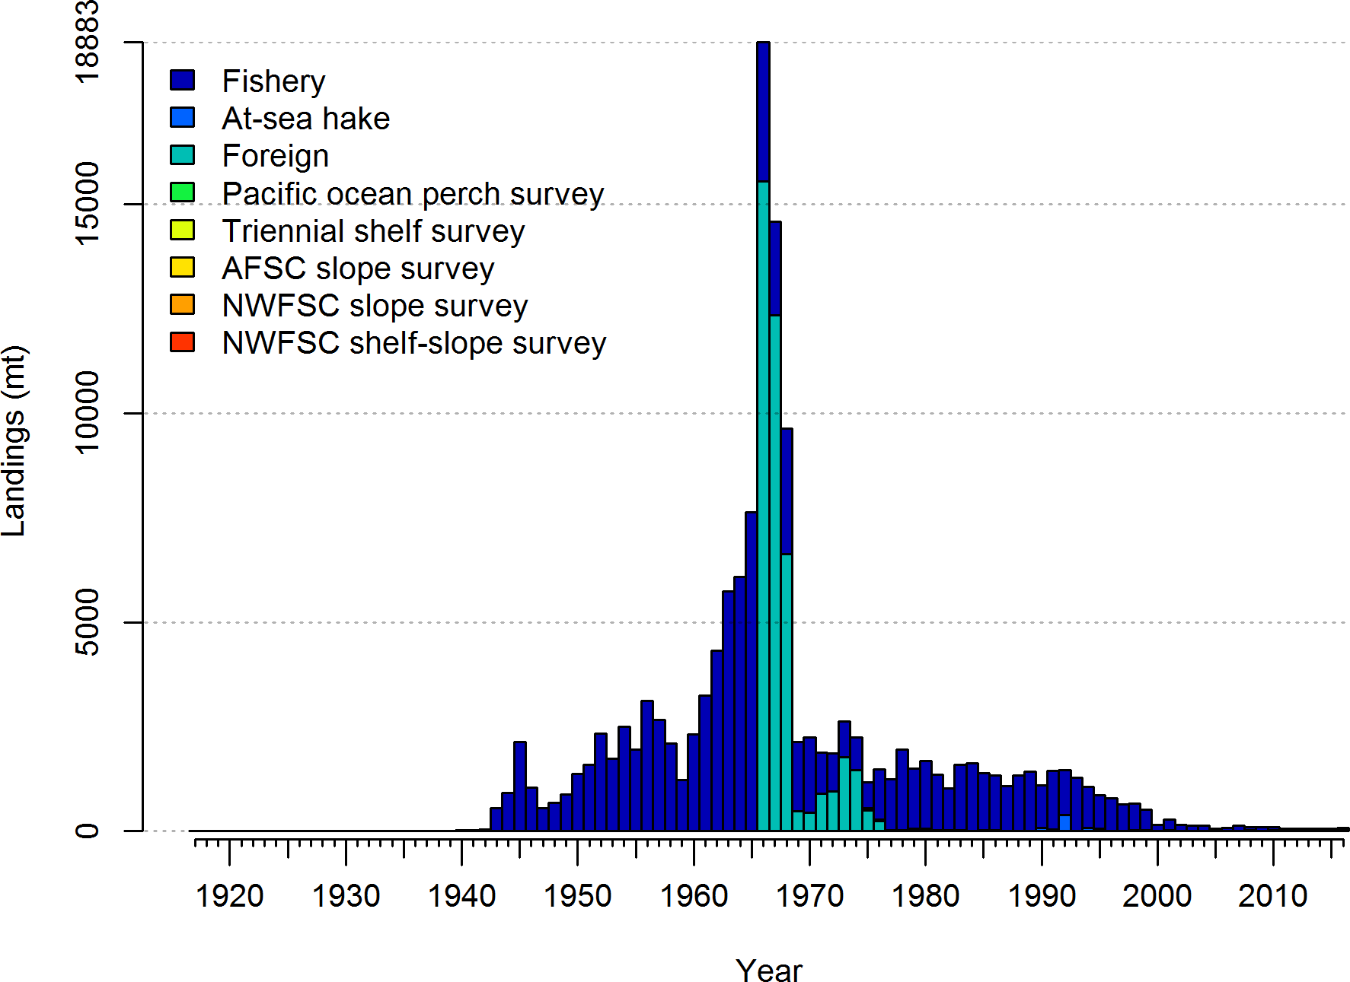

Figure 1: Total catches Pacific ocean perch through 2016.

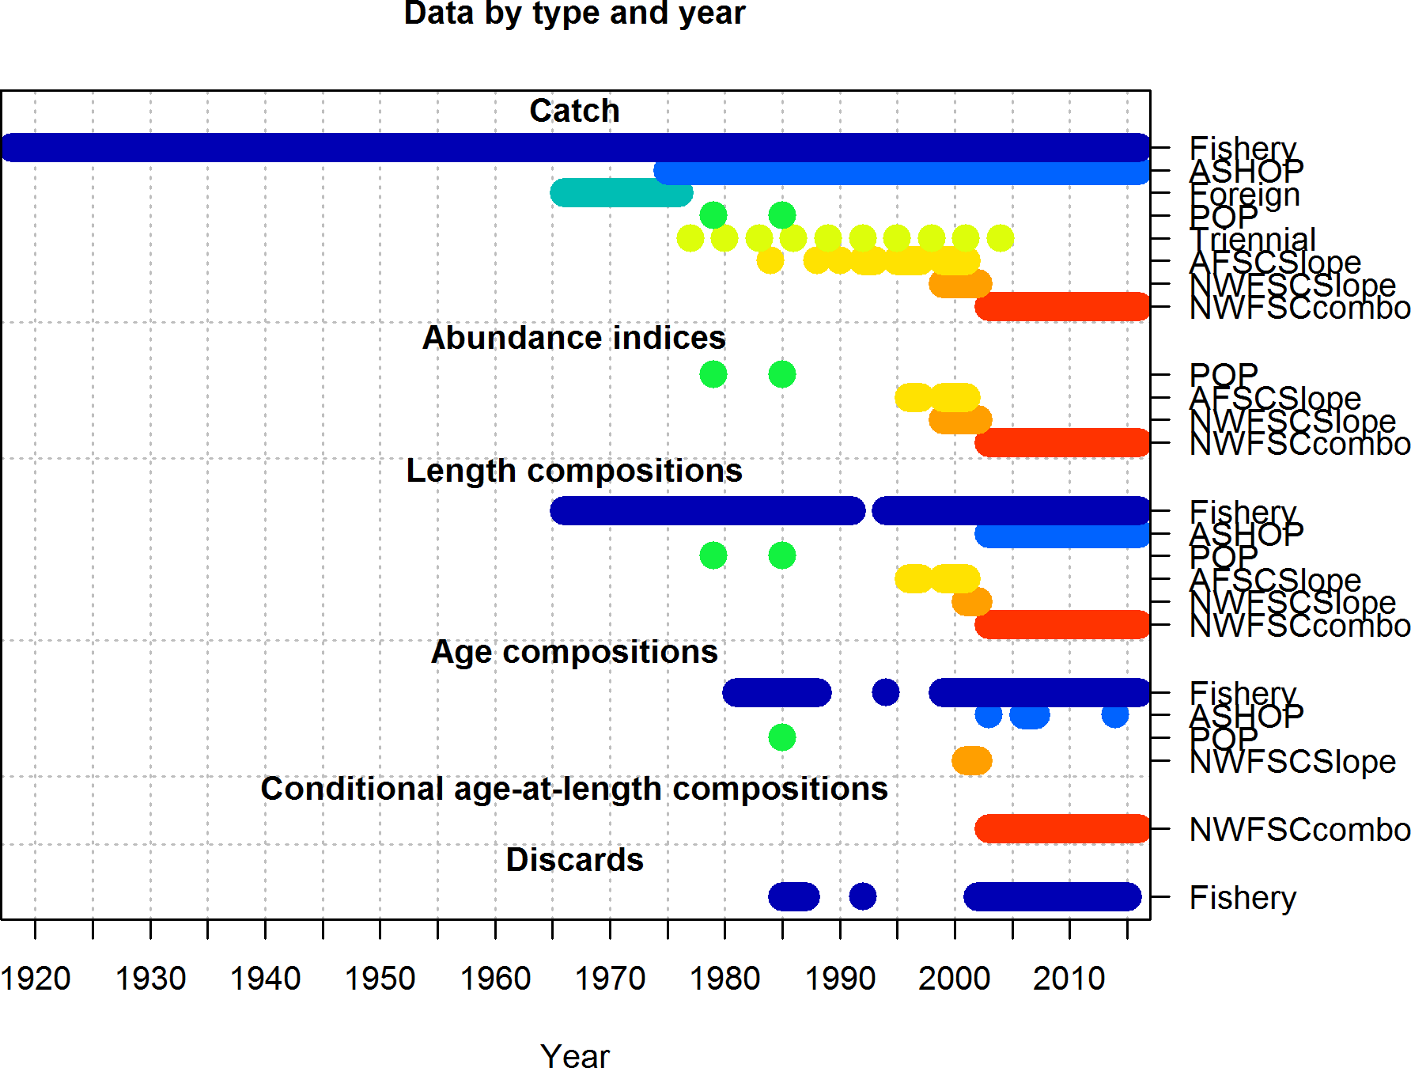

Figure 2: Summary of data sources used in the base model.

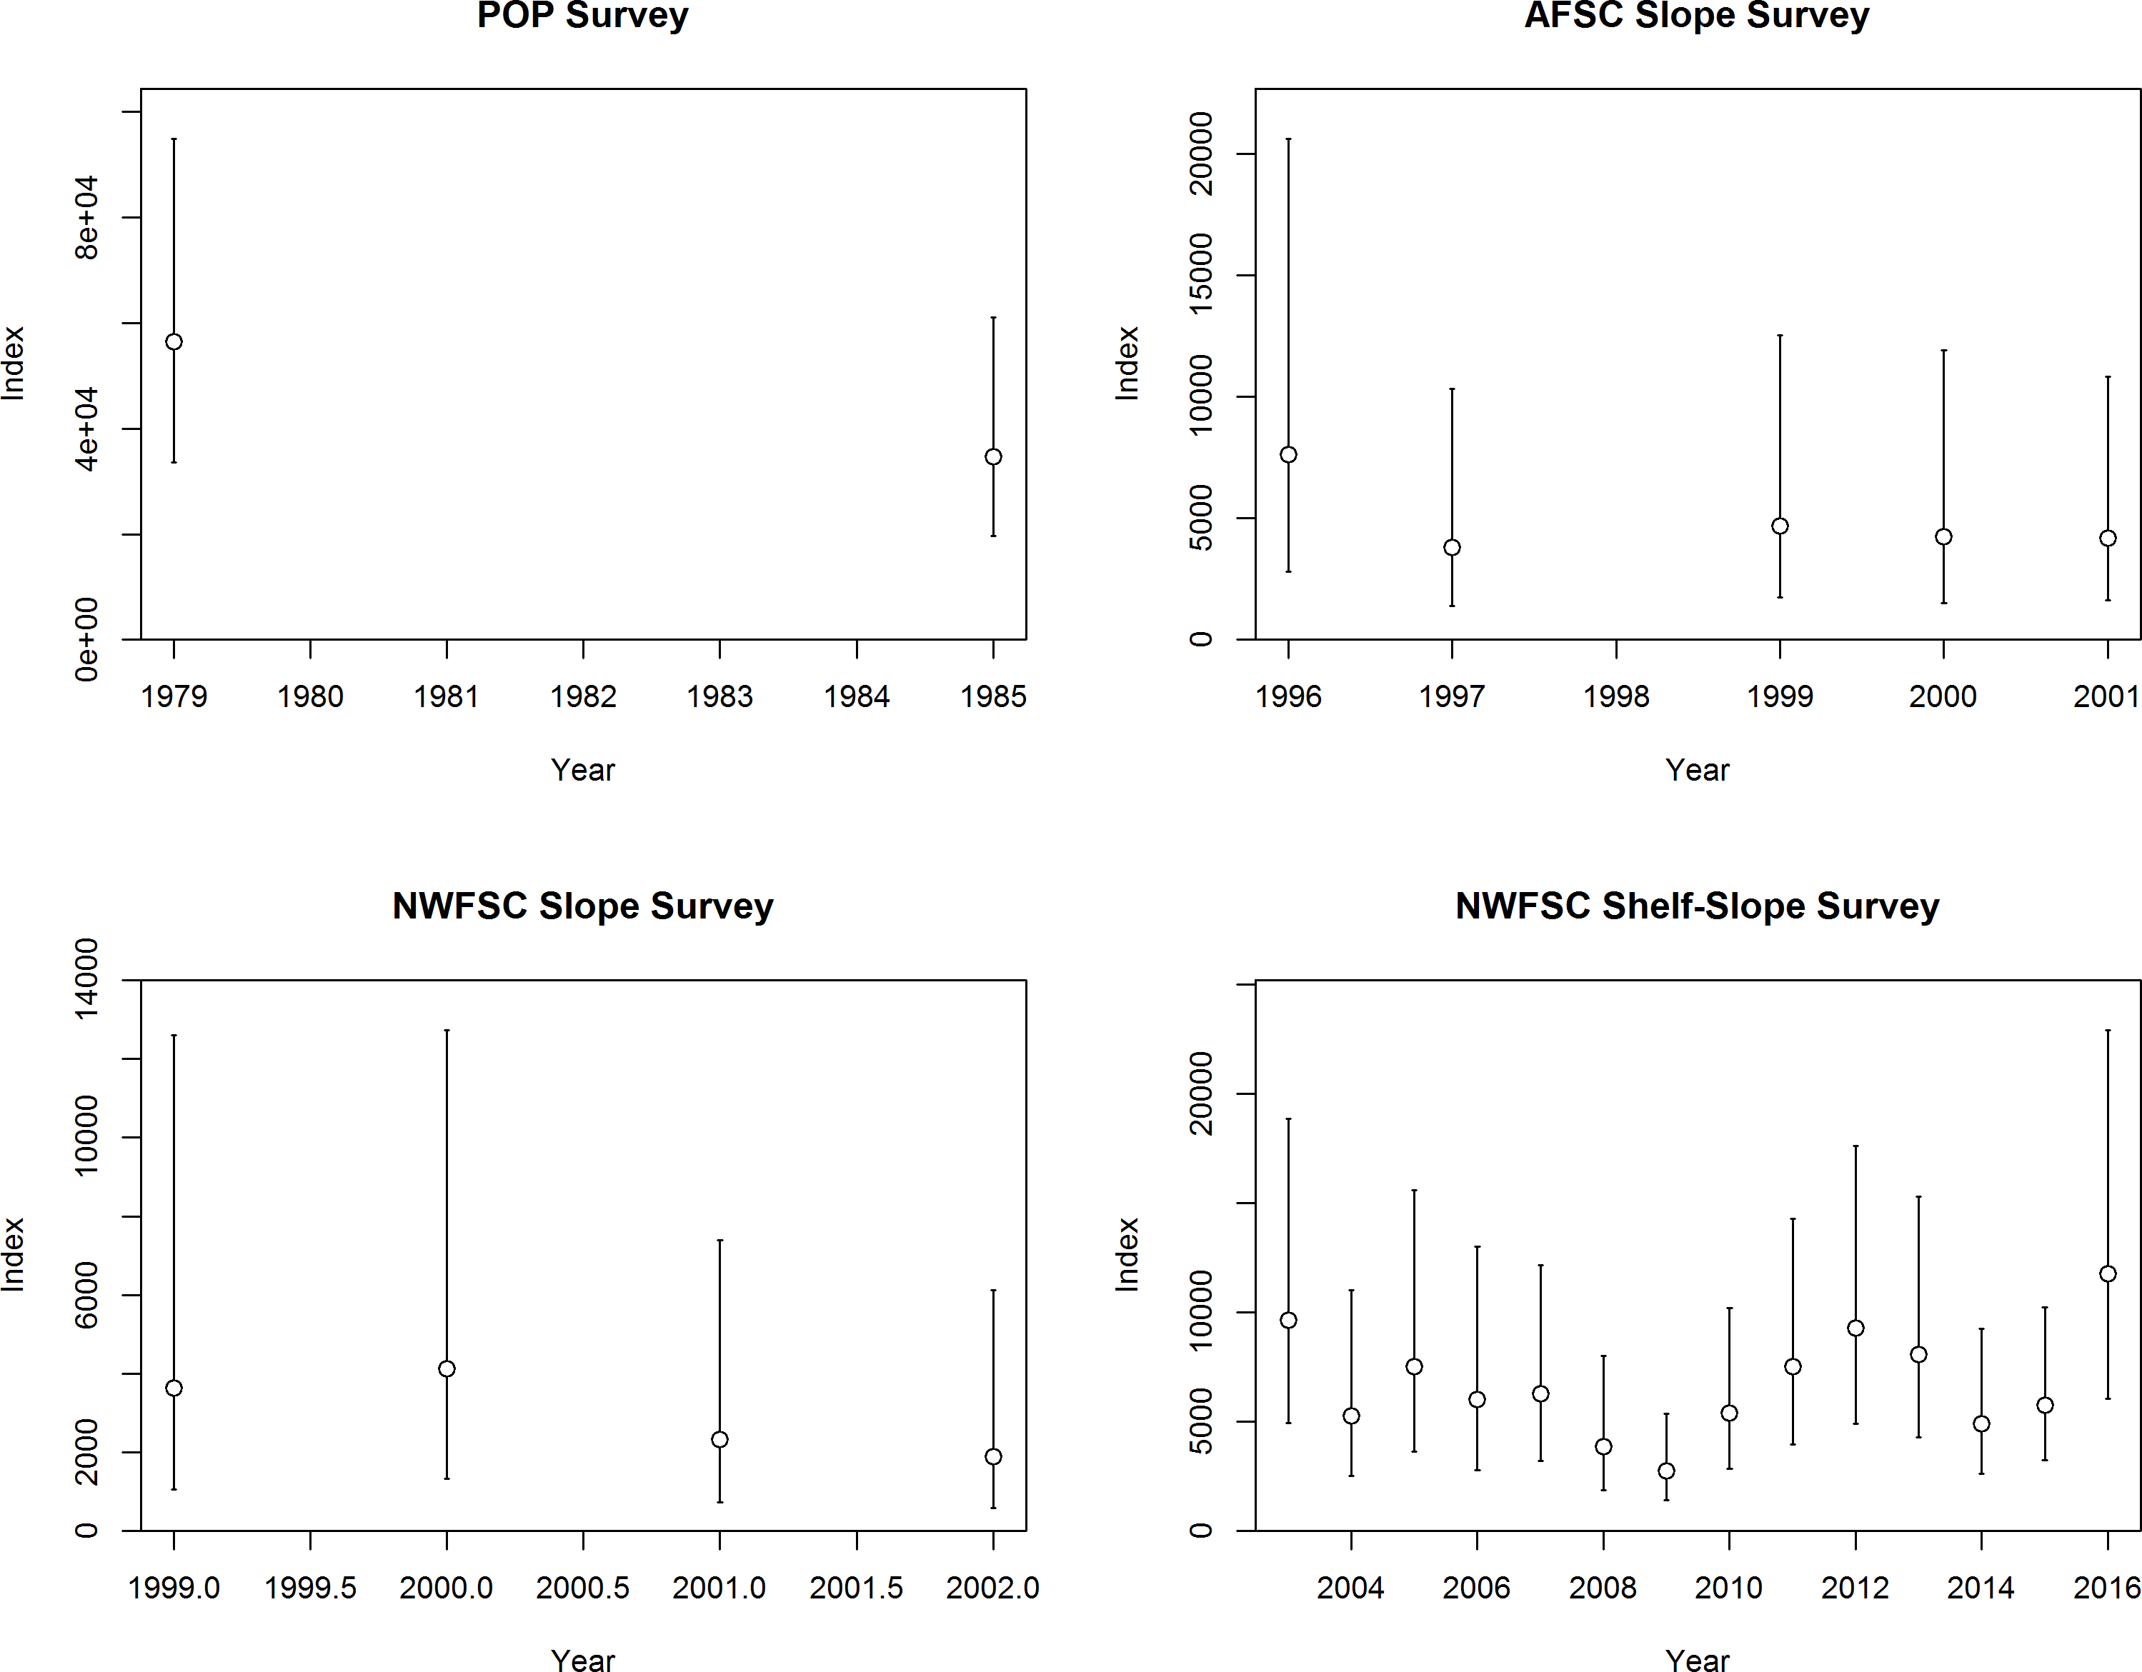

Figure 3: Fishery-dependent and fishery-independent indices for Pacific ocean perch.

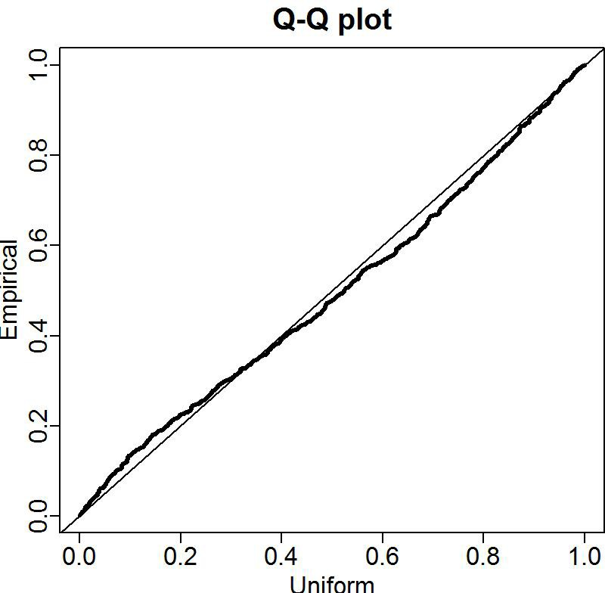

Figure 4: Q-Q plots for the VAST lognormal distribution for the NWFSC shelf-slope survey.

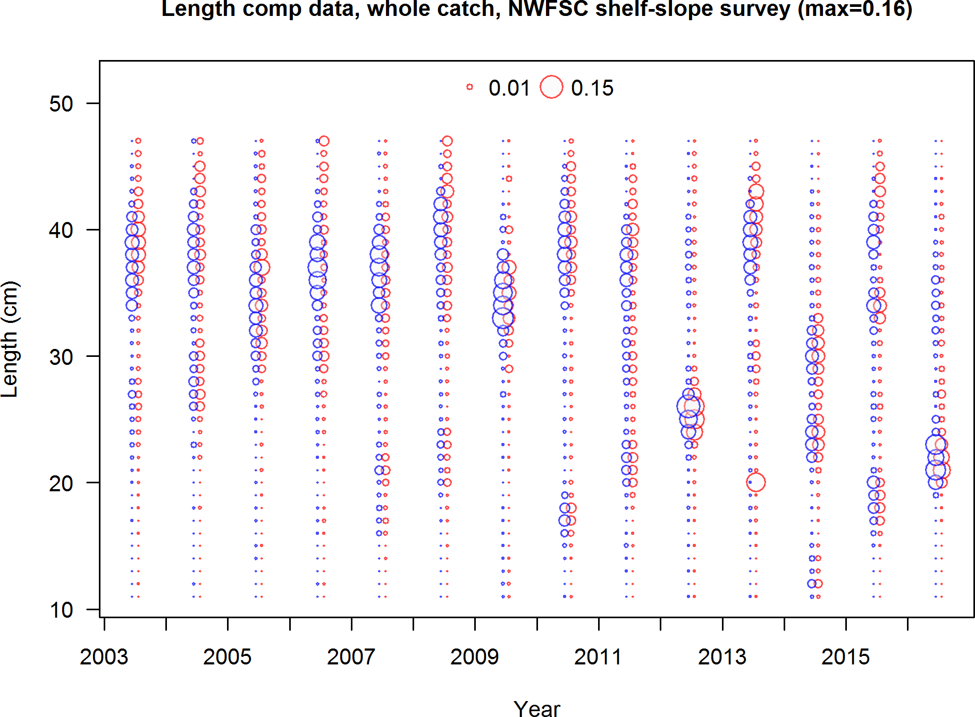

Figure 5: NWFSC shelf-slope survey length frequency distributions for Pacific ocean perch.

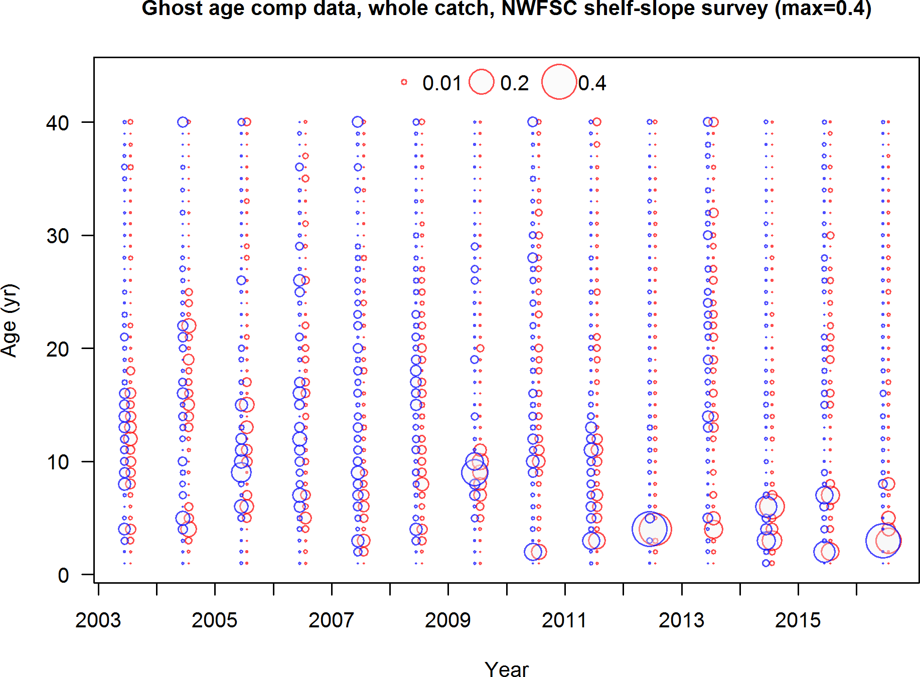

Figure 6: NWFSC shelf-slope survey age frequency distributions for Pacific ocean perch.

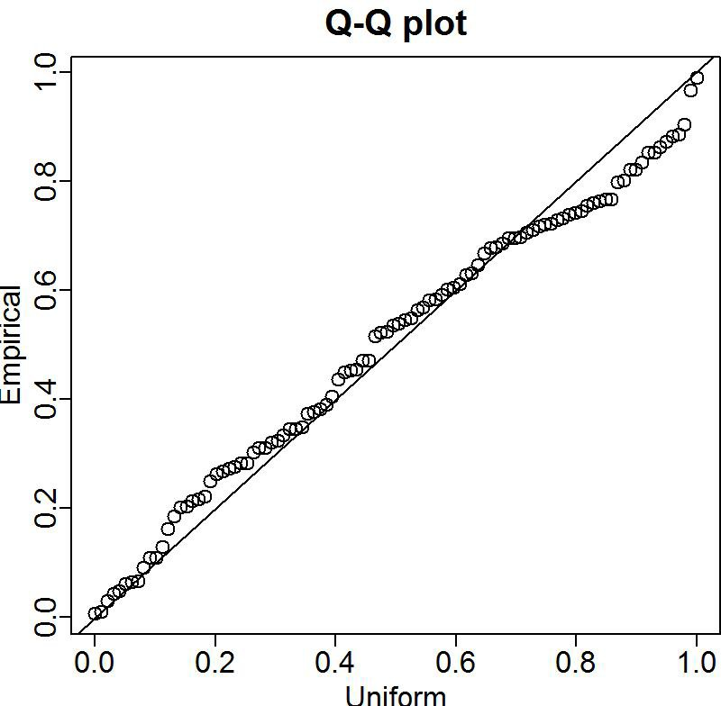

Figure 7: Q-Q plots for the VAST lognormal distribution for the NWFSC slope survey.

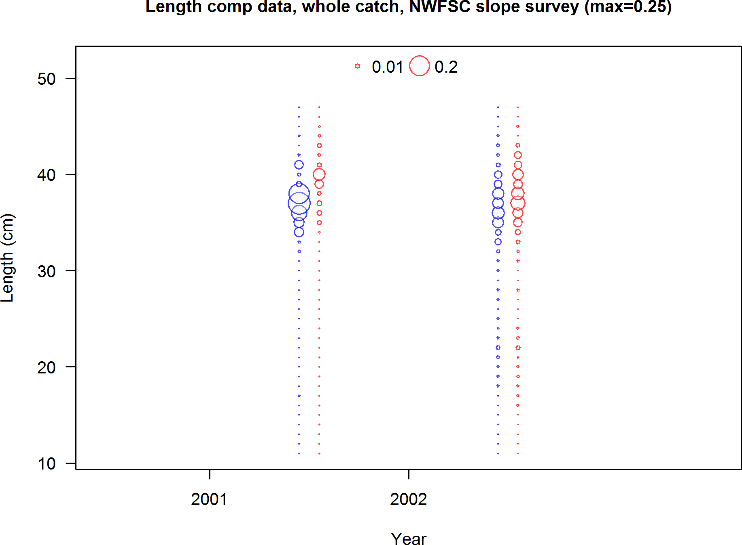

Figure 8: NWFSC slope survey length frequency distributions for Pacific ocean perch.

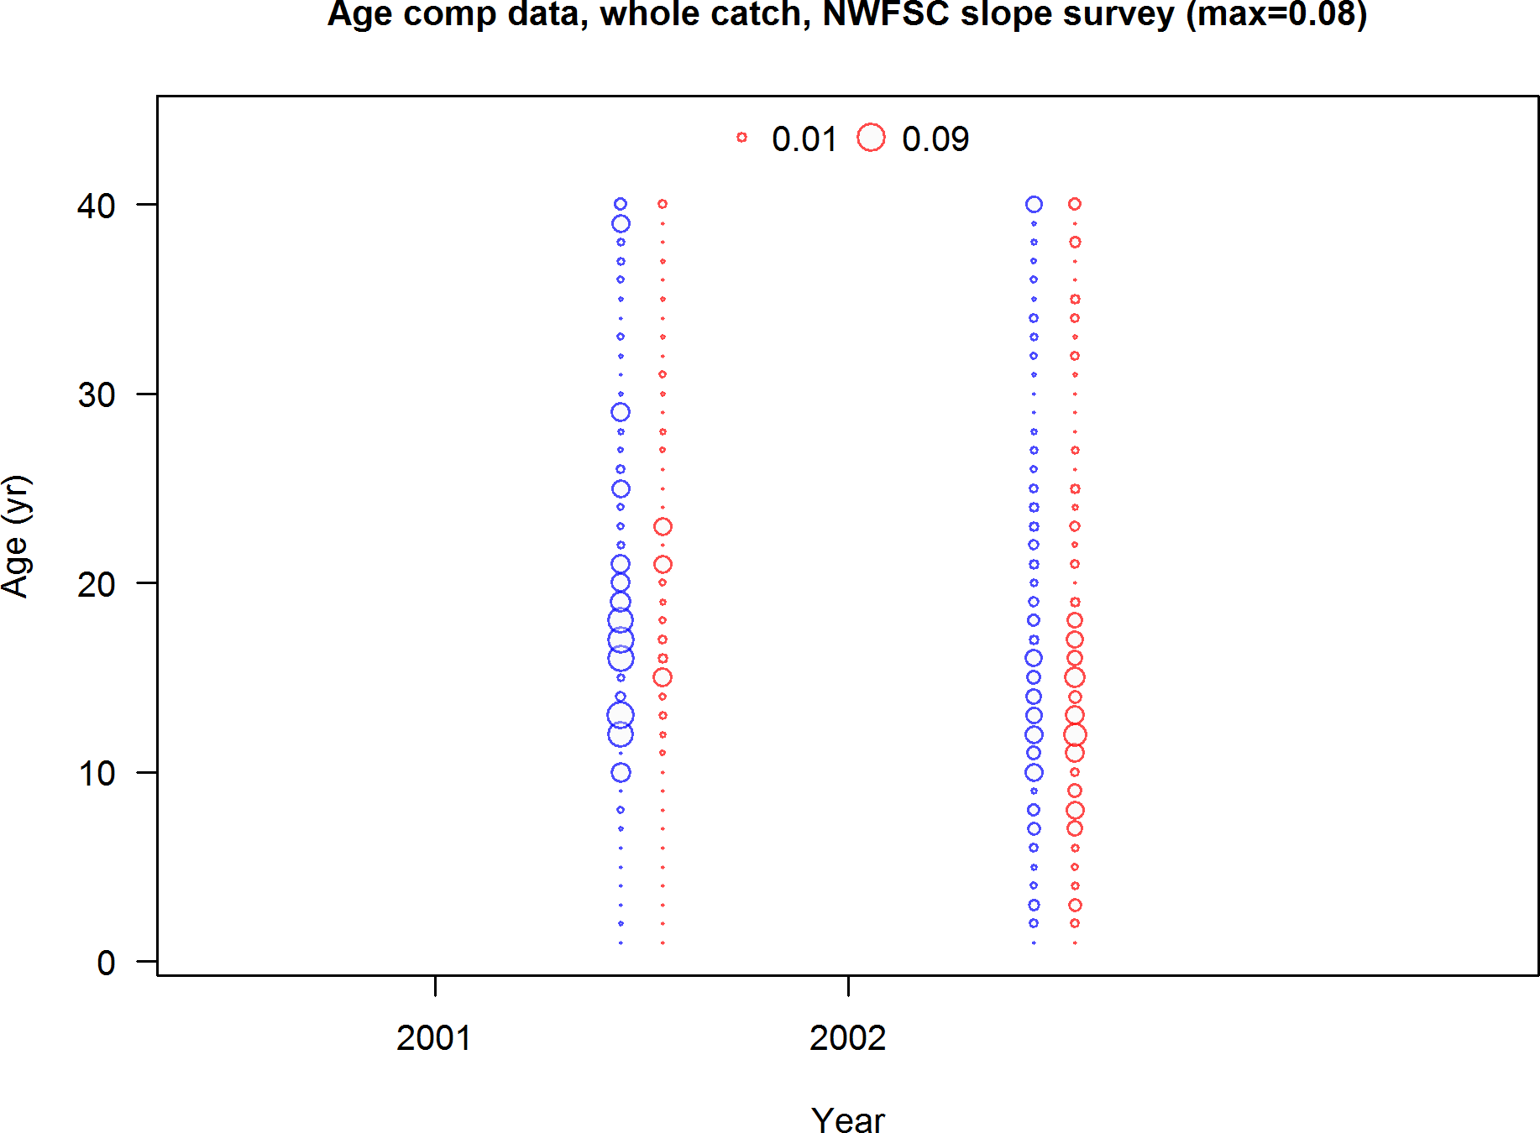

Figure 9: NWFSC slope survey age frequency distributions for Pacific ocean perch.

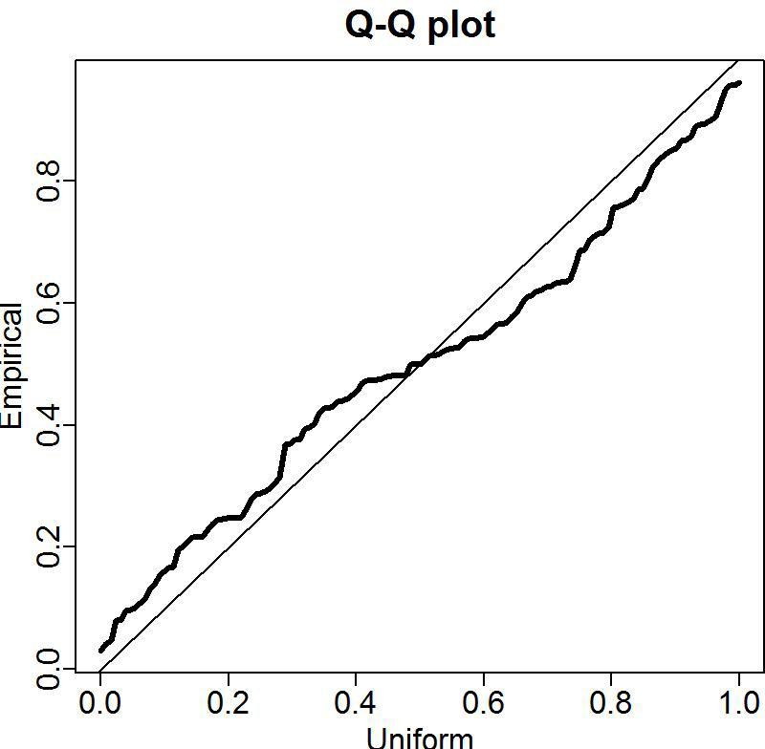

Figure 10: Q-Q plots for the VAST lognormal distribution for the AFSC slope survey.

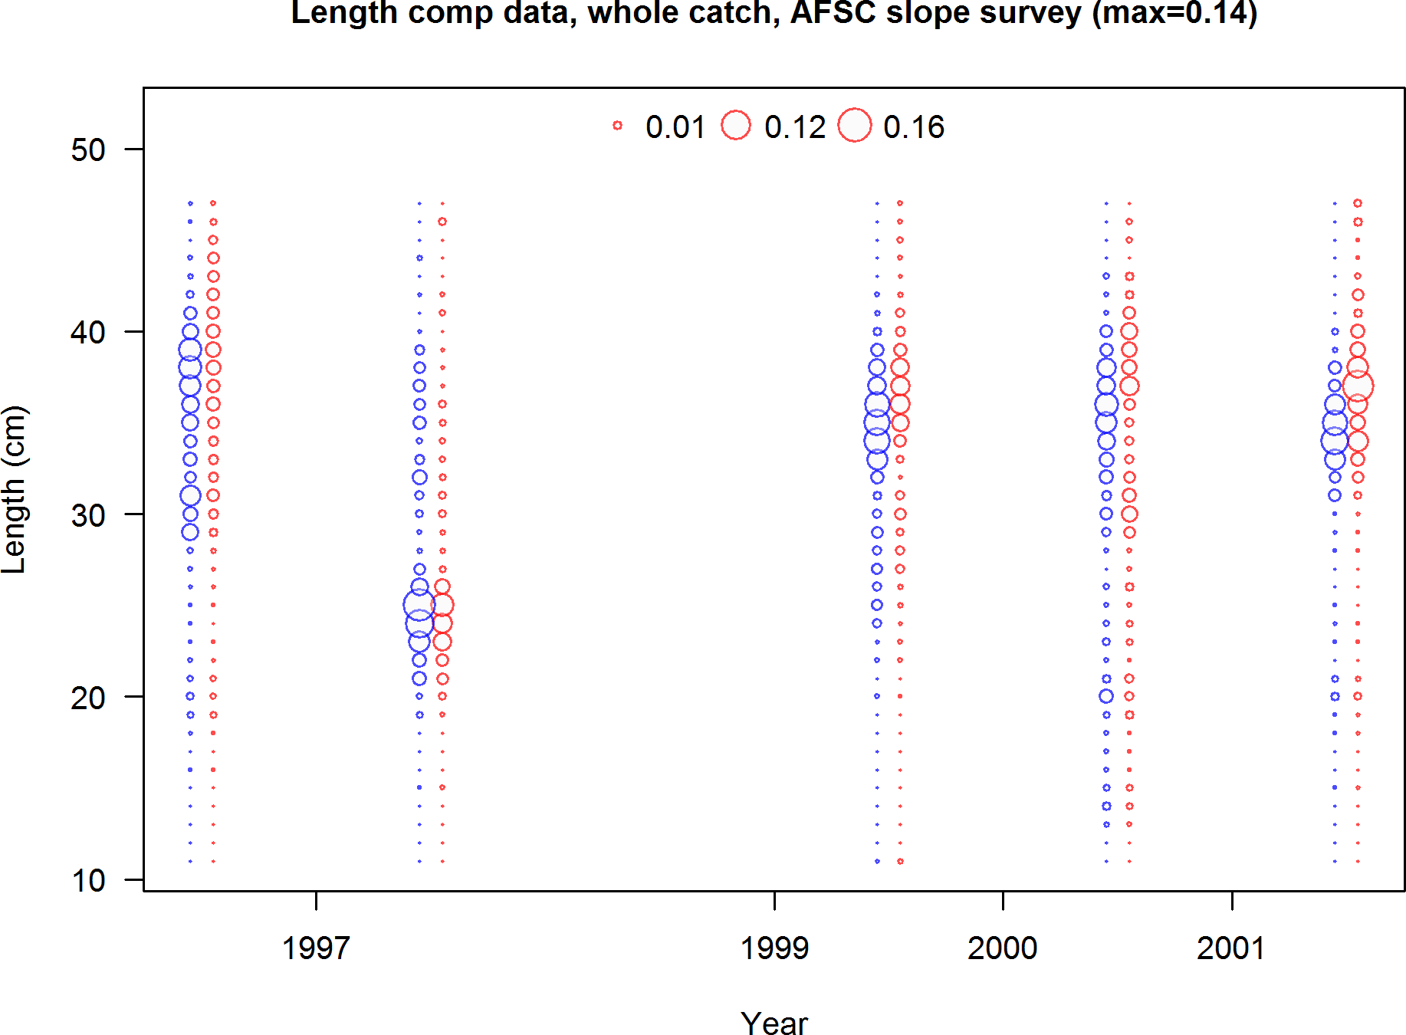

Figure 11: AFSC slope survey length frequency distributions for Pacific ocean perch.

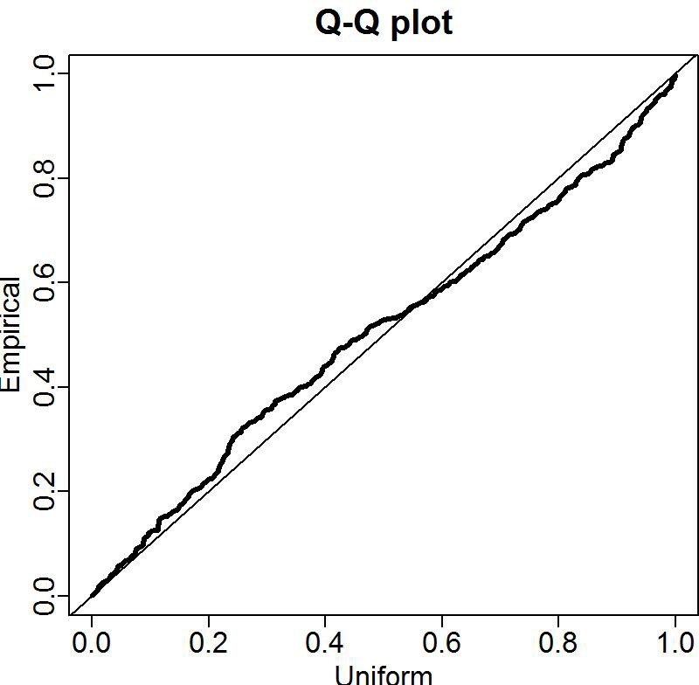

Figure 12: Q-Q plots for the VAST lognormal distribution for the Pacific ocean perch survey.

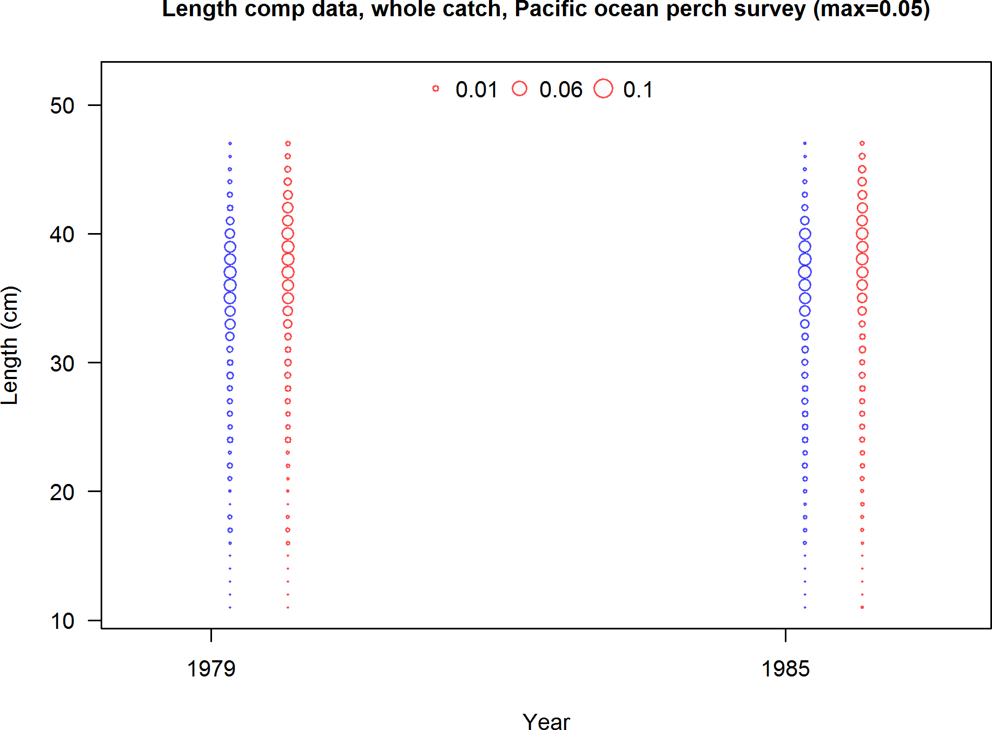

Figure 13: Pacific ocean perch survey length frequency distributions for Pacific ocean perch.

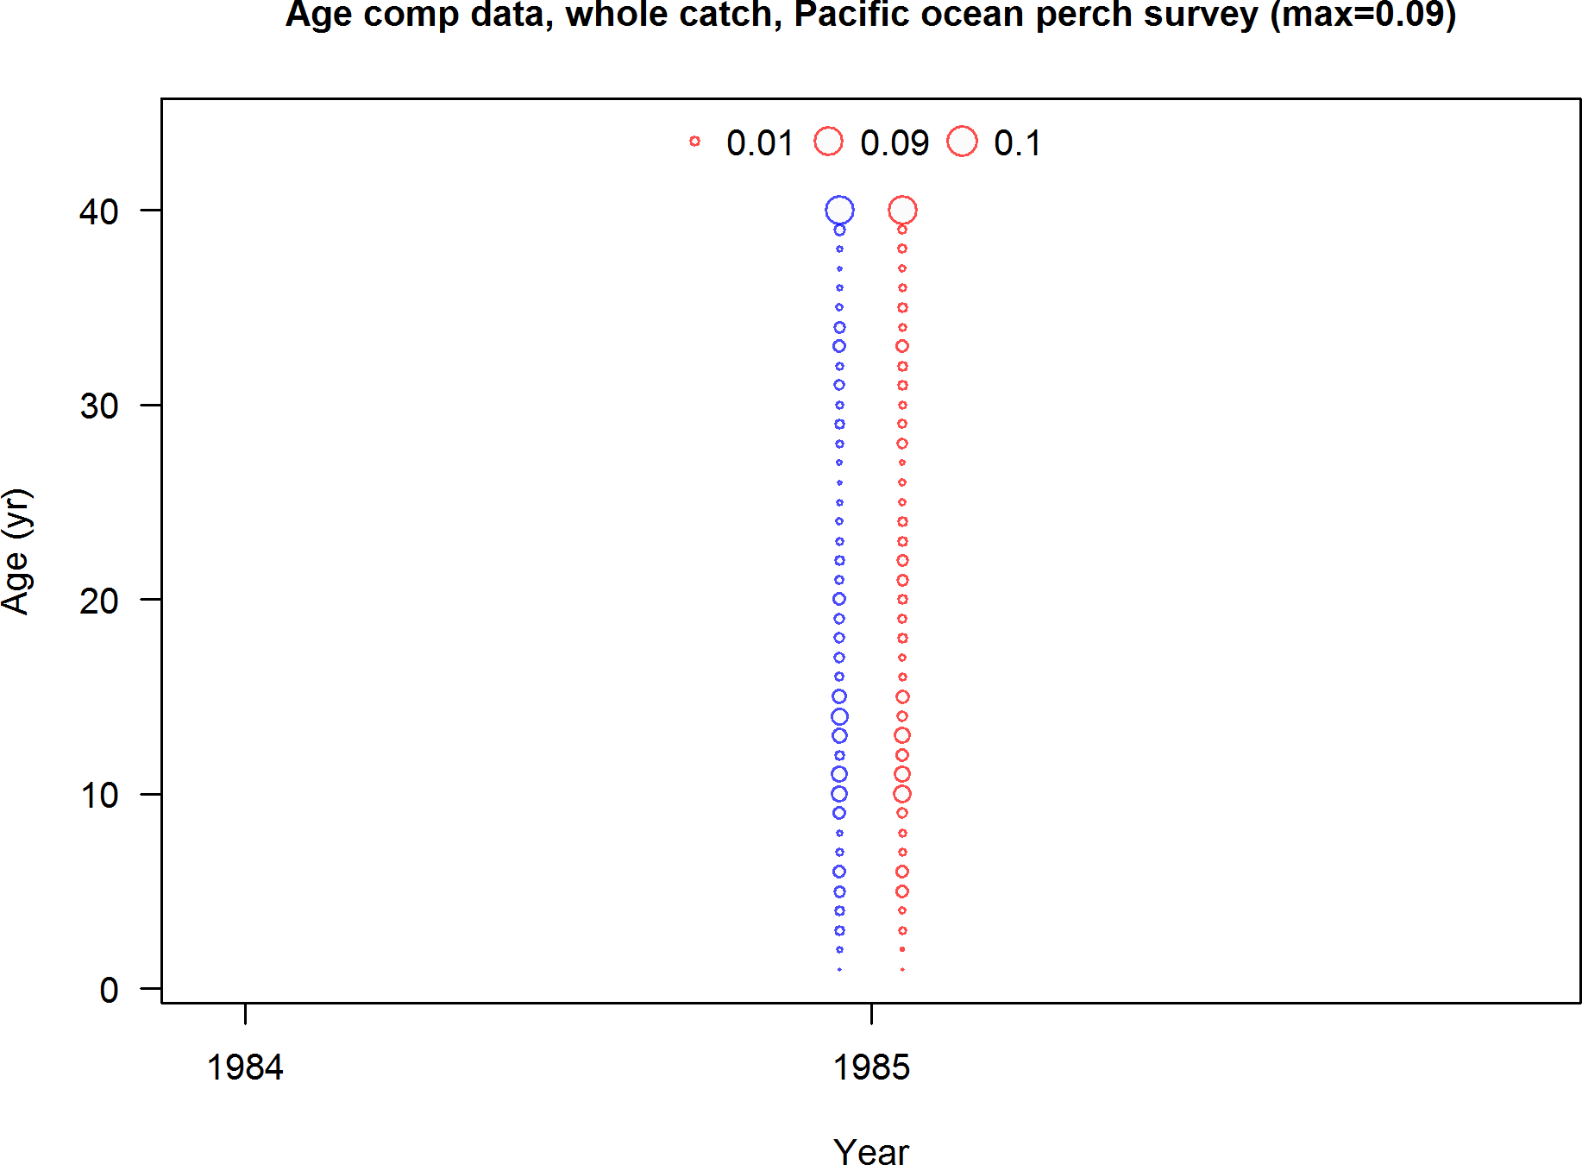

Figure 14: Pacific ocean perch survey age frequency distributions for Pacific ocean perch.

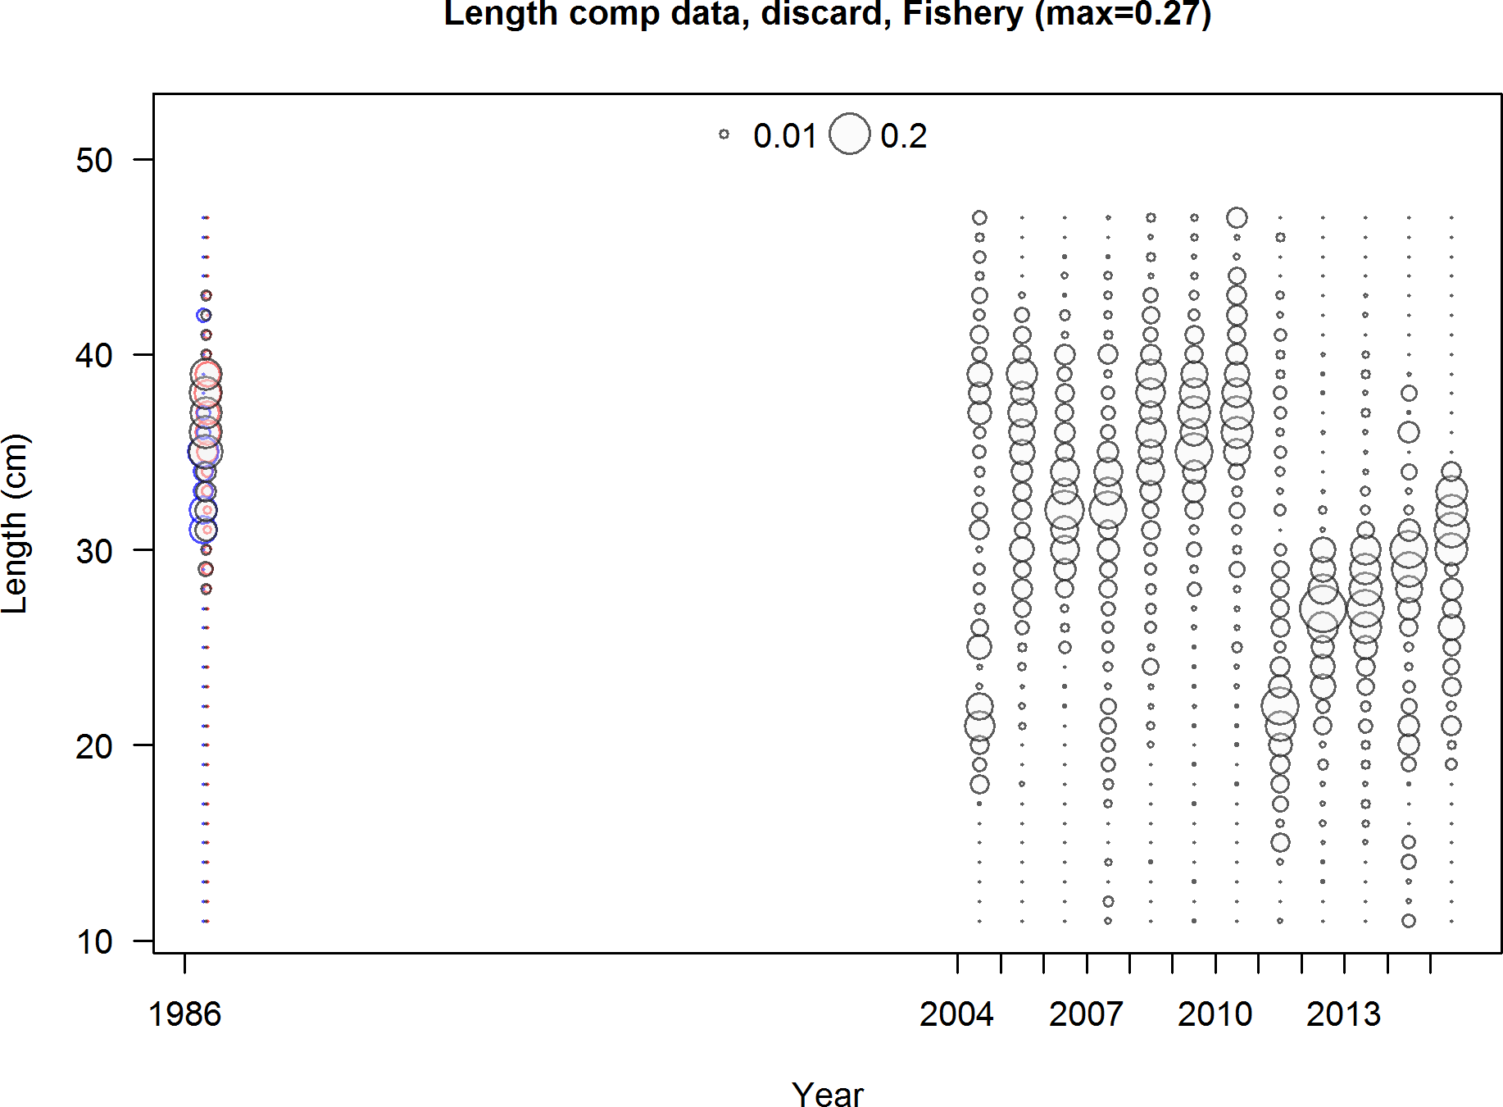

Figure 15: Discard length frequency distributions from WCGOP for Pacific ocean perch.

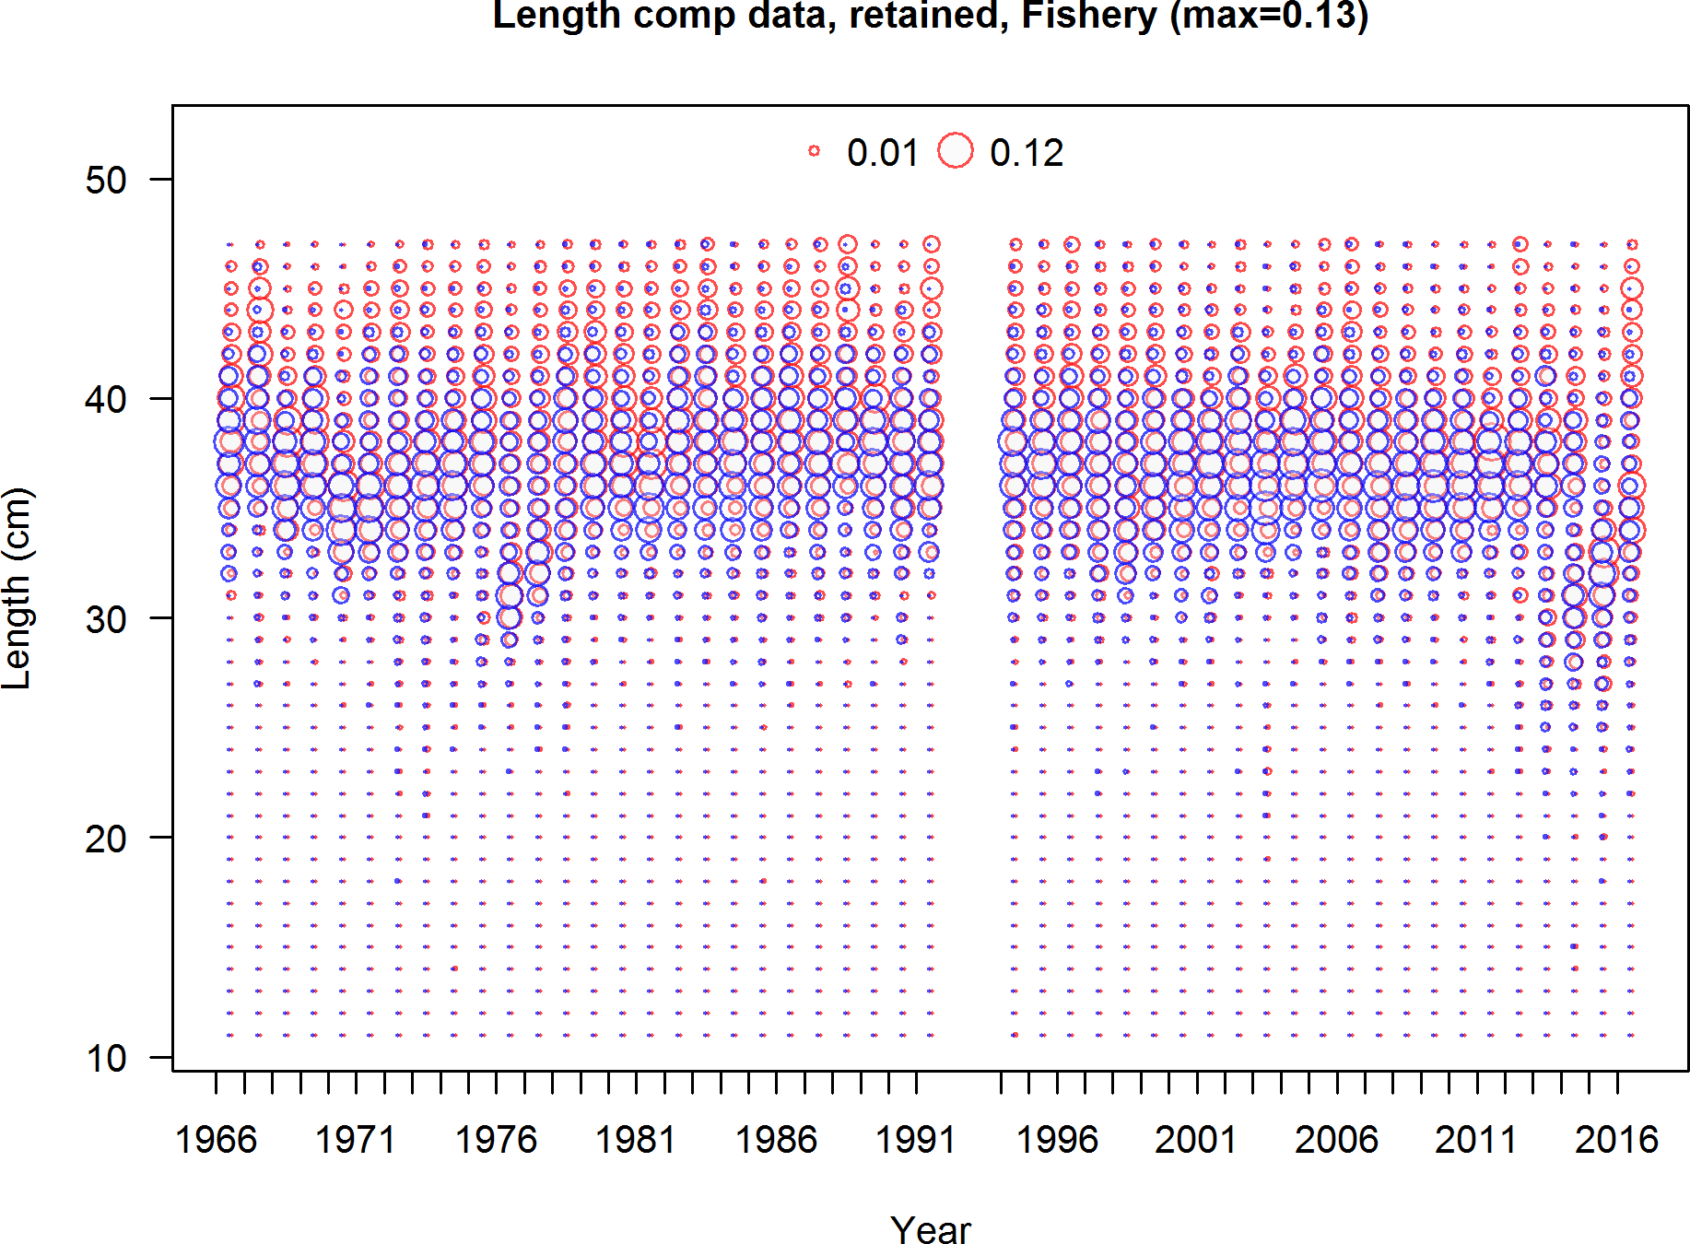

Figure 16: Commercial fishery length frequency distributions for Pacific ocean perch.

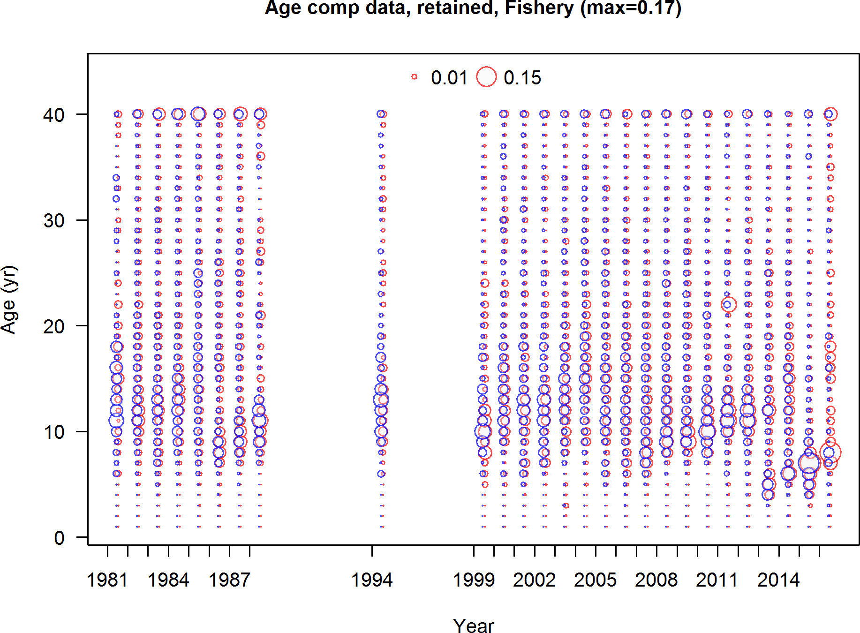

Figure 17: Commercial fishery age frequency distributions for Pacific ocean perch.

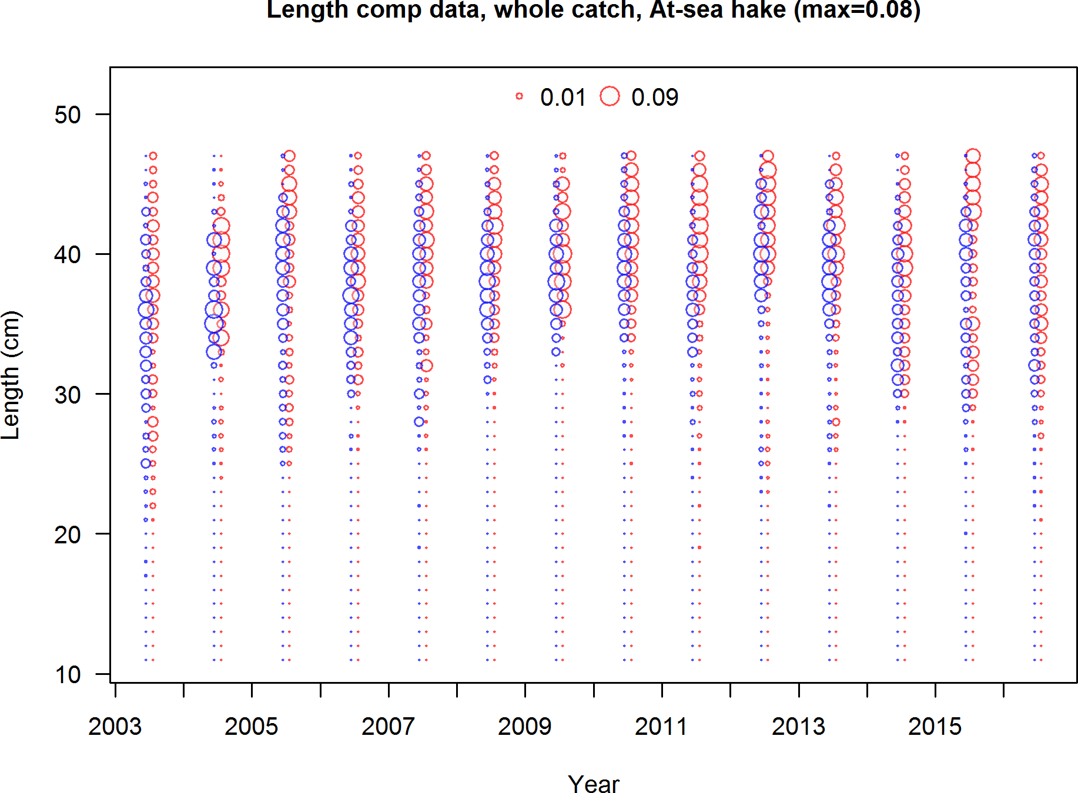

Figure 18: At-sea hake fishery length frequency distributions for Pacific ocean perch.

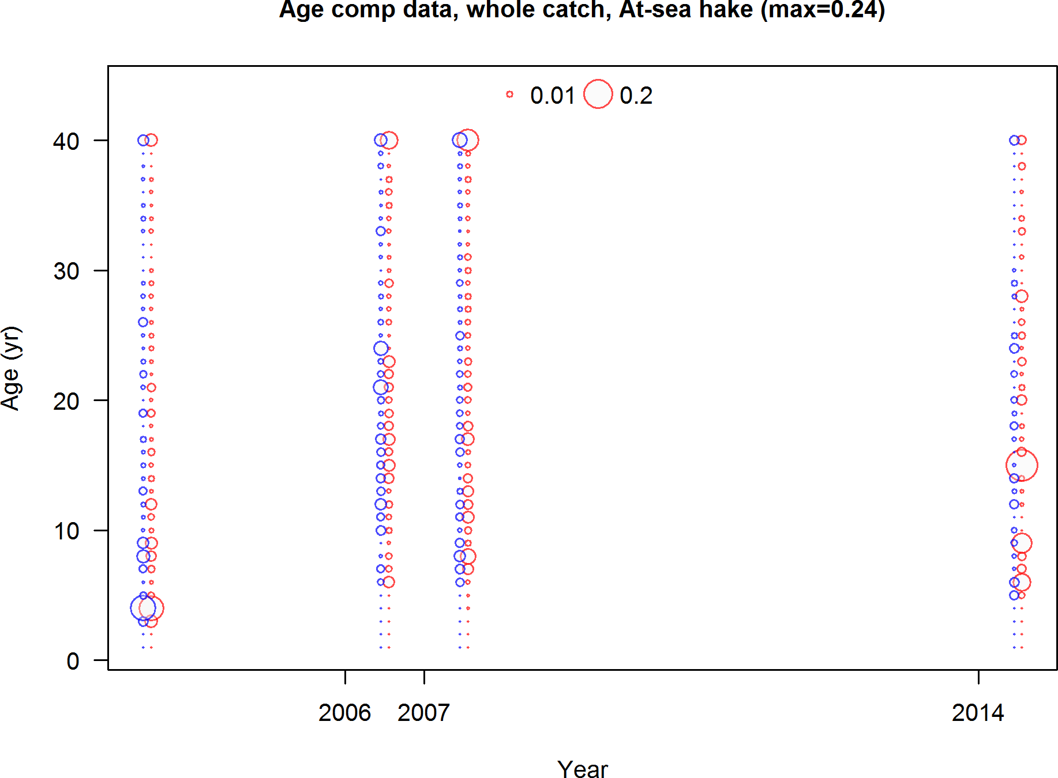

Figure 19: At-sea hake fishery age frequency distributions for Pacific ocean perch.

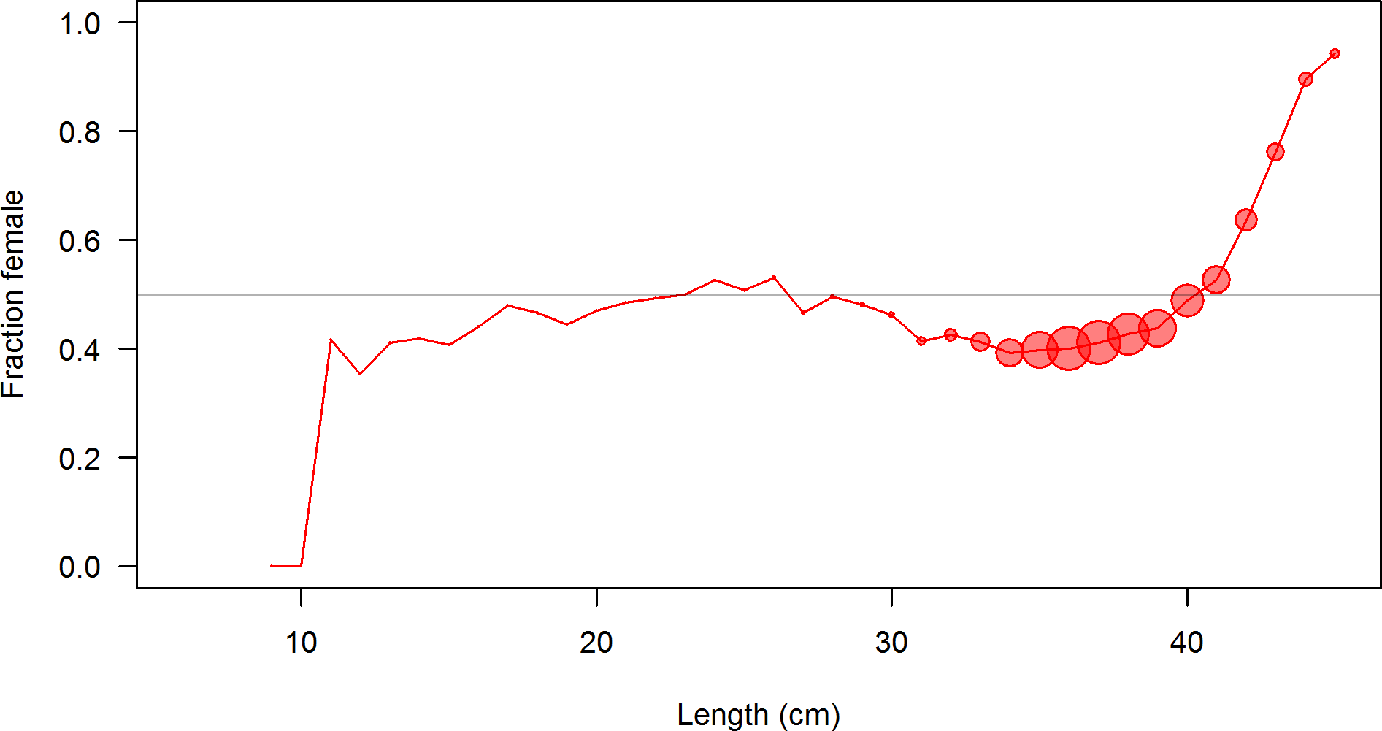

Figure 20: The estimated sex ratio of Pacific ocean perch at length from all biological data sources. The size of the bubble is related to the numbers of observations by length.

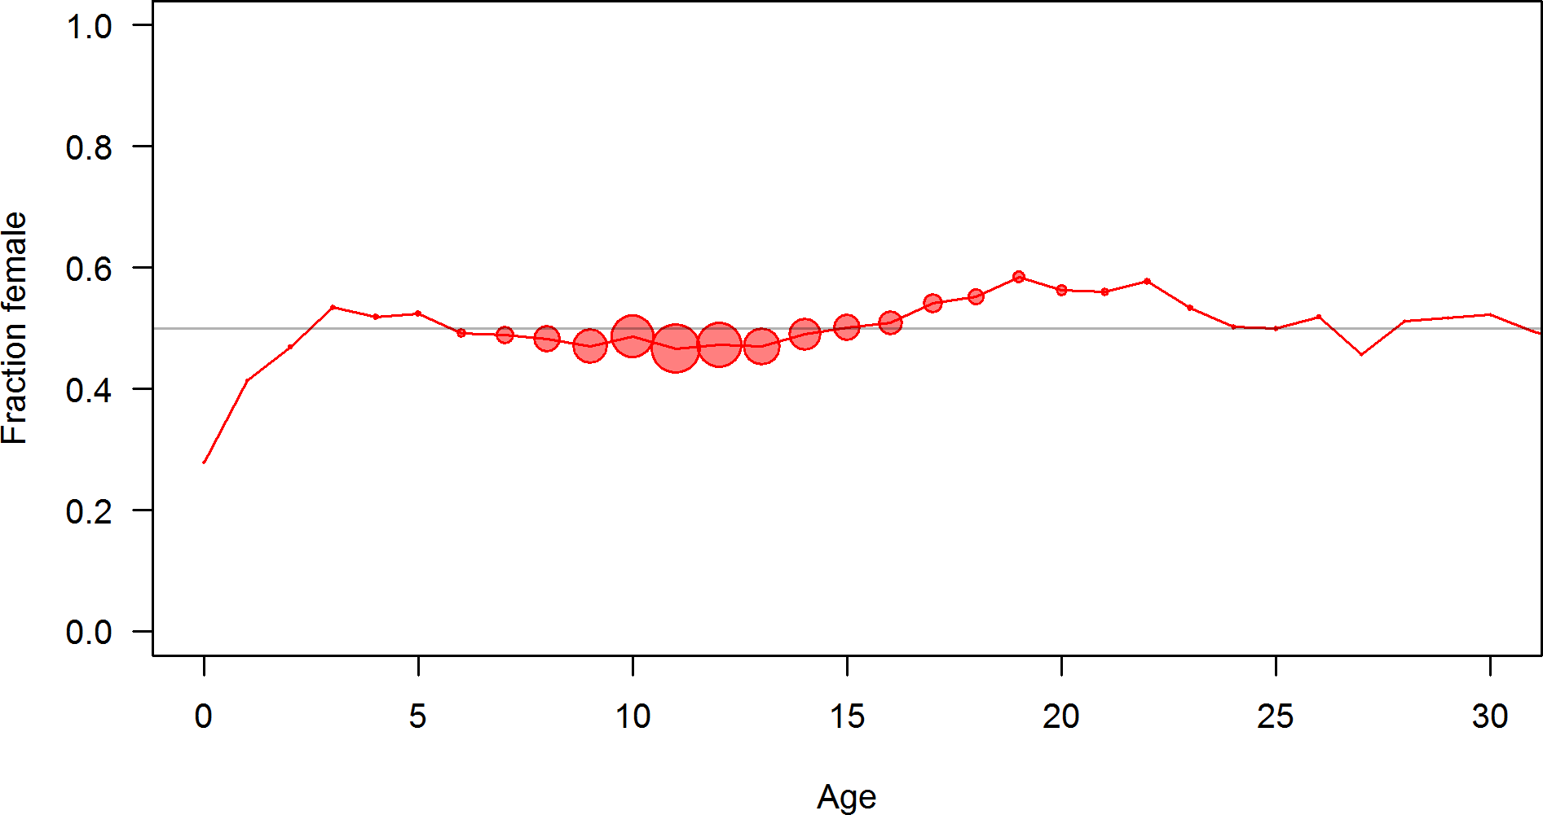

Figure 21: The estimated sex ratio of Pacific ocean perch at age from all biological data sources. The size of the bubble is related to the numbers of observations by age.

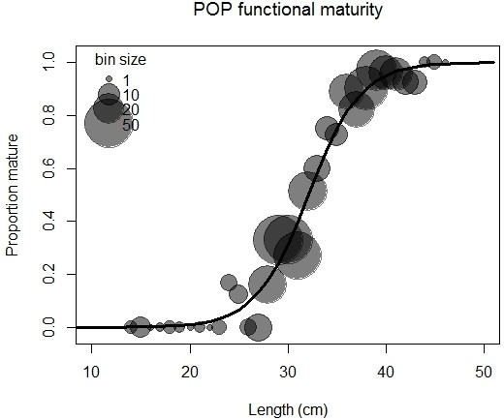

Figure 22: The estimated functional maturity of Pacific ocean perch at length. The size of the bubble is related to the numbers of maturity observations by length.

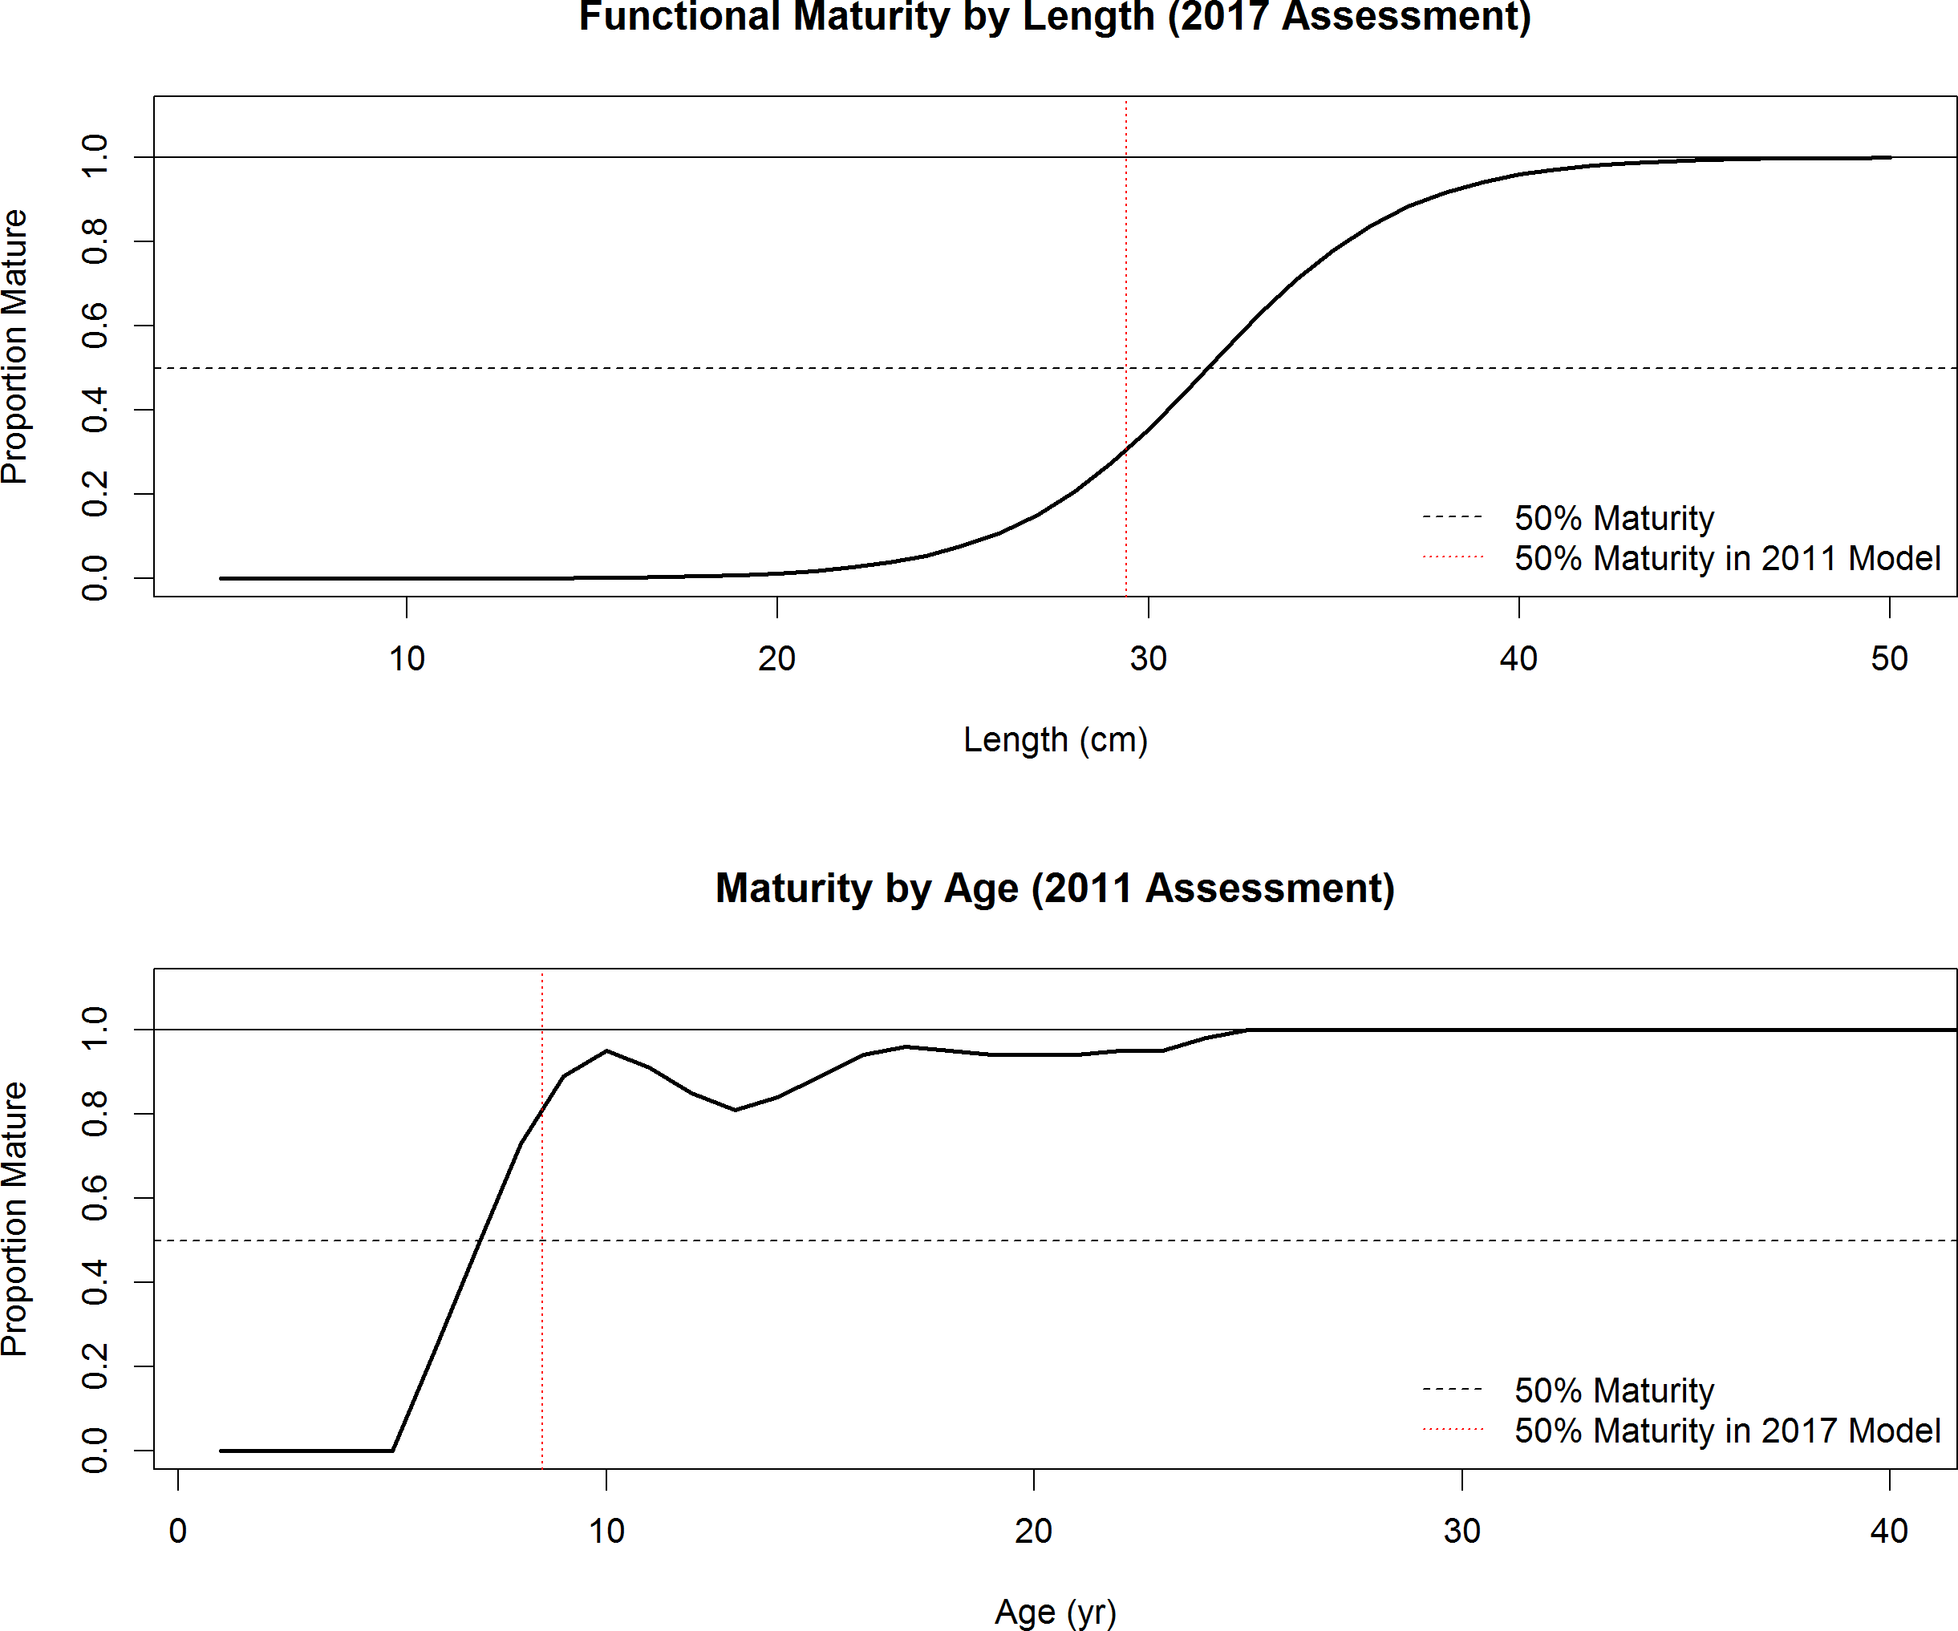

Figure 23: Comparison between estimated maturity-at-length used in this assessment and maturity-at-age applied in the 2011 assessment of Pacific ocean perch.

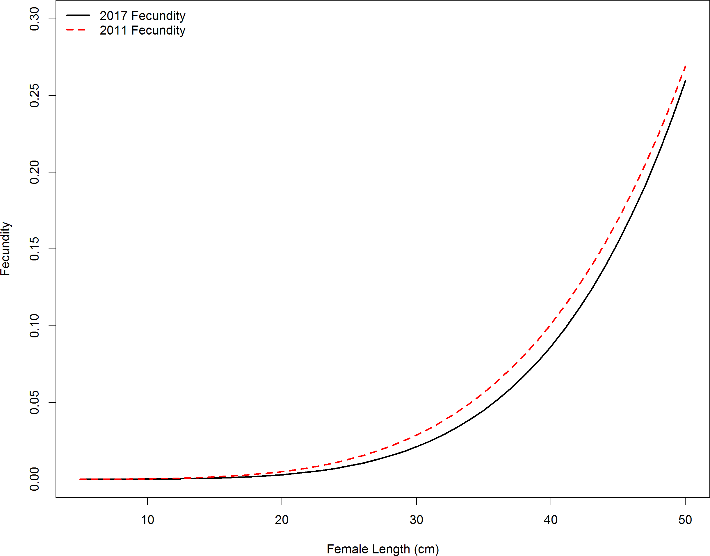

Figure 24: Fecundity at length of Pacific ocean perch in the base model and a comparison of the fecundity in the 2011 assessment.

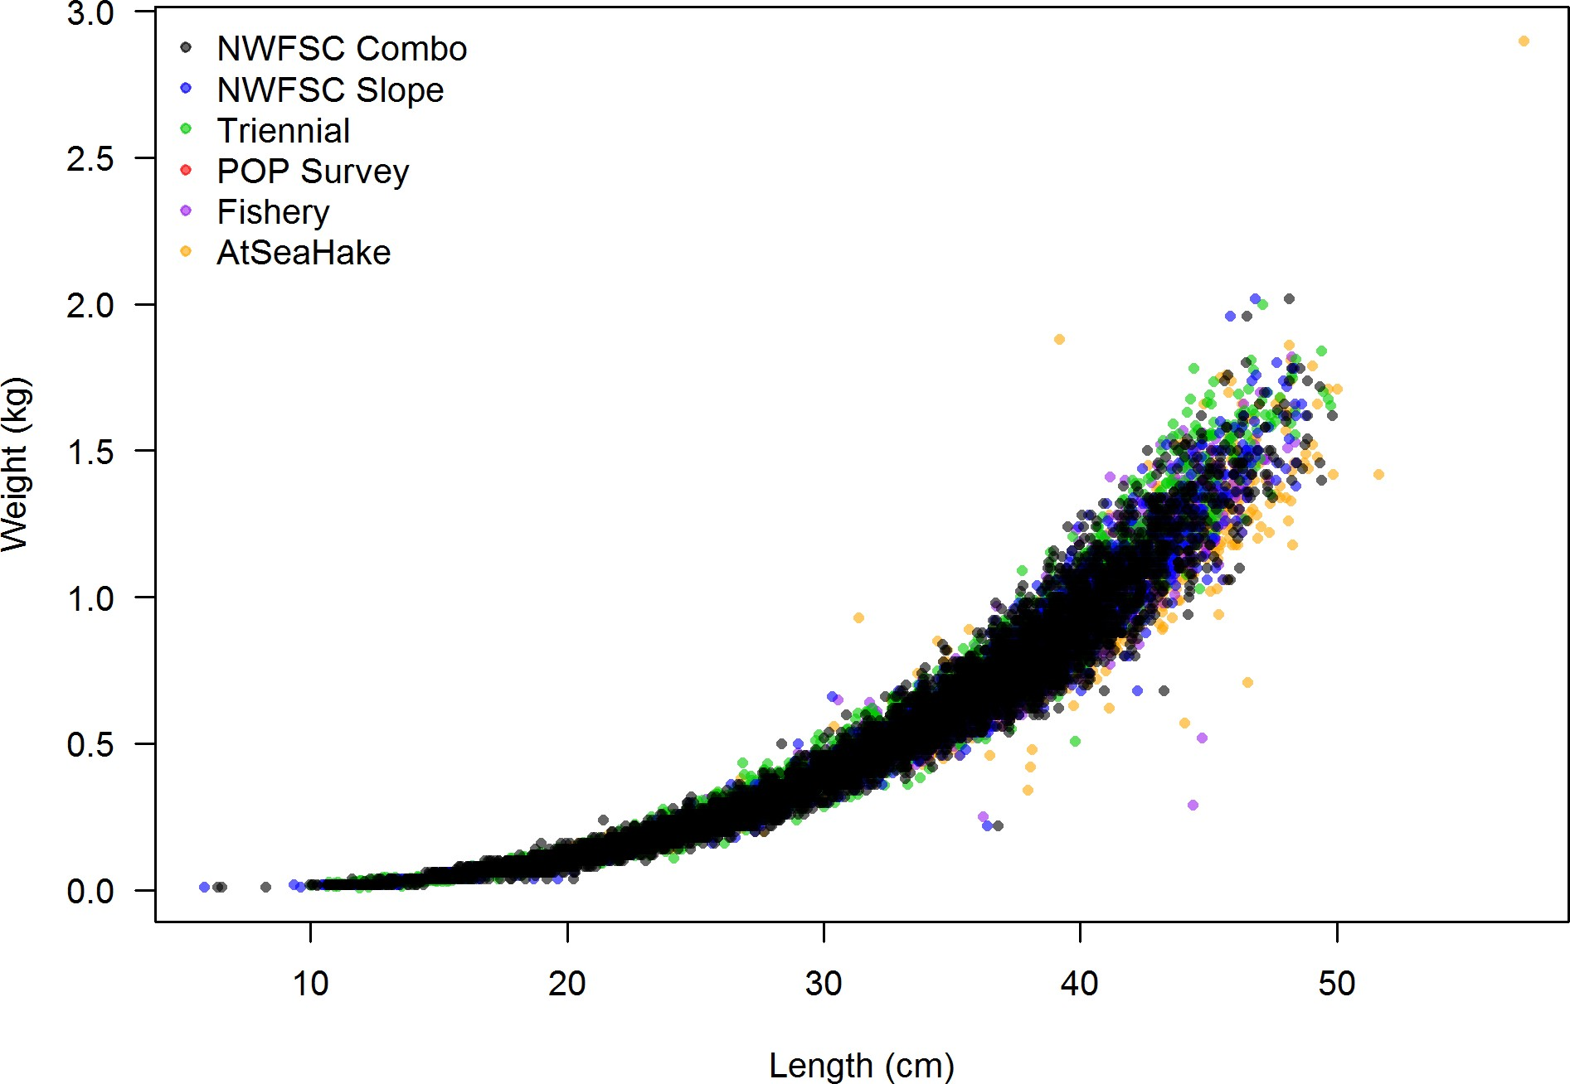

Figure 25: Weight-at-length for Pacific ocean perch from all data sources.

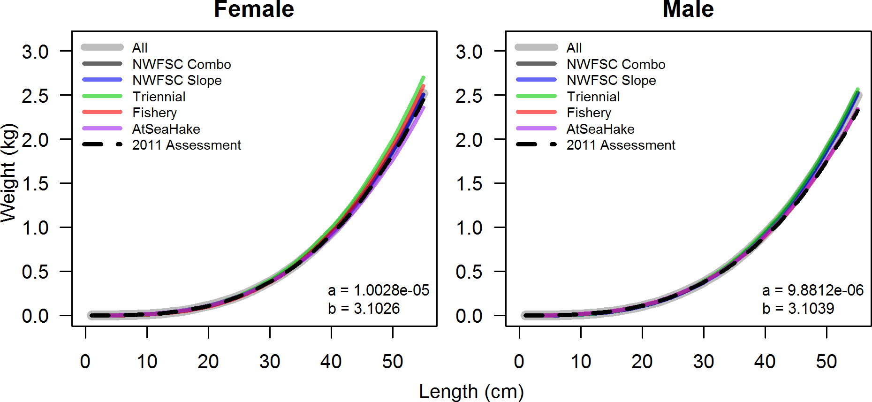

Figure 26: Estimated weight-at-length for Pacific ocean perch from all data sources.

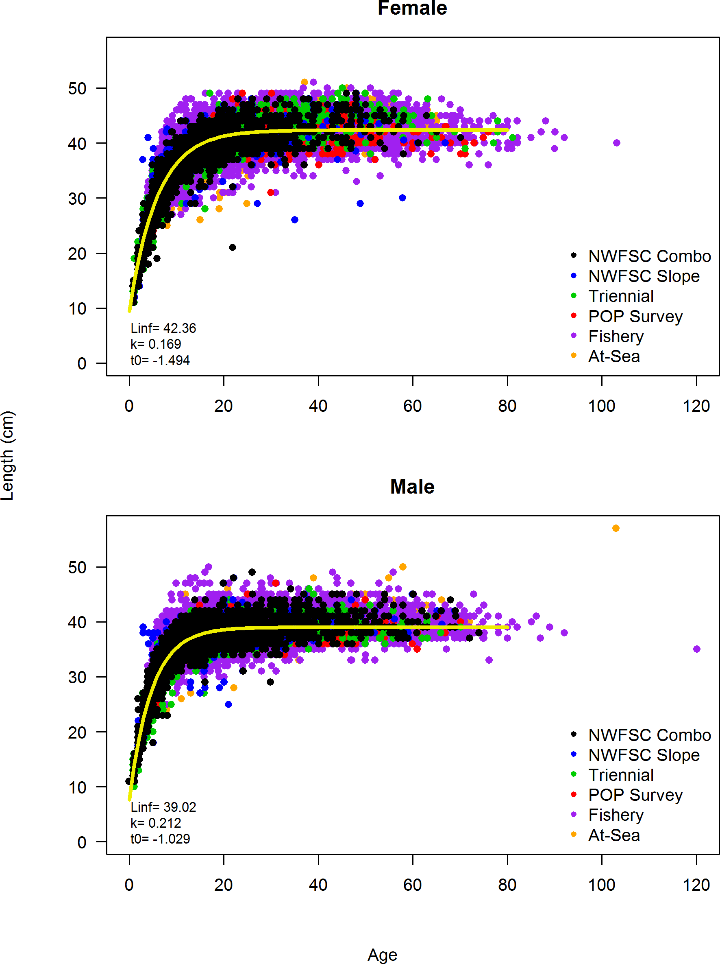

Figure 27: Estimated length-at-age for Pacific ocean perch from all data sources.

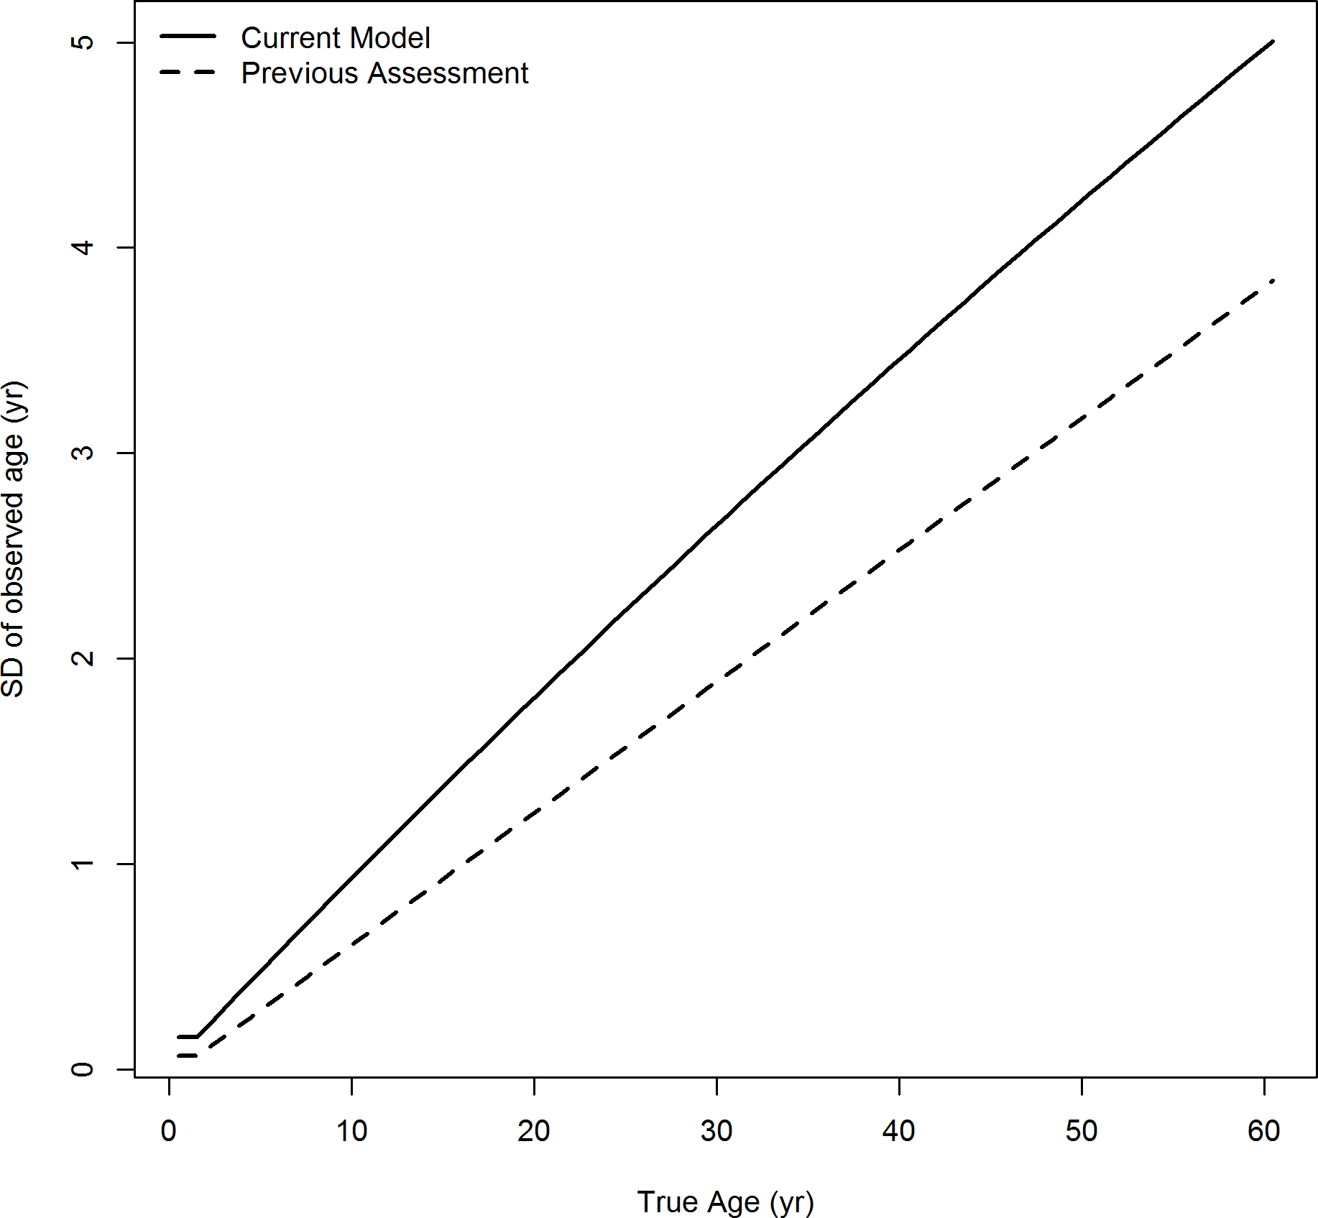

Figure 28: The estimated ageing error used in this assessment compared to the ageing error assumed in the previous assessment for Pacific ocean perch.

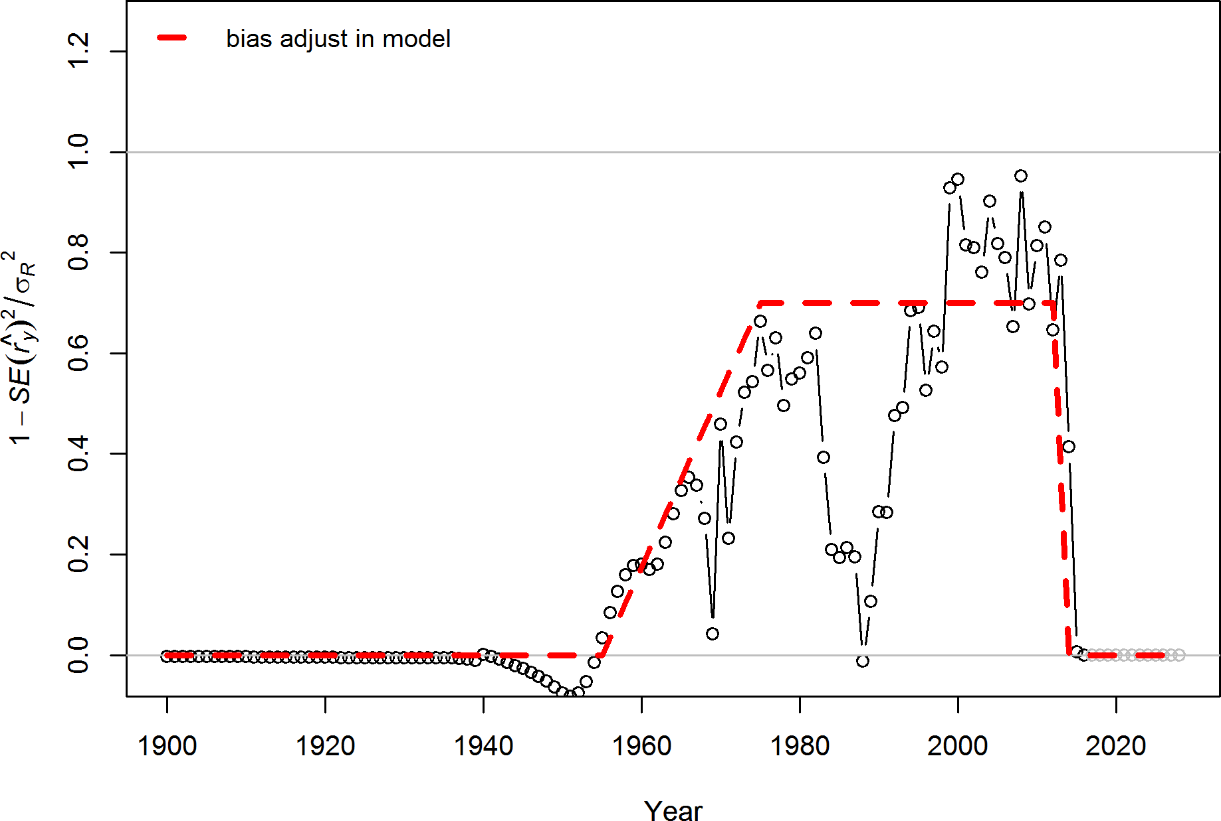

Figure 29: Recruitment bias ramp applied in the base model.

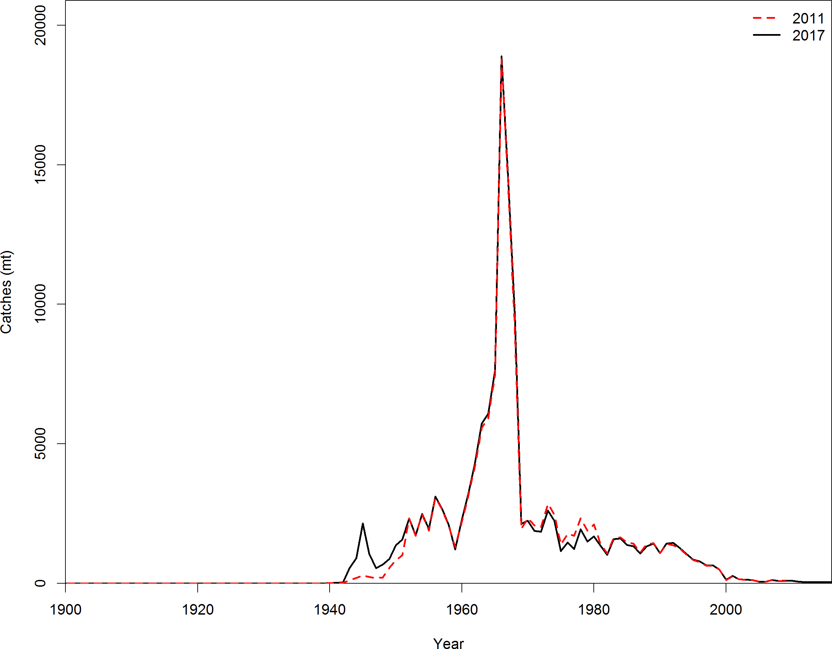

Figure 30: Comparison of the catches assumed by this assessment and the previous assessment for Pacific ocean perch.

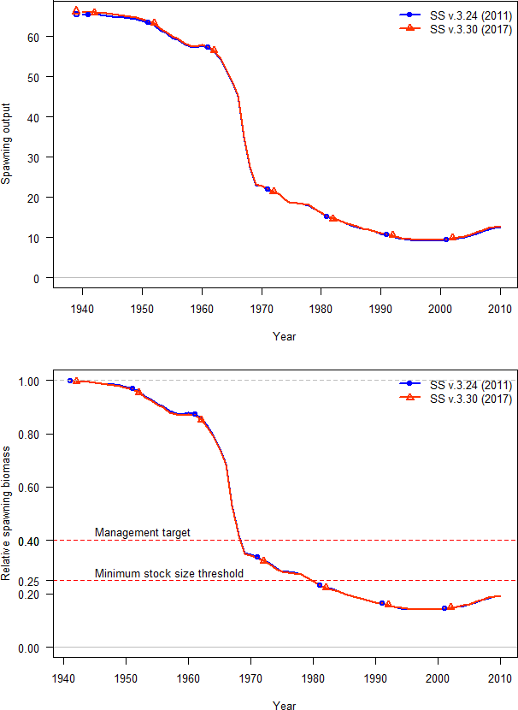

Figure 31: Comparison of model bridging estimates from Stock Synthesis version 3.30 and

3.24 for Pacific ocean perch for the 2011 asse9s9sment.

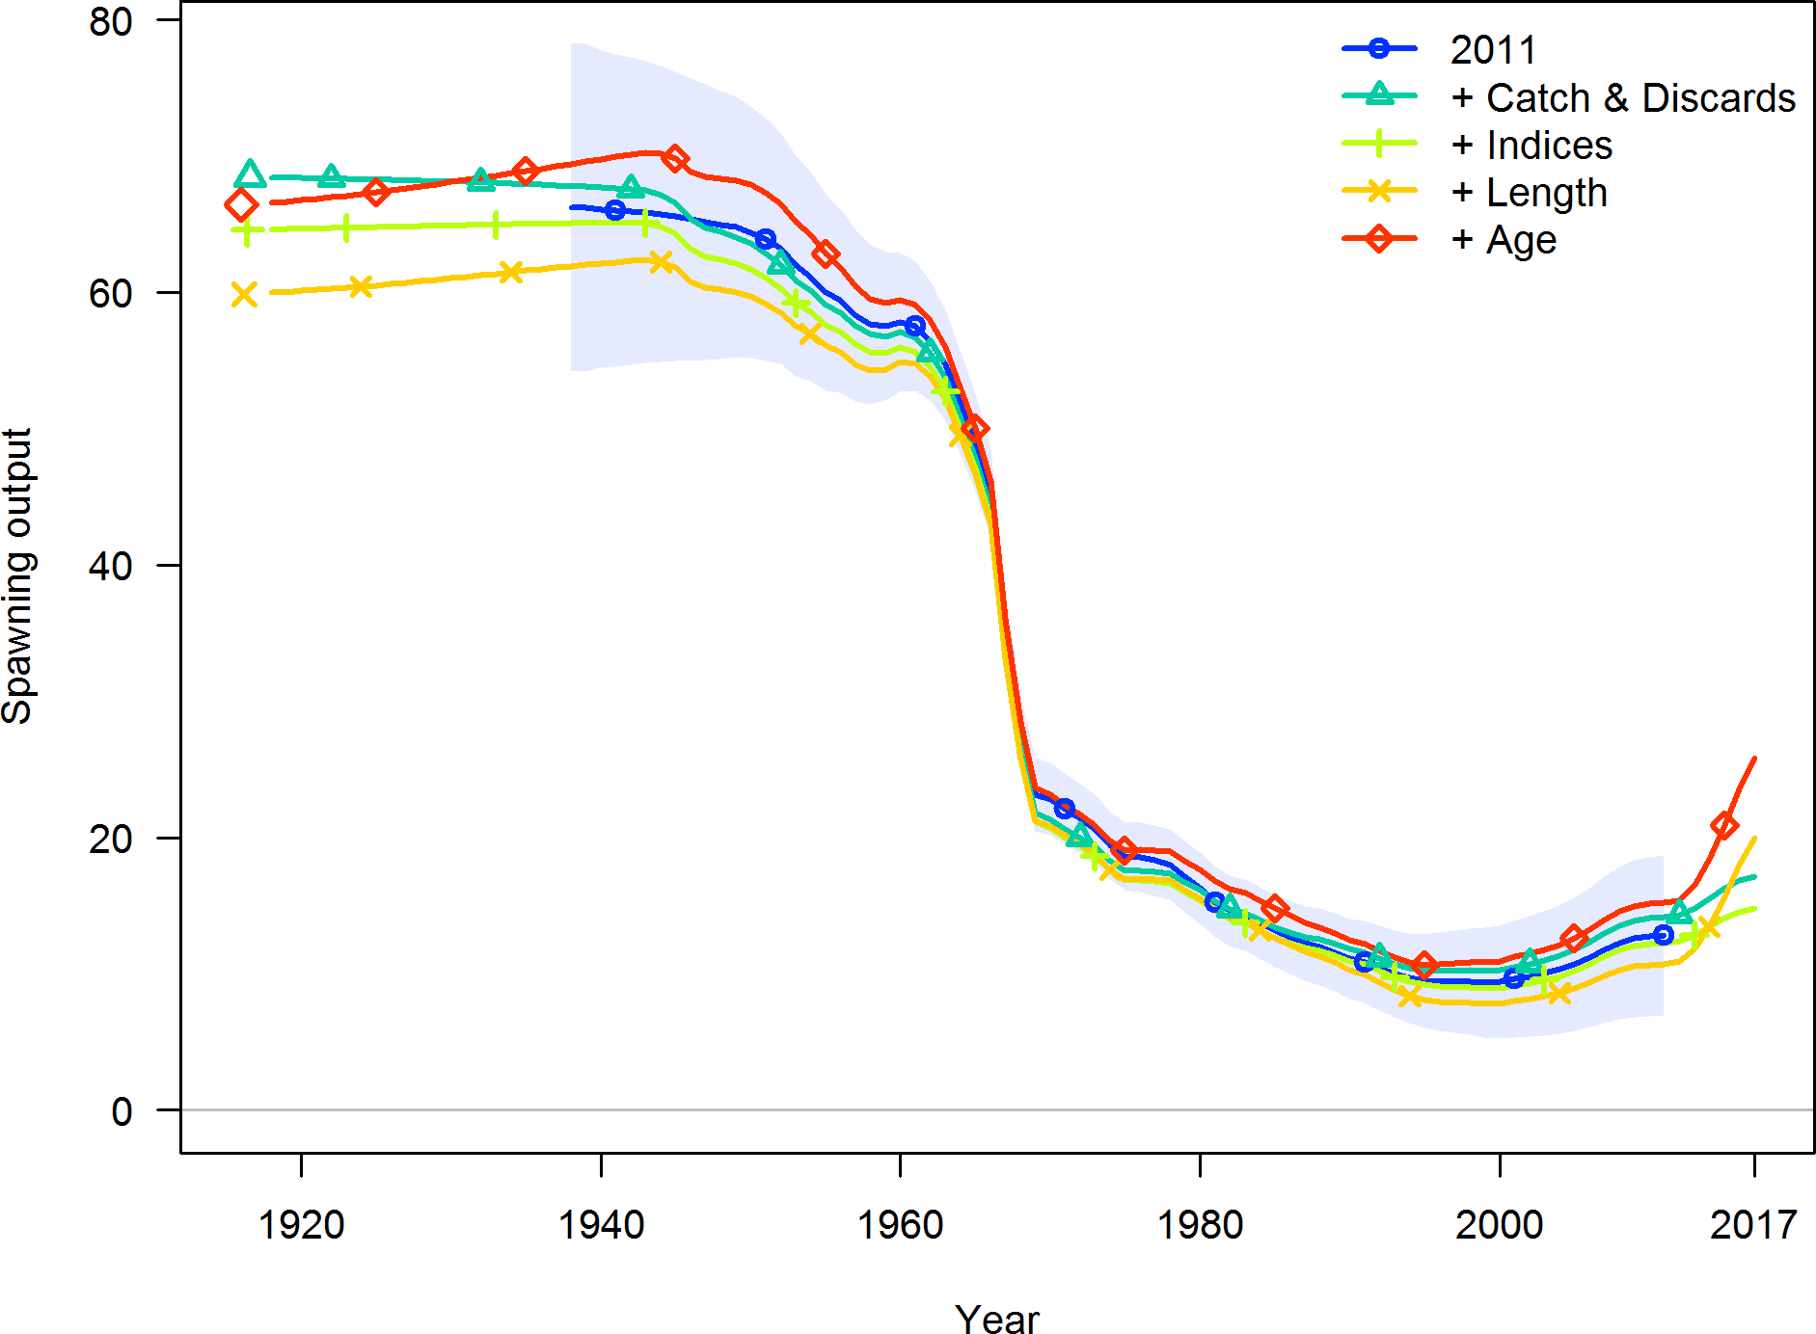

Figure 32: Estimates of spawning output when each of the data sets used in the current assessment was added to the 2011 model without updating model assumptions. Each data source was included in an additive fashion where the final model “+ Age” is the 2011 model with all data sources updated.

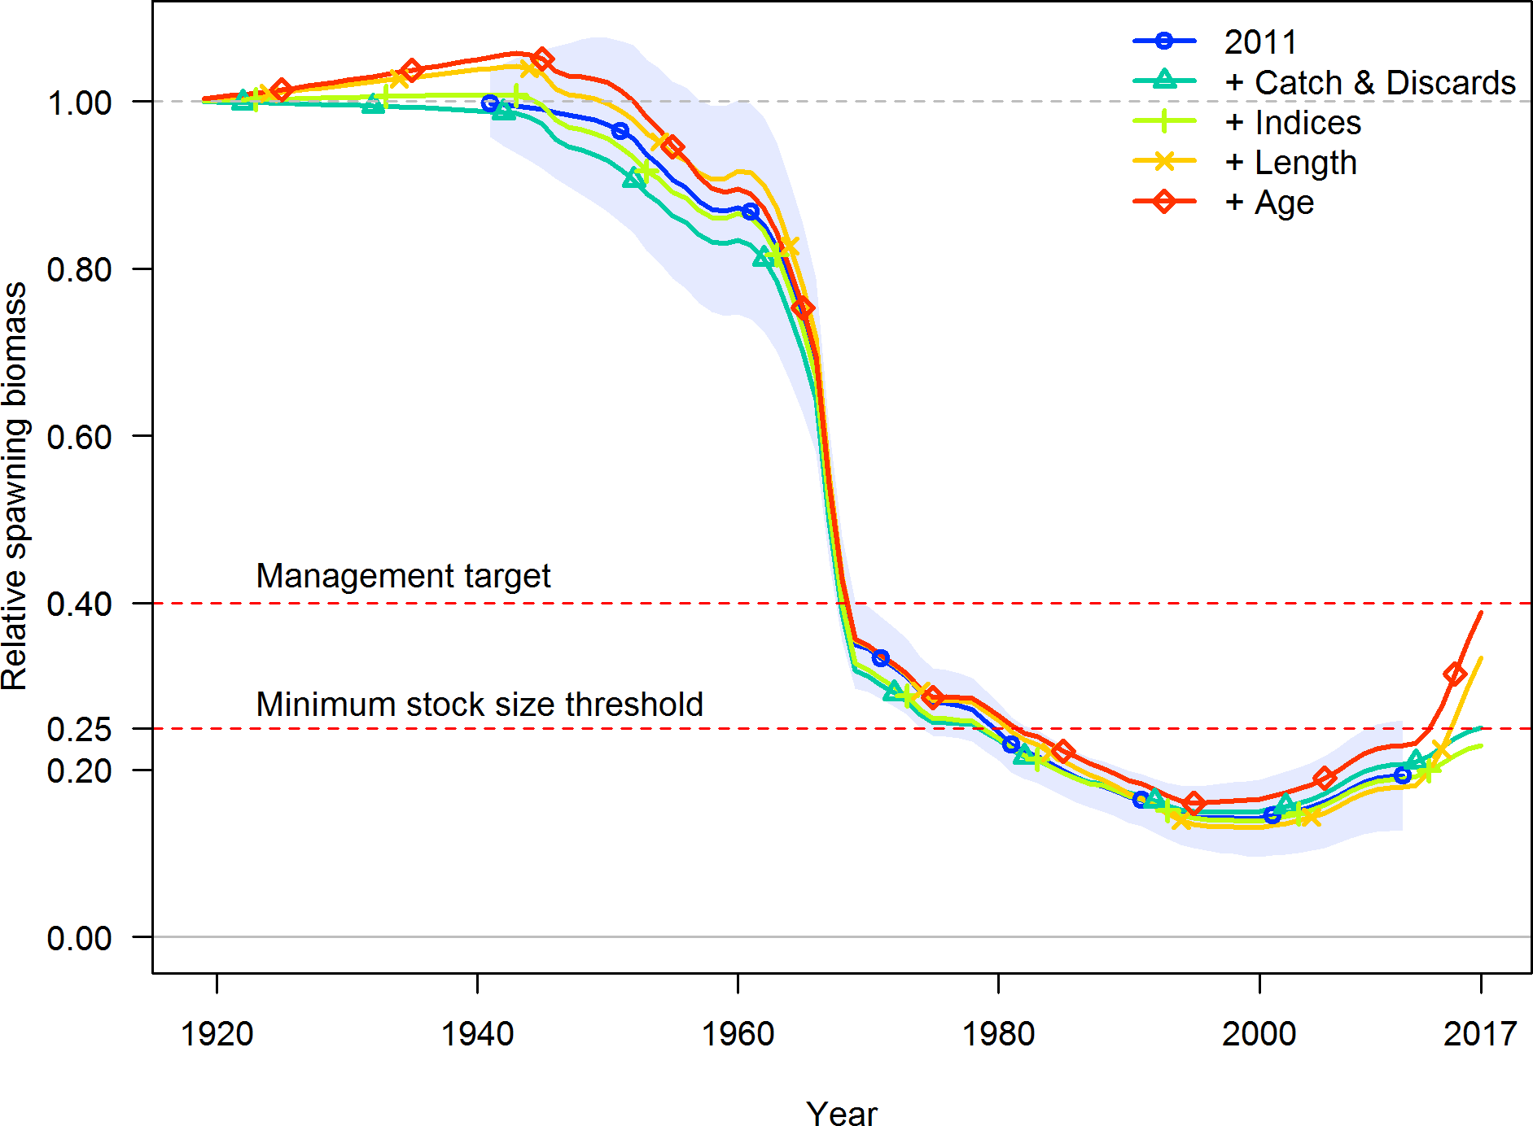

Figure 33: Estimated of relative spawning output when each of the data sets used in the current assessment was added to the 2011 model without updating model assumptions. Each data source was included in an additive fashion where the final model “+ Age” is the 2011 model with all data sources updated.

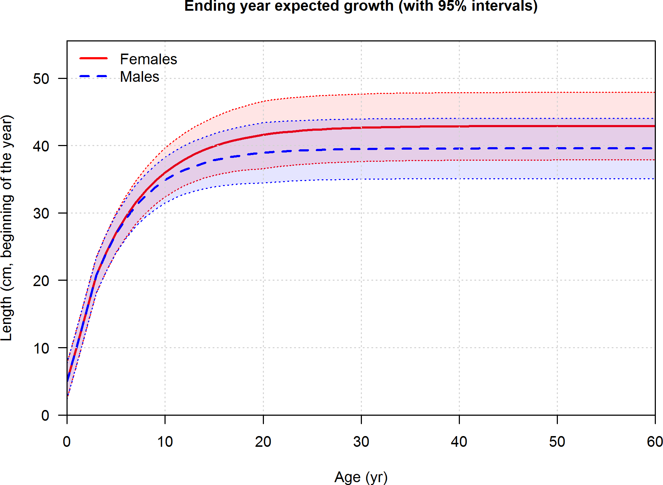

Figure 34: Estimated length-at-age for male and female for Pacific ocean perch with estimated CV.

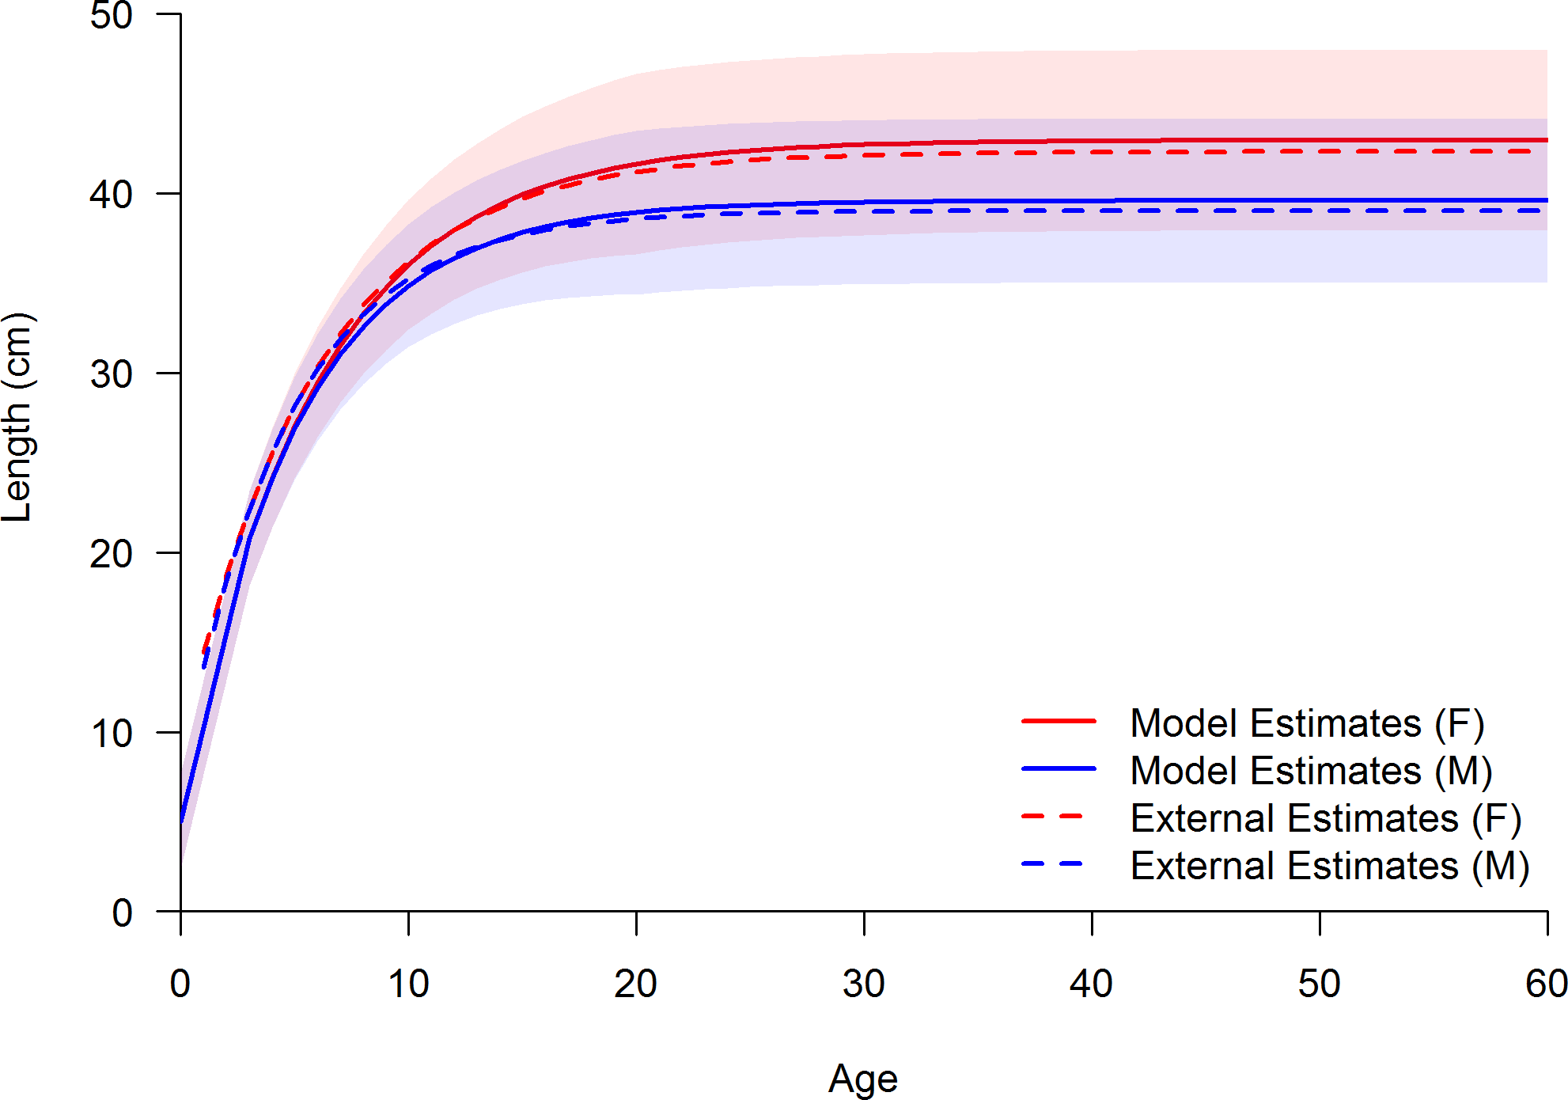

Figure 35: Comparison between the estimated length-at-age for male and female (solid lines) for Pacific ocean perch with estimated CV to the external estimates based on the data (dashed lines).

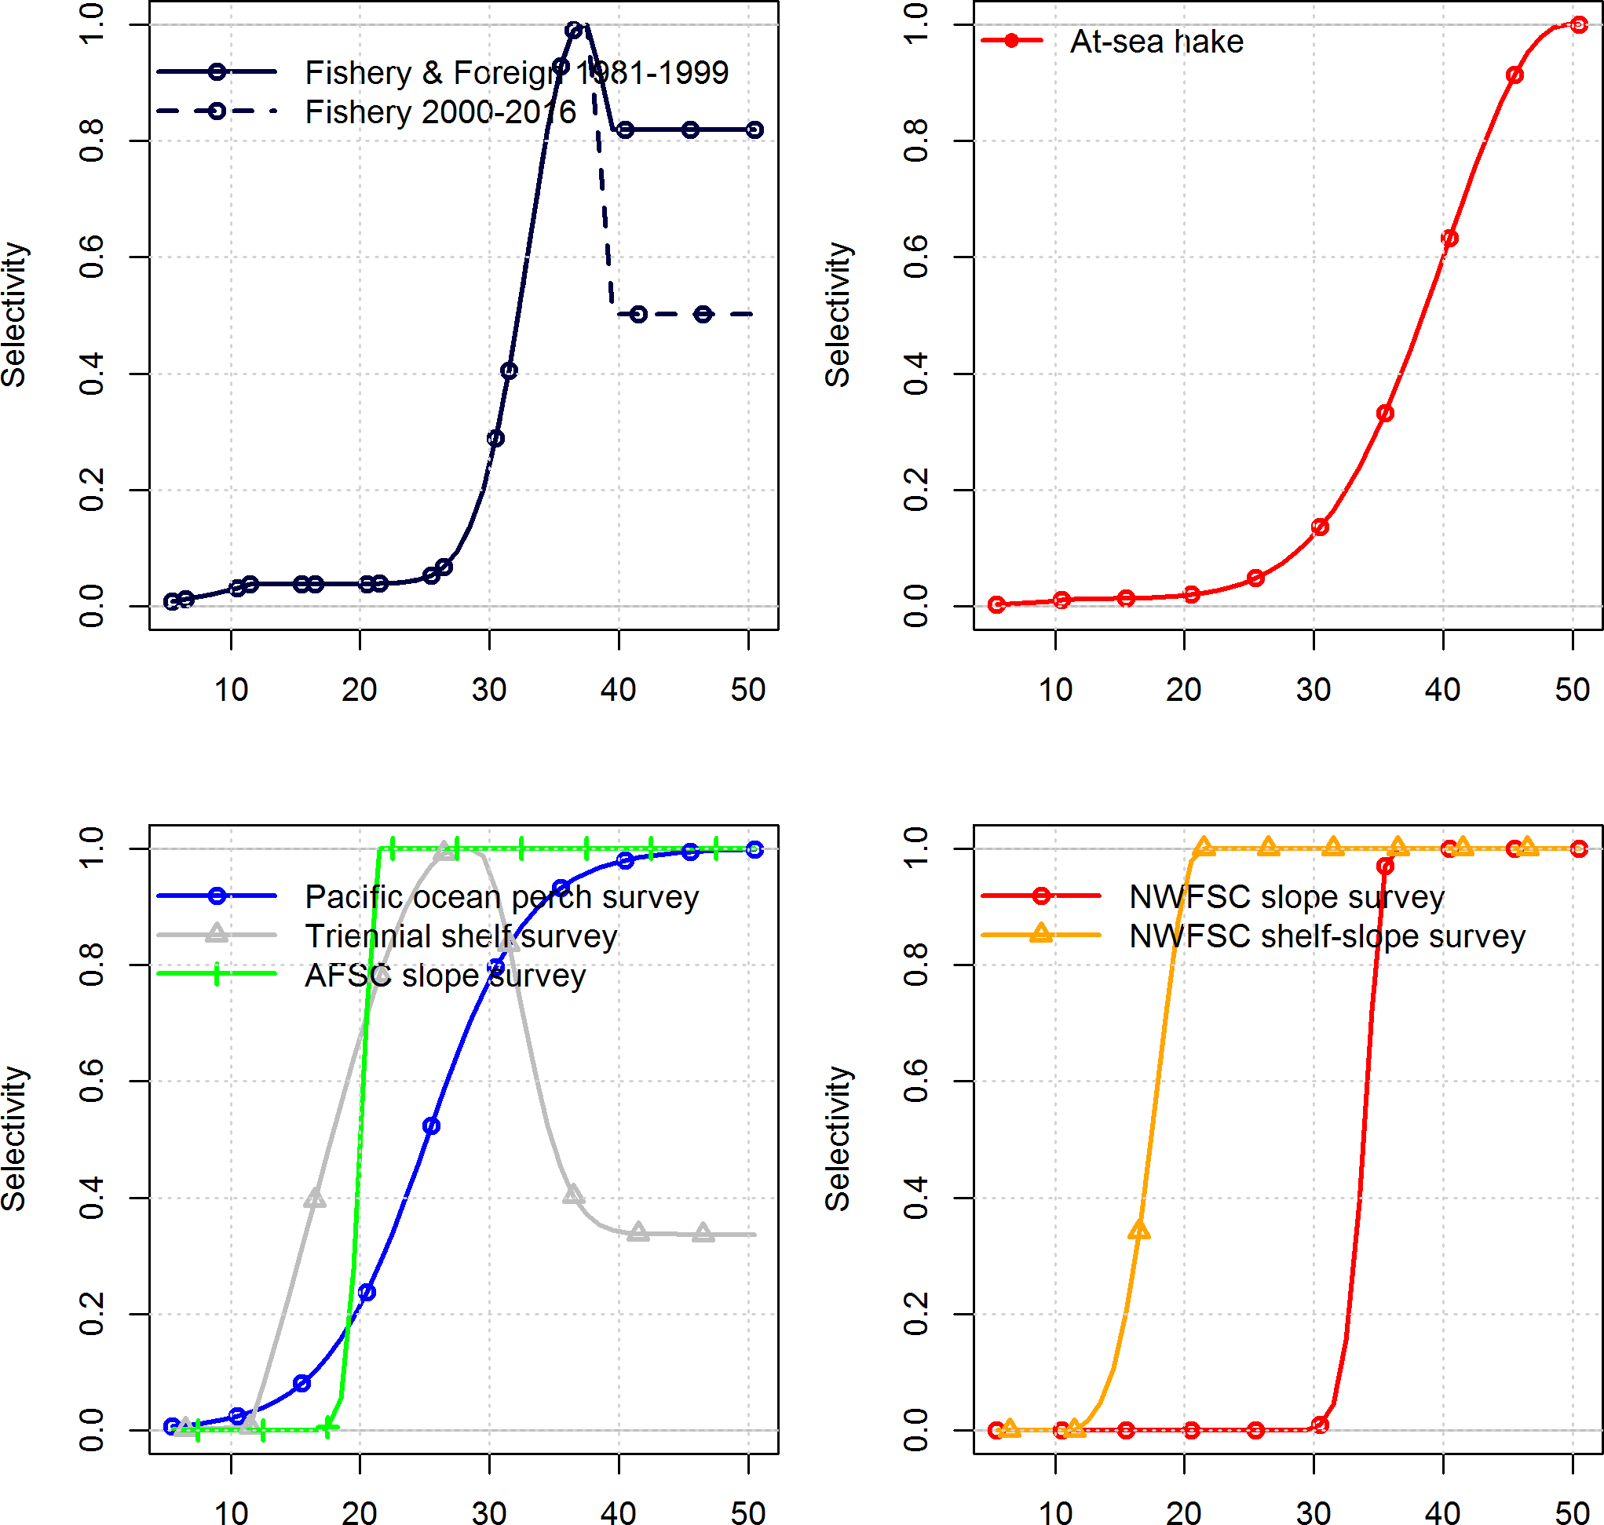

Figure 36: Estimated selectivity by length by each fishery and survey for Pacific ocean perch. The Triennial selectivity was fixed at the estimated selectivity from preliminary models using the Triennial data. The final selectivity was only used to remove Triennial catch from the population.

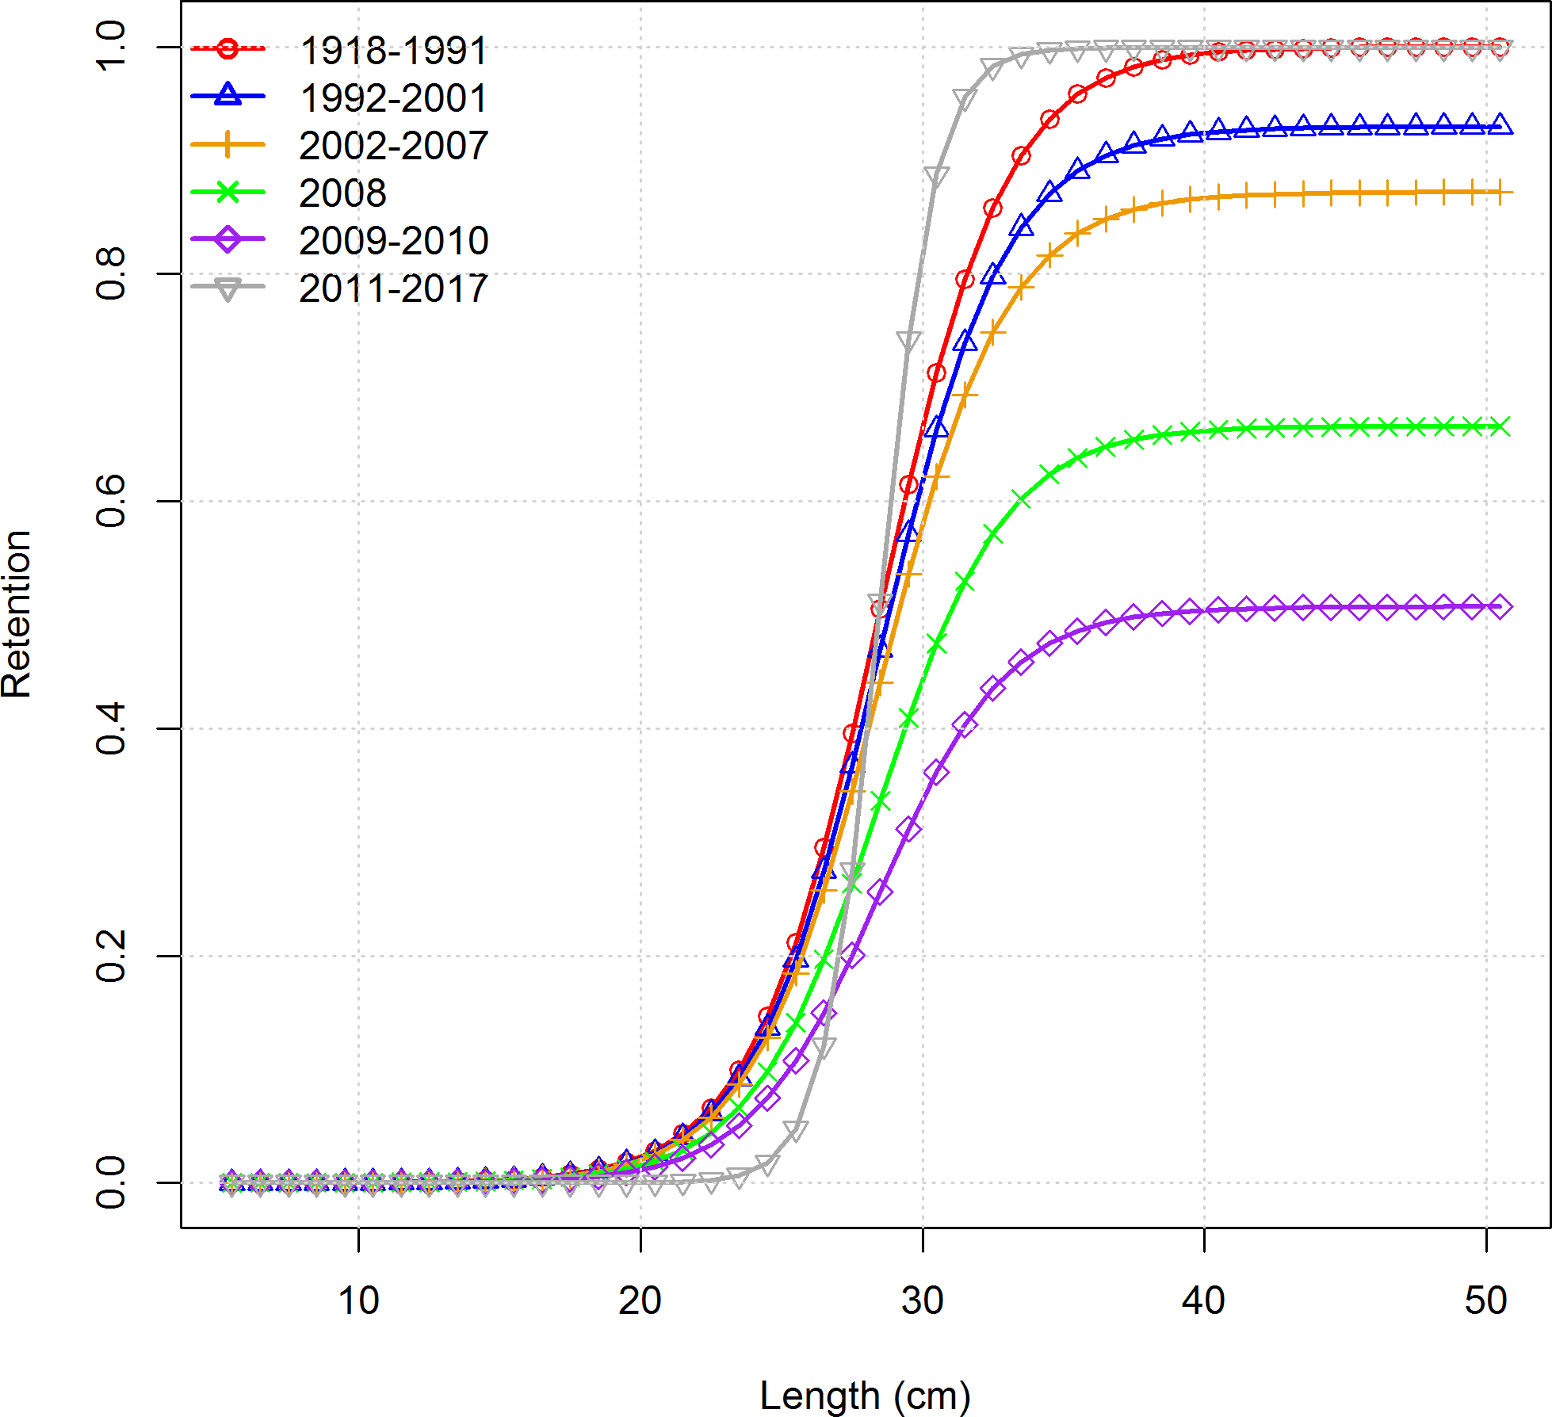

Figure 37: Estimated retention by length by the fishery fleet for Pacific ocean perch.



Figure 38: Estimated time-series of recruitment for Pacific ocean perch.

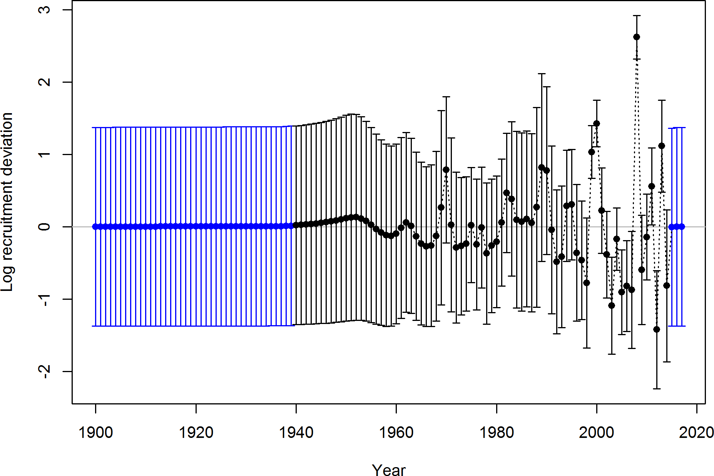

Figure 39: Estimated time-series of recruitment deviations for Pacific ocean perch.

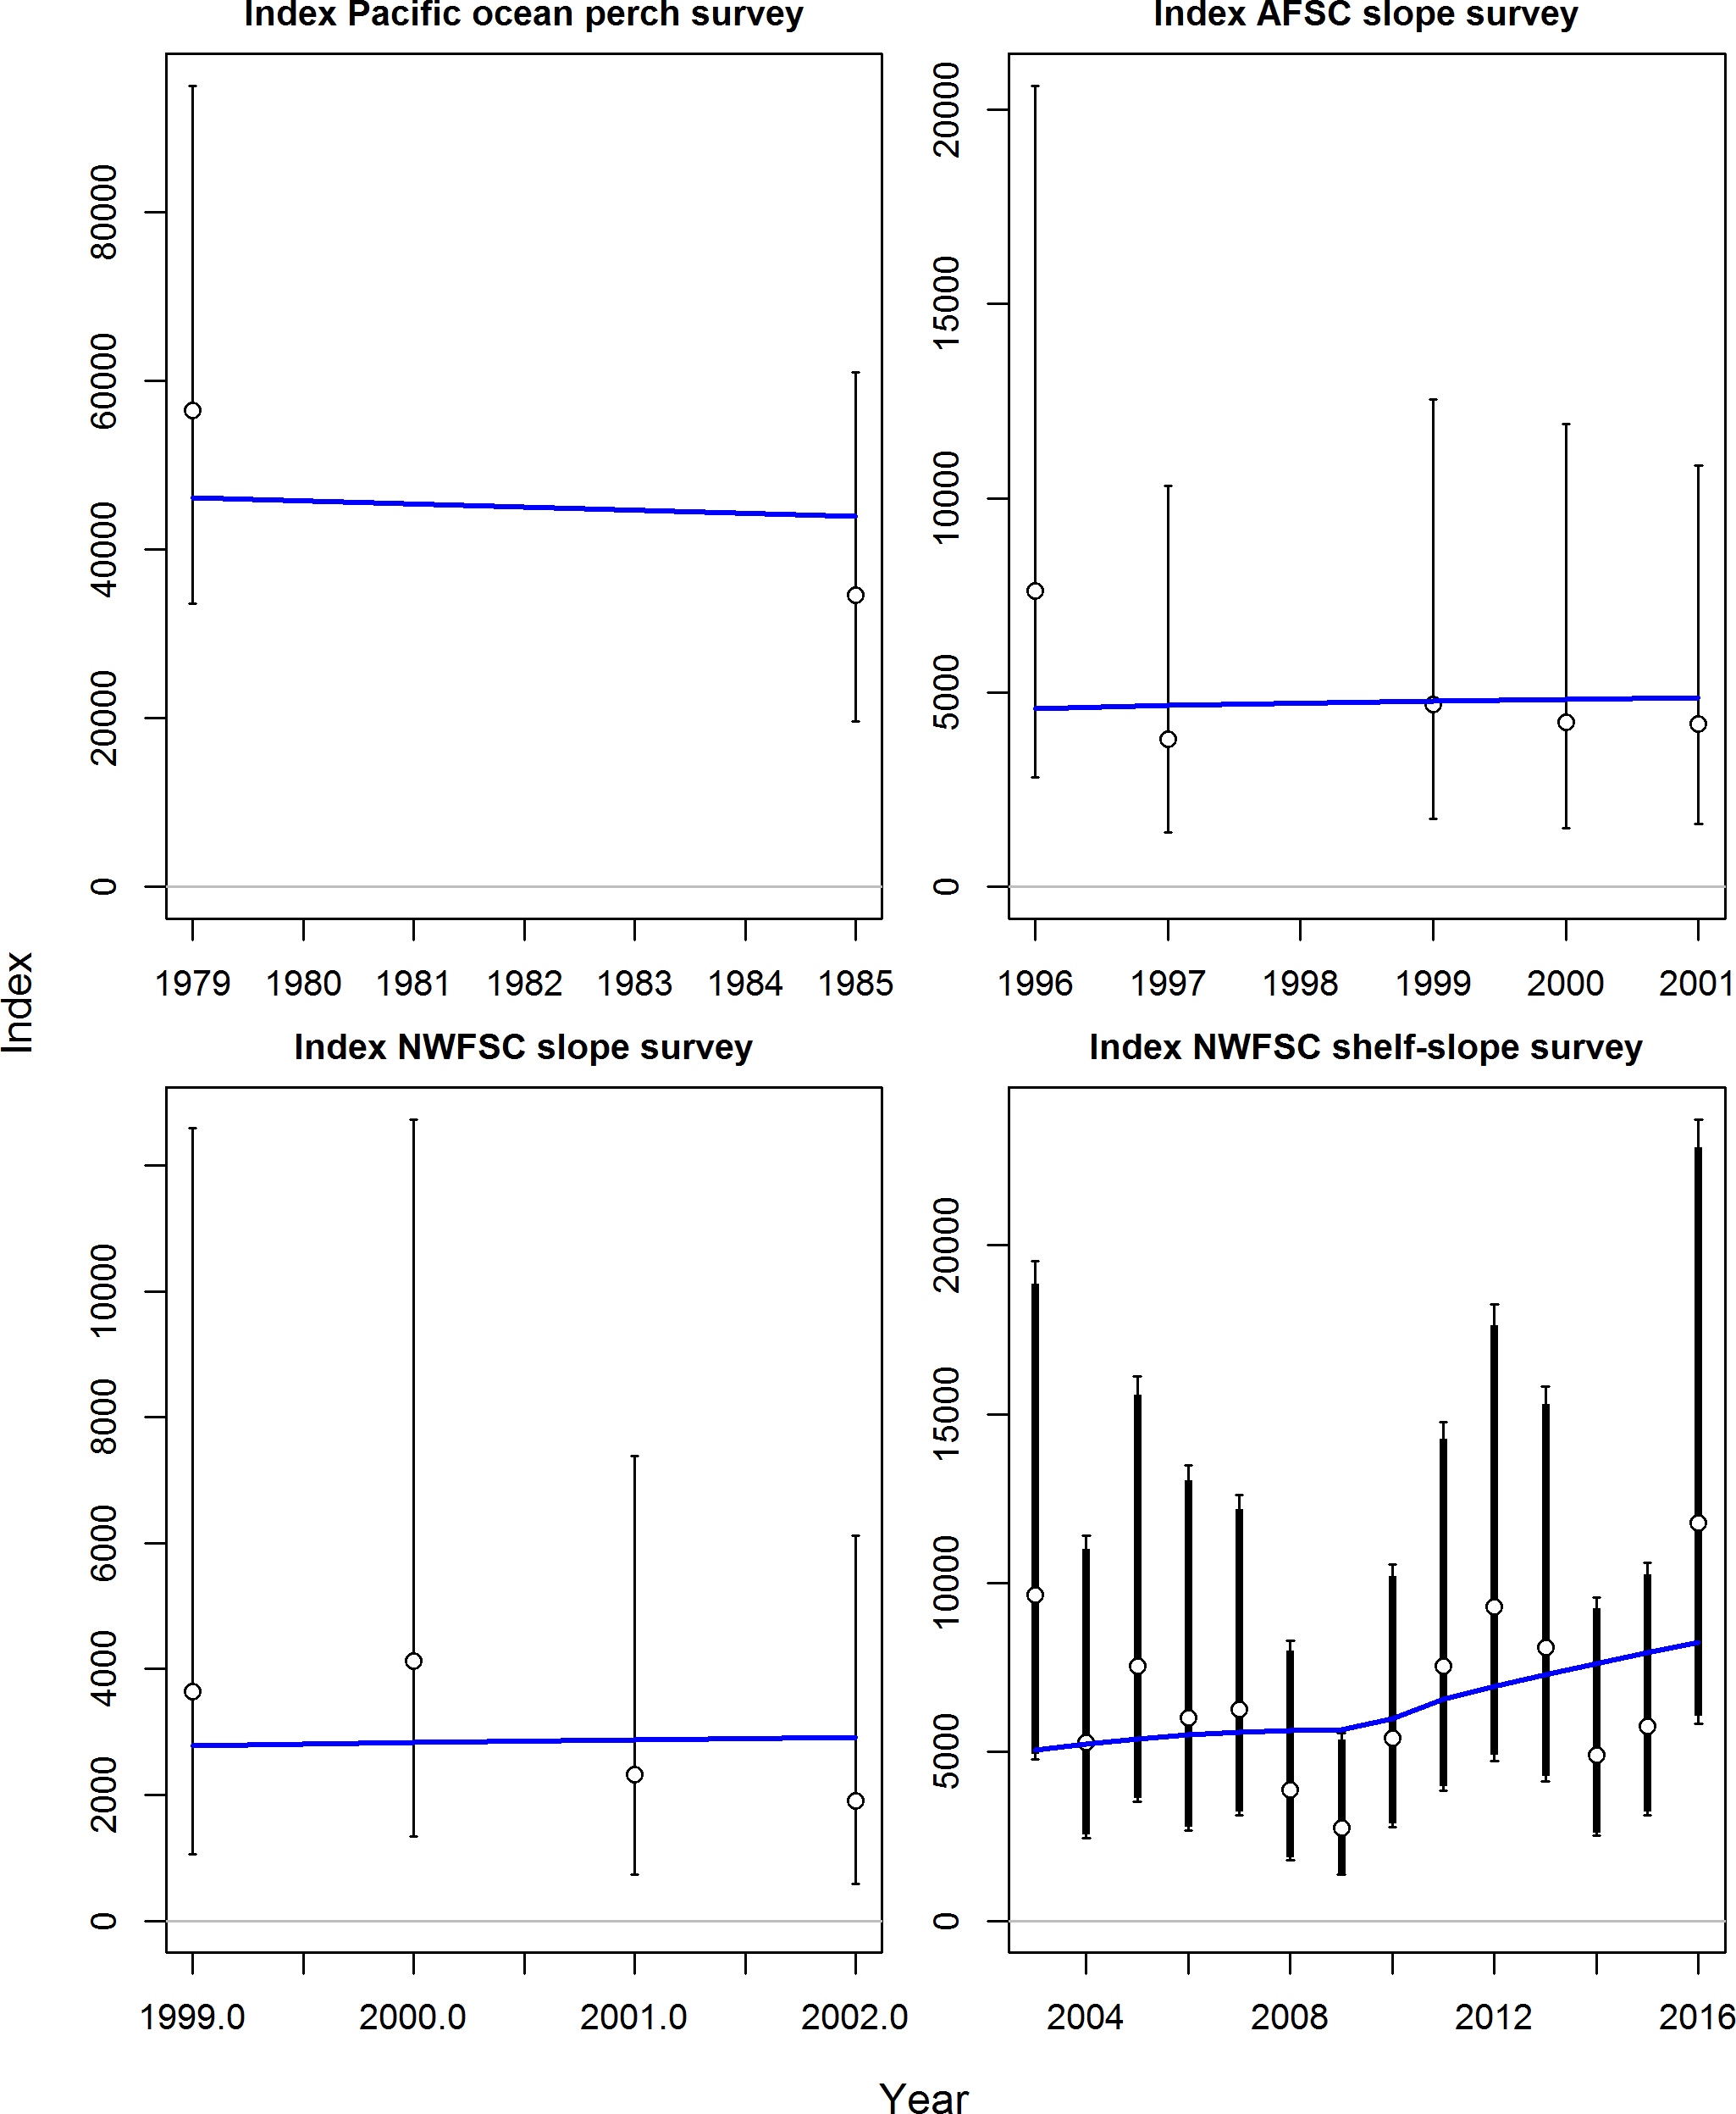

Figure 40: Estimated fits to the survey indices for Pacific ocean perch.

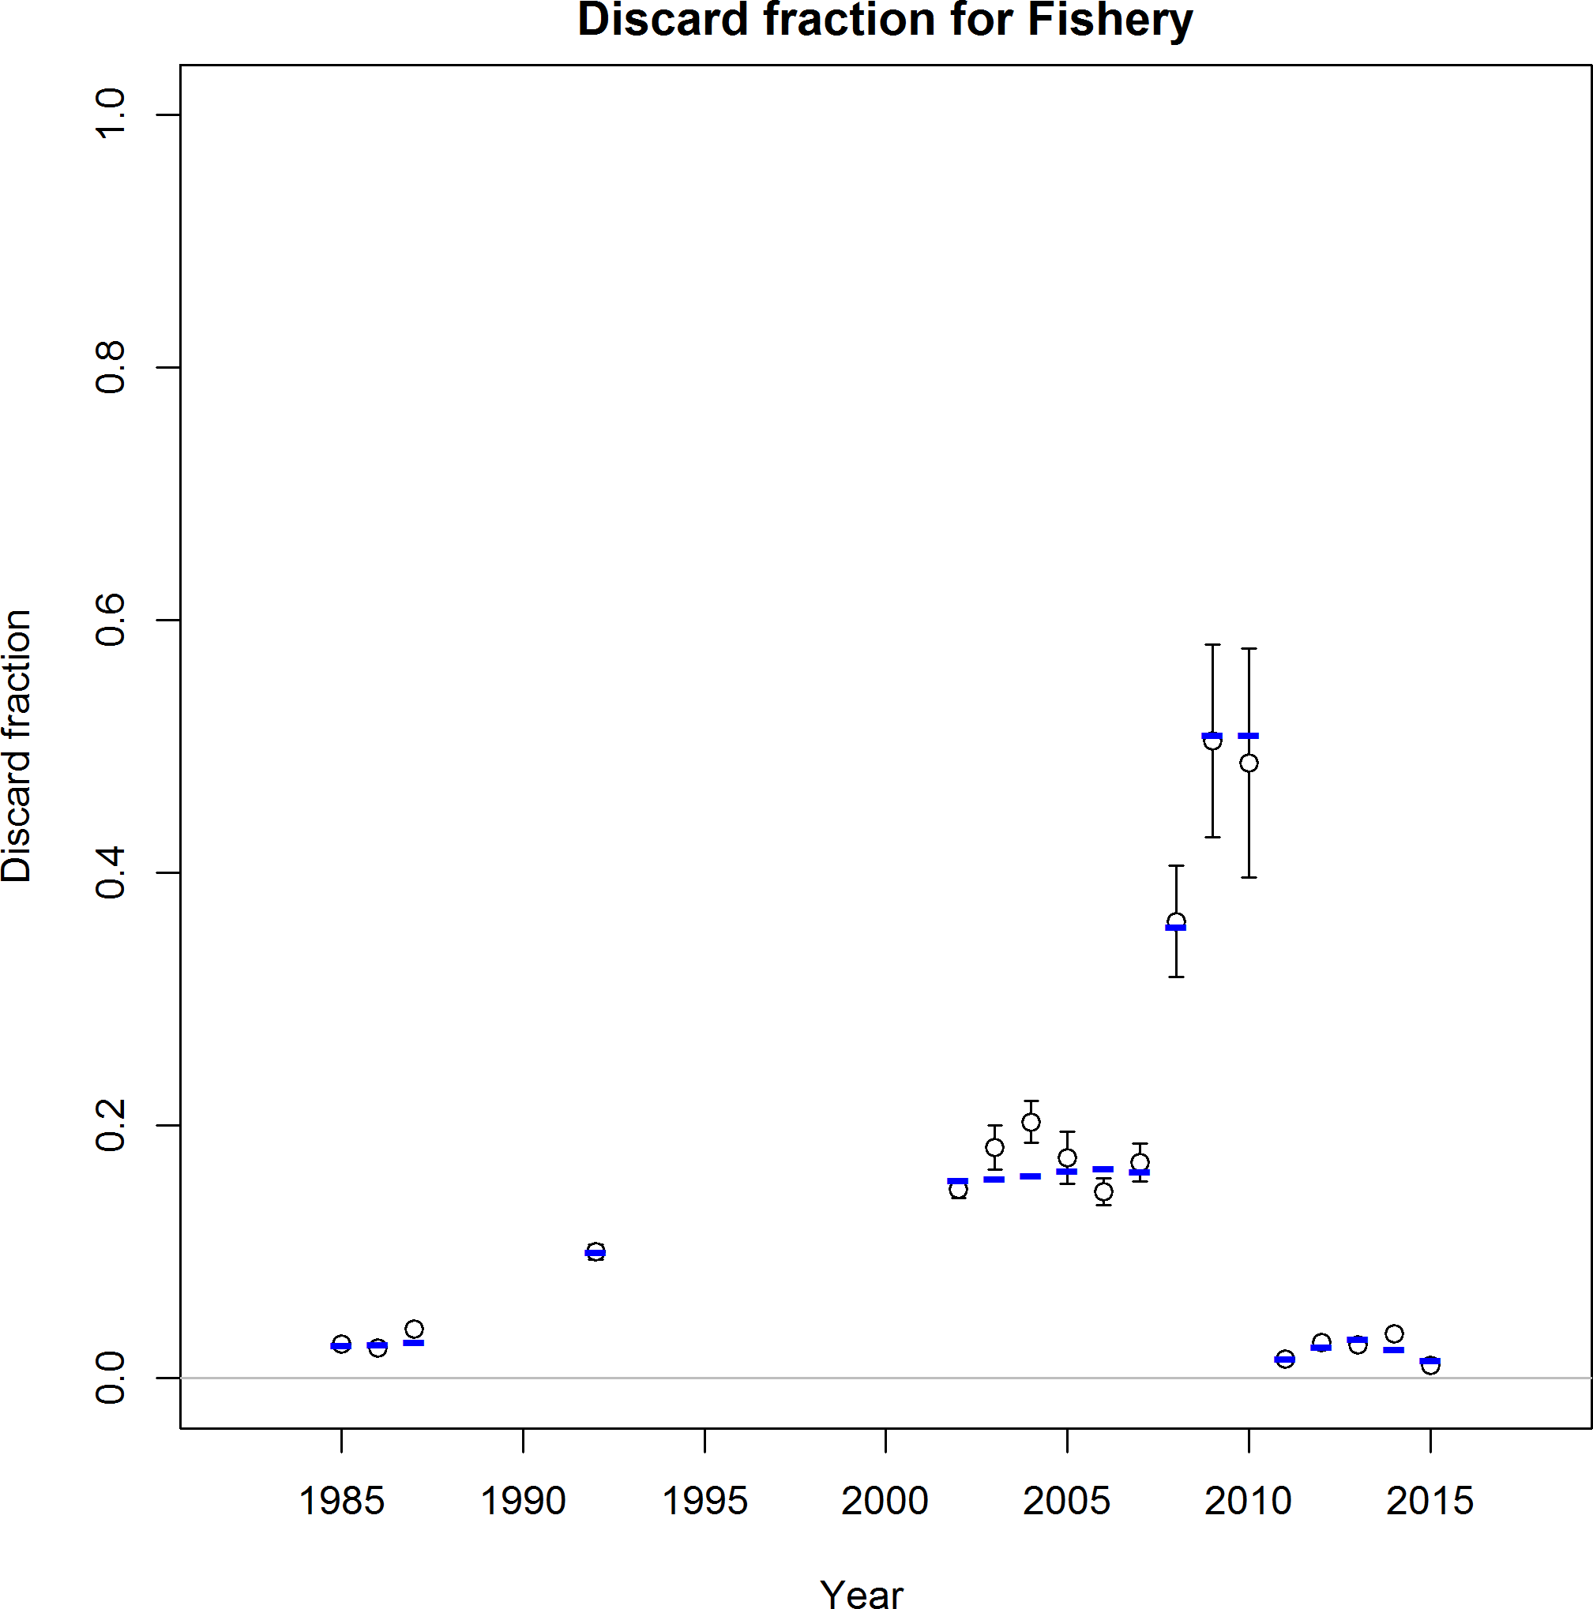

Figure 41: Estimated fits to the discard rates for Pacific ocean perch.

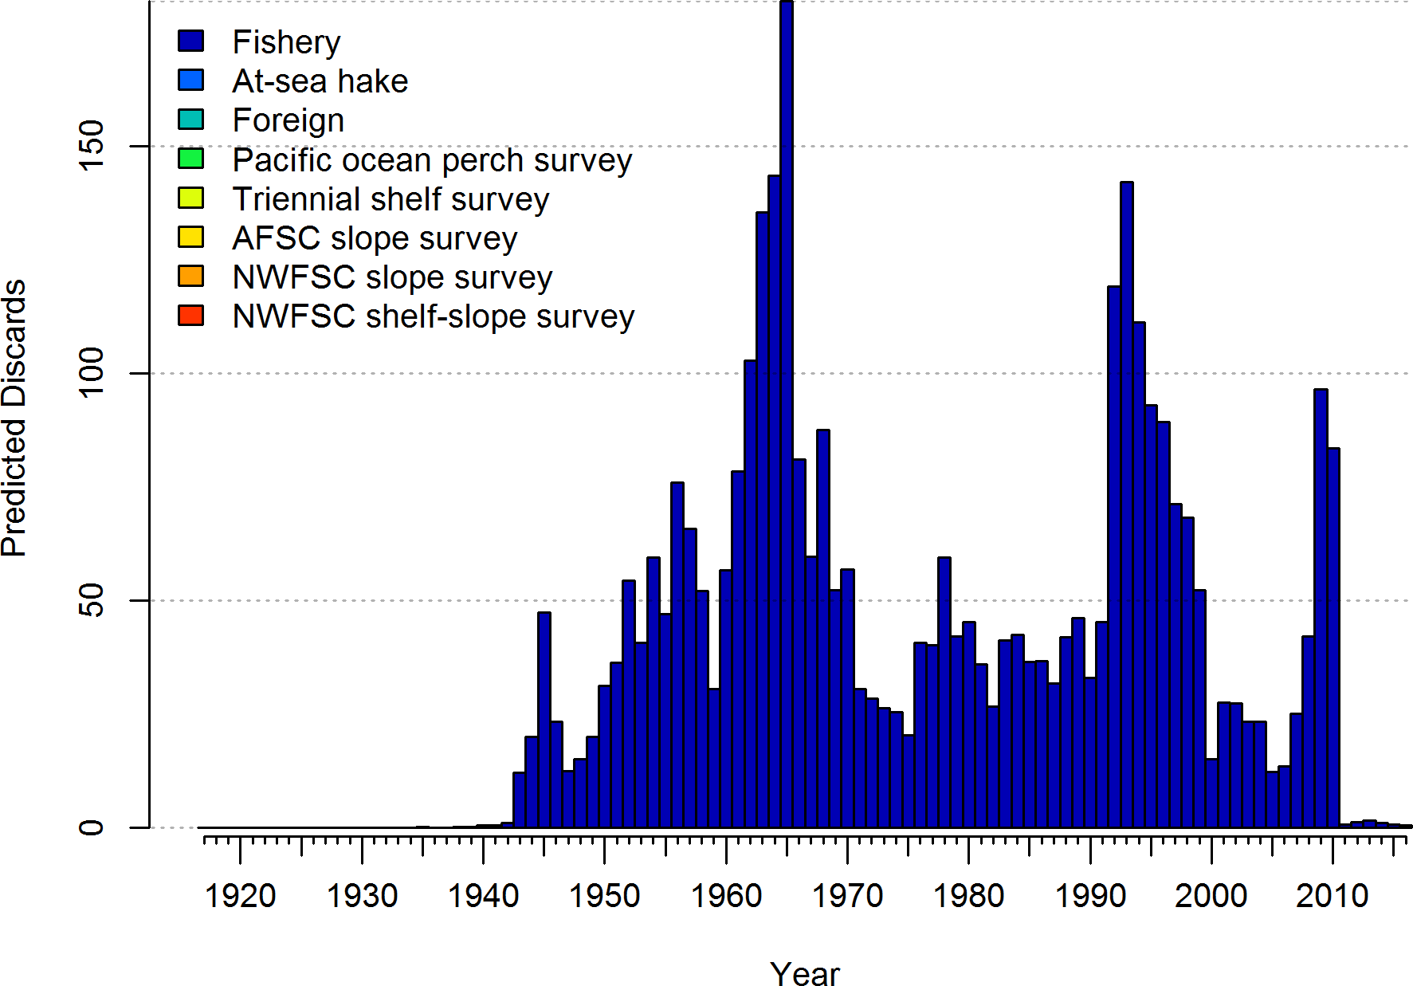

Figure 42: Estimated total discards for Pacific ocean perch. Estimated discard contributes less than 3.5 percent of the total morality across all years from the fishery.

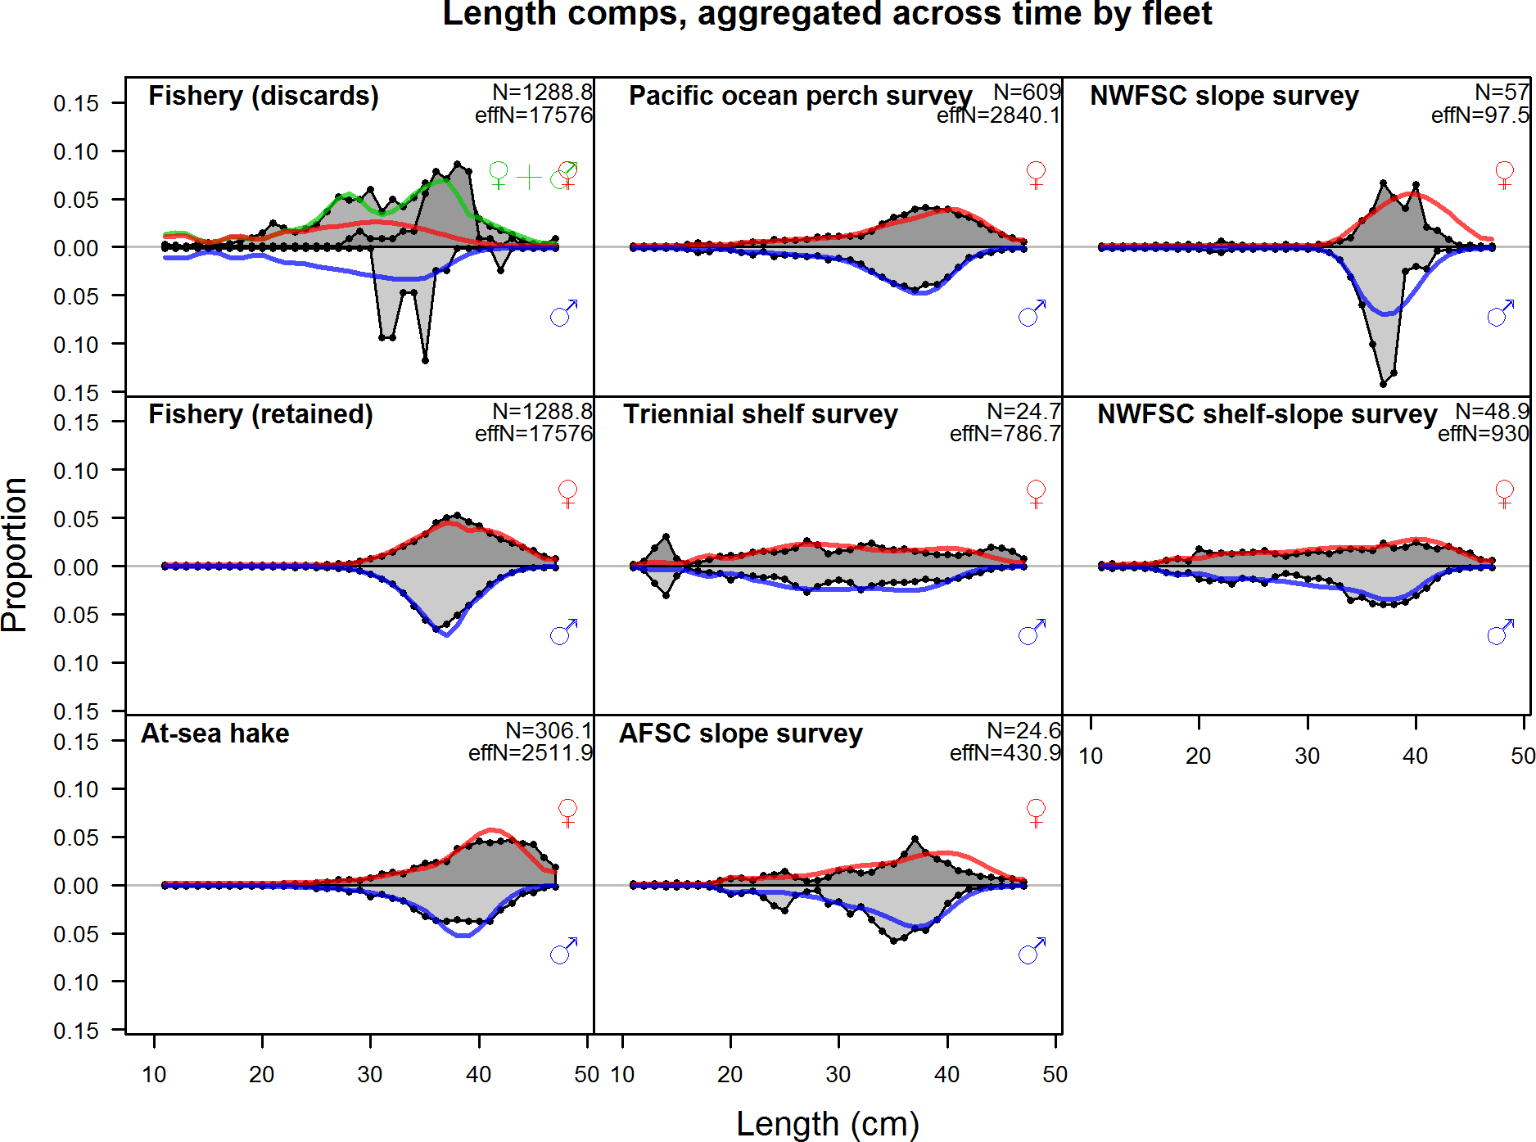

Figure 43: Length compositions aggregated across time by fleet. Labels ‘retained’ and ‘discard’ indicate retained or discarded samples for each fleet. Panels without this designation represent the whole catch. The Triennial shelf survey length data were not used in the final model, but the implied model fits are shown.

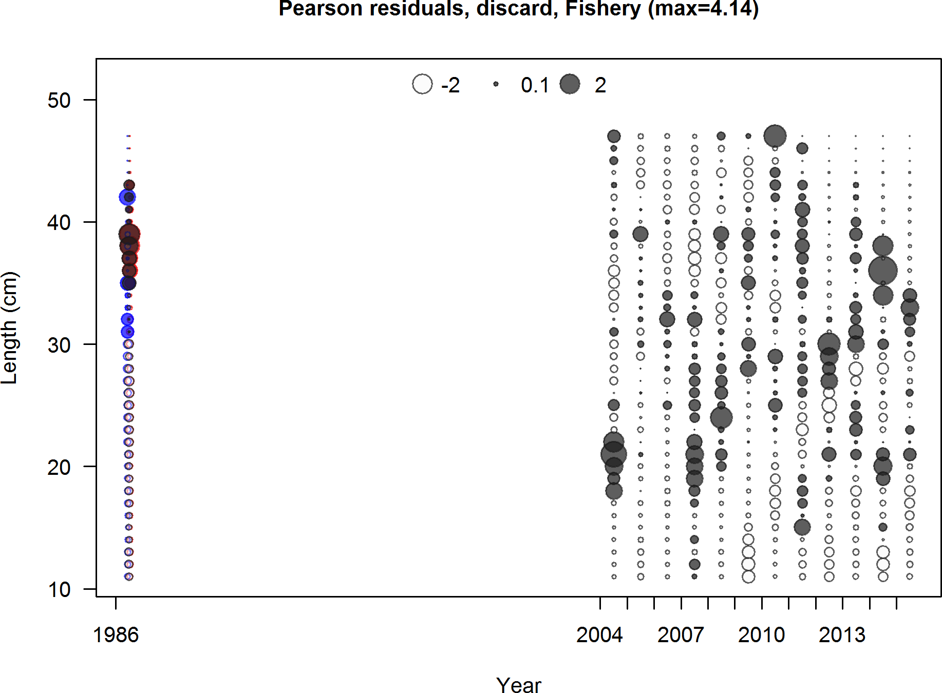

Figure 44: Pearson residuals, discard, Fishery (max=4.14)

Closed bubbles are positive residuals (observed *>* expected) and open bubbles are negative residuals (observed *<* expected).

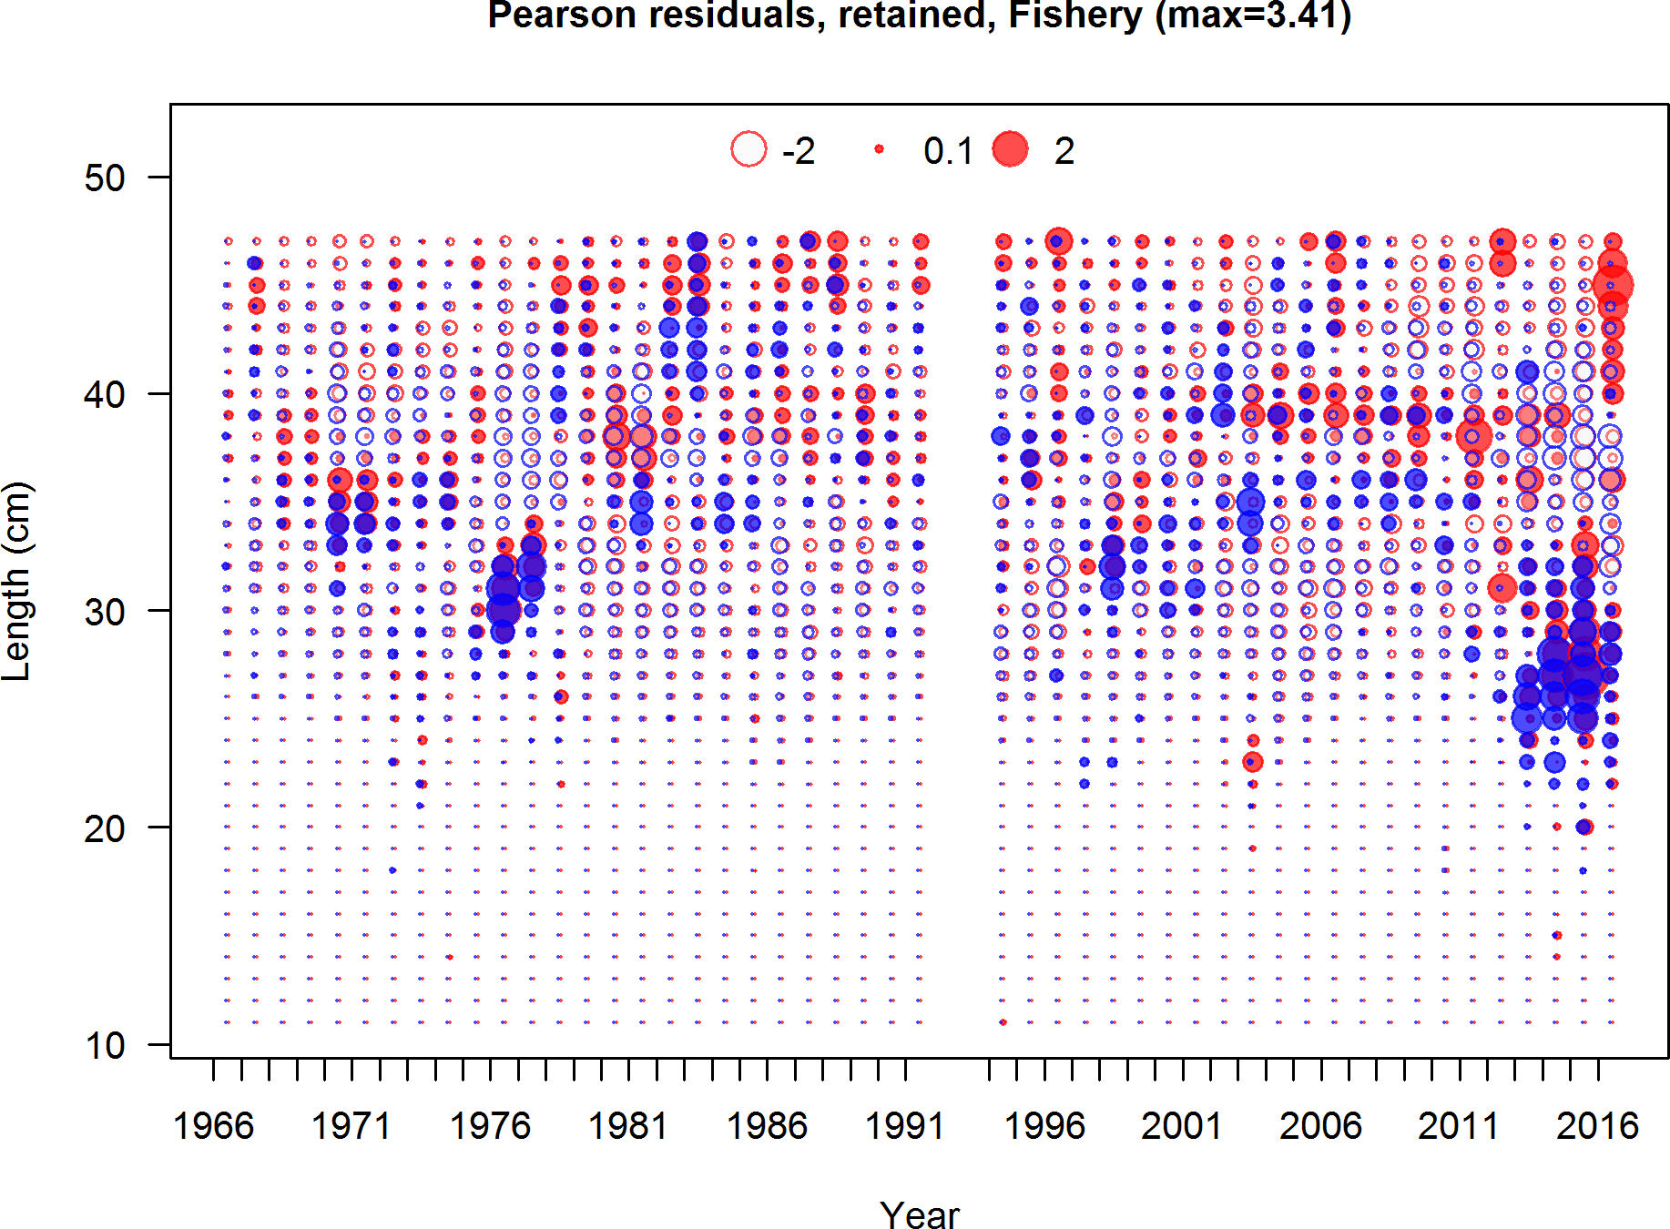

Figure 45: Pearson residuals, retained, Fishery (max=3.41)

Closed bubbles are positive residuals (observed *>* expected) and open bubbles are negative residuals (observed *<* expected).

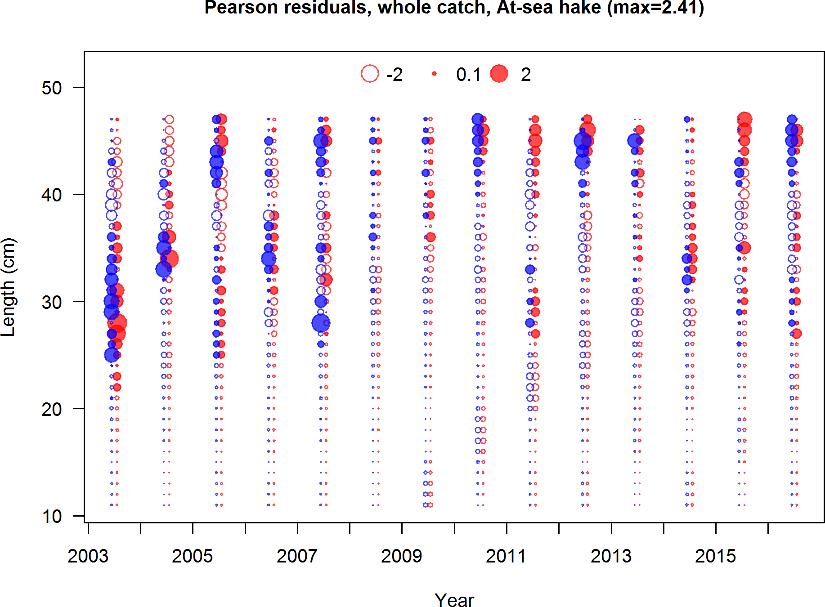

Figure 46: Pearson residuals, whole catch, At sea hake (max=2.41)

Closed bubbles are positive residuals (observed *>* expected) and open bubbles are negative residuals (observed *<* expected).

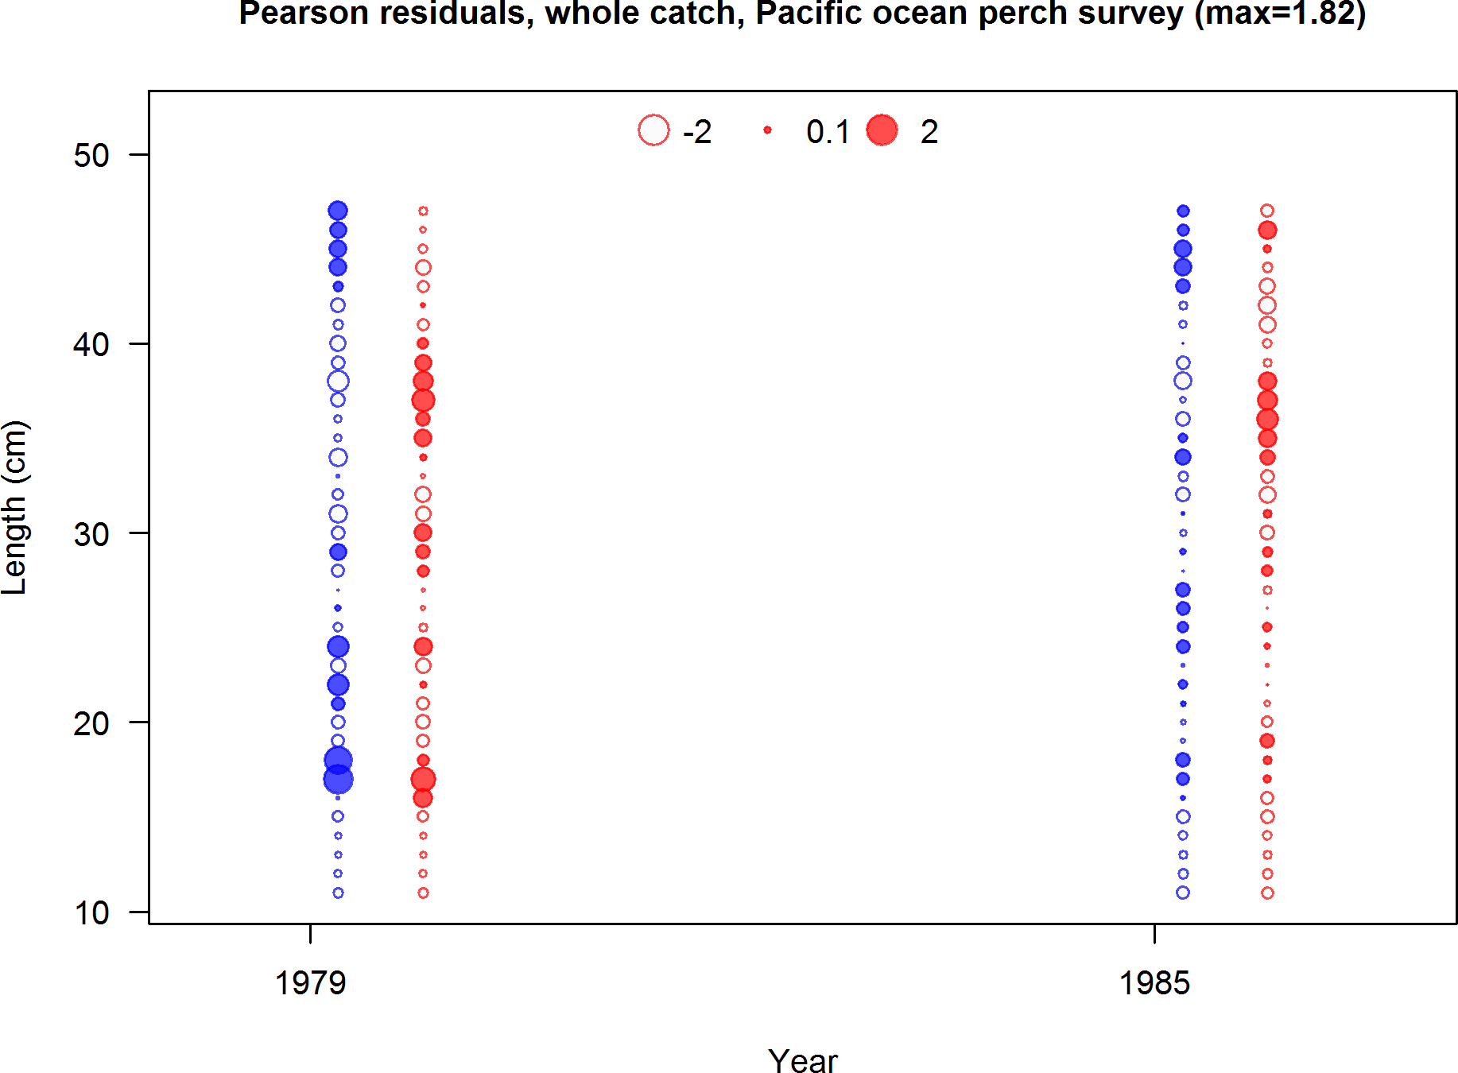

Figure 47: Pearson residuals, whole catch, Pacific ocean perch survey (max=1.82)

Closed bubbles are positive residuals (observed *>* expected) and open bubbles are negative residuals (observed *<* expected).

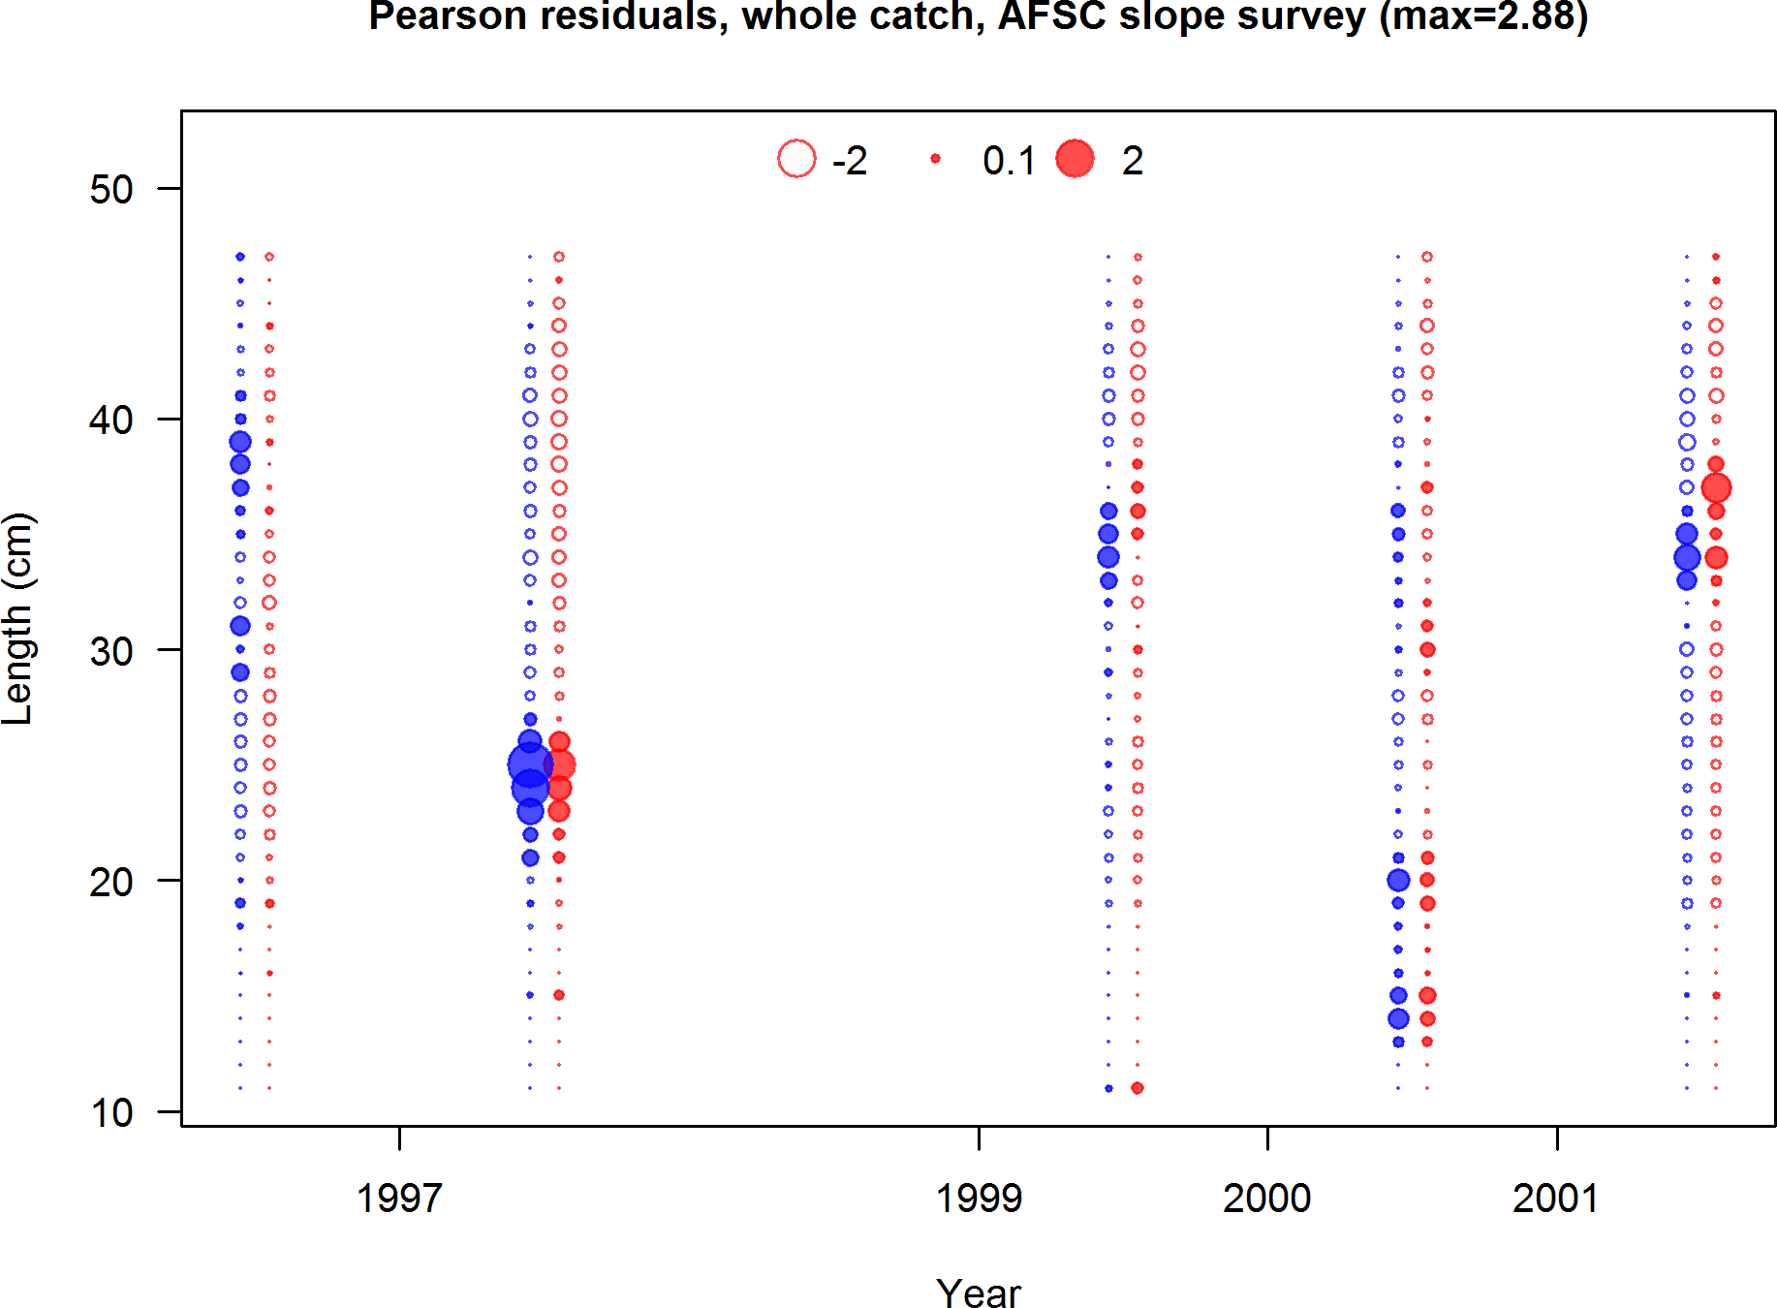

Figure 48: Pearson residuals, whole catch, AFSC slope survey (max=2.88)

Closed bubbles are positive residuals (observed *>* expected) and open bubbles are negative residuals (observed *<* expected).

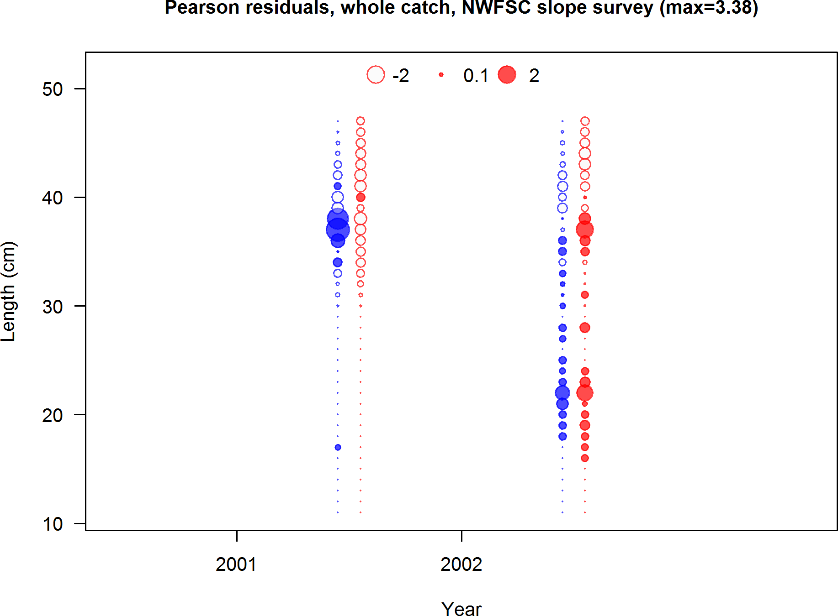

Figure 49: Pearson residuals, whole catch, NWFSC slope survey (max=3.38)

Closed bubbles are positive residuals (observed *>* expected) and open bubbles are negative residuals (observed *<* expected).

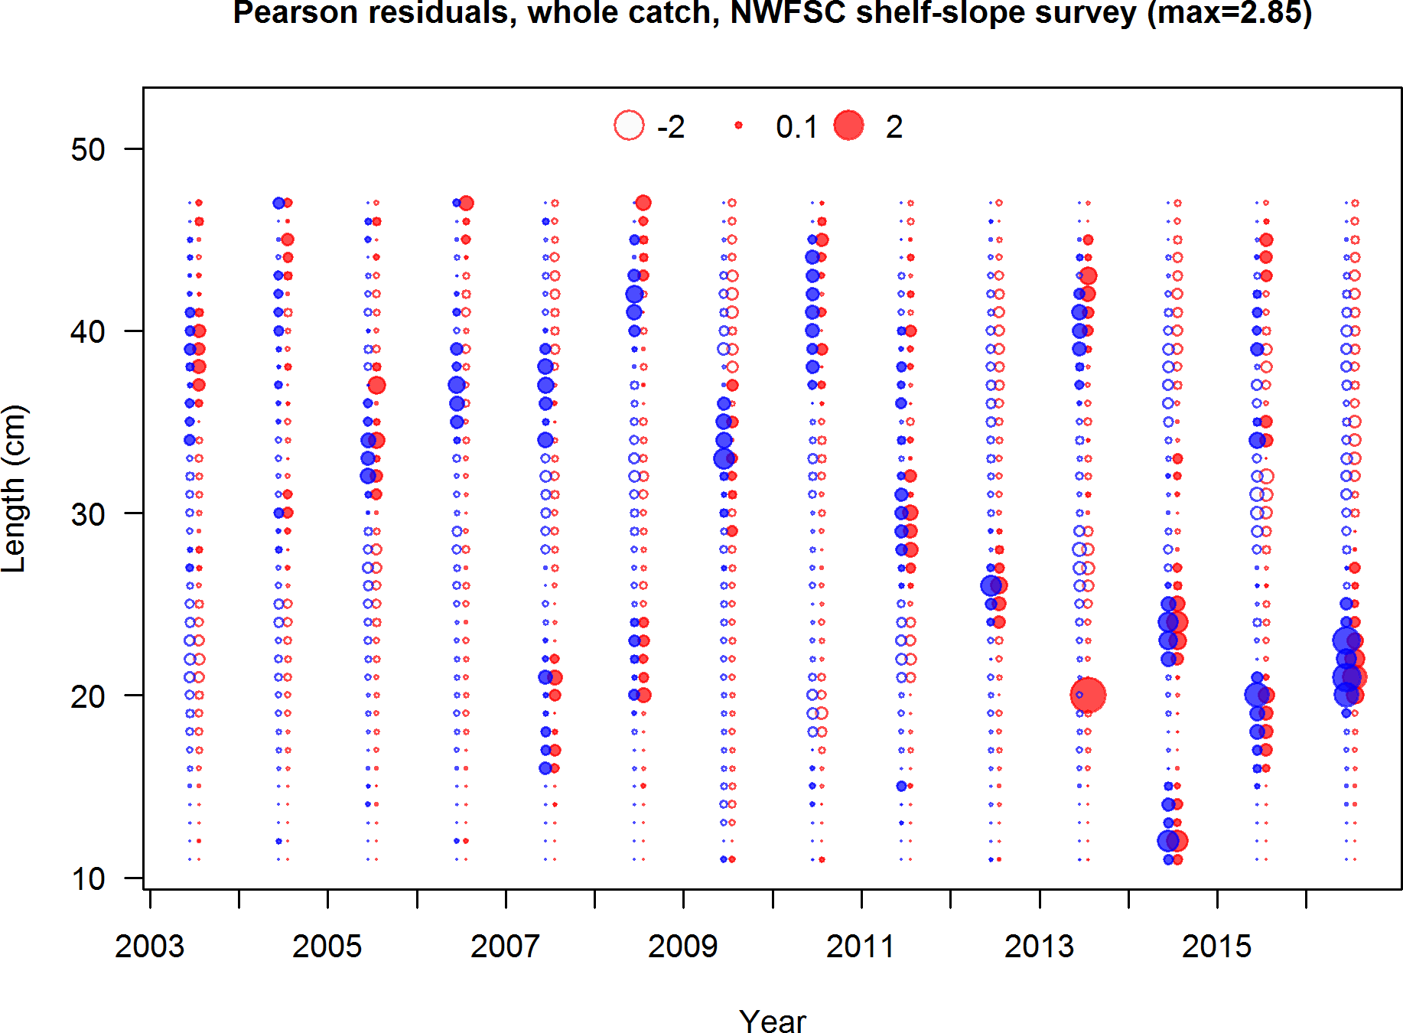

Figure 50: Pearson residuals, whole catch, NWFSC shelf slope survey (max=2.85)

Closed bubbles are positive residuals (observed *>* expected) and open bubbles are negative residuals (observed *<* expected).

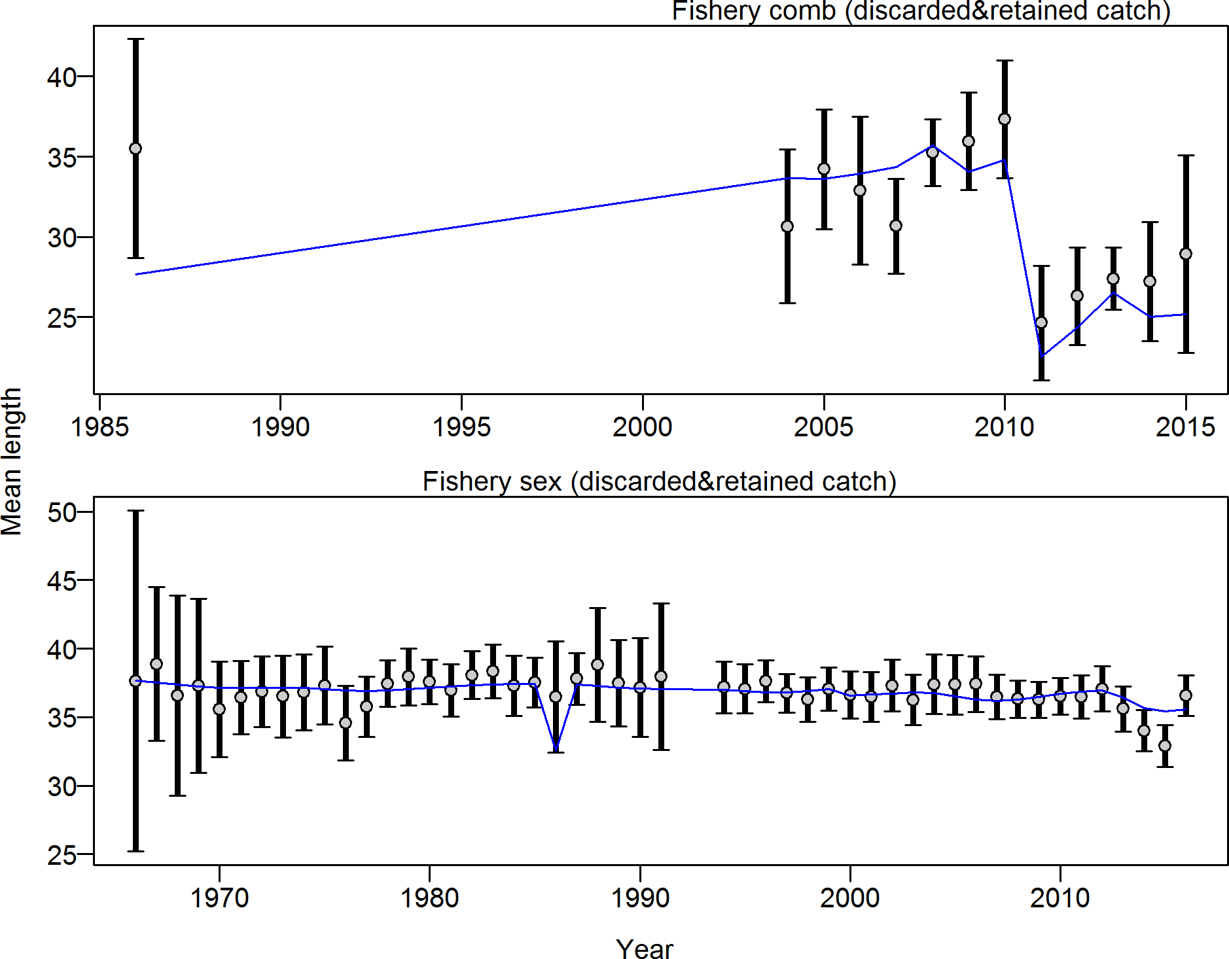

Figure 51: Mean length for Fishery with 95% confidence intervals based on current samples sizes. Francis data weighting method TA1.8: thinner intervals (with capped ends) show result of further adjusting sample sizes based on suggested multiplier (with 95% interval) for len data from Fishery: 0.9903 (0.6743 1.745) For more info, see Francis, R.I.C.C. (2011). Data weighting in statistical fisheries stock assessment models. Can. J. Fish. Aquat. Sci. 68: 1124 1138.

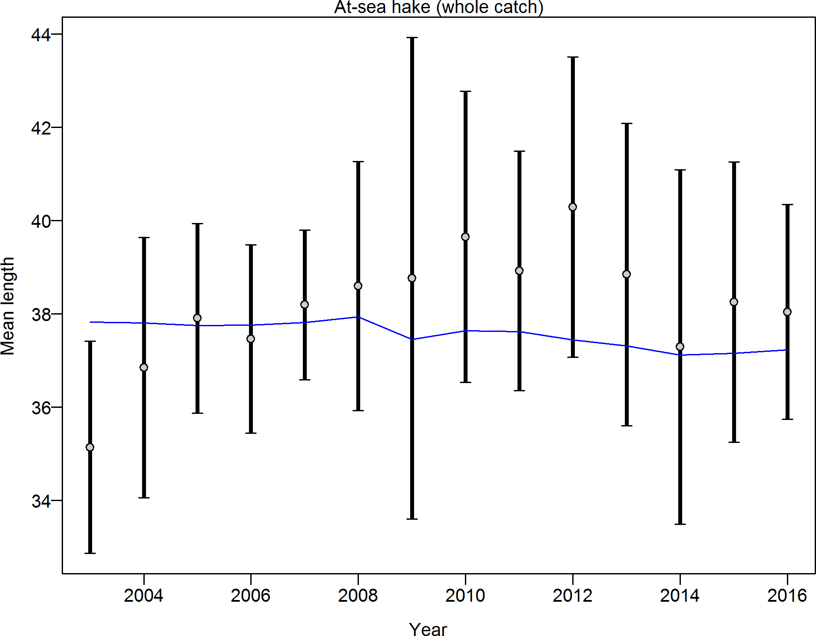

Figure 52: Mean length for At sea hake with 95% confidence intervals based on current samples sizes. Francis data weighting method TA1.8: thinner intervals (with capped ends) show result of further adjusting sample sizes based on suggested multiplier (with 95% interval) for len data from At sea hake: 0.9939 (0.4994 5.6181) For more info, see Francis, R.I.C.C. (2011). Data weighting in statistical fisheries stock assessment models. Can. J. Fish. Aquat. Sci. 68: 1124 1138.

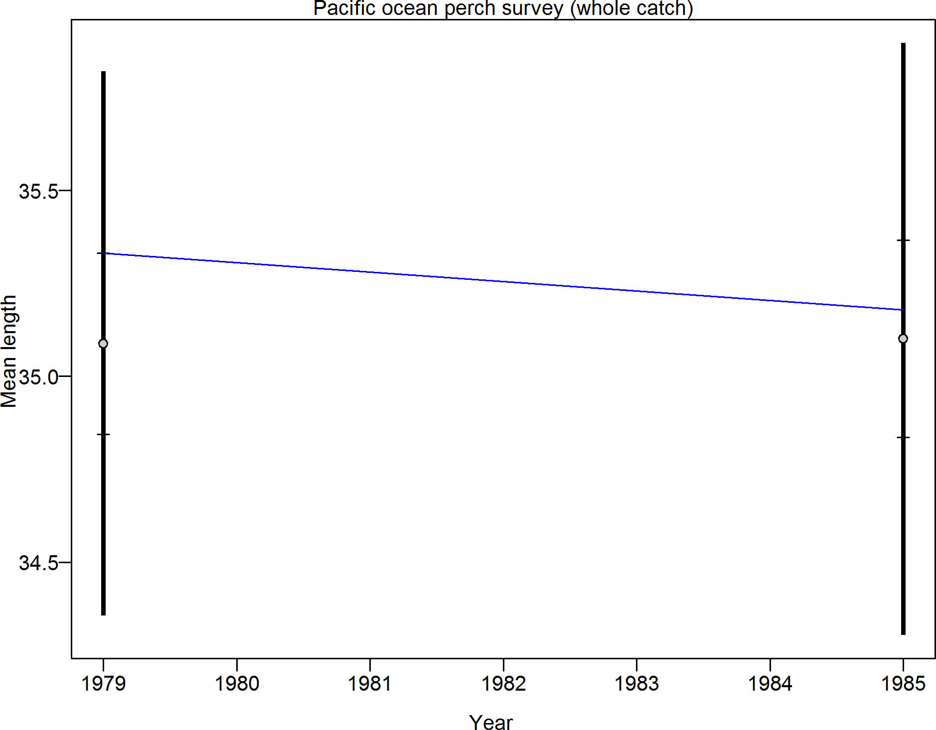

Figure 53: Mean length for Pacific ocean perch survey with 95% confidence intervals based on current samples sizes. Francis data weighting method TA1.8: thinner intervals (with capped ends) show result of further adjusting sample sizes based on suggested multiplier (with 95% interval) for len data from Pacific ocean perch survey: 9.0018 (9.0018 Inf) For more info, see Francis, R.I.C.C. (2011). Data weighting in statistical fisheries stock assessment models. Can. J. Fish. Aquat. Sci. 68: 1124 1138.

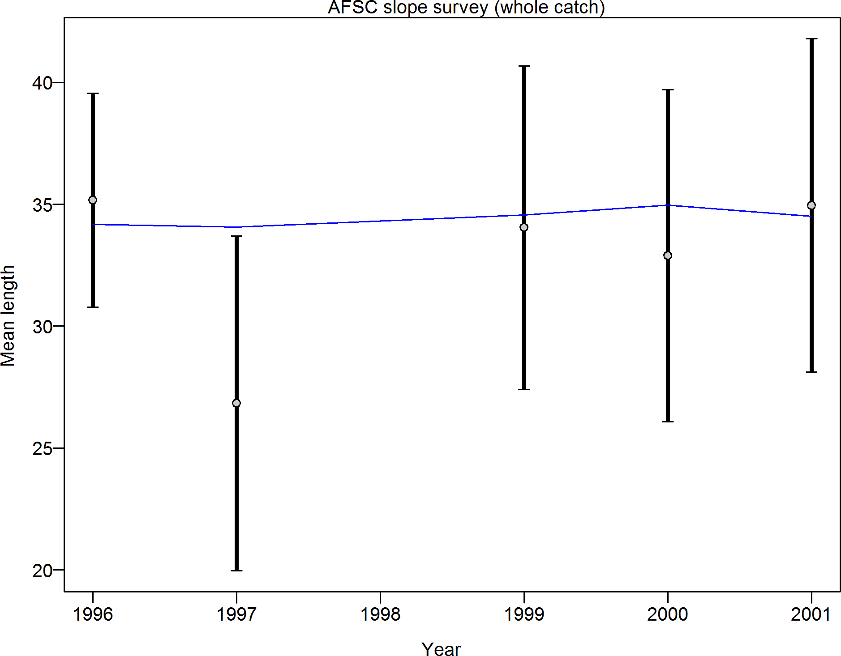

Figure 54: Mean length for AFSC slope survey with 95% confidence intervals based on current samples sizes. Francis data weighting method TA1.8: thinner intervals (with capped ends) show result of further adjusting sample sizes based on suggested multiplier (with 95% interval) for len data from AFSC slope survey: 0.9963 (0.5782 16.165) For more info, see Francis, R.I.C.C. (2011). Data weighting in statistical fisheries stock assessment models. Can. J. Fish. Aquat. Sci. 68: 1124 1138.

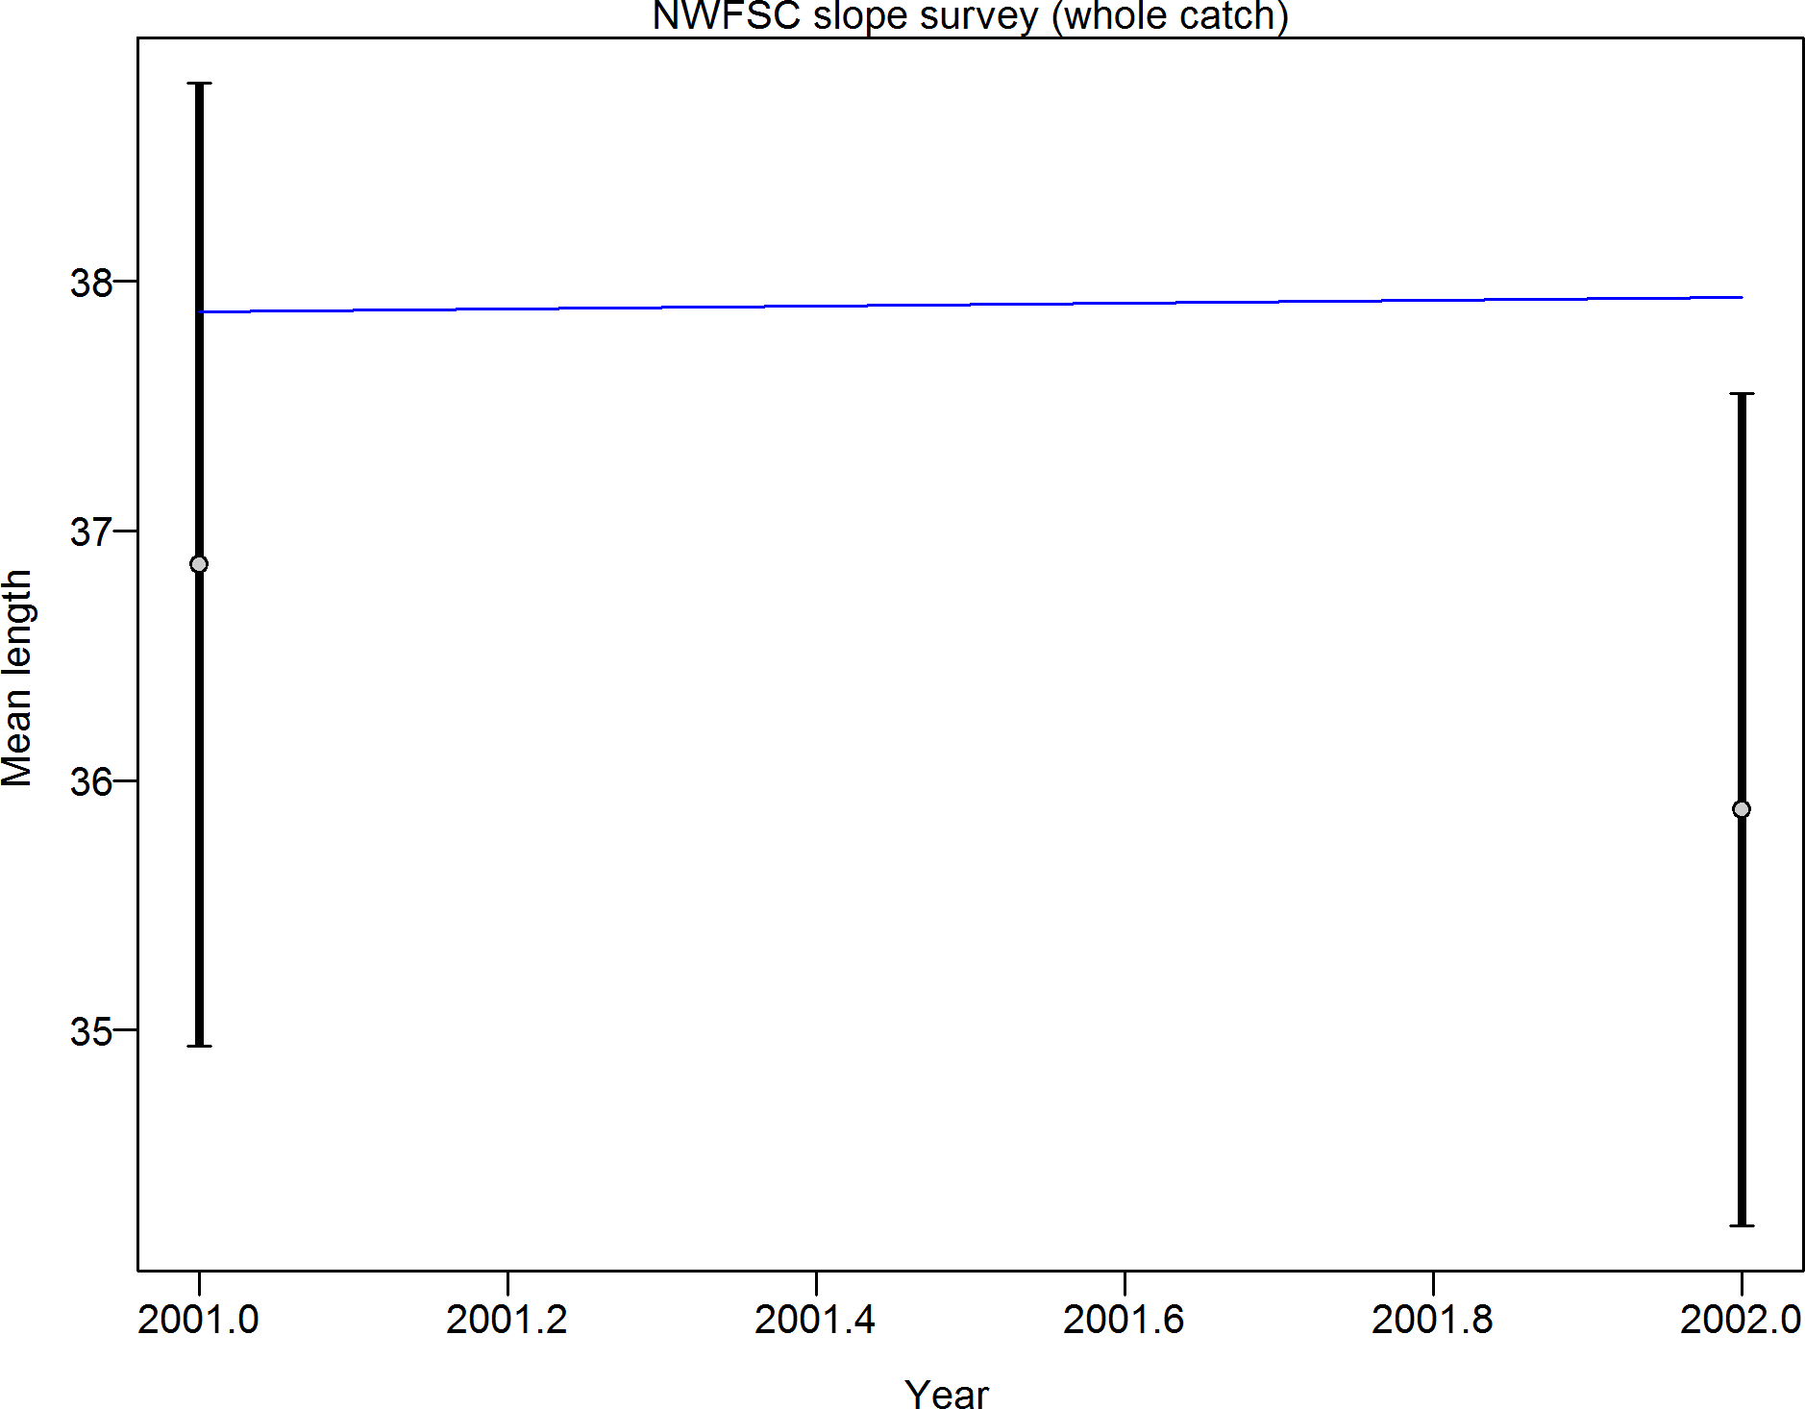

Figure 55: Mean length for NWFSC slope survey with 95% confidence intervals based on current samples sizes. Francis data weighting method TA1.8: thinner intervals (with capped ends) show result of further adjusting sample sizes based on suggested multiplier (with 95% interval) for len data from NWFSC slope survey: 0.9971 (0.9971 Inf) For more info, see Francis, R.I.C.C. (2011). Data weighting in statistical fisheries stock assessment models. Can. J. Fish. Aquat. Sci. 68: 1124 1138.

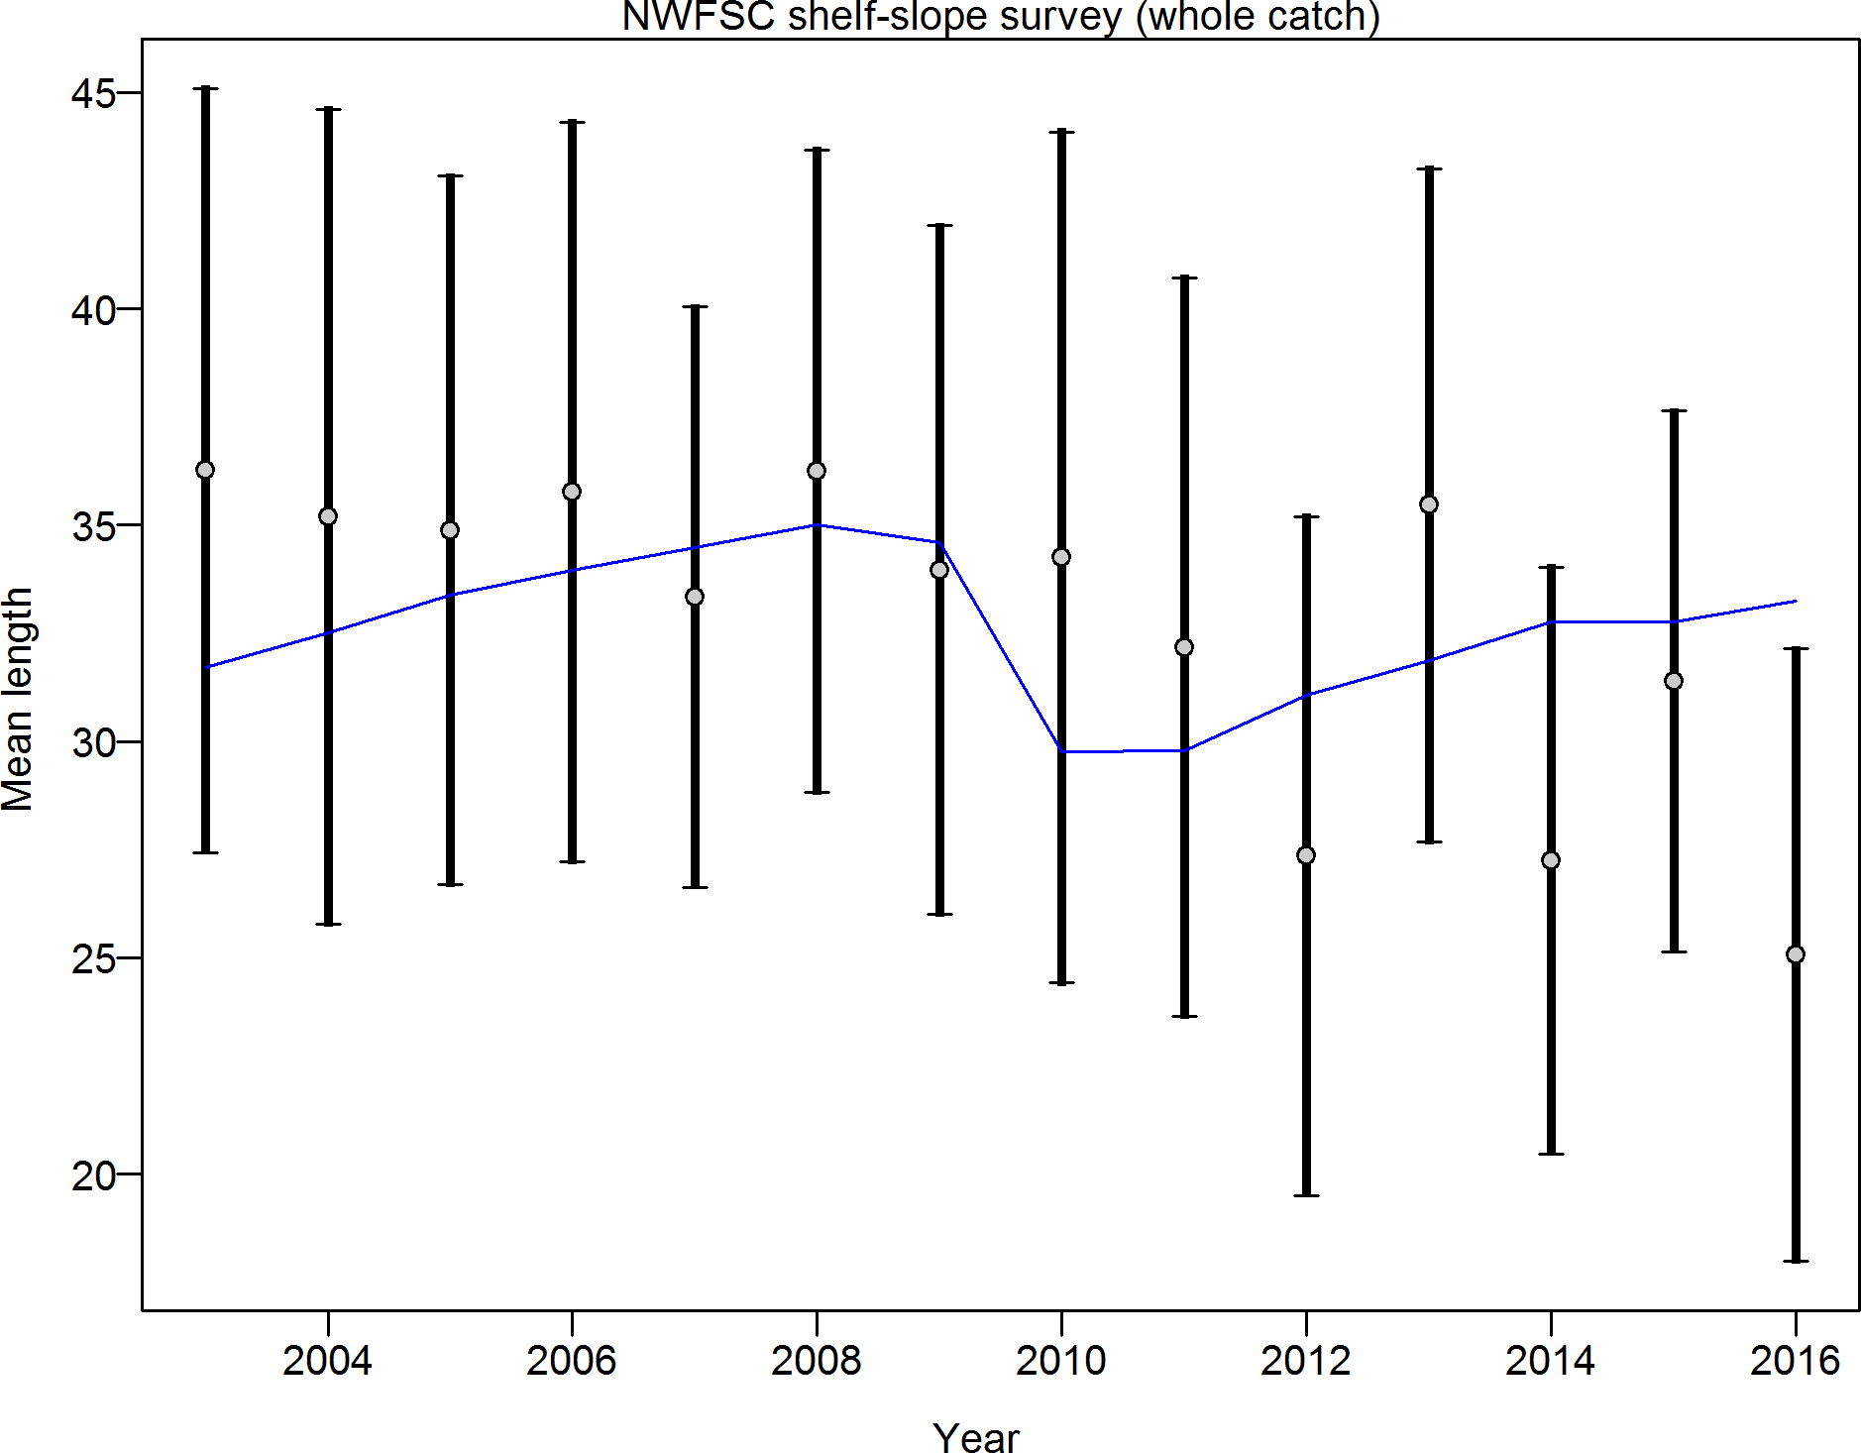

Figure 56: Mean length for NWFSC shelf slope survey with 95% confidence intervals based on current samples sizes. Francis data weighting method TA1.8: thinner intervals (with capped ends) show result of further adjusting sample sizes based on suggested multiplier (with 95% interval) for len data from NWFSC shelf slope survey: 1.0149 (0.594 4.0526) For more info, see Francis, R.I.C.C. (2011). Data weighting in statistical fisheries stock assessment models. Can. J. Fish. Aquat. Sci. 68: 1124 1138.

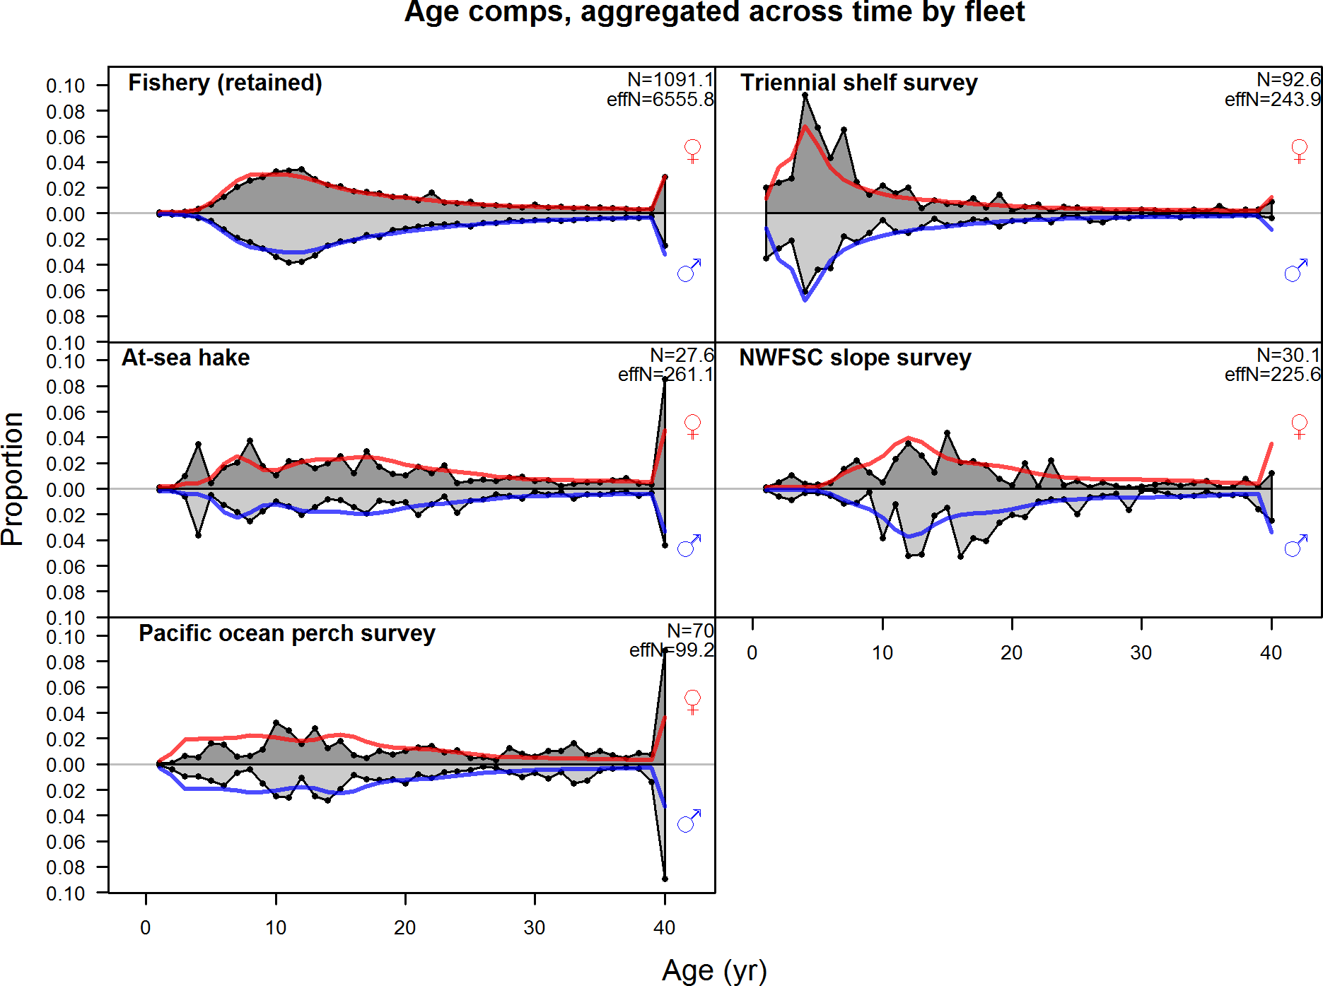

Figure 57: Age compositions aggregated across time by fleet. The Triennial shelf survey age data were not used in the final model, but the implied model fits are shown.

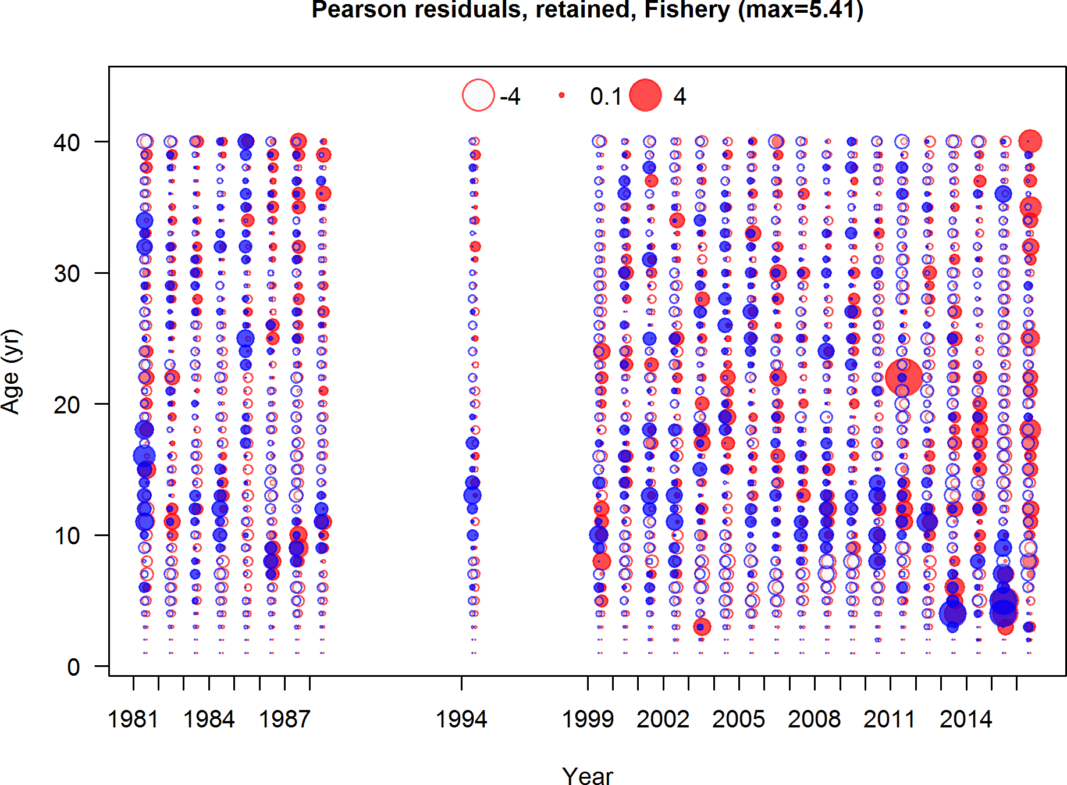

Figure 58: Pearson residuals, retained, Fishery (max=5.41)

Closed bubbles are positive residuals (observed *>* expected) and open bubbles are negative residuals (observed *<* expected).

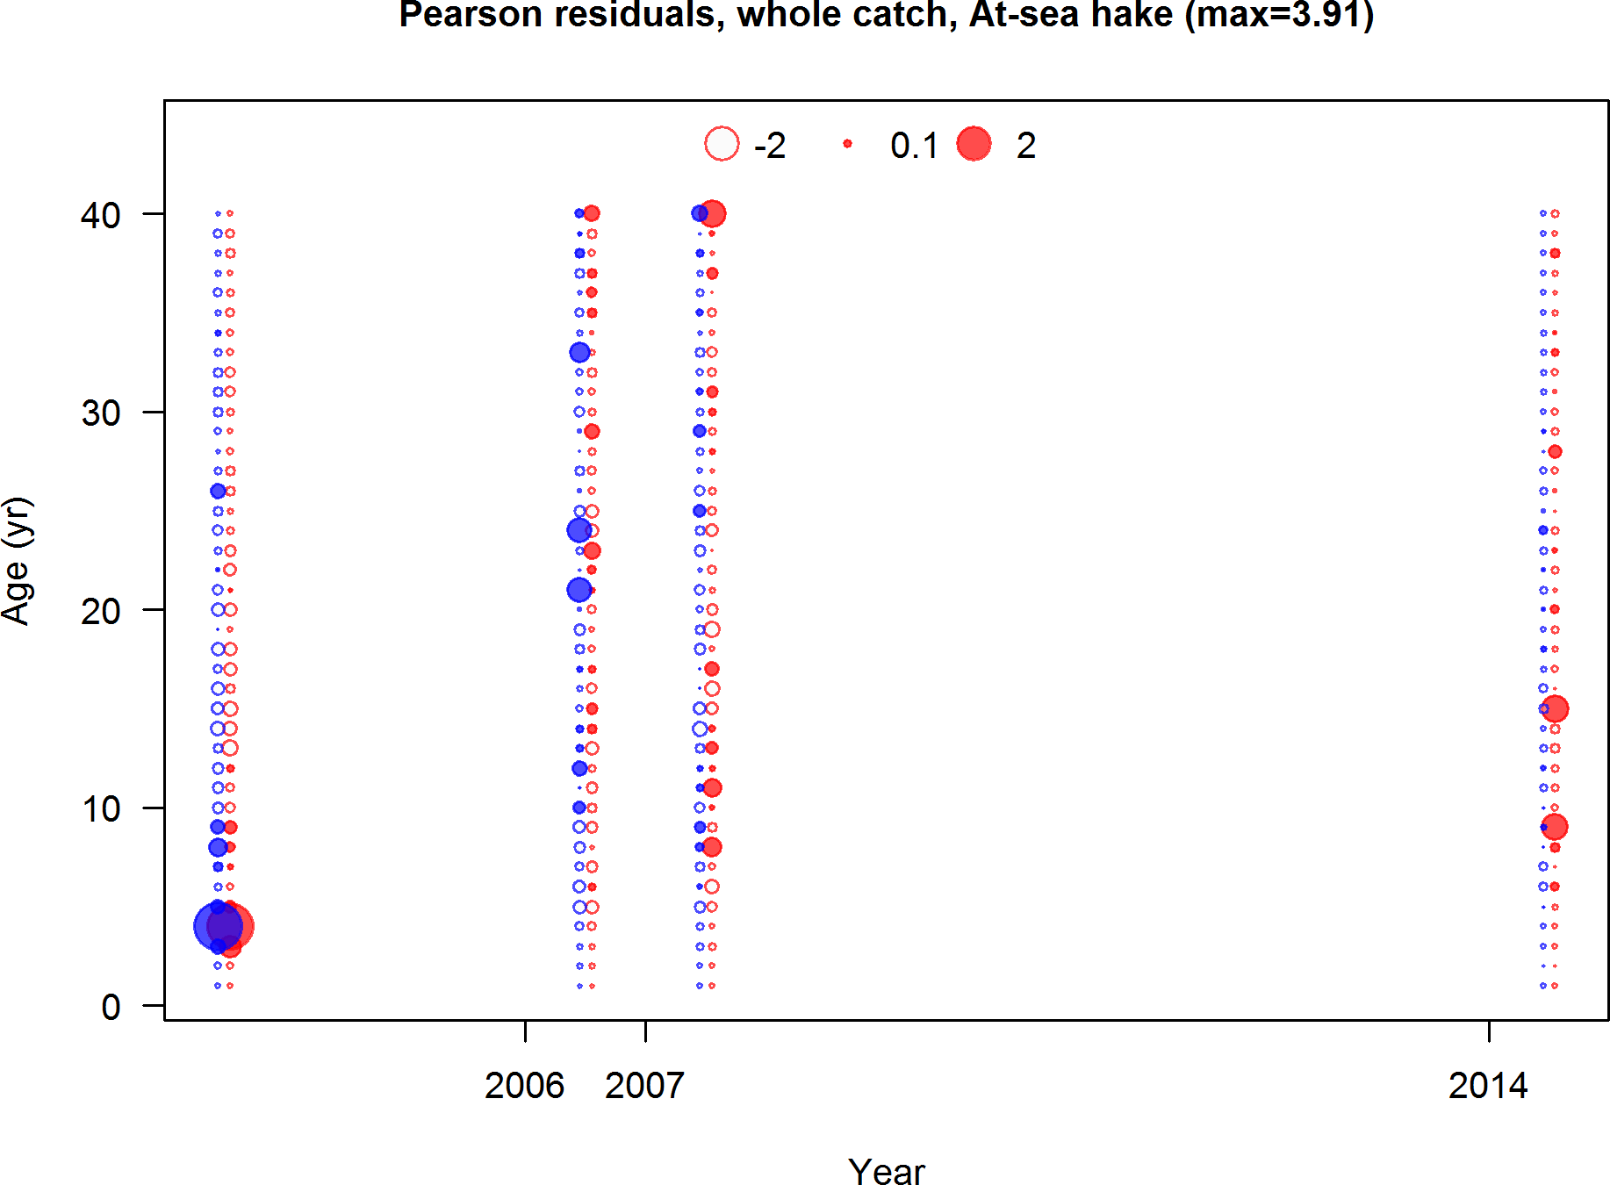

Figure 59: Pearson residuals, whole catch, At sea hake (max=3.91)

Closed bubbles are positive residuals (observed *>* expected) and open bubbles are negative residuals (observed *<* expected).

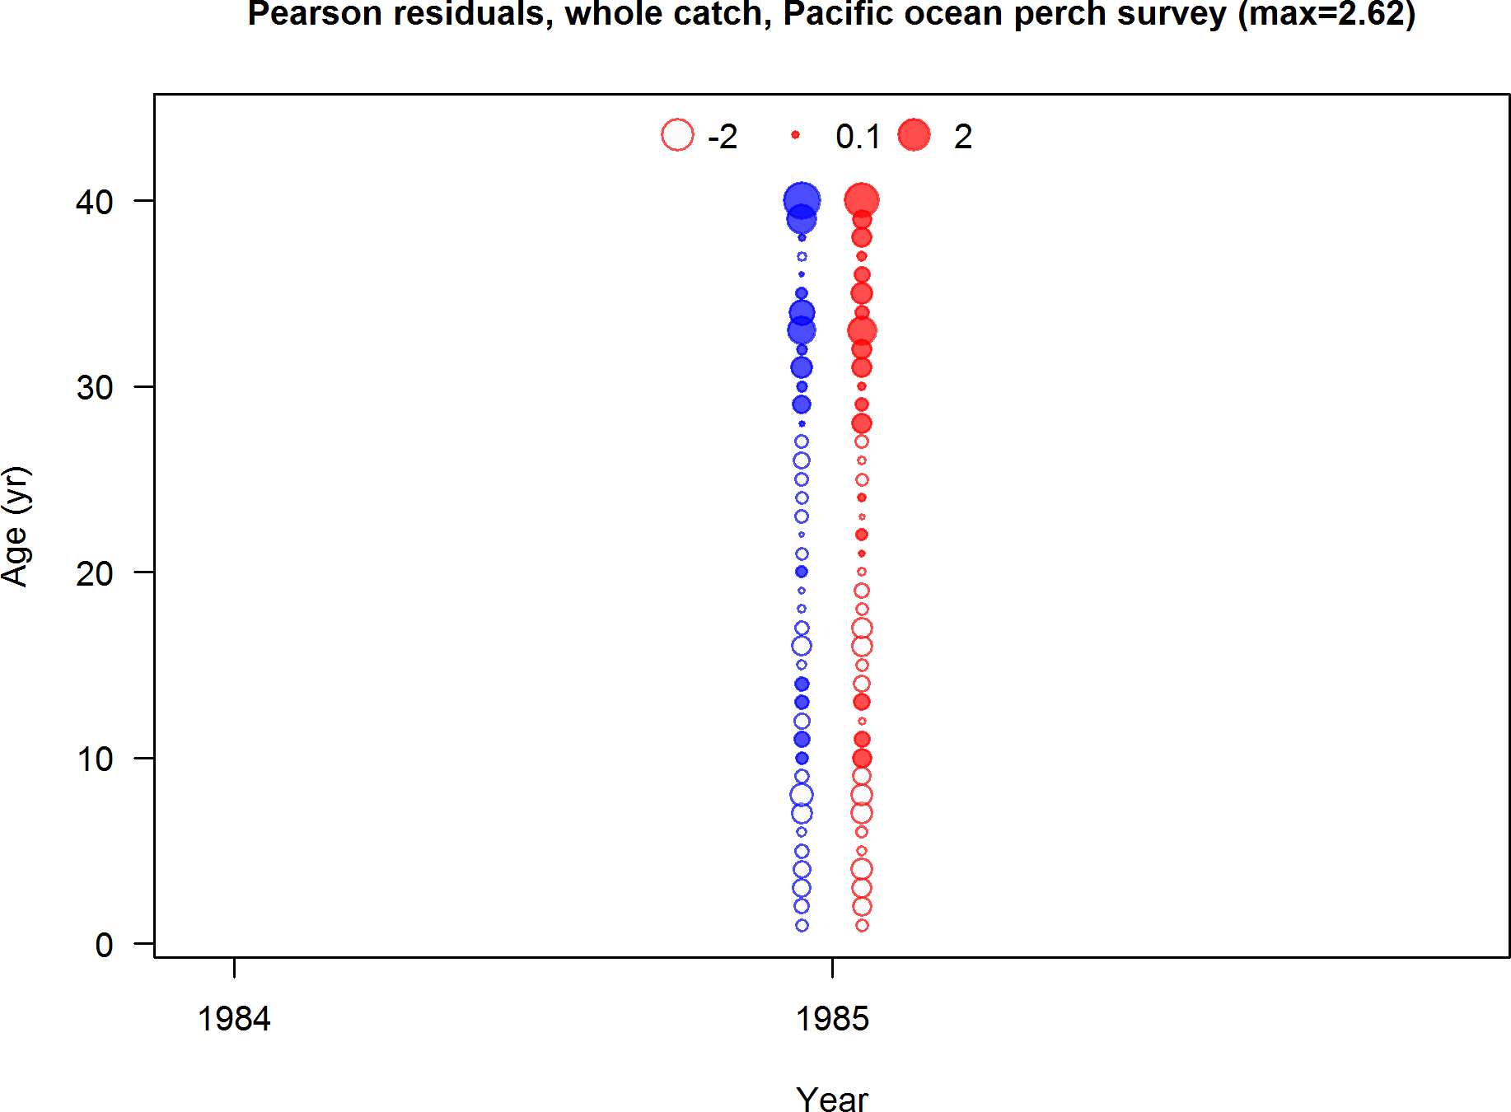

Figure 60: Pearson residuals, whole catch, Pacific ocean perch survey (max=2.62)

Closed bubbles are positive residuals (observed *>* expected) and open bubbles are negative residuals (observed *<* expected).

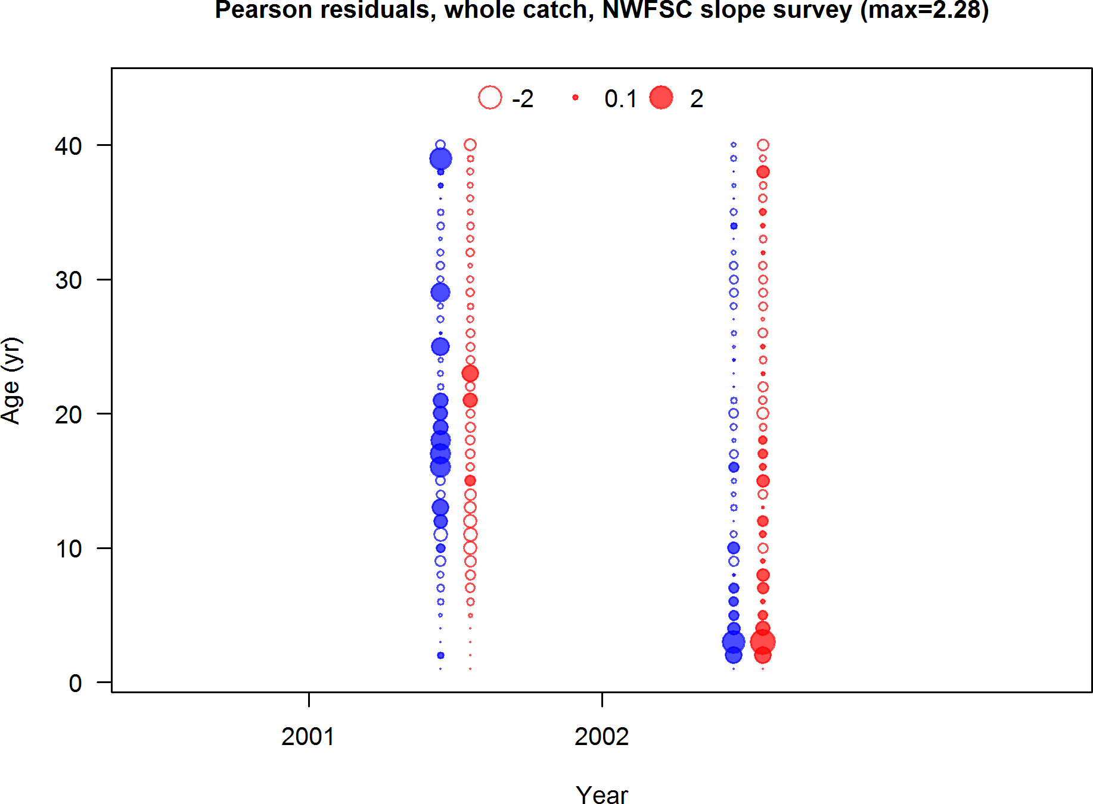

Figure 61: Pearson residuals, whole catch, NWFSC slope survey (max=2.28)

Closed bubbles are positive residuals (observed *>* expected) and open bubbles are negative residuals (observed *<* expected).

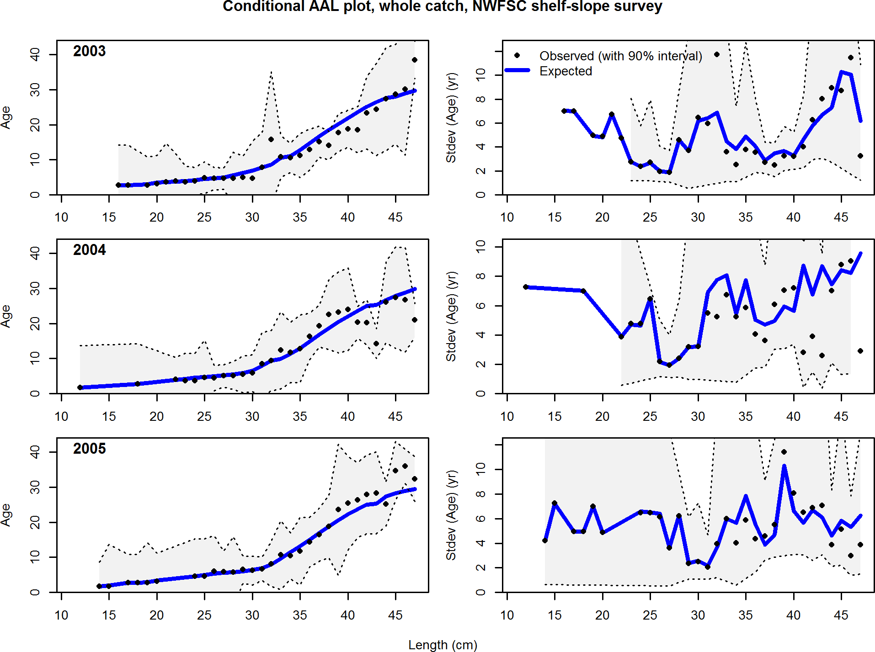

Figure 62: Conditional AAL plot, whole catch, NWFSC shelf slope survey (plot 1 of 5) These plots show mean age and std. dev. in conditional AAL. Left plots are mean AAL by size class (obs. and pred.) with 90% CIs based on adding 1.64 SE of mean to the data. Right plots in each pair are SE of mean AAL (obs. and pred.) with 90% CIs based on the chi square distribution.

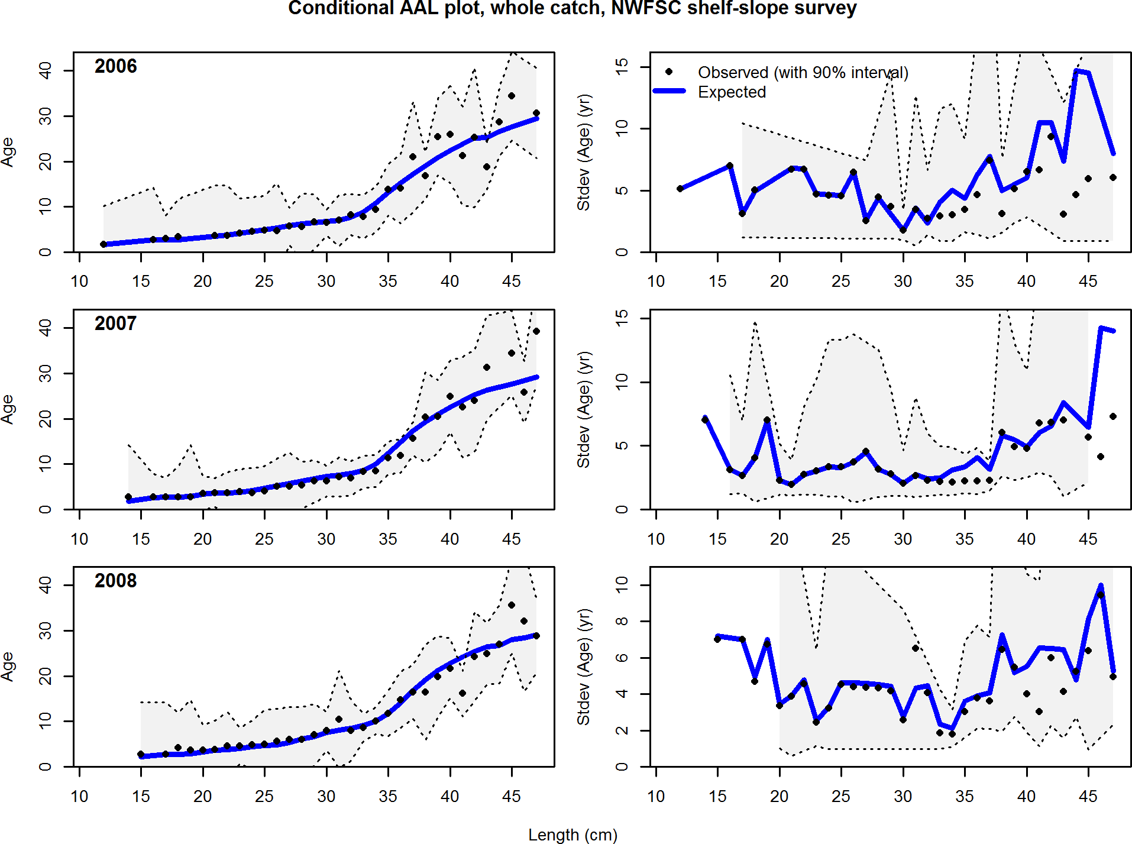

Figure 63: Conditional AAL plot, whole catch, NWFSC shelf slope survey (plot 2 of 5)

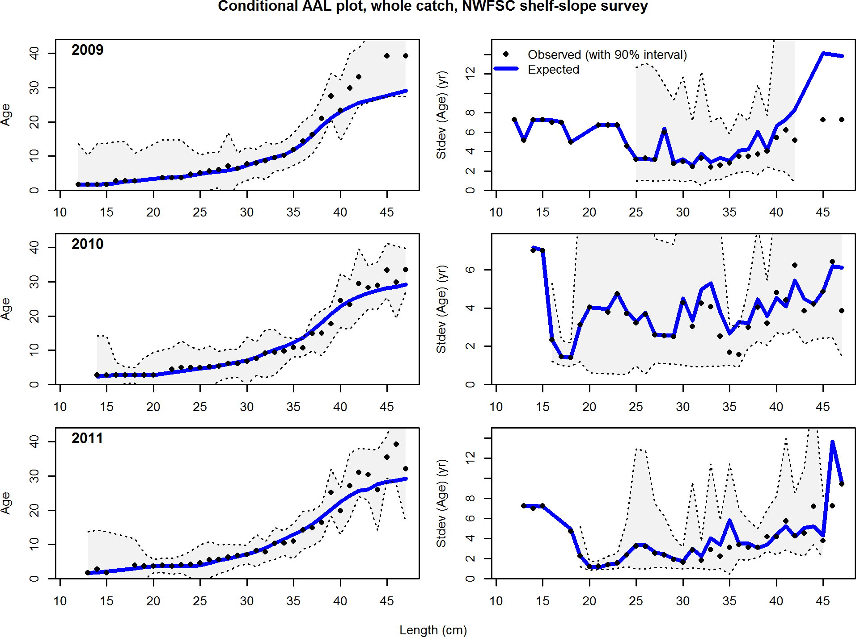

Figure 64: Conditional AAL plot, whole catch, NWFSC shelf slope survey (plot 3 of 5)

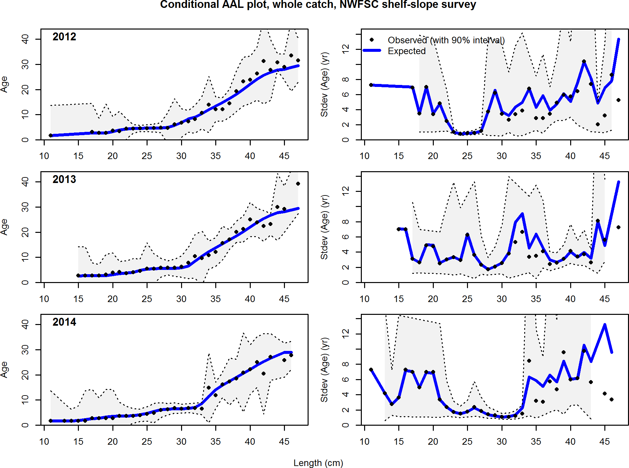

Figure 65: Conditional AAL plot, whole catch, NWFSC shelf slope survey (plot 4 of 5)

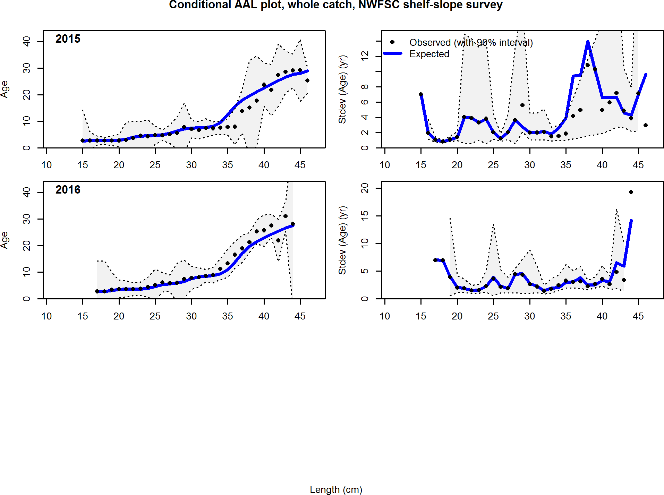

Figure 66: Conditional AAL plot, whole catch, NWFSC shelf slope survey (plot 5 of 5)

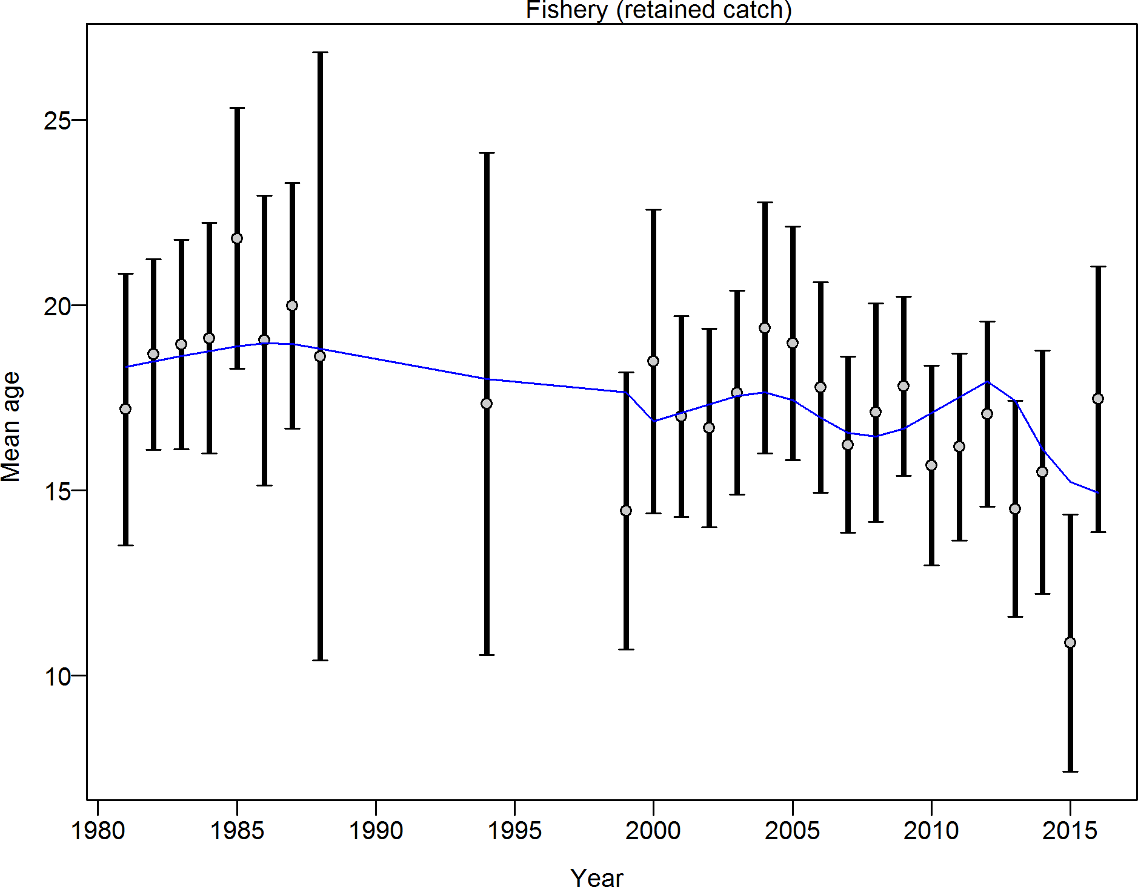

Figure 67: Mean age for Fishery with 95% confidence intervals based on current samples sizes. Francis data weighting method TA1.8: thinner intervals (with capped ends) show result of further adjusting sample sizes based on suggested multiplier (with 95% interval) for age data from Fishery: 0.9999 (0.6705 2.0064) For more info, see Francis, R.I.C.C. (2011). Data weighting in statistical fisheries stock assessment models. Can. J. Fish. Aquat. Sci. 68: 1124 1138.

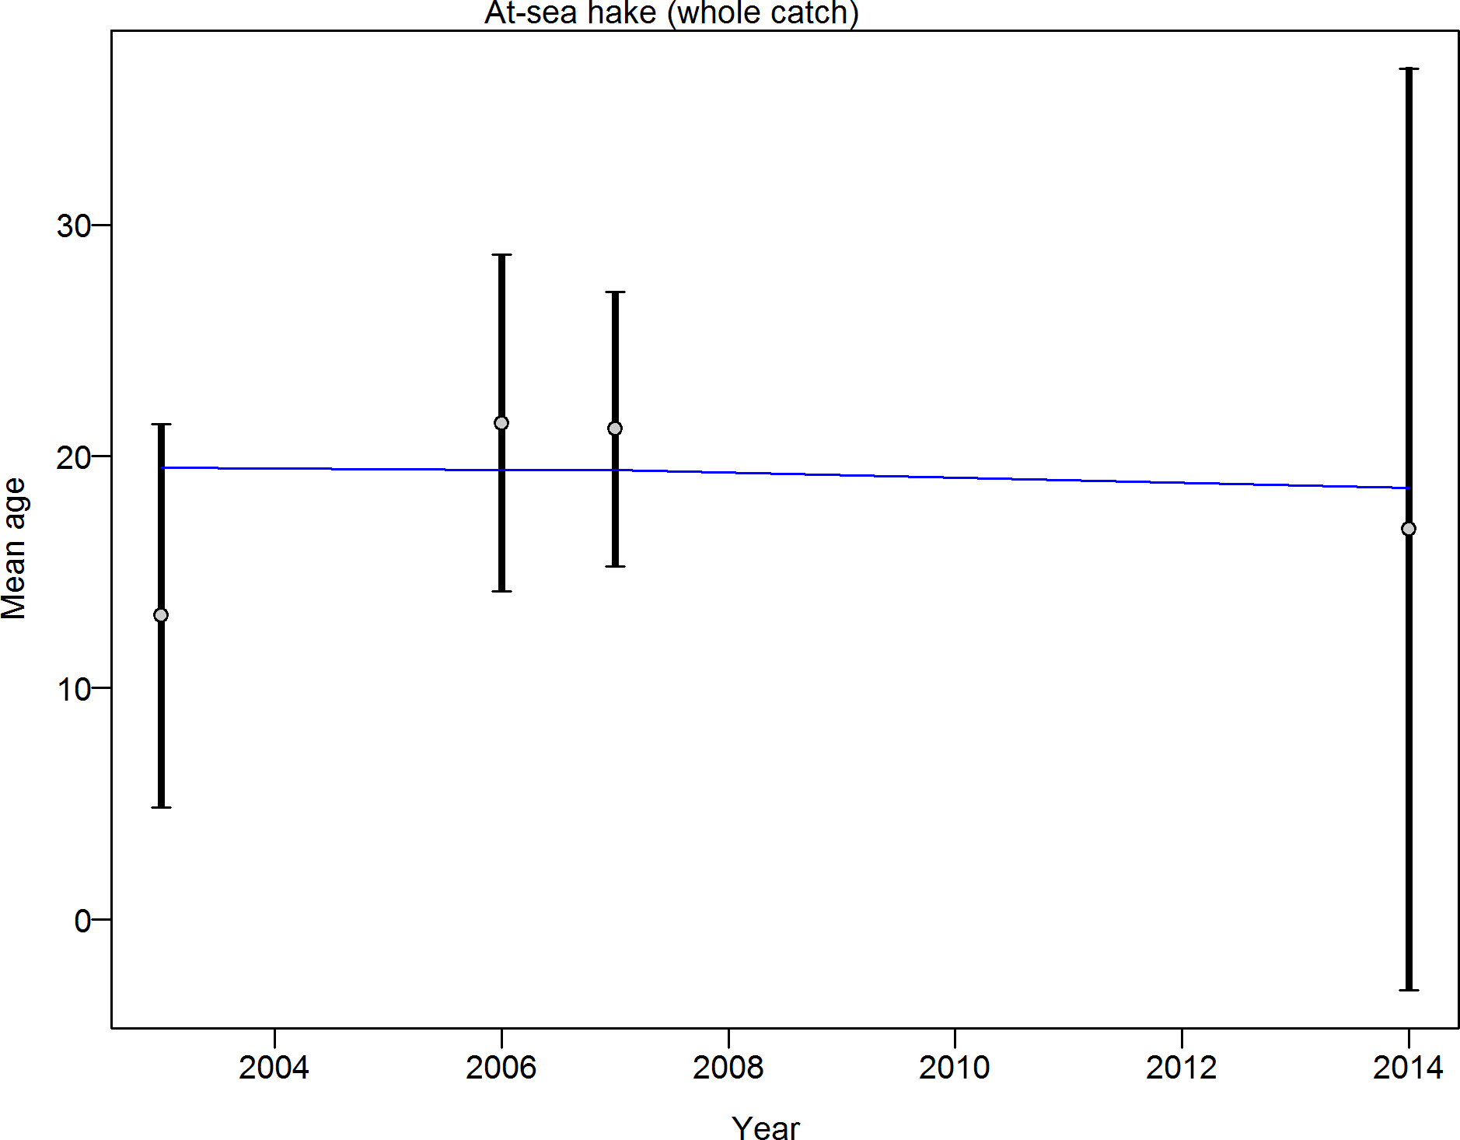

Figure 68: Mean age for At sea hake with 95% confidence intervals based on current samples sizes. Francis data weighting method TA1.8: thinner intervals (with capped ends) show result of further adjusting sample sizes based on suggested multiplier (with 95% interval) for age data from At sea hake: 1.0068 (0.6598 2756.7898) For more info, see Francis, R.I.C.C. (2011). Data weighting in statistical fisheries stock assessment models. Can. J. Fish. Aquat. Sci. 68: 1124 1138.

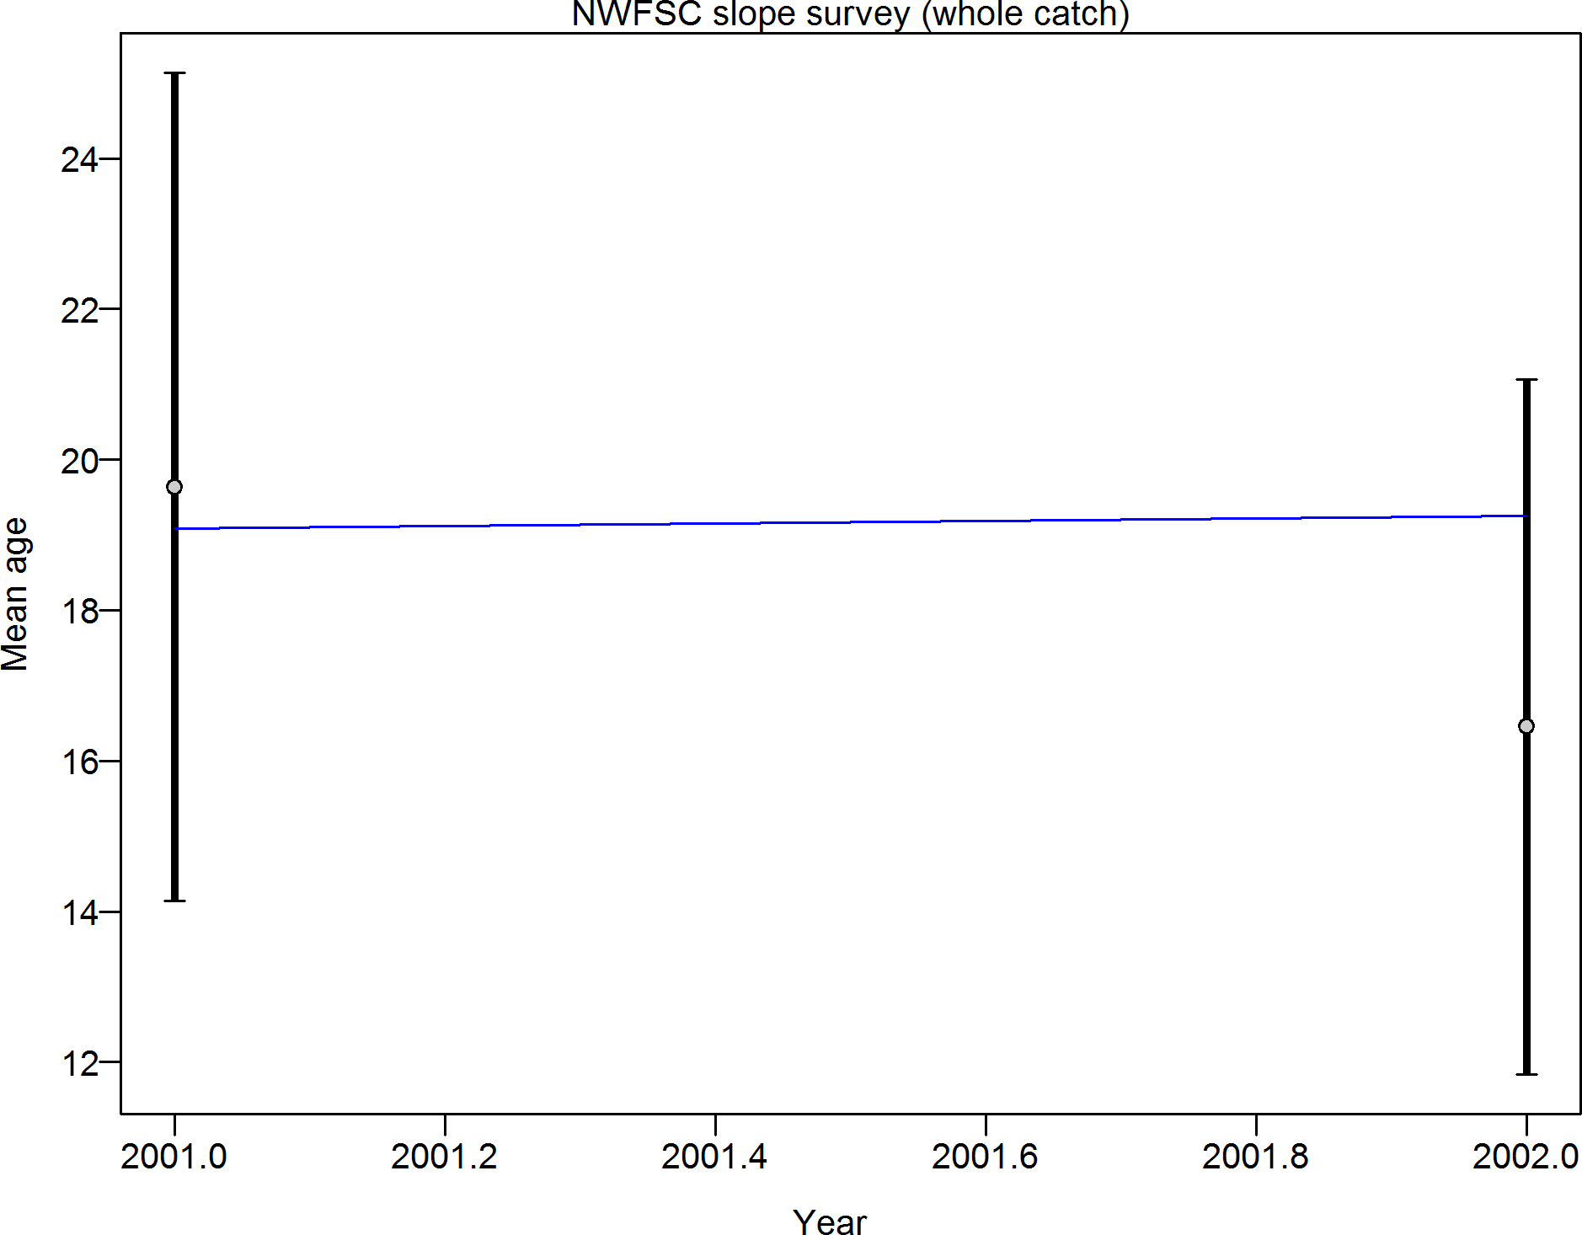

Figure 69: Mean age for NWFSC slope survey with 95% confidence intervals based on current samples sizes. Francis data weighting method TA1.8: thinner intervals (with capped ends) show result of further adjusting sample sizes based on suggested multiplier (with 95% interval) for age data from NWFSC slope survey: 1.0004 (1.0004 Inf) For more info, see Francis,

R.I.C.C. (2011). Data weighting in statistical fisheries stock assessment models. Can. J. Fish. Aquat. Sci. 68: 1124 1138.

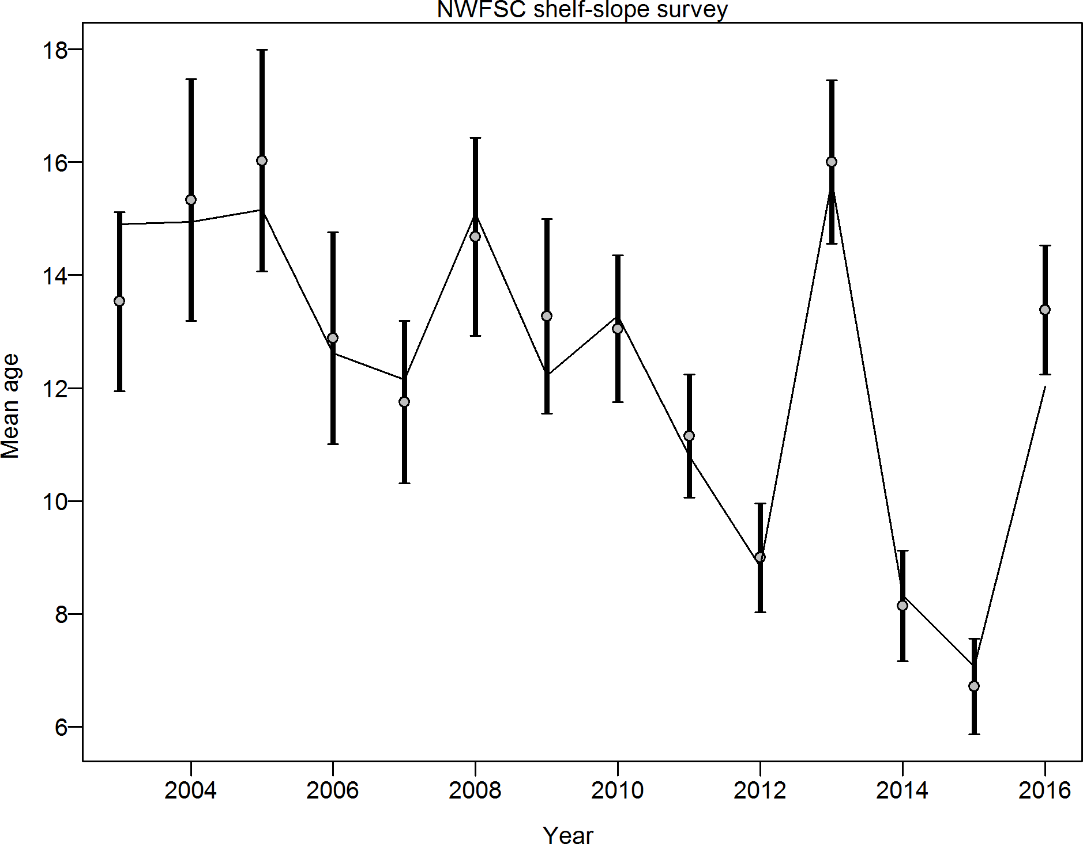

Figure 70: Mean age from conditional data (aggregated across length bins) for NWFSC shelf slope survey with 95% confidence intervals based on current samples sizes. Francis data weighting method TA1.8: thinner intervals (with capped ends) show result of further adjusting sample sizes based on suggested multiplier (with 95% interval) for conditional age at length data from NWFSC shelf slope survey: 1.0037 (0.5733 3.5119) For more info, see Francis, R.I.C.C. (2011). Data weighting in statistical fisheries stock assessment models. Can. J. Fish. Aquat. Sci. 68: 1124 1138.



Figure 71: Estimated time-series of spawning output trajectory (circles and line: median; light broken lines: 95% credibility intervals) for Pacific ocean perch.

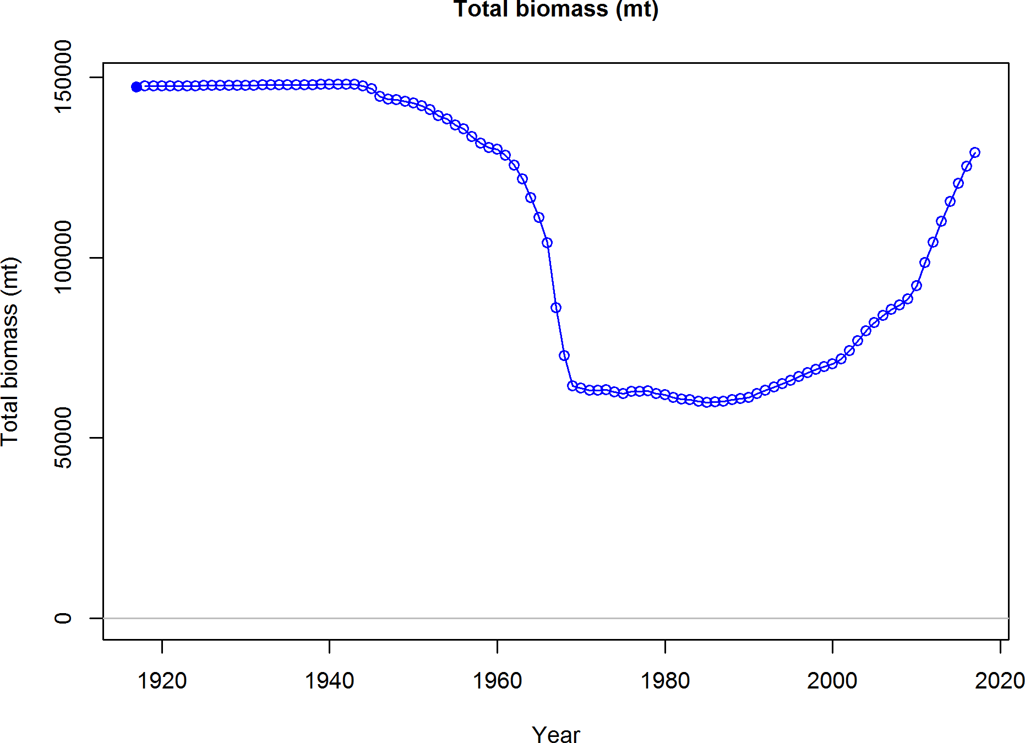

Figure 72: Estimated time-series of total biomass for Pacific ocean perch.



Figure 73: Estimated time-series of relative spawning output (depletion) (circles and line: median; light broken lines: 95% credibility intervals) for Pacific ocean perch.

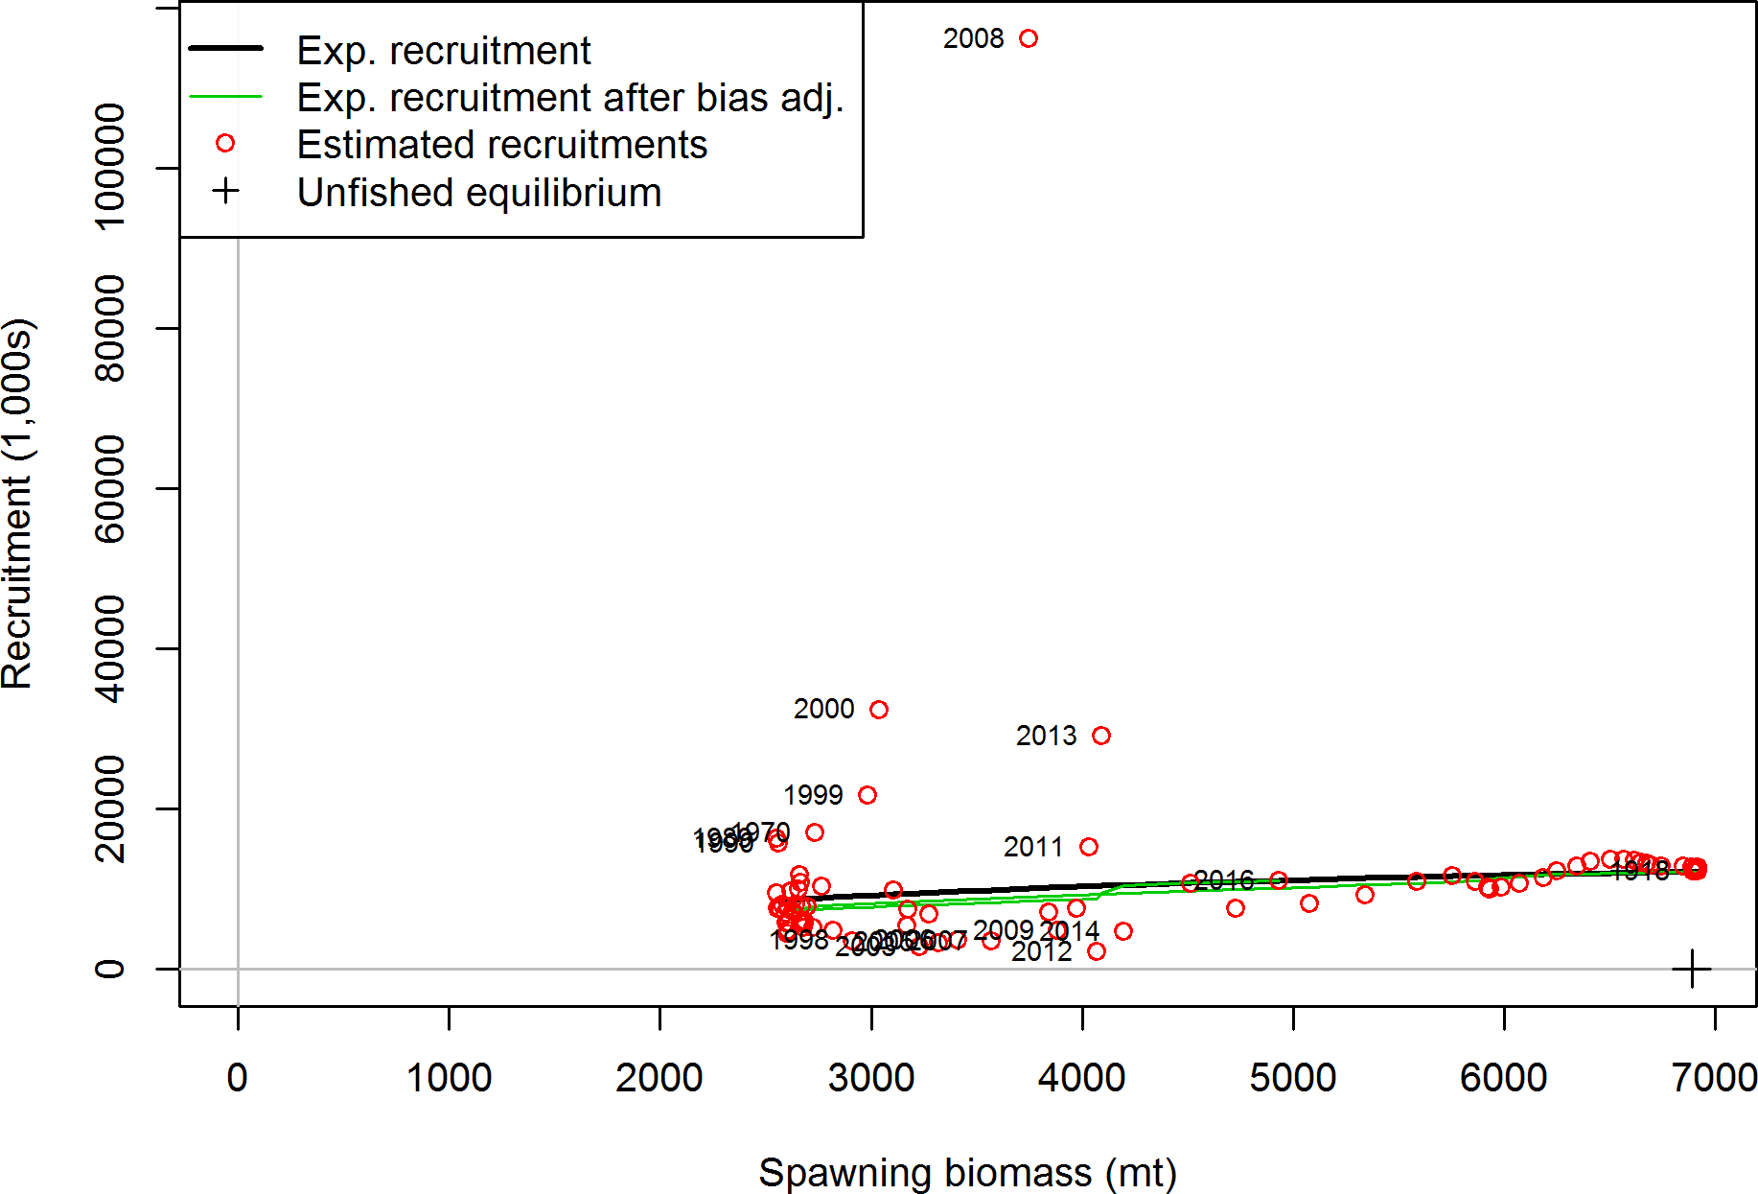

Figure 74: Estimated recruitment (red circles) and the assumed stock-recruit relationship (black line). The green line shows the effect of the bias correction for the lognormal distribution

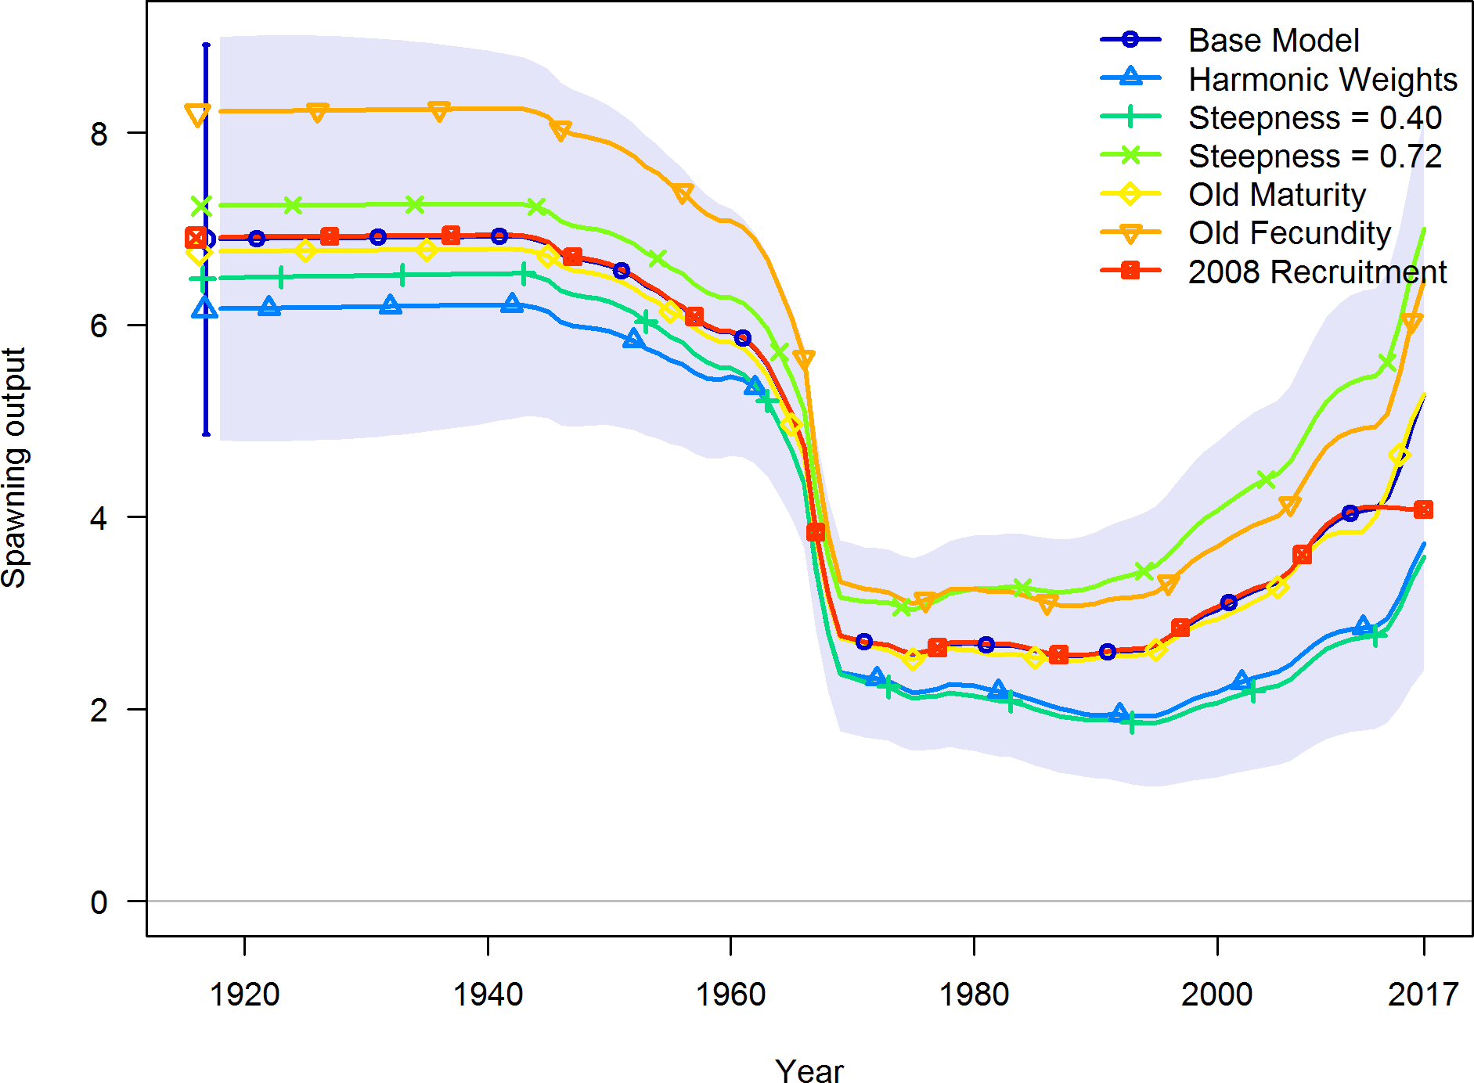

Figure 75: Time-series of spawning output for model sensitivities for Pacific ocean perch.

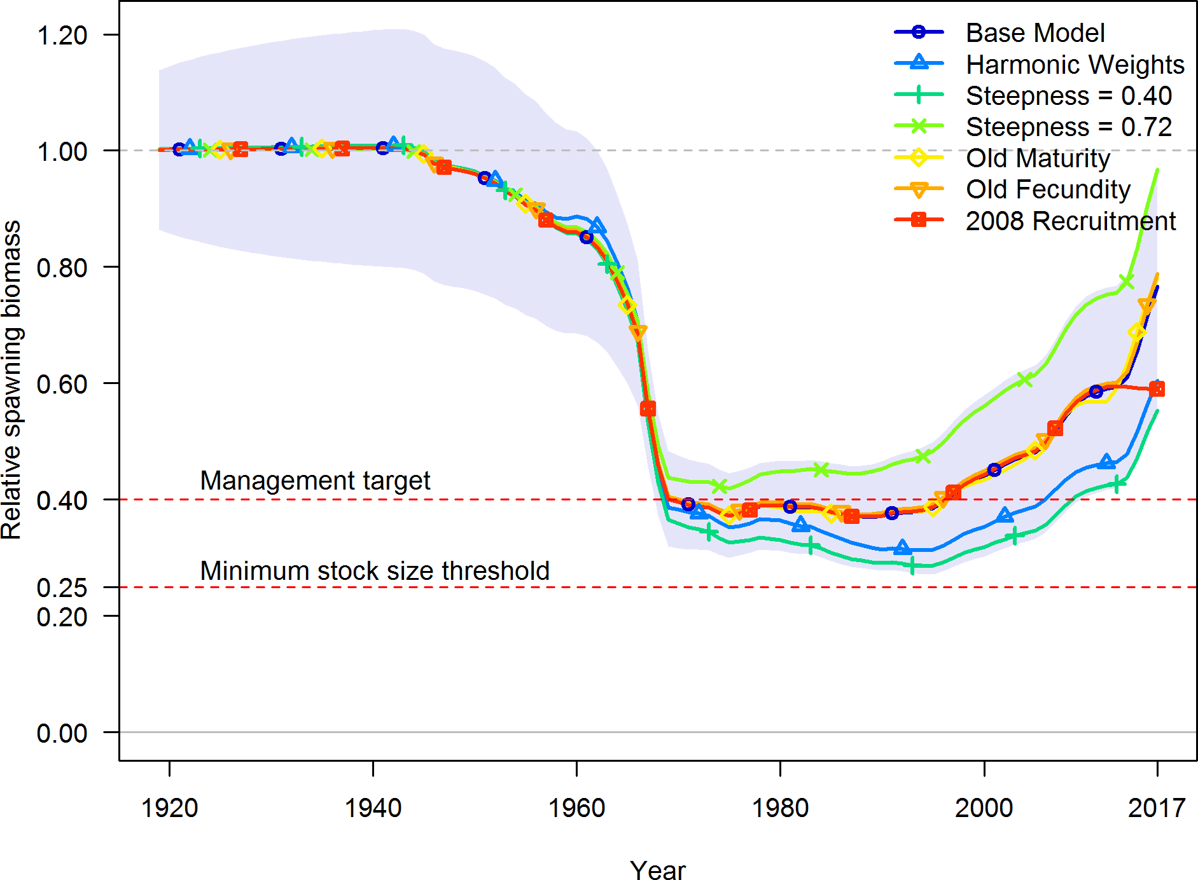

Figure 76: Time-series of relative spawning output (depletion) for model sensitivities for Pacific ocean perch.

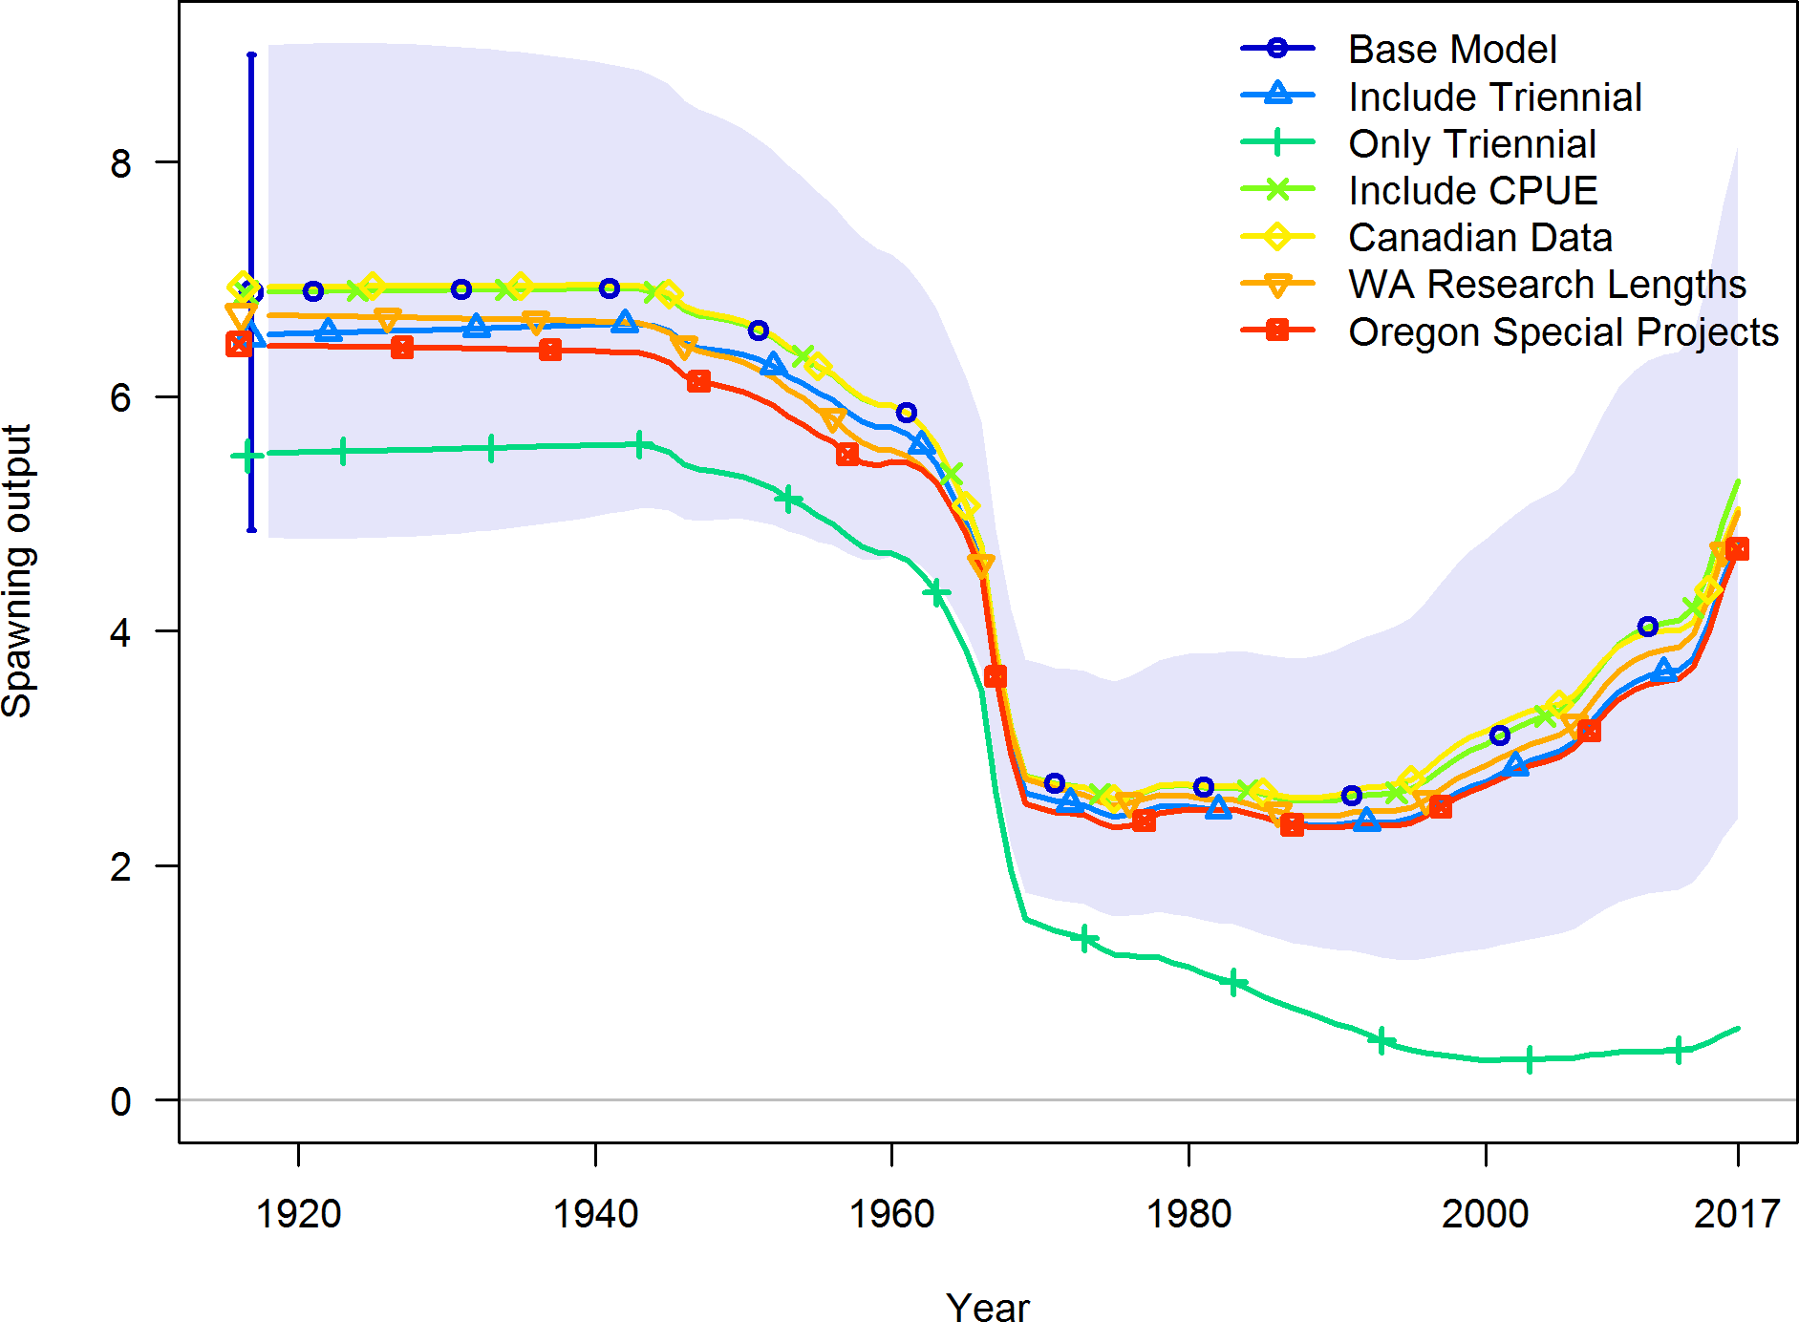

Figure 77: Time-series of spawning output for model sensitivities for Pacific ocean perch.

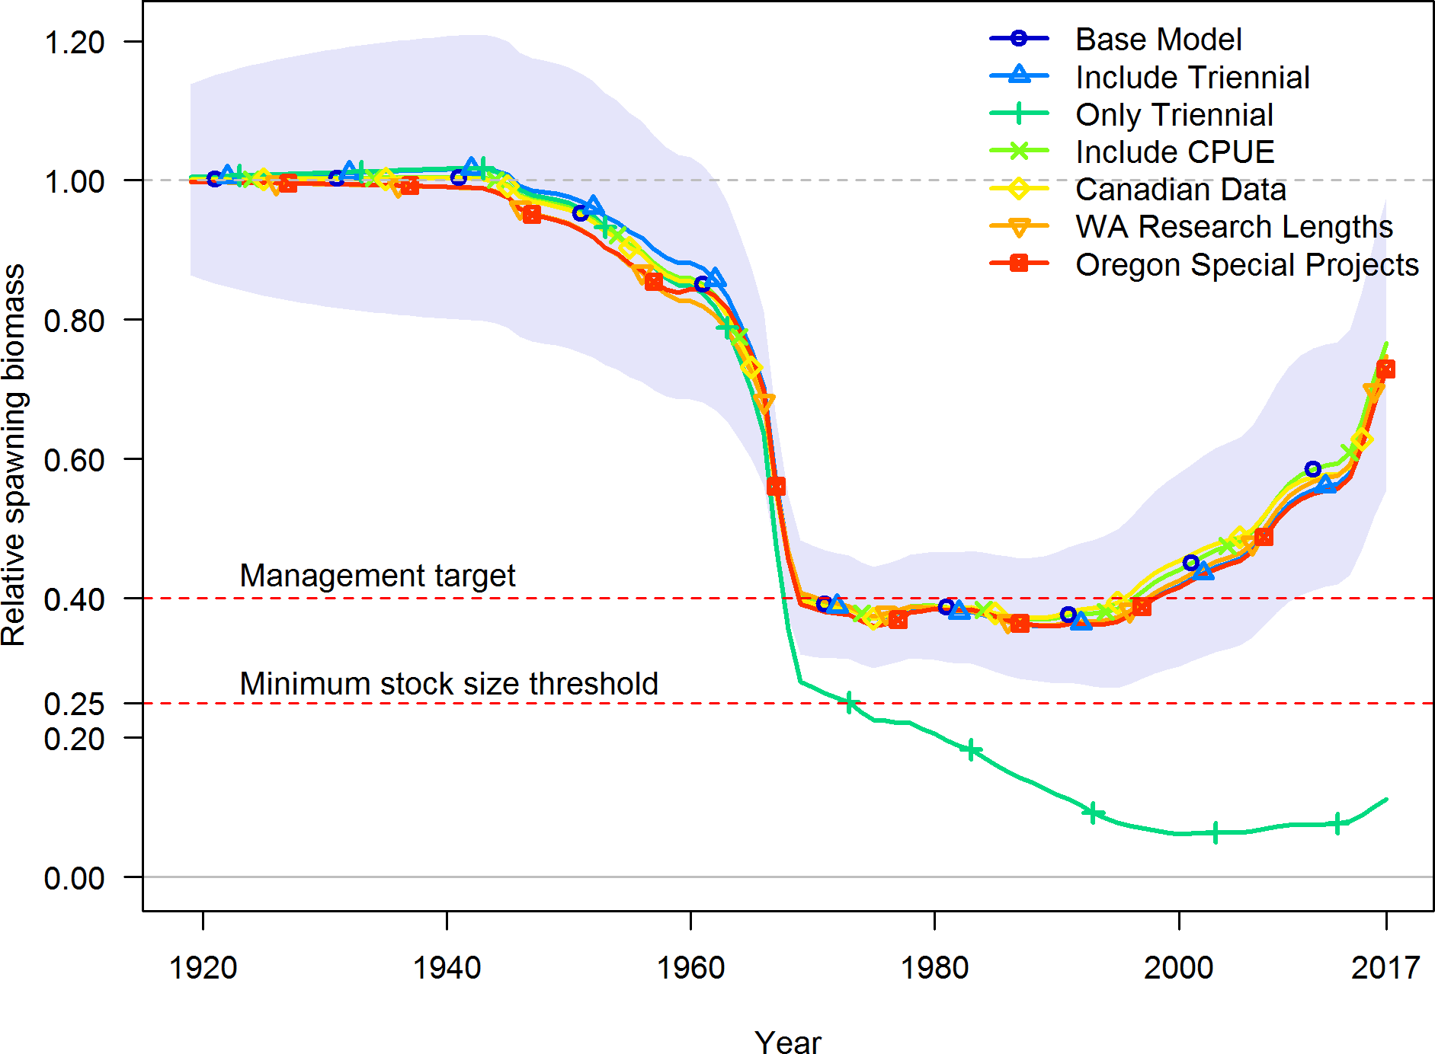

Figure 78: Time-series of relative spawning outptut (depletion) for model sensitivities for Pacific ocean perch.

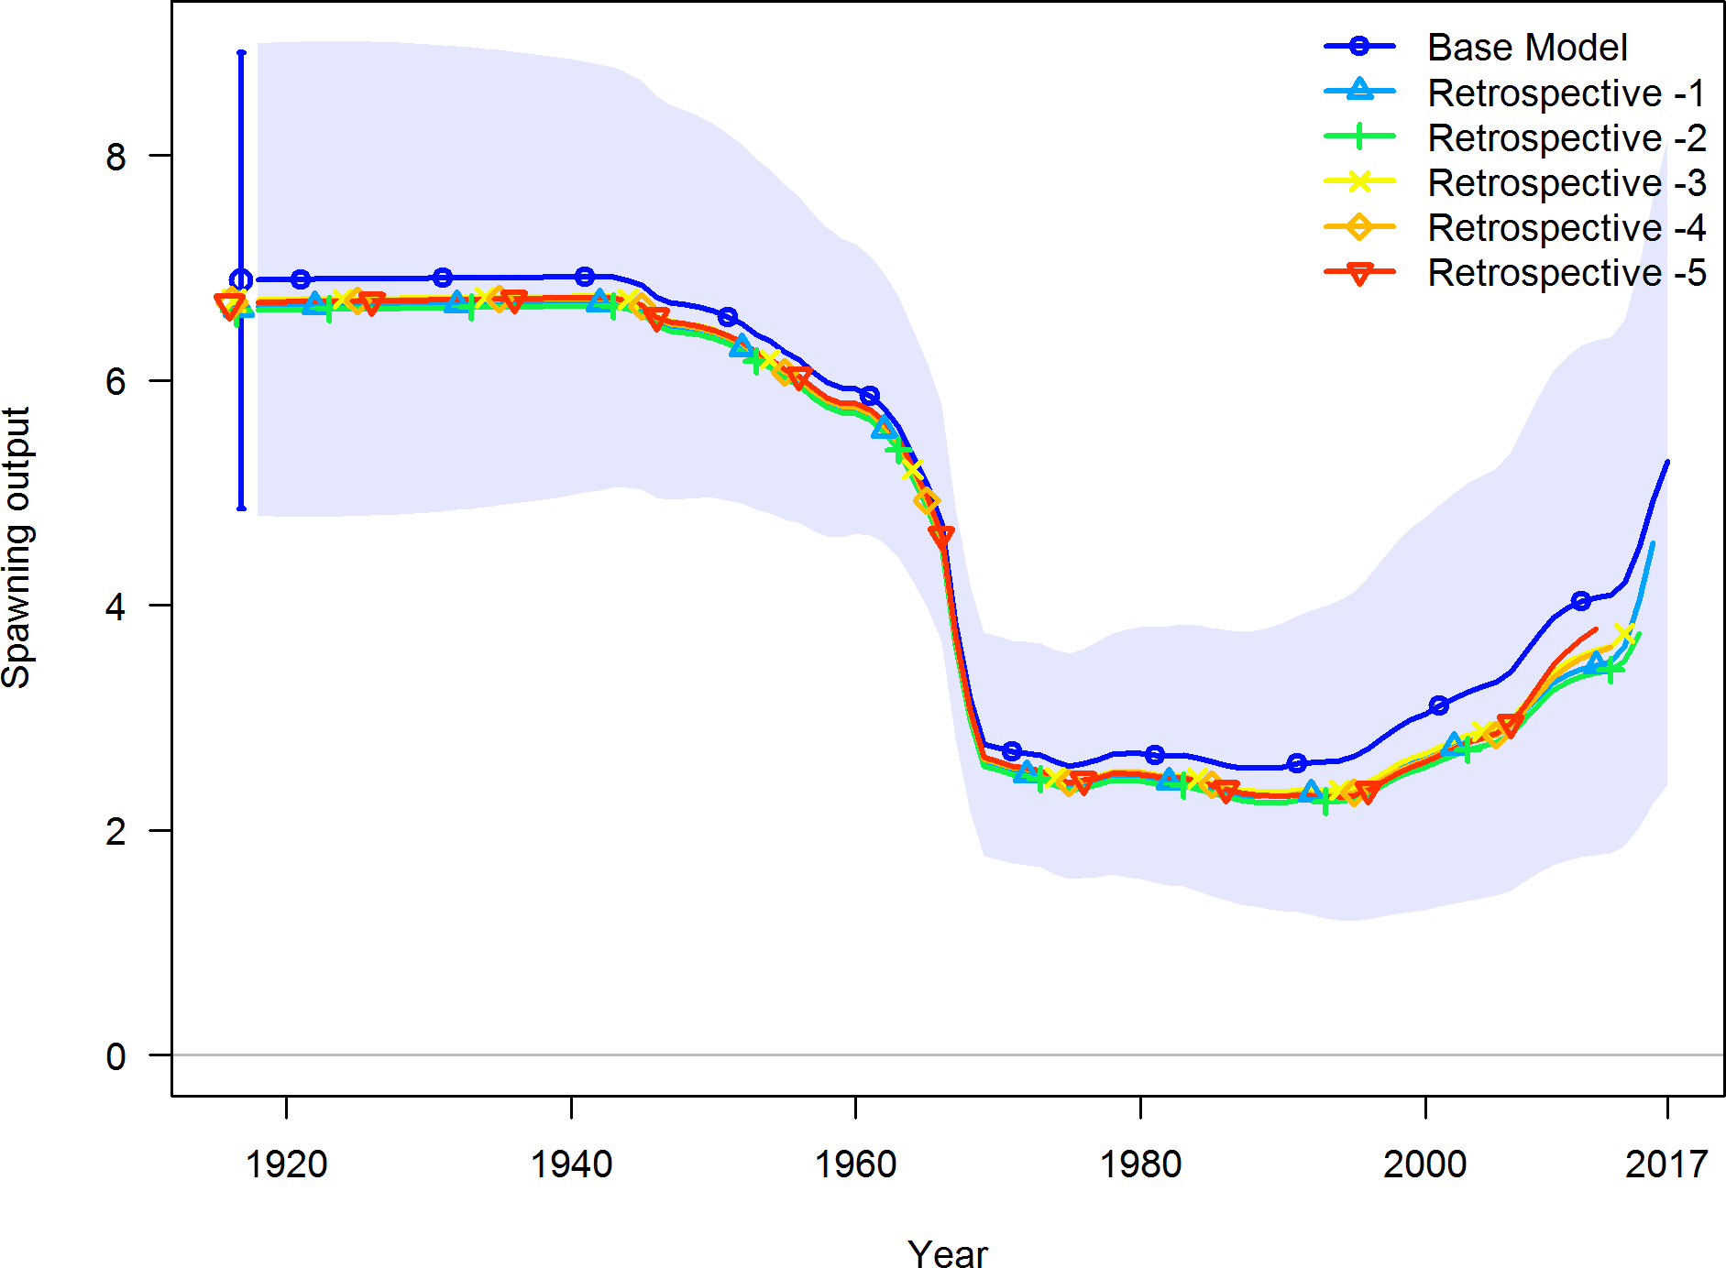

Figure 79: Retrospective pattern for spawning output.

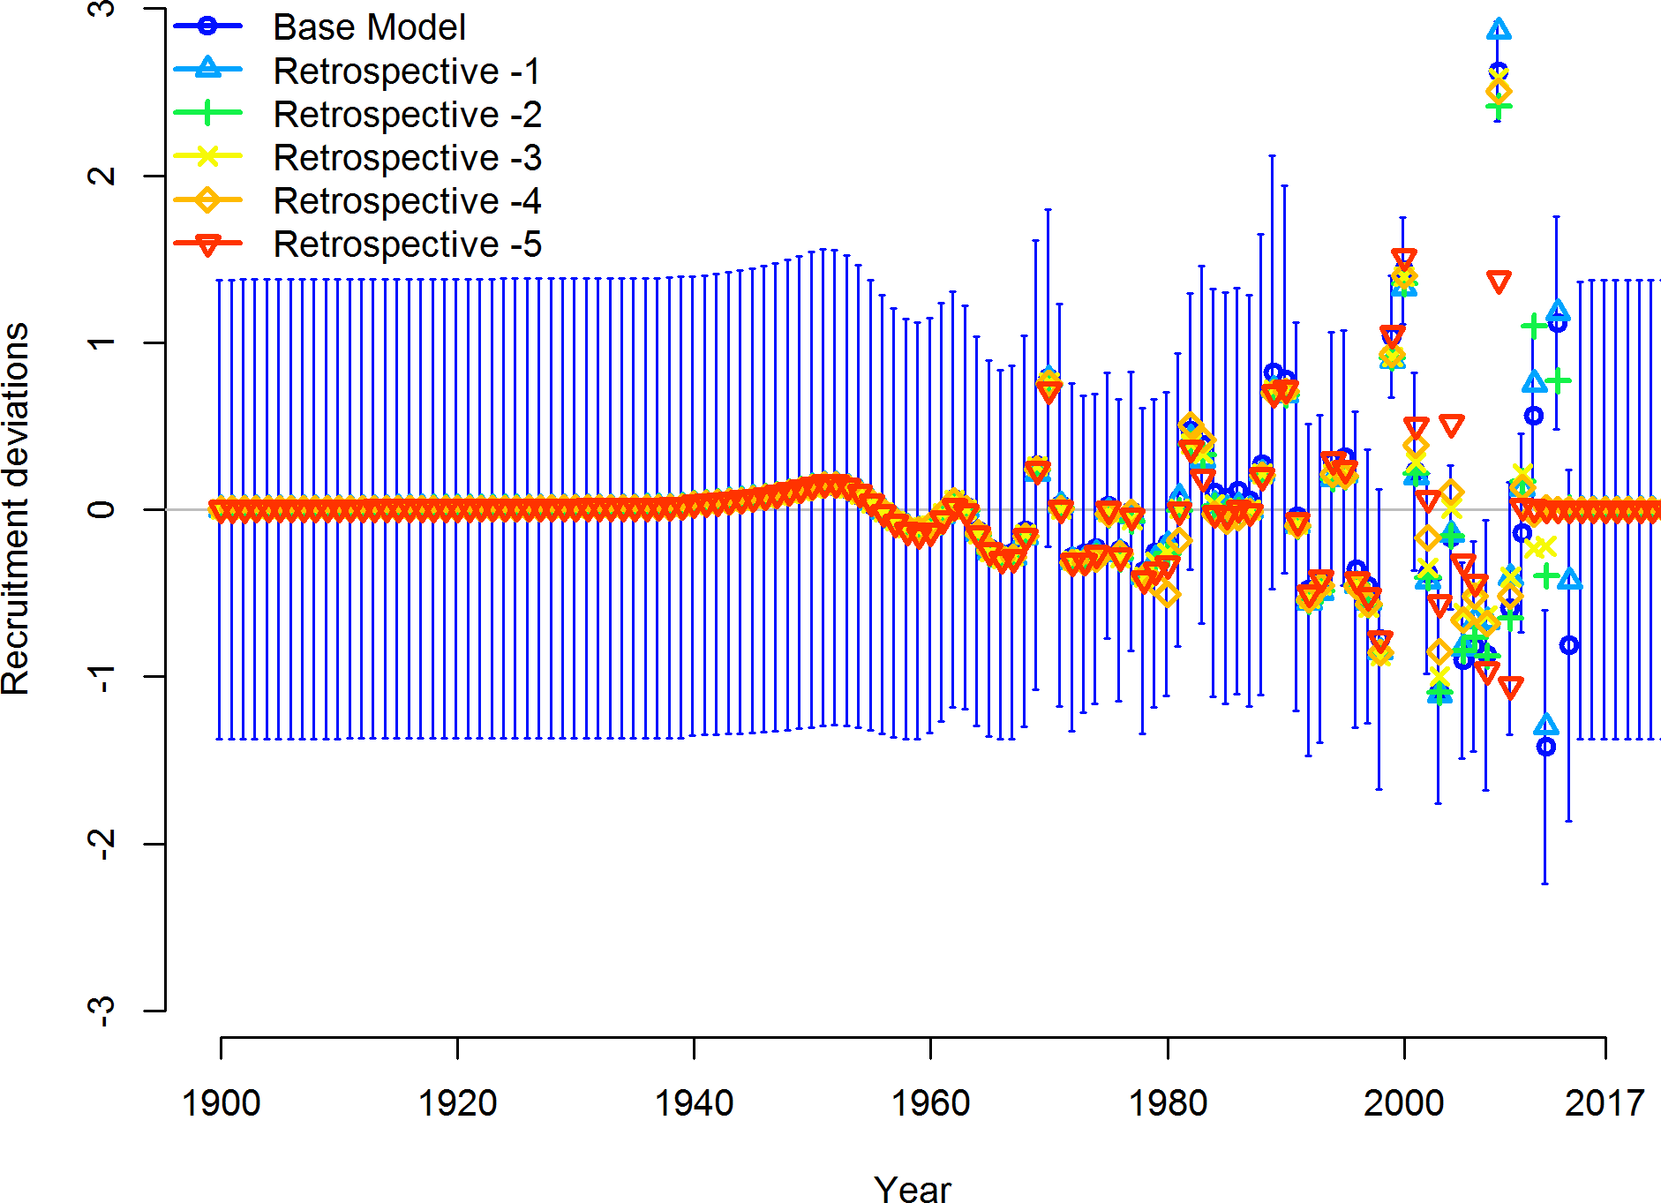

Figure 80: Retrospective pattern for estimated recruitment deviations.

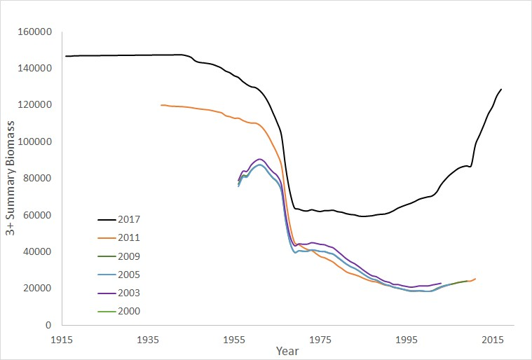

Figure 81: Pattern for estimated 3+ summary biomass from each assessment since 2000.

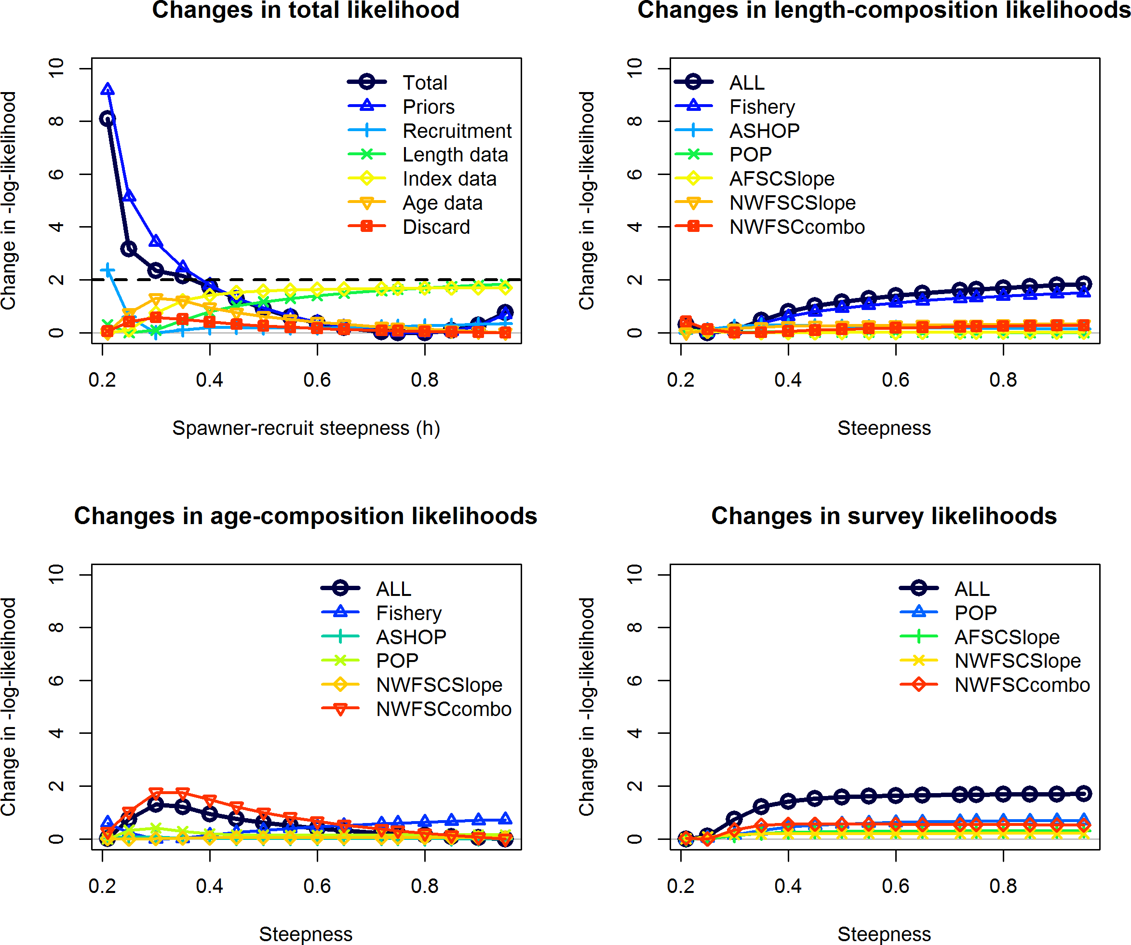

Figure 82: Likelihood profile across steepness values.

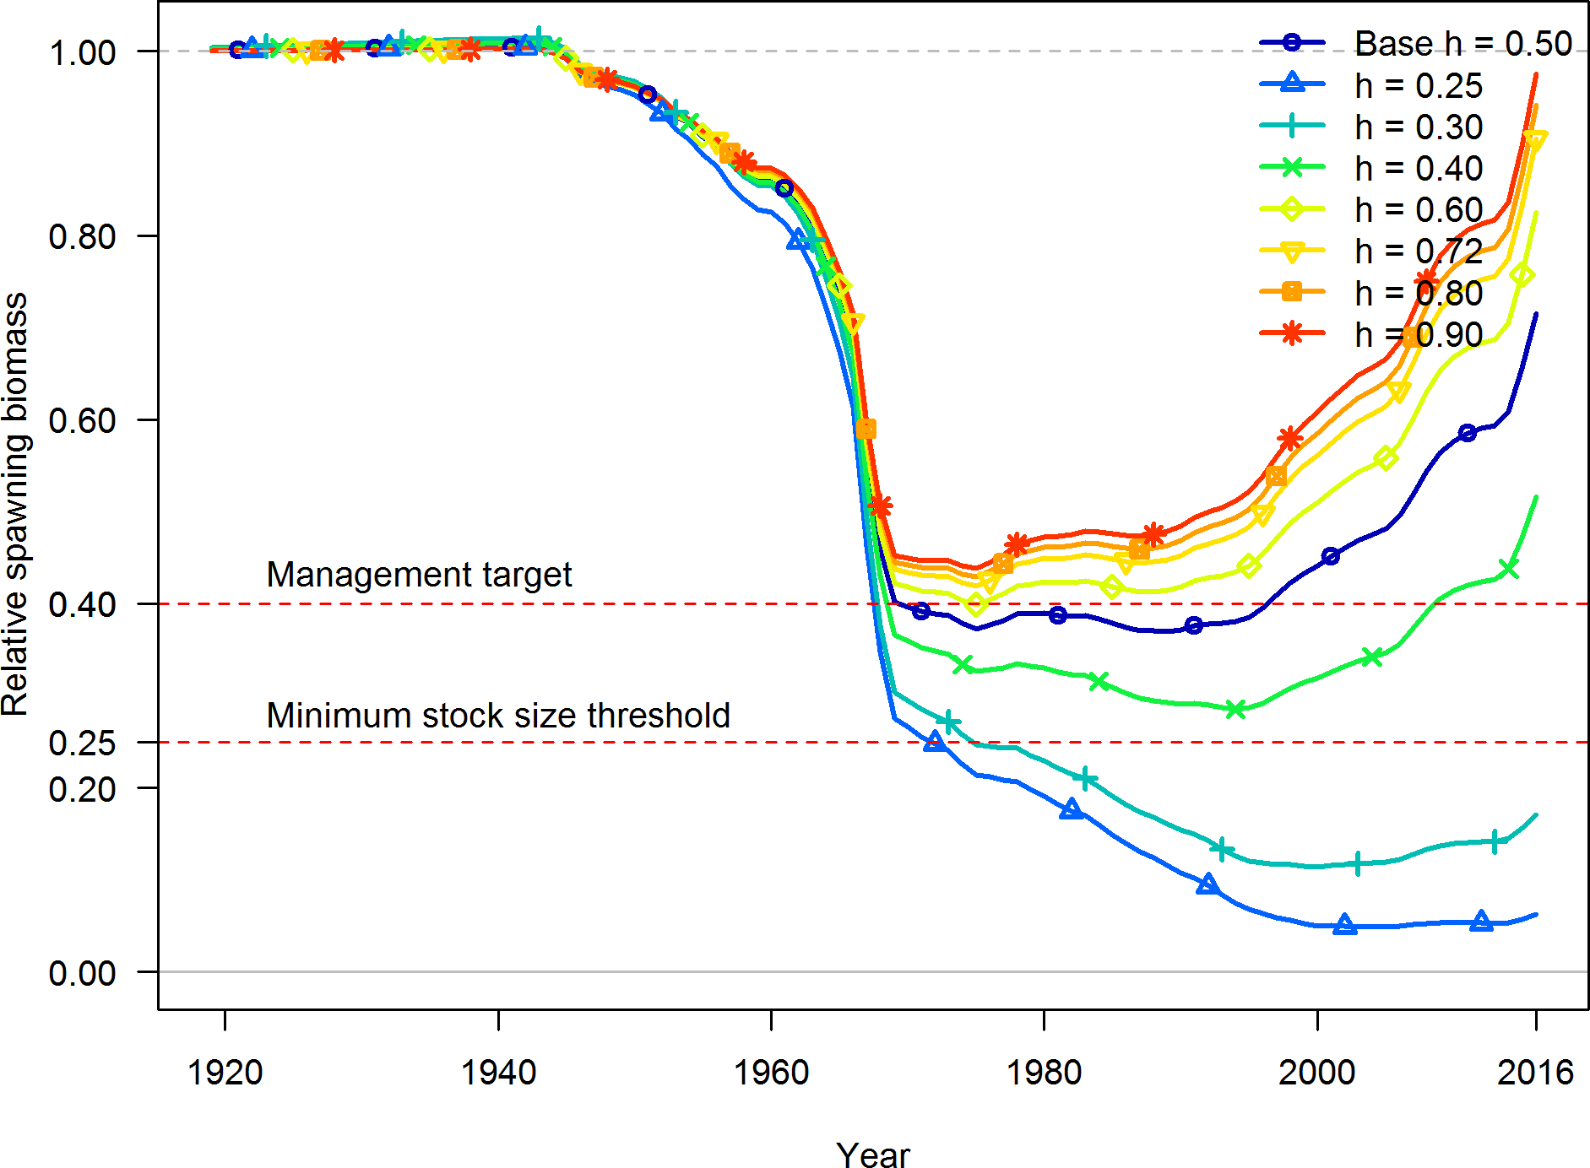

Figure 83: Trajectories of relative spawning output (depletion) across values of steepness.

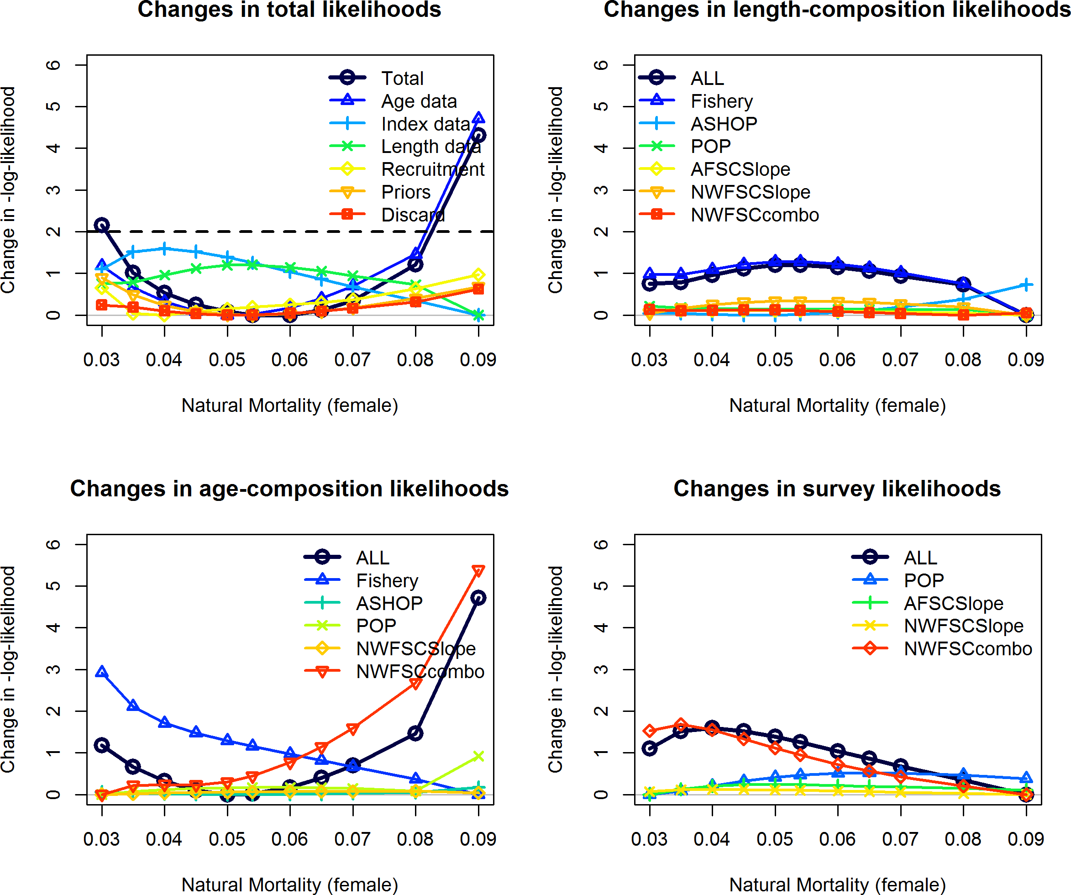

Figure 84: Likelihood profile across natural mortality values. Male natural mortality was fixed to equal female natural mortality.

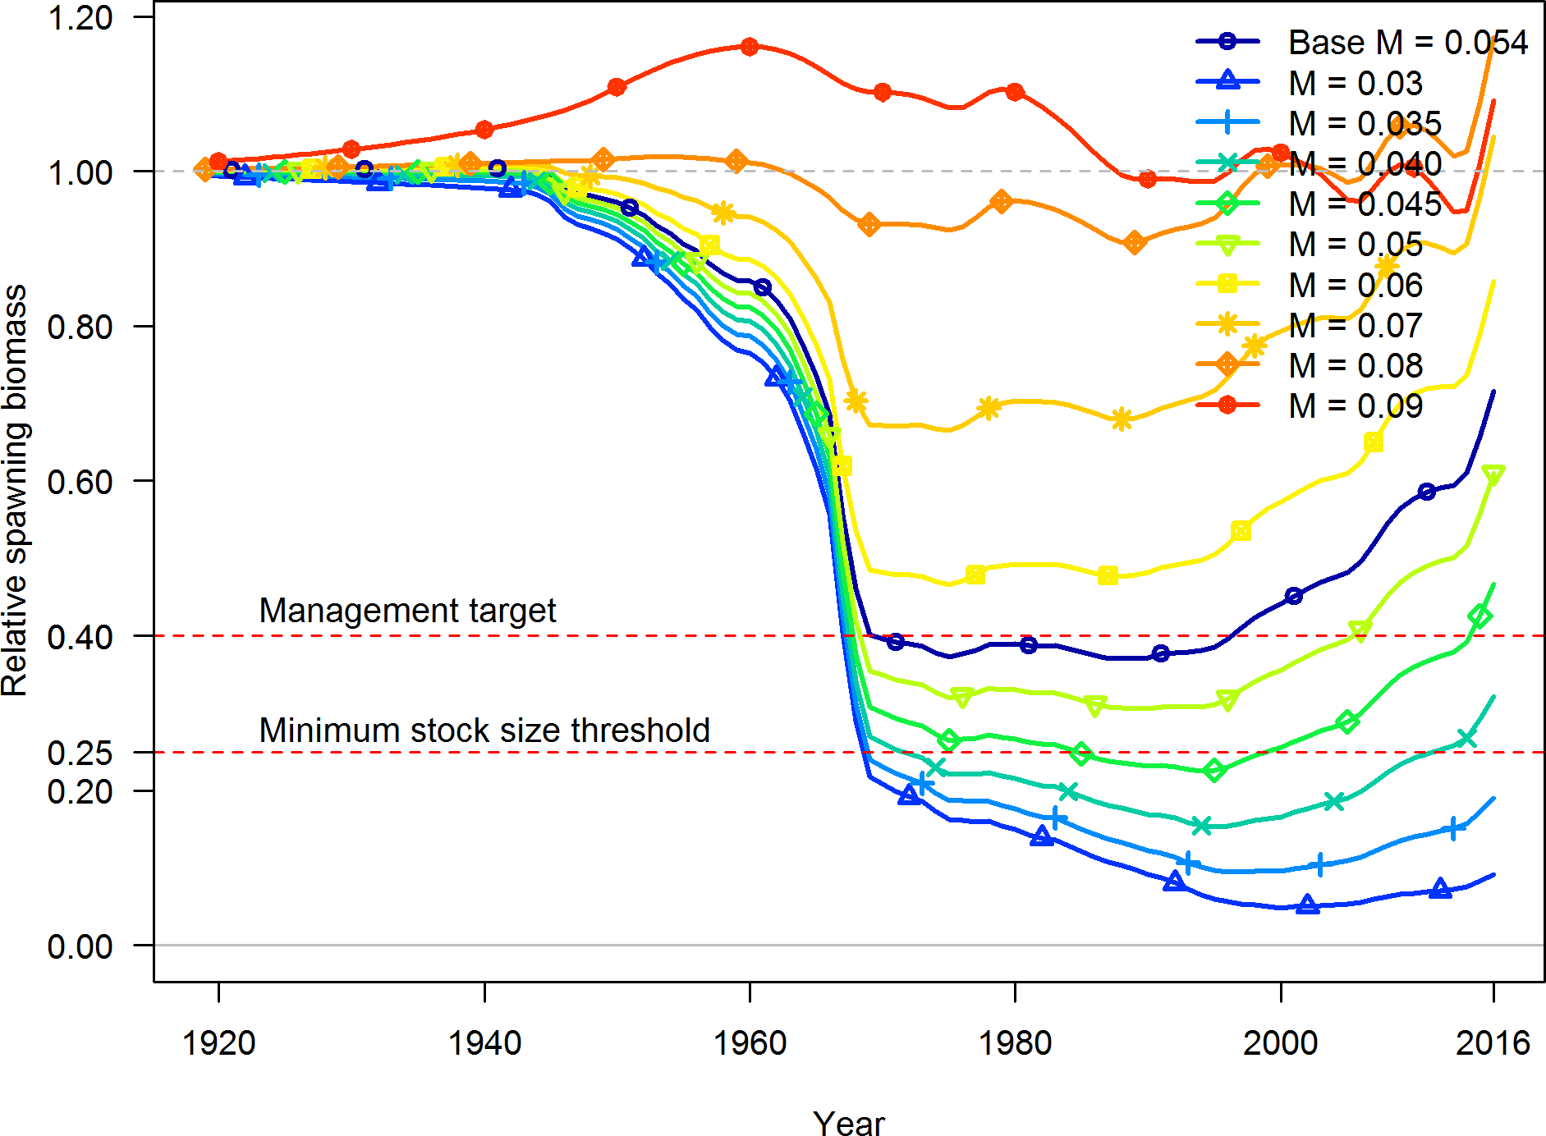

Figure 85: Trajectories of relative spawning output (depletion) across values of natural mortality.

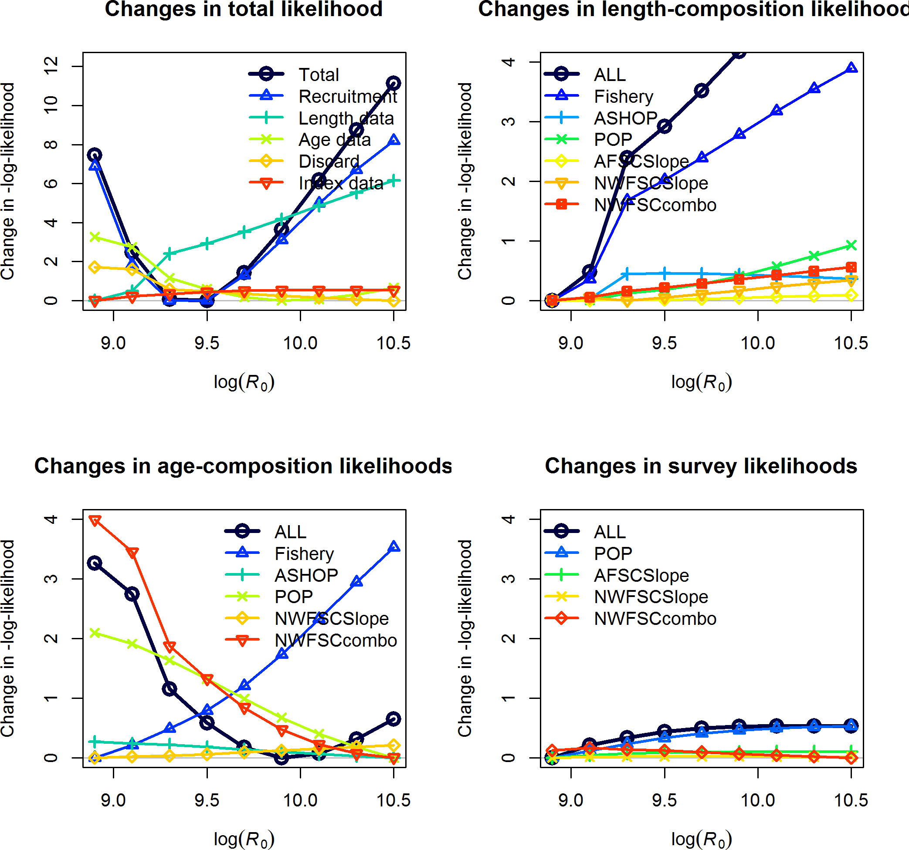

Figure 86: Likelihood profile across R0 values.



Figure 87: Estimated spawning potential ratio (1-SPR)/(1-SPR50%) for the base-case model. One minus SPR is plotted so that higher exploitation rates occur on the upper portion of the y-axis. The management target is plotted as a red horizontal line and values above this reflect harvests in excess of the overfishing proxy based on the SPR50% harvest rate. The last year in the time series is 2016.



Figure 88: Equilibrium yield curve for the base case model. Values are based on the 2016 fishery selectivity and with steepness fixed at 0.50.

1. **Appendix A. Detailed Fit to Length Composition Data**

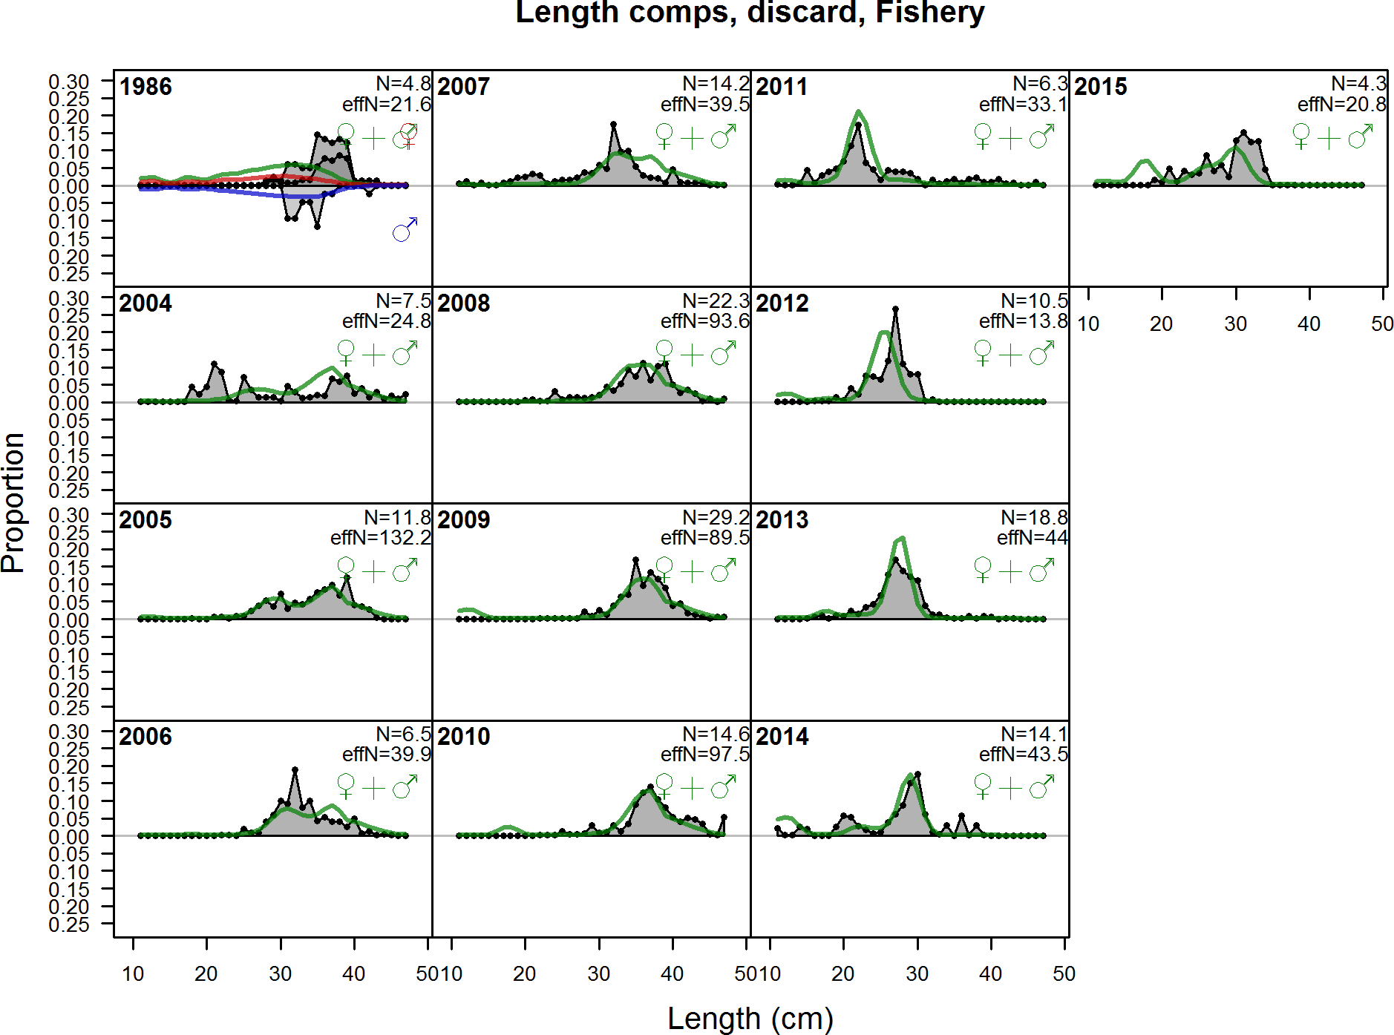

Figure 89: Length comps, discard, Fishery

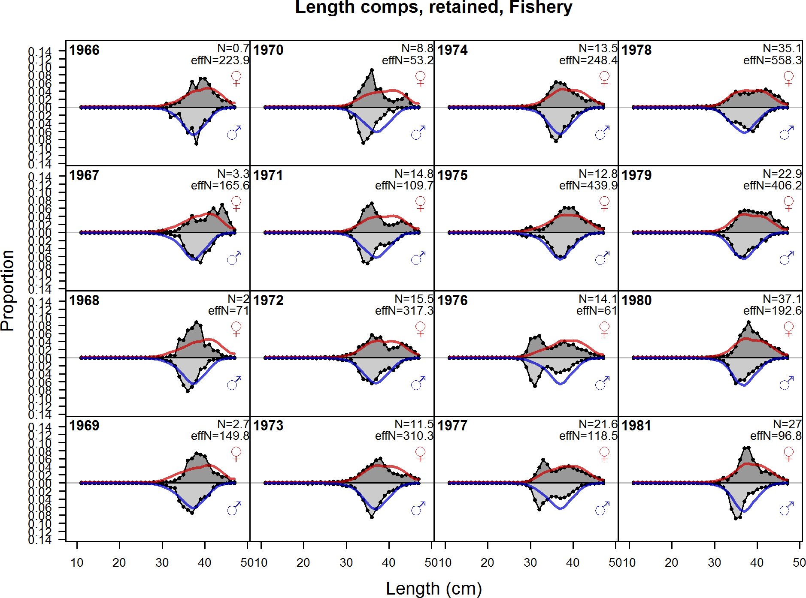

Figure 90: Length comps, retained, Fishery (plot 1 of 4)

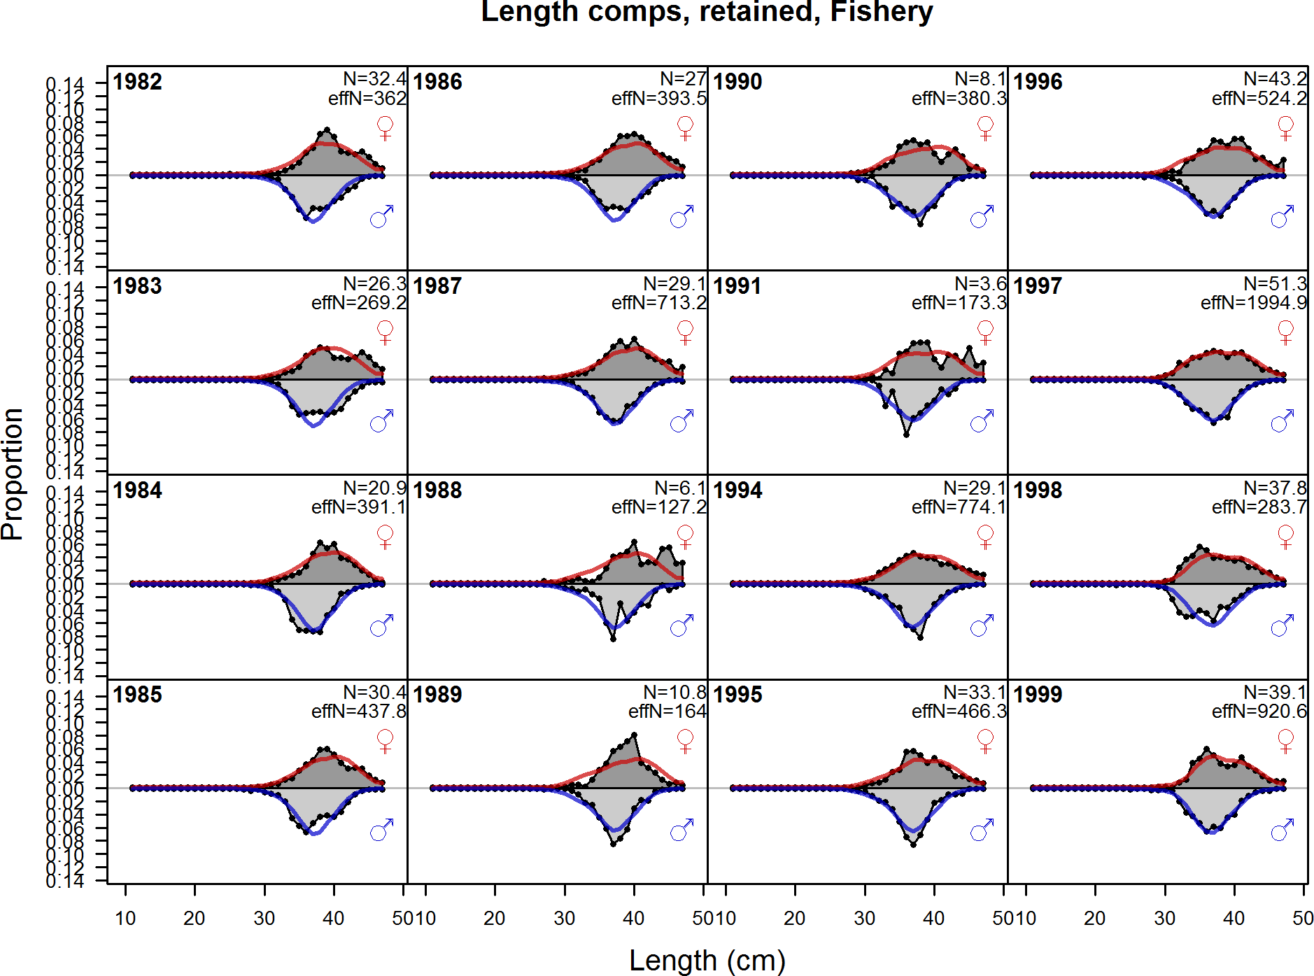

Figure 91: Length comps, retained, Fishery (plot 2 of 4)

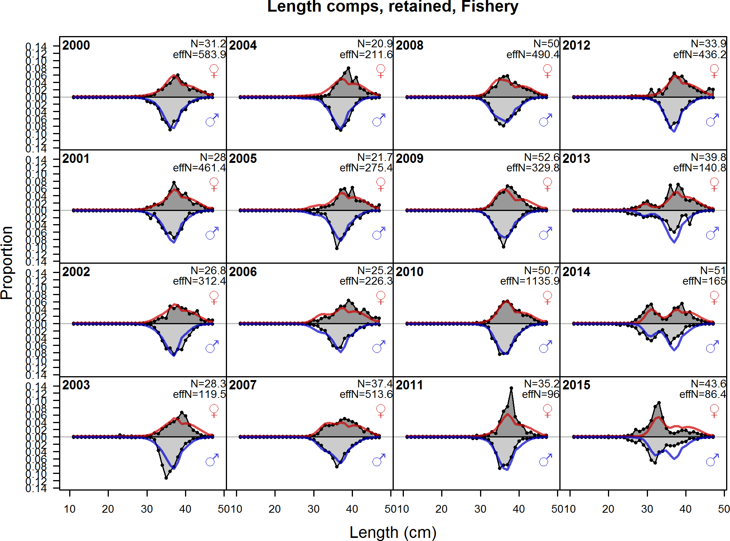

Figure 92: Length comps, retained, Fishery (plot 3 of 4)

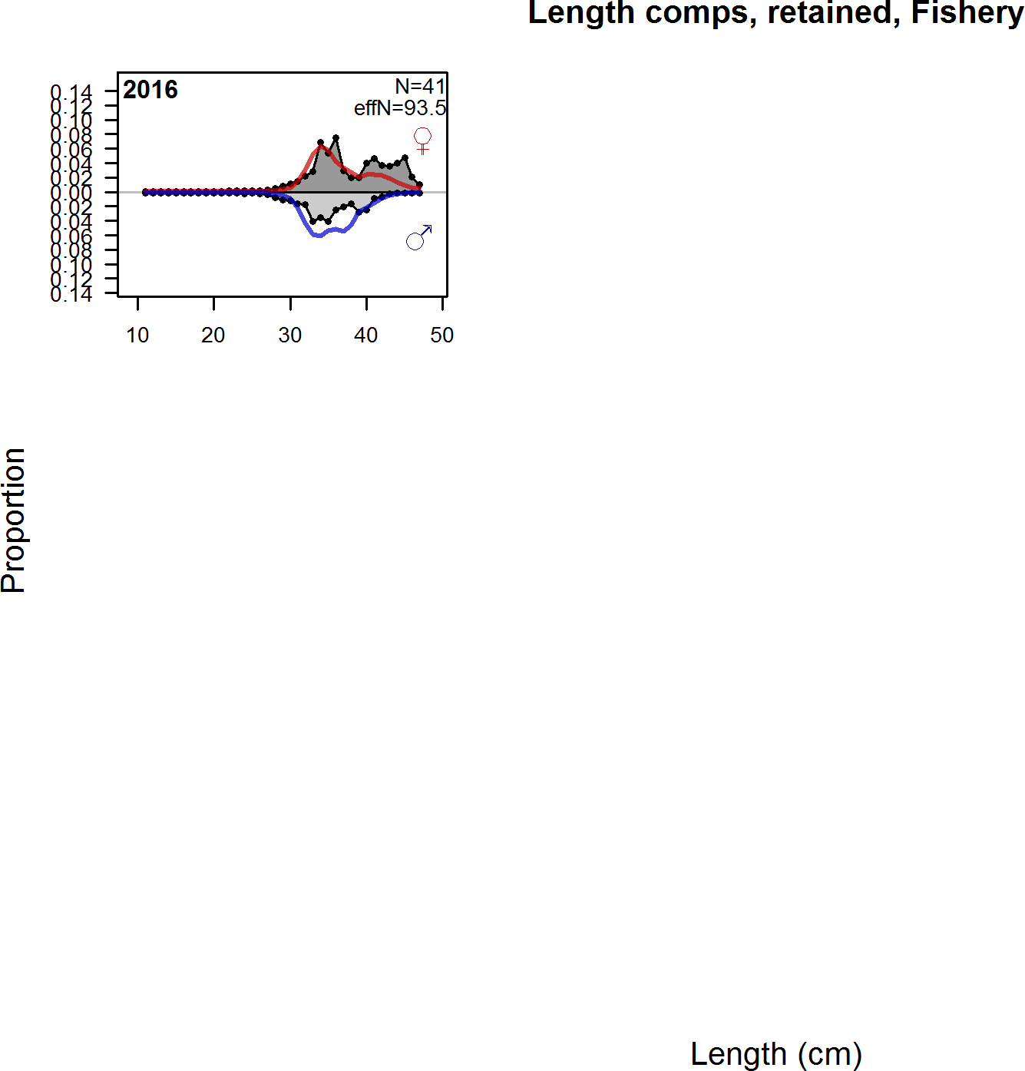

Figure 93: Length comps, retained, Fishery (plot 4 of 4)

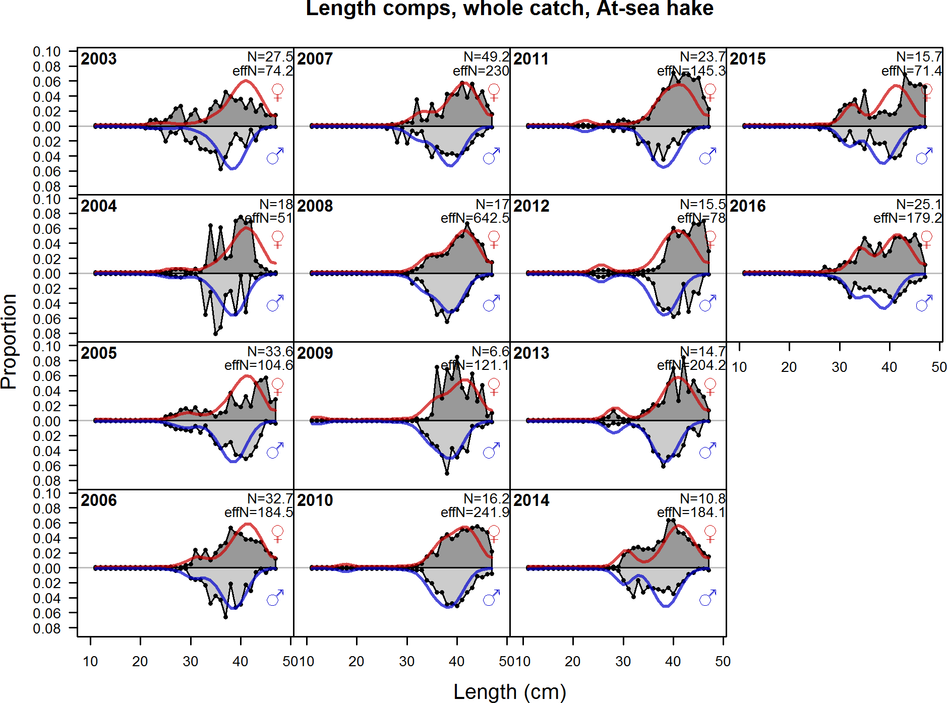

Figure 94: Length comps, whole catch, At sea hake

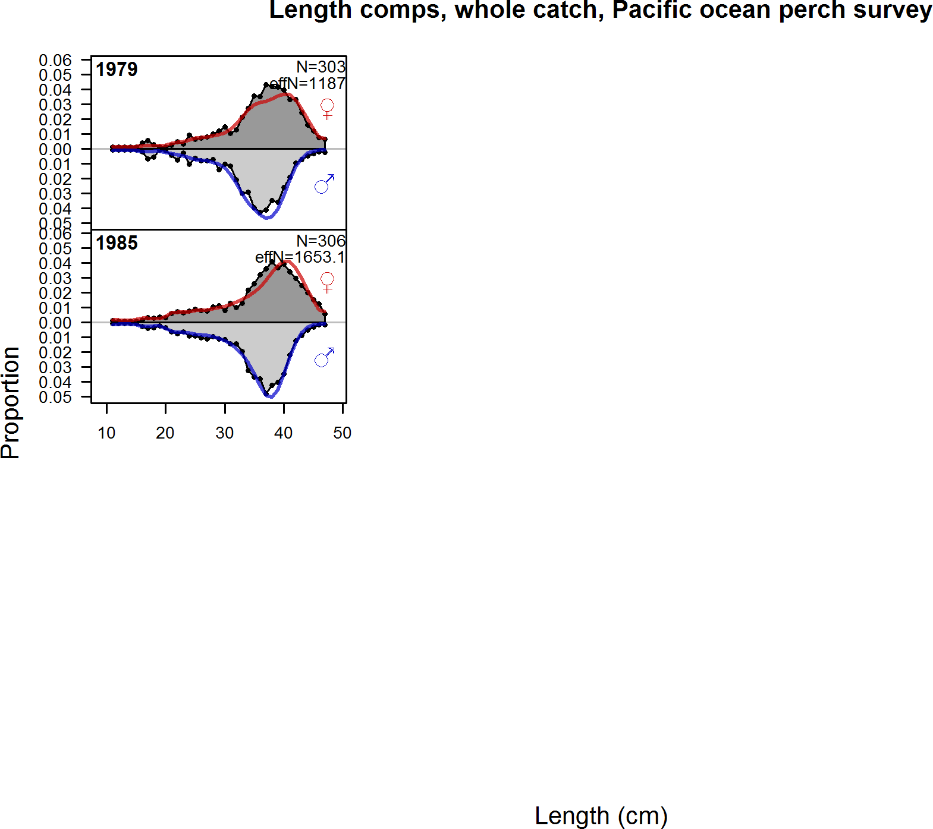

Figure 95: Length comps, whole catch, Pacific ocean perch survey

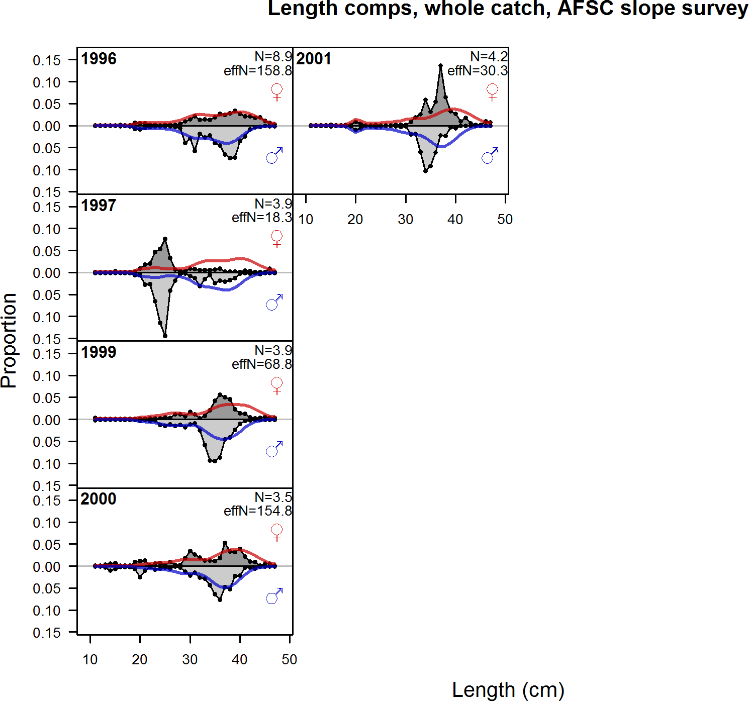

Figure 96: Length comps, whole catch, AFSC slope survey

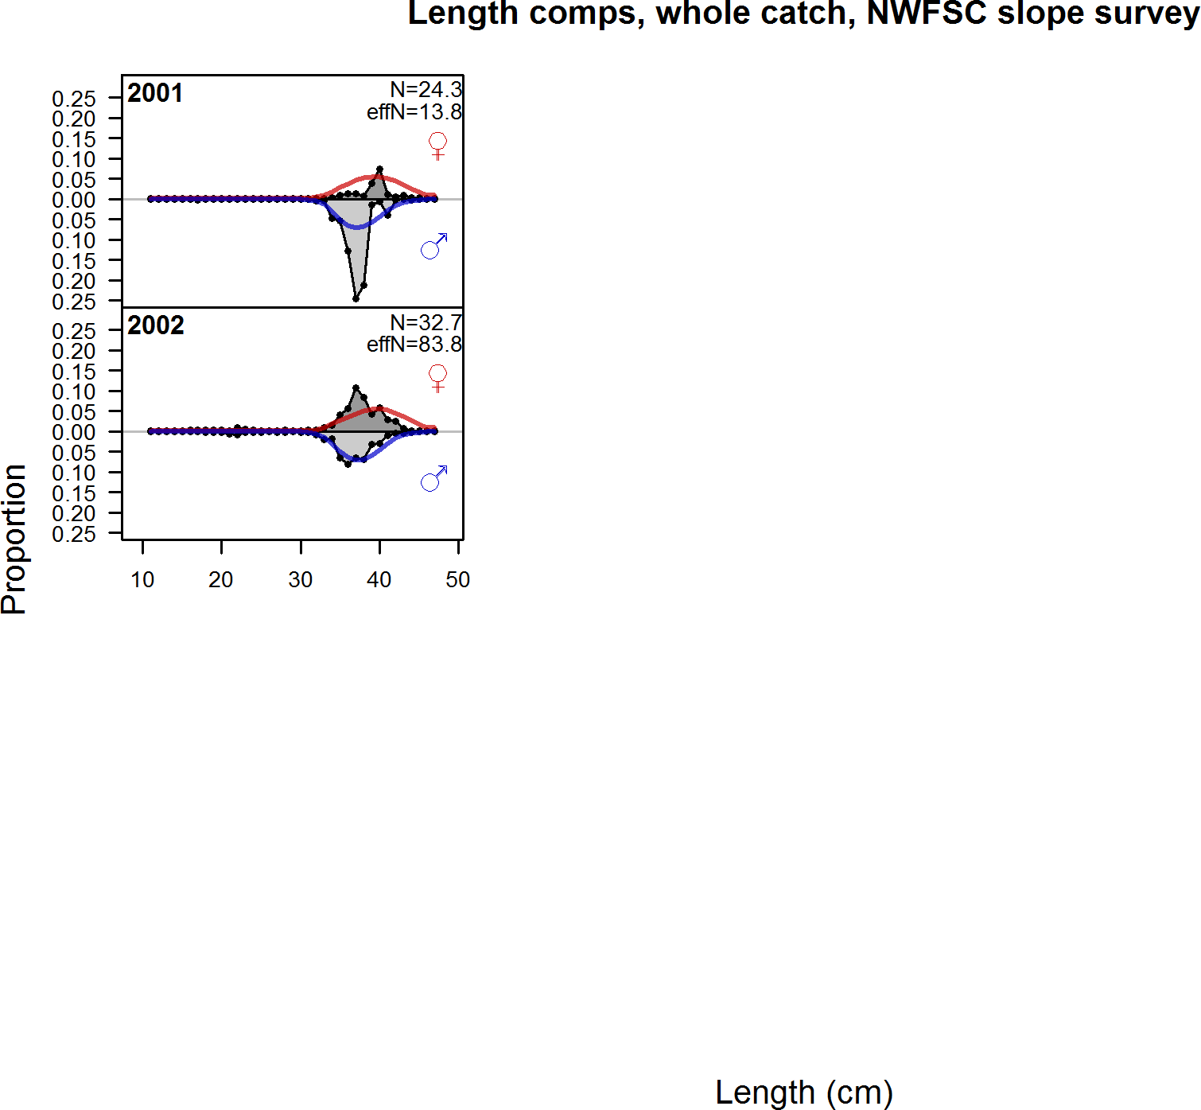

Figure 97: Length comps, whole catch, NWFSC slope survey

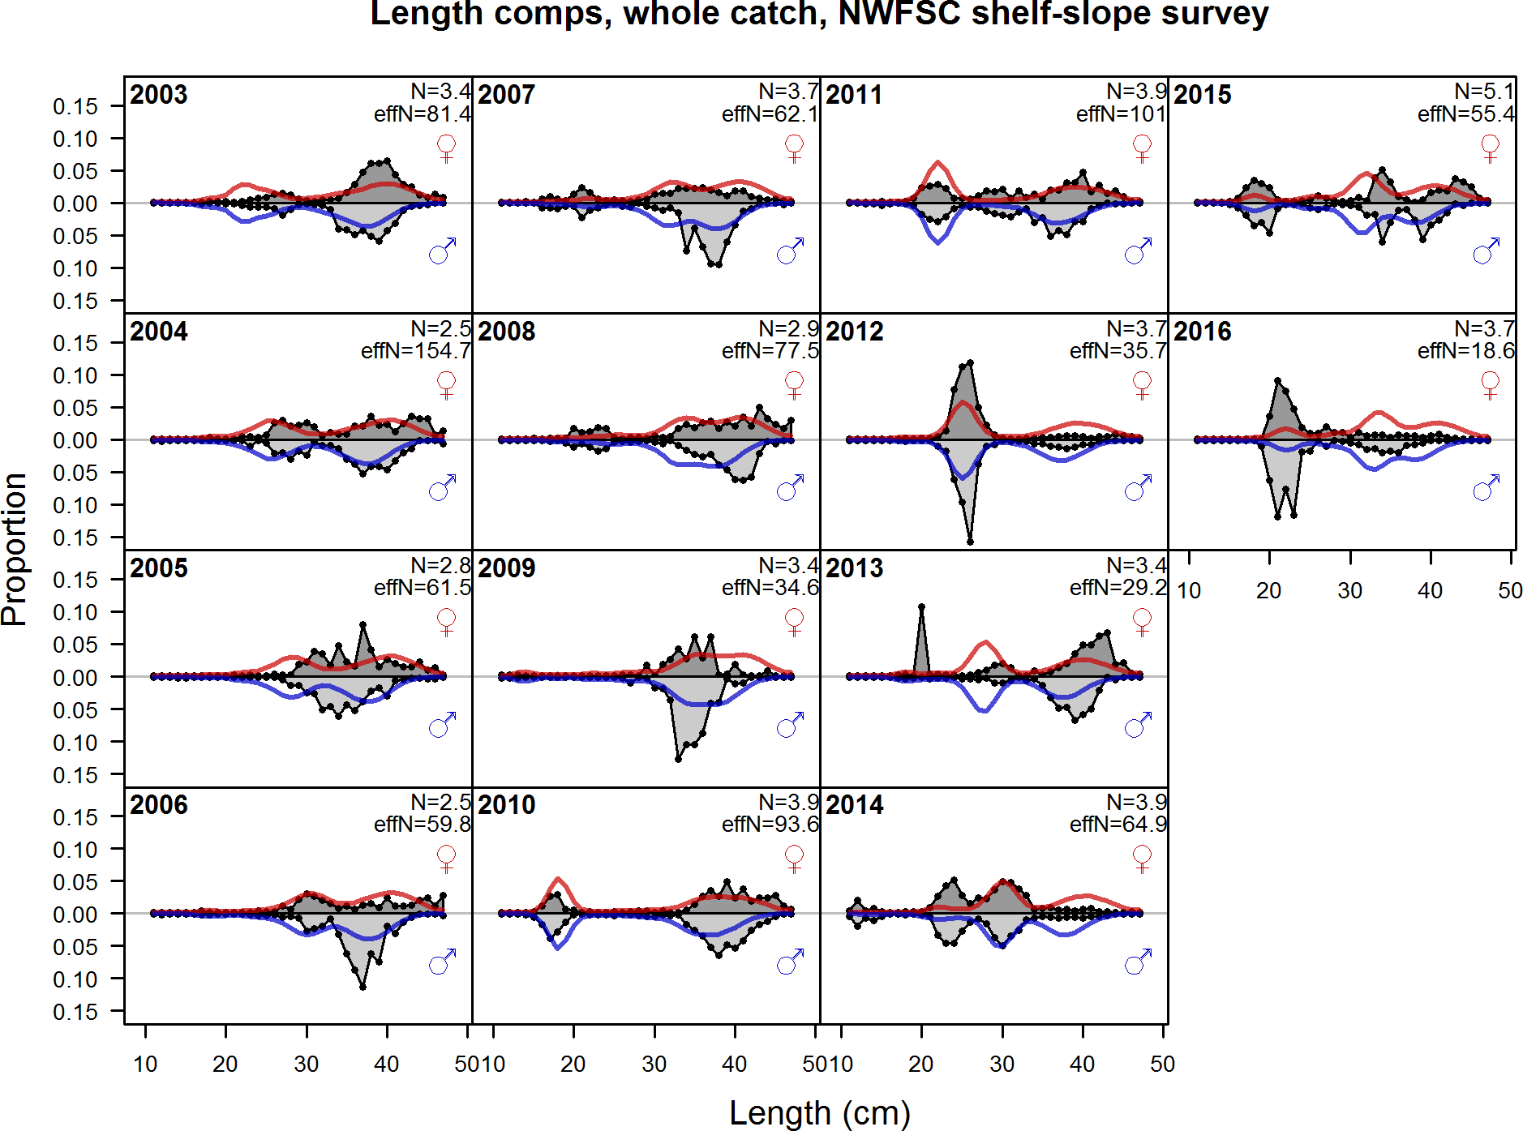

Figure 98: Length comps, whole catch, NWFSC shelf slope survey

1. **Appendix B. Detailed Fit to Age Composition Data**

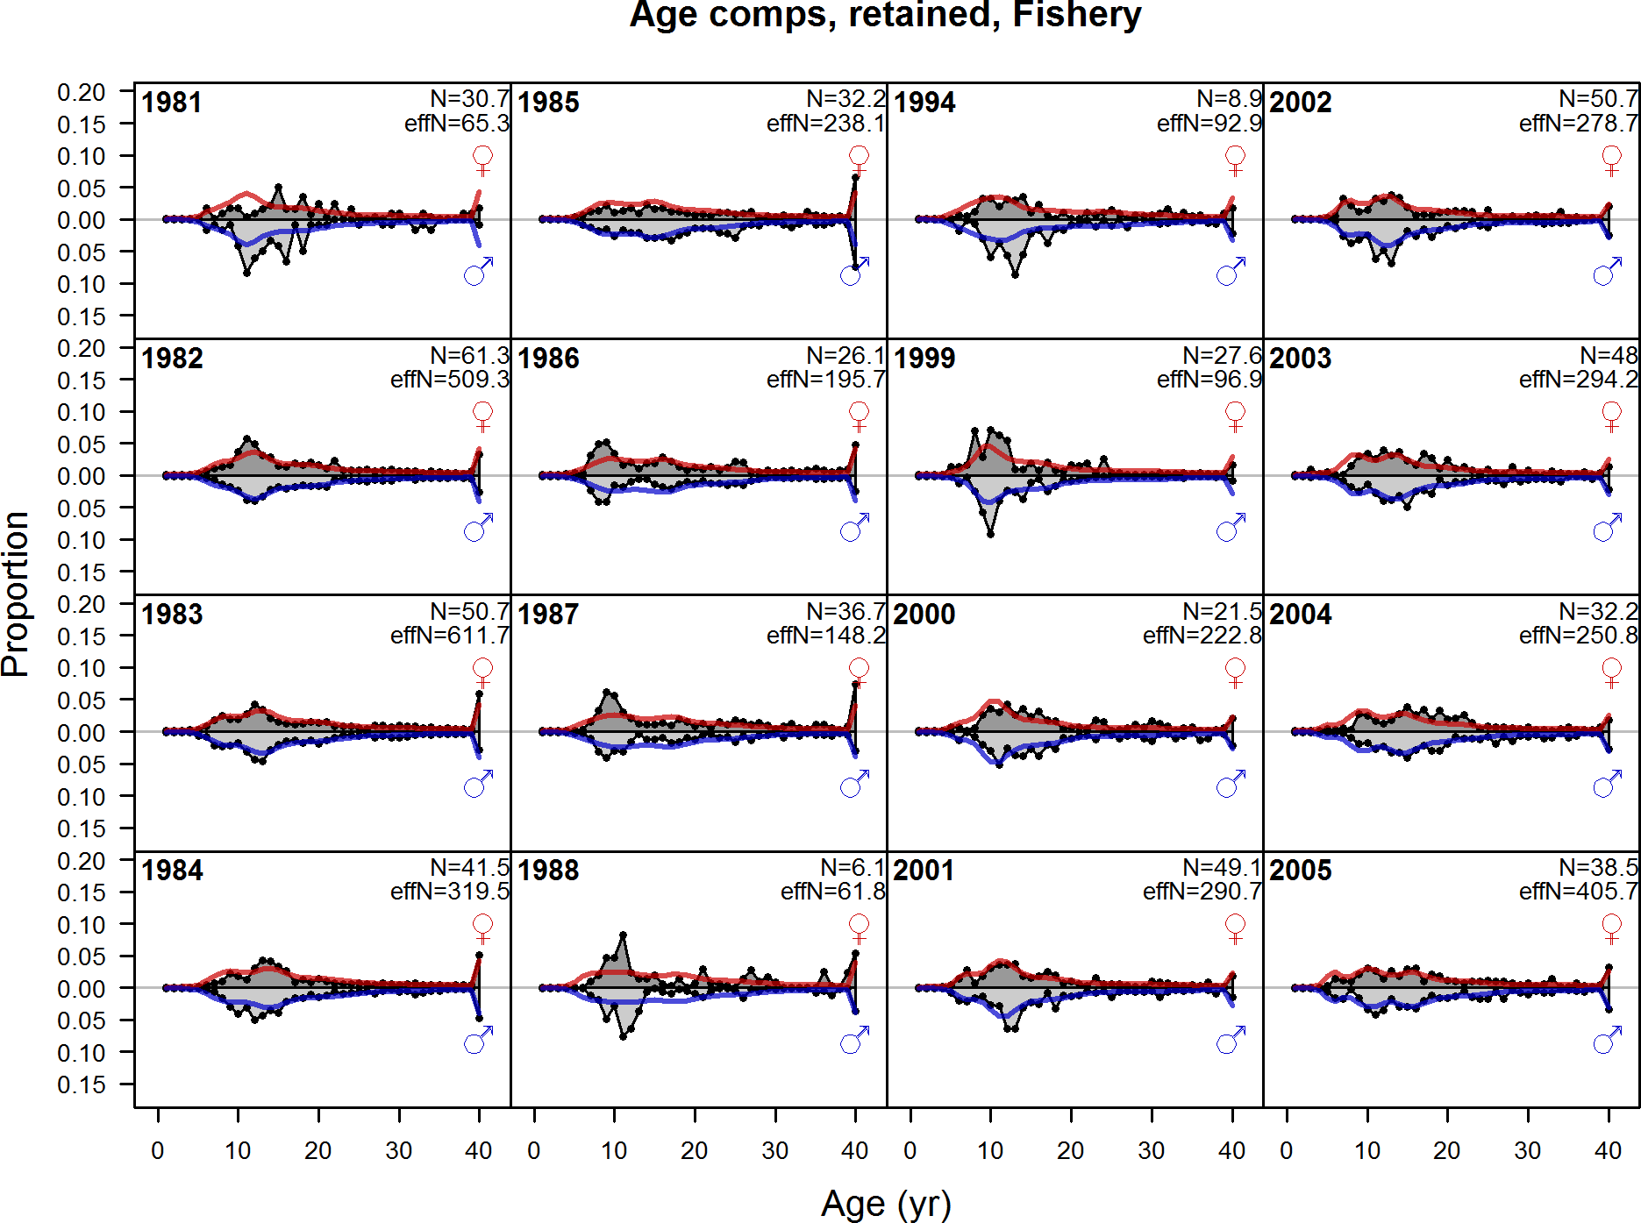

Figure 99: Age comps, retained, Fishery (plot 1 of 2)

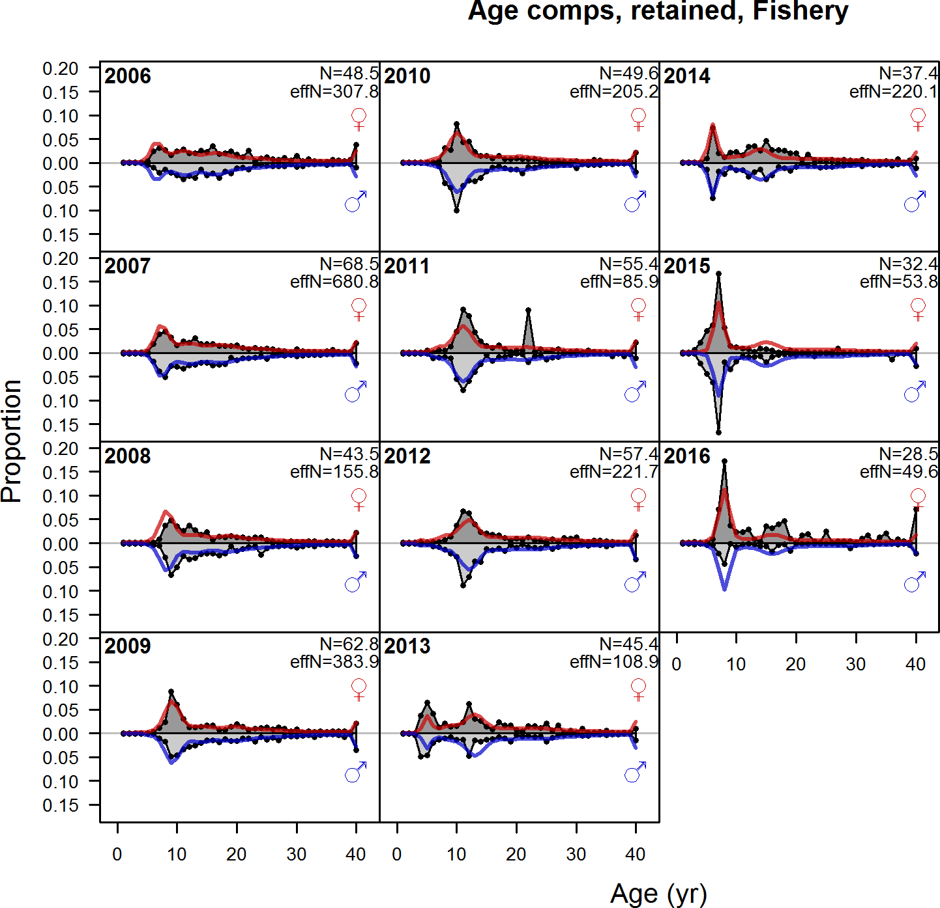

Figure 100: Age comps, retained, Fishery (plot 2 of 2)

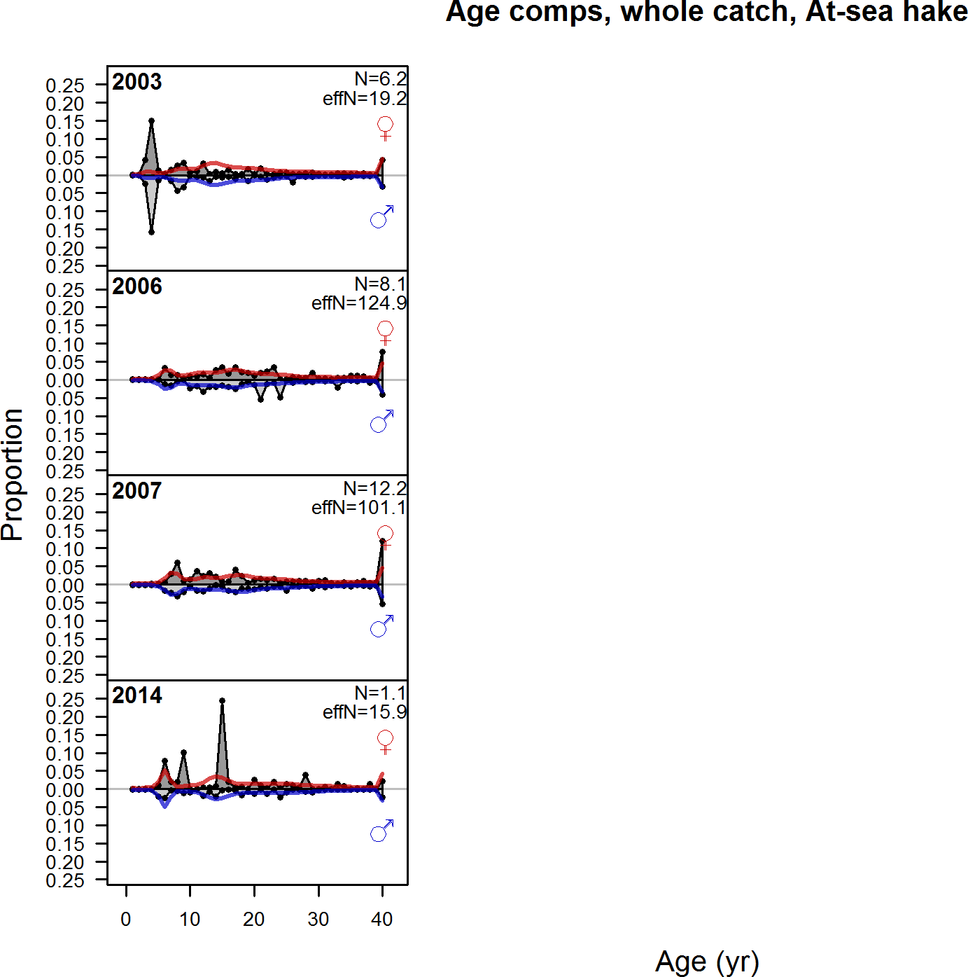

Figure 101: Age comps, whole catch, At sea hake

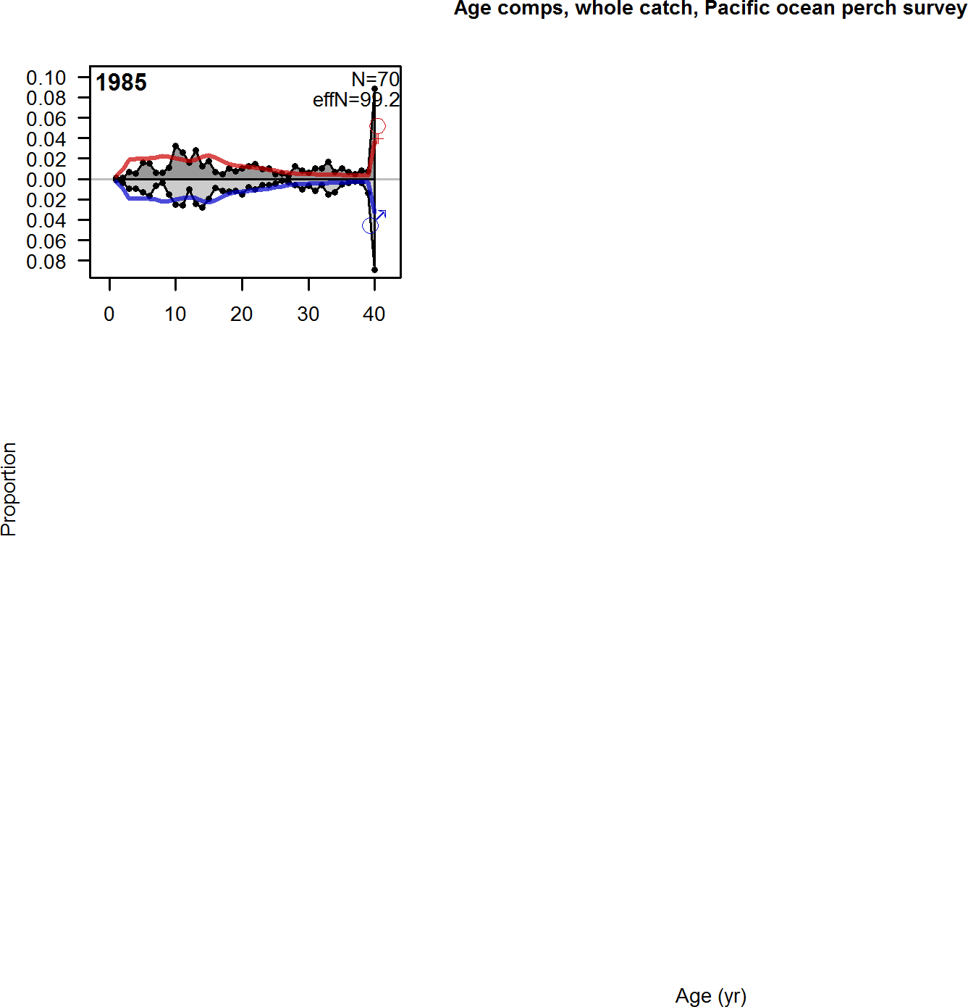

Figure 102: Age comps, whole catch, Pacific ocean perch survey

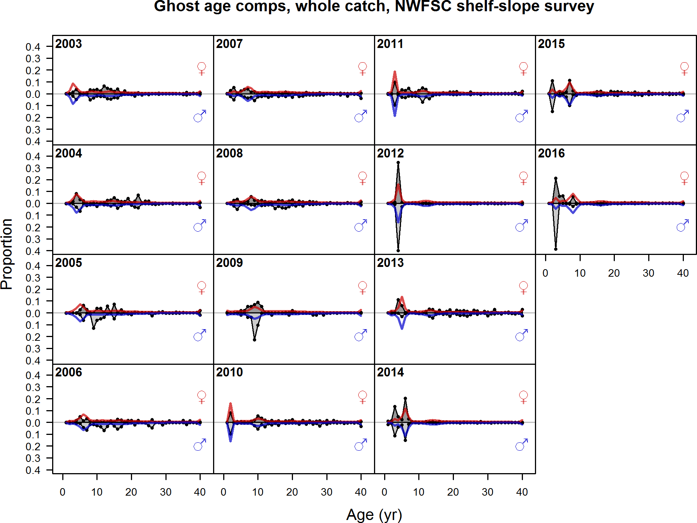

Figure 103: Ghost age comps, whole catch, NWFSC shelf slope survey

1. **Appendix C. Description of CPUE and Triennial Data**

Data on catch-per-unit-effort (CPUE) in mt/hr from the domestic fishery were combined for the INPFC Vancouver and Columbia areas Gunderson (1977). Although these data reflect catch rates for the US fleet, the highest catch rates coincided with the beginning of removals by the foreign fleet. This suggests that, barring unaccounted changes in fishing efficiency during this period, the level of abundance was high at that time. The estimated index of abundance is shown in Table 32 and Figure 104.

The Triennial shelf survey index of abundance was estimated based on the data using the VAST delta-GLMM model. The estimated index of abundance is shown in Table 32 and Figure 104. The lognormal distribution with random strata-year had the lowest AIC and was chosen as the final model. The index shows a decline in abundance in the early years of the time-series and abundance remaining flat for the latter years.

Triennial shelf survey length and age compositions were expanded based upon the survey stratification. The number of tows with length data ranged from 17 in 1986 to 81 in 1998 (Table 33). Ages were read using surface reading methods until 1989 when the break-and-burn method replaced surface reads as the best method to age Pacific ocean perch. Unfortunately, surface reading of Pacific ocean perch otoliths results in significant underestimates of age. Due to this, these otoliths were excluded from analysis. The available ages from the Triennial shelf survey and the number of tows where otoliths were collected are shown in Table 34. The expanded length and age frequencies from this survey are shown in Figures 105 and 106, respectively.

Including the fishery CPUE or the Triennial survey data in the final base model had only negligible changes in the stock size and status (Figures 107 and 108).

Table 32: Summary of the fishery CPUE and the Triennial shelf survey indices not used in the stock assessment.

|  |  |  |  |  |
| --- | --- | --- | --- | --- |
|  | Fishery CPUE | | Triennial |  |
| Year | Obs SE | | Obs | SE |
| 1956 | 0.40 | 0.40 | - | - |
| 1957 | 0.30 | 0.40 | - | - |
| 1958 | 0.32 | 0.40 | - | - |
| 1959 | 0.29 | 0.40 | - | - |
| 1960 | 0.28 | 0.40 | - | - |
| 1961 | 0.31 | 0.40 | - | - |
| 1962 | 0.29 | 0.40 | - | - |
| 1963 | 0.34 | 0.40 | - | - |
| 1964 | 0.35 | 0.40 | - | - |
| 1965 | 0.55 | 0.40 | - | - |
| 1966 | 0.47 | 0.40 | - | - |
| 1967 | 0.30 | 0.40 | - | - |
| 1968 | 0.17 | 0.40 | - | - |
| 1969 | 0.18 | 0.40 | - | - |
| 1970 | 0.17 | 0.40 | - | - |
| 1971 | 0.20 | 0.40 | - | - |
| 1972 | 0.20 | 0.40 | - | - |
| 1973 | 0.11 | 0.40 | - | - |
| 1980 | - | - | 10384 | 0.64 |
| 1983 | - | - | 8974 | 0.59 |
| 1986 | - | - | 2977 | 0.65 |
| 1989 | - | - | 4873 | 0.65 |
| 1992 | - | - | 3207 | 0.64 |
| 1995 | - | - | 2724 | 0.62 |
| 1998 | - | - | 4163 | 0.63 |
| 2001 | - | - | 1494 | 0.63 |
| 2004 | - | - | 2922 | 0.67 |

Table 33: Summary of Triennial shelf survey length samples. The sample sizes were calculated according to Stewart and Hamel (2014), which determined that the approximate realized sample size for shelf/slope rockfish species was 2.43 fish per tow.

|  |  |  |  |
| --- | --- | --- | --- |
| Year | Tows | Fish | Sample Size |
| 1980 | 18 | 1315 | 43 |
| 1983 | 40 | 2820 | 97 |
| 1986 | 17 | 877 | 41 |
| 1989 | 42 | 1851 | 102 |
| 1992 | 33 | 1182 | 80 |
| 1995 | 71 | 1136 | 172 |
| 1998 | 81 | 1482 | 196 |
| 2001 | 74 | 669 | 179 |
| 2004 | 63 | 1240 | 153 |

Table 34: Summary of Triennial shelf survey age samples. The sample sizes were calculated according to Stewart and Hamel (2014), which determined that the approximate realized sample size for shelf/slope rockfish species was 2.43 fish per tow.

|  |  |  |  |
| --- | --- | --- | --- |
| Year | Tows | Fish | Sample Size |
| 1989 | 15 | 577 | 36 |
| 1992 | 10 | 373 | 24 |
| 1995 | 12 | 275 | 29 |
| 1998 | 28 | 352 | 68 |
| 2001 | 43 | 342 | 104 |
| 2004 | 57 | 416 | 138 |

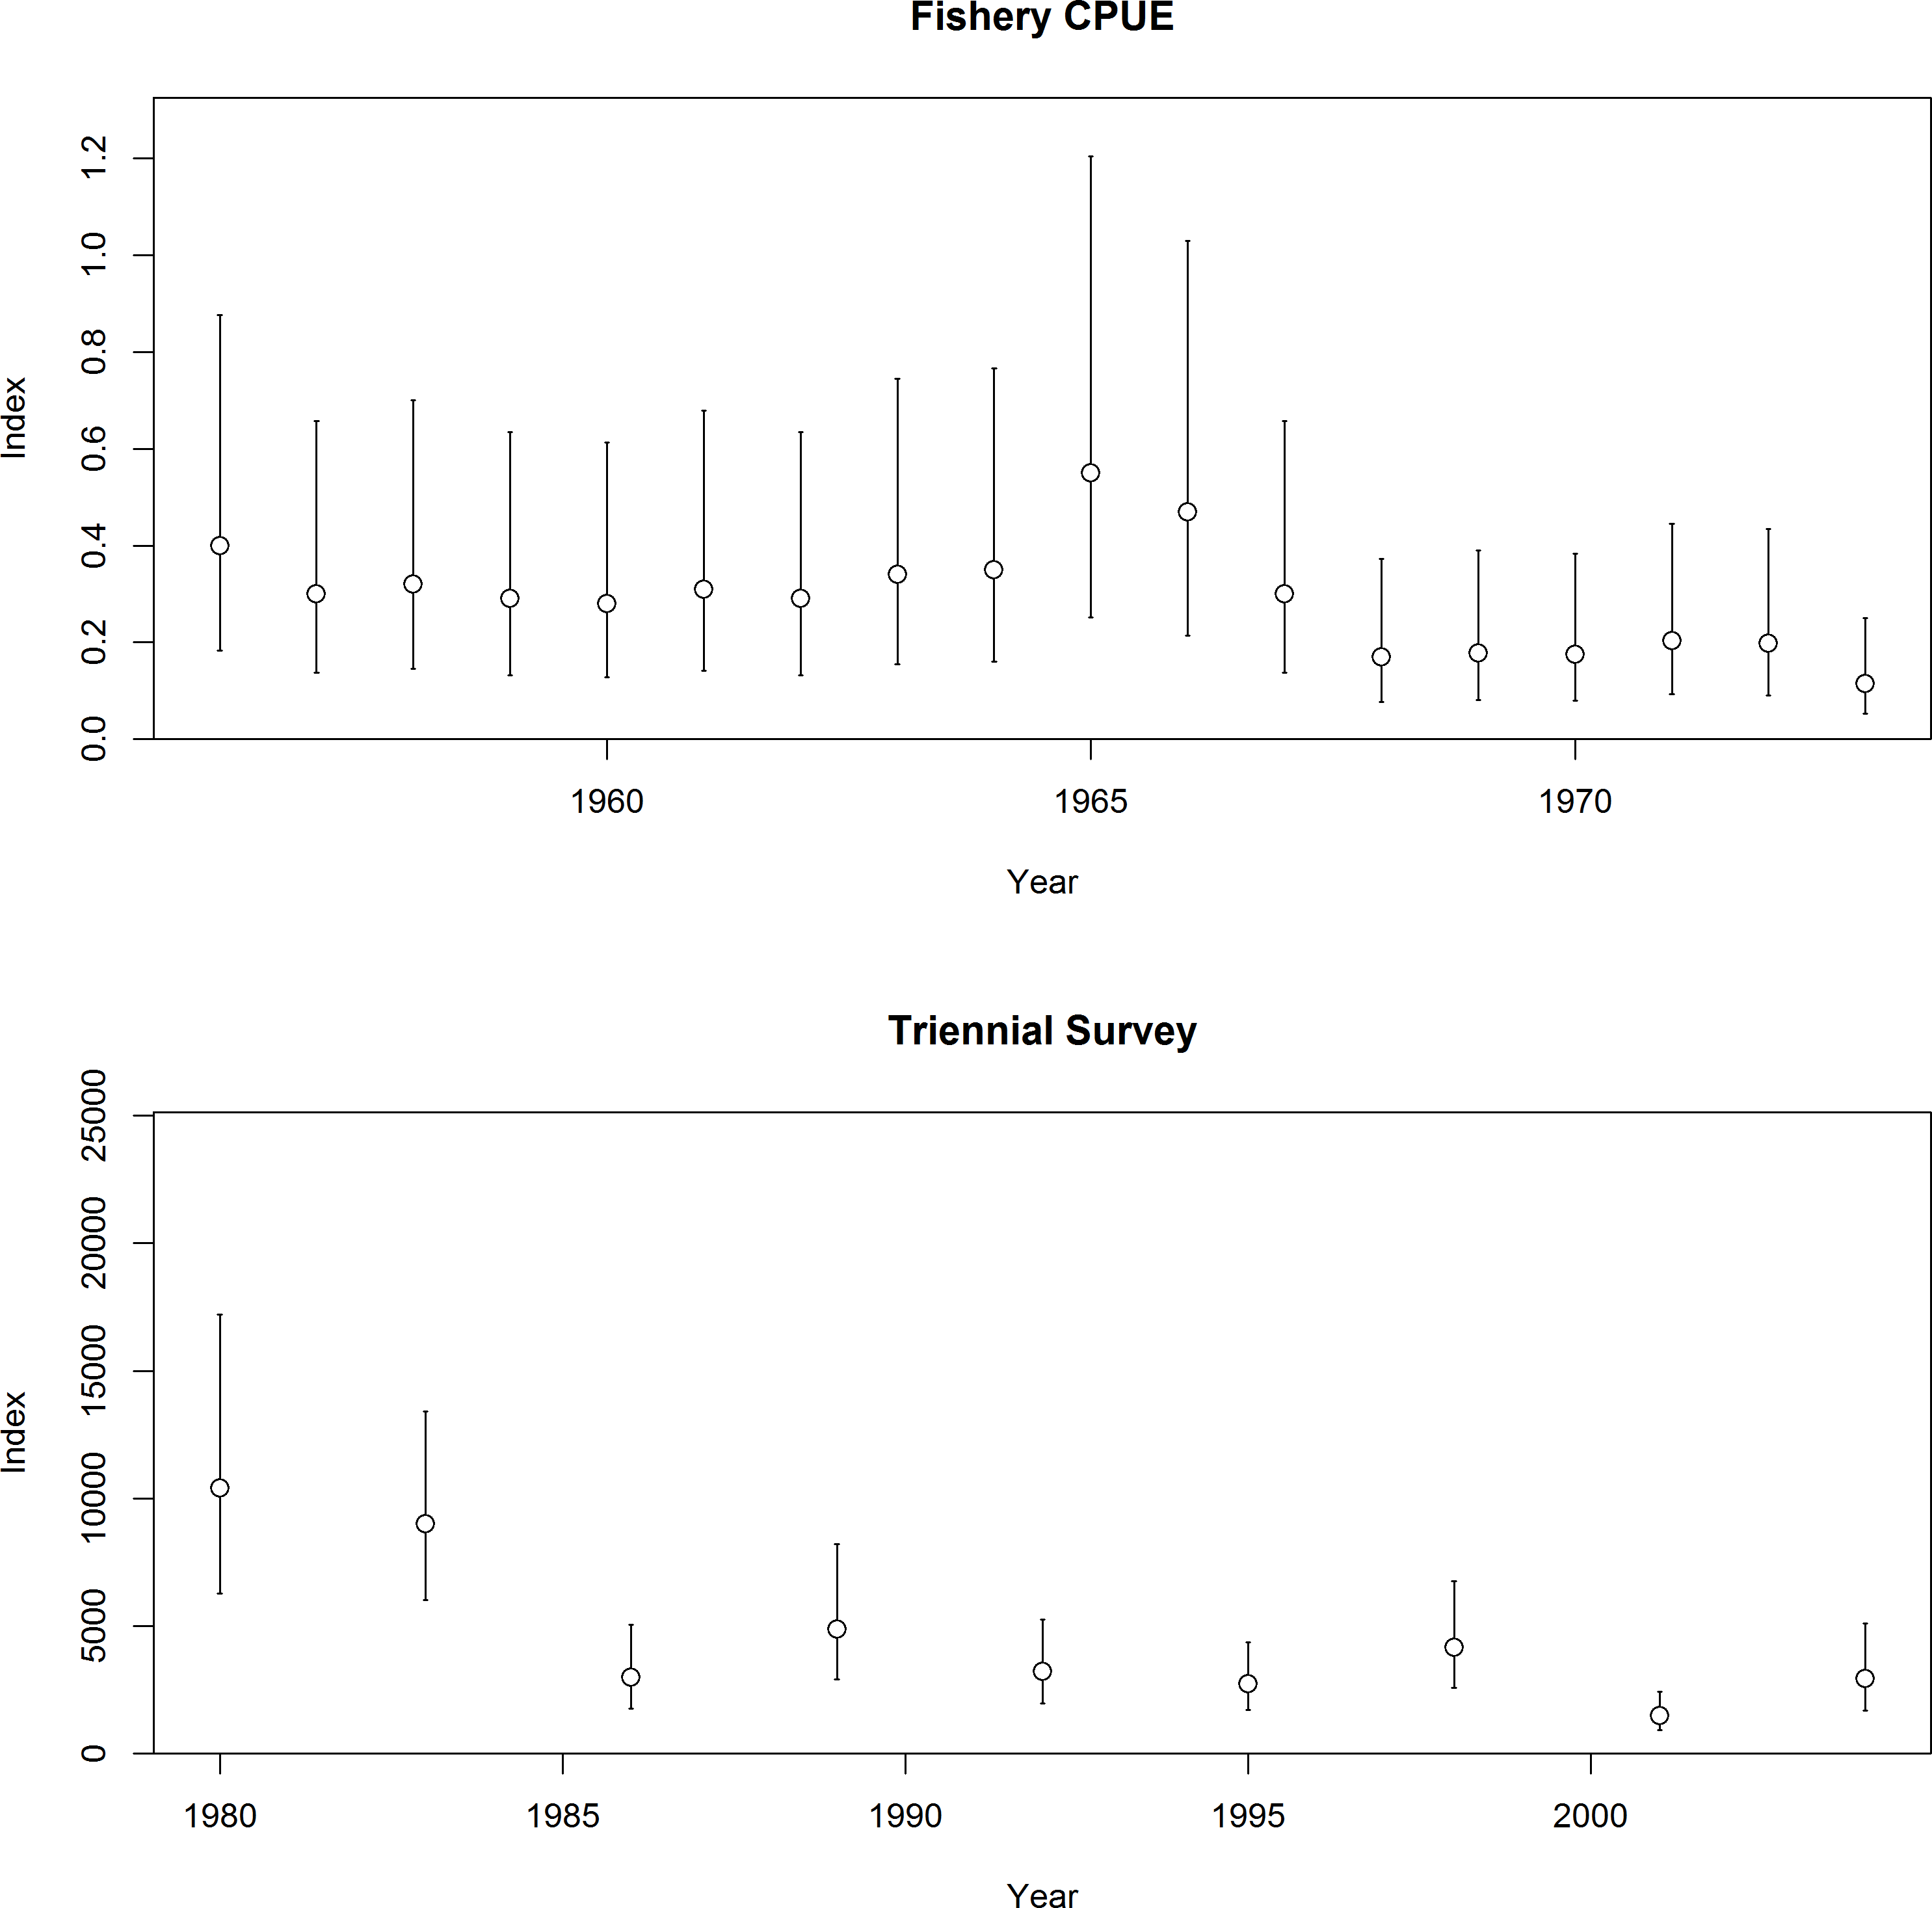

Figure 104: Fishery CPUE and Triennial shelf survey indices of abundance for Pacific ocean perch. The fishery CPUE was based on Gunderson 1977 and the Triennial shelf survey index was estimated using VAST.

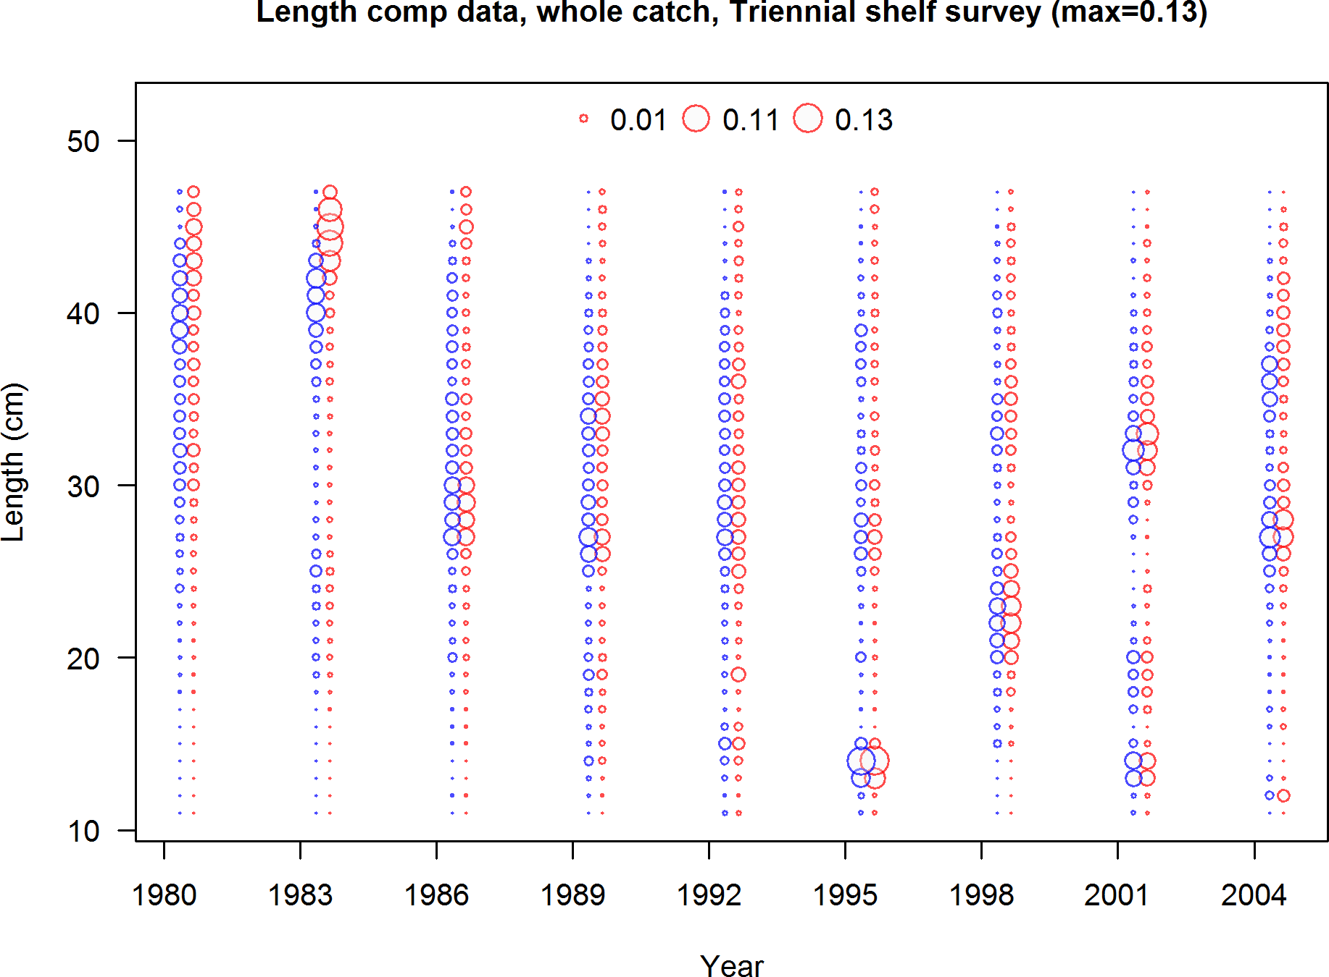

Figure 105: Triennial shelf survey length frequency distributions for Pacific ocean perch.

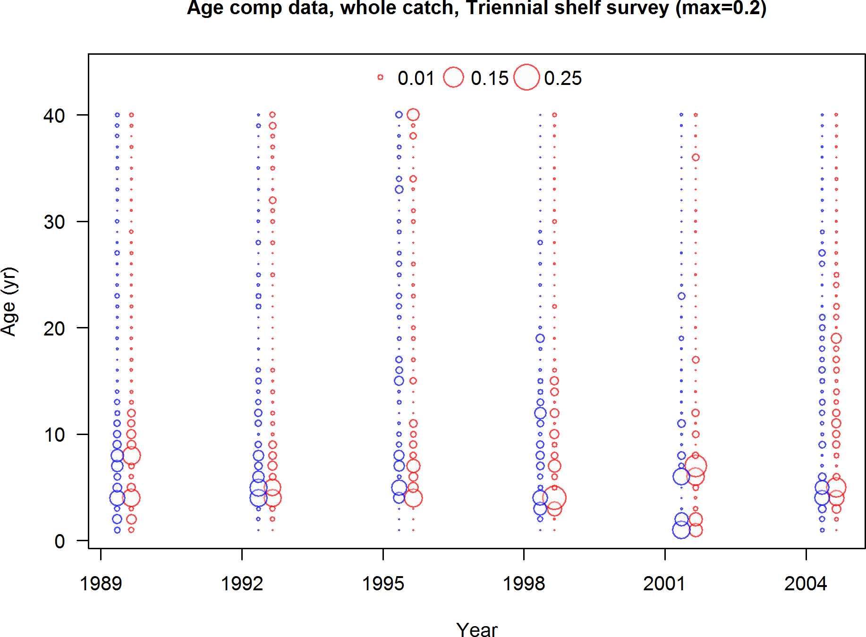

Figure 106: Triennial shelf survey age frequency distributions for Pacific ocean perch.

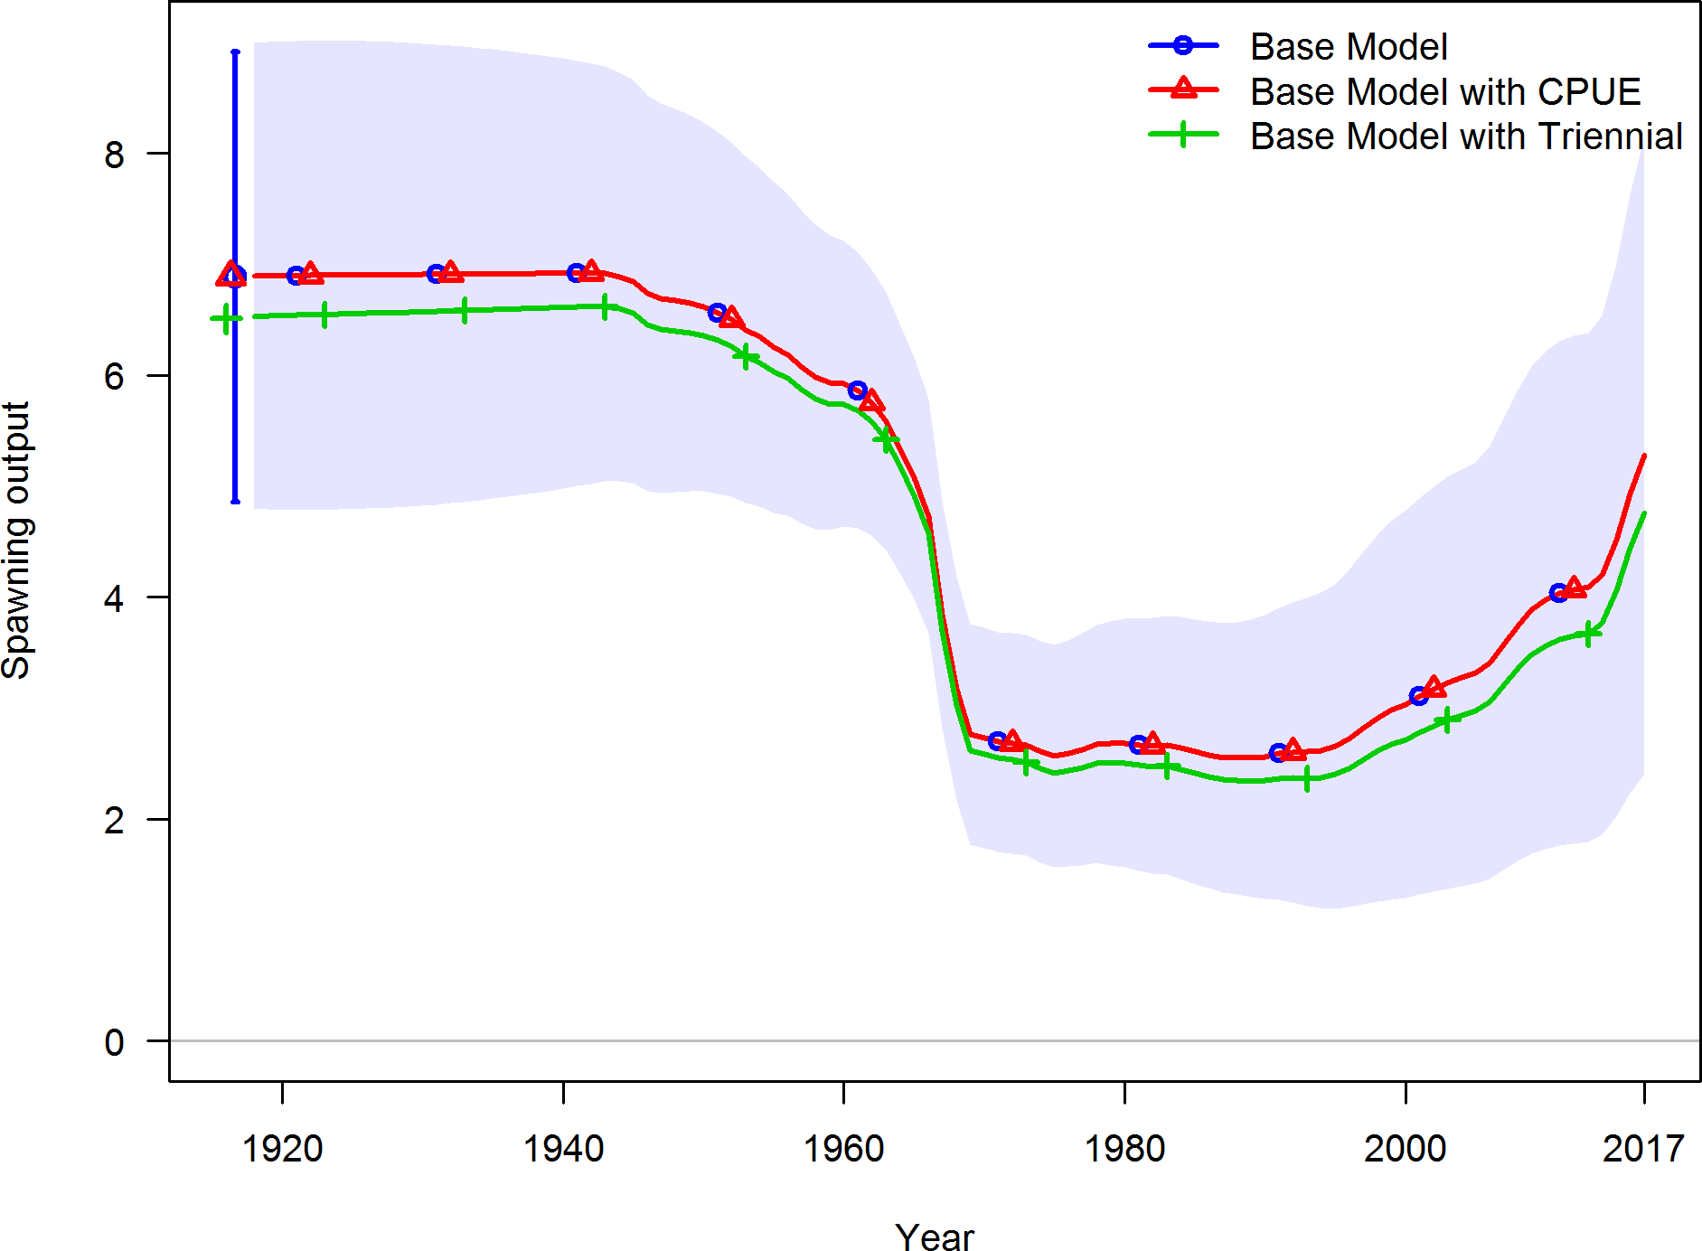

Figure 107: Plot comparison of spawning output when either the fishery CPUE or the Triennial shelf survey data are included in the base model for Pacific ocean perch.

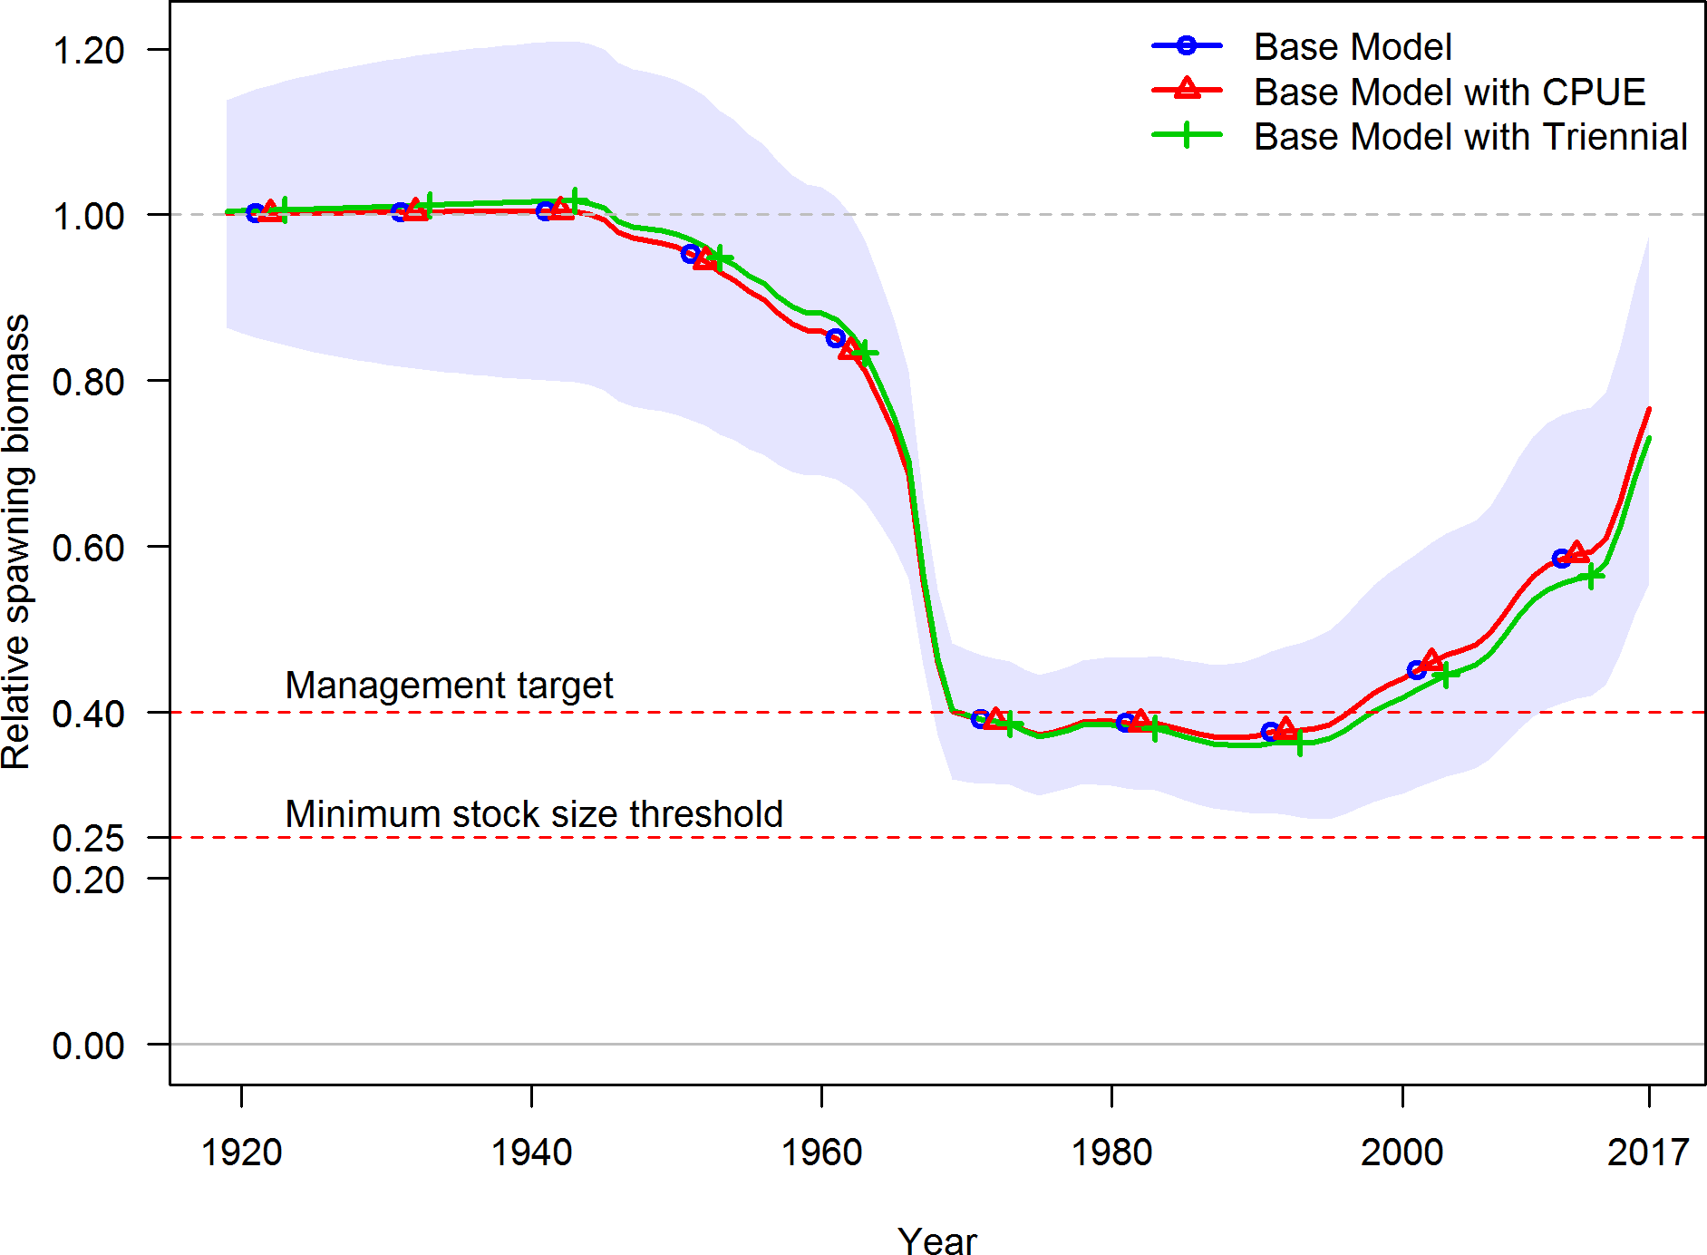

Figure 108: Plot comparison of relative spawning output (depletion) when either the fishery CPUE or the Triennial shelf survey data are included in the base model for Pacific ocean perch.

1. **Appendix D. SSC Groundfish Subcommittee Dis- cussion Regarding Steepness**

The Pacific ocean perch base model is highly sensitive to steepness. In the final base model the profile over steepness is flat across a wide range of potential values. The flat profile over steepness was in contrast to the previous assessment model from 2011 where the likelihood was minimized at a value of 0.40. The change in perceived information regarding steepness between this and the last assessment is due to the new data since 2011, the updated data weighting approach, and minor changes in model structure. Given the lack of information regarding steepness, preliminary models explored using the mean of the 2017 steepness prior, the approach endorsed by the SSC when there is not information regarding steepness for a specific stock. However, using the steepness prior of 0.72 resulted in Pacific ocean perch being estimated near unfished conditions, a result that was in strong contrast to the previous assessment which estimated the stock size at 19.1% of unfished stock size in 2011. Due to concerns of plausibility, the STAT team presented an initial model to the STAR panel for review using an intermediate steepness value of 0.50. This value was selected because the resulting spawning output was encapsulated within the uncertainty from when steepness was assumed to be 0.40, the previous assessment value, and 0.72, the current mean of the steepness prior. Over the course of the week of the STAR panel after many discussions both the STAR panel and the STAT team agreed that in the absence of information regarding steepness the base model should use the mean of the prior. However, upon review by the SSC, it was concluded that the results of the assessment model were implausible when the steepness prior of 0.72 was used. In particular, the value of catchability for Pacific ocean perch from the NWFSC shelf-slope survey was 0.05, far below that for other rockfish species observed off the US west coast. The SSC requested additional model exploration be done and reviewed at the SSC Groundfish Subcommittee (GFSC) September 28, 2017 meeting regarding steepness and re-examining the information provided by the Triennial shelf survey.

Preliminary models included the Triennial shelf survey but it was removed from the final base model during the STAR panel due to model lack of fit to this data-set which was in contrast to all other available data and concerns that this survey did not sample a representative subset of the population off the US west coast. Additionally, the estimates of spawning output and depletion with and without the Triennial survey data, given the value of steepness, were negligible indicating that the other sources of information were the more influential data in the model. However, profiles over steepness from preliminary models which included the Triennial shelf survey indicated that the index of abundance supported low steepness values (there was no information from the length or age composition data). The perceived information regarding steepness from this index of abundance is due to a change in the abundance index between the first two data points of the survey, 1980 and 1983, which are higher than the subsequent years that drop to lower abundance levels from 1986 to 2004 (final year of the survey). A profile over steepness values when the Triennial shelf survey was used as a single time-series resulted in a profile that had a local minimum at 0.75 with global minimum occurring at a steepness value of 0.27 (Figure 109). The estimated stock status when assuming a steepness value of 0.27, a value that is far lower than any other

estimated steepness value for a US west coast groundfish stock, was less that 10% of the unfished spawning output in 2017. The STAT team and the SSC GFSC agreed that this was not a plausible based upon other estimated steepness values from US west coast groundfish.

The models explored regarding steepness either using the mean of the prior or the value supported by the Triennial shelf survey index led to quite different estimates of depletion for Pacific ocean perch in 2017. Given the insufficient information to estimate steepness within the model an alternative approach for determining steepness was proposed by Dr. Owen Hamel during the SSC GFSC webinar held on September 28, 2017. The subcommittee notes state:

*The GFSC therefore concluded that the available data are insufficient to estimate steepness. It is usual in this situation to base the assessment on the mean of the prior for steepness (0.72), but this value leads to an unrealistically low estimate of survey catchability (i.e. model A [fixing steepness at 0.27]), and the prior is rather diffuse with comparable support for values anywhere between 0.4 and 1.0. Dr. Hamel provided a way to account for uncertainty in steepness that the GFSC recommends be adopted. This involves calculating current ending spawning output biomass for steepness values ranging from 0.25 to 0.95 in increments of 0.05 and assuming each value to be equally plausible). The expected (i.e., arithmetic mean) ending spawning output is 5,364 million eggs, which corresponds most closely to a steepness value of*

*0.5 (5,296 million eggs for the run in the profile). Thus, the model in which steepness is set to 0.5 represents the expected ending spawning output given steepness values between 0.225 and 0.975 are considered equally likely.*

*The GFSC therefore recommends that the base model be revised to fix steepness to 0.5. The final base model should be retuned, checked by jittering, and presented to the SSC for final approval and adoption.*

The STAT team agreed with the recommendation to fix steepness at 0.50 for the Pacific ocean perch base model.

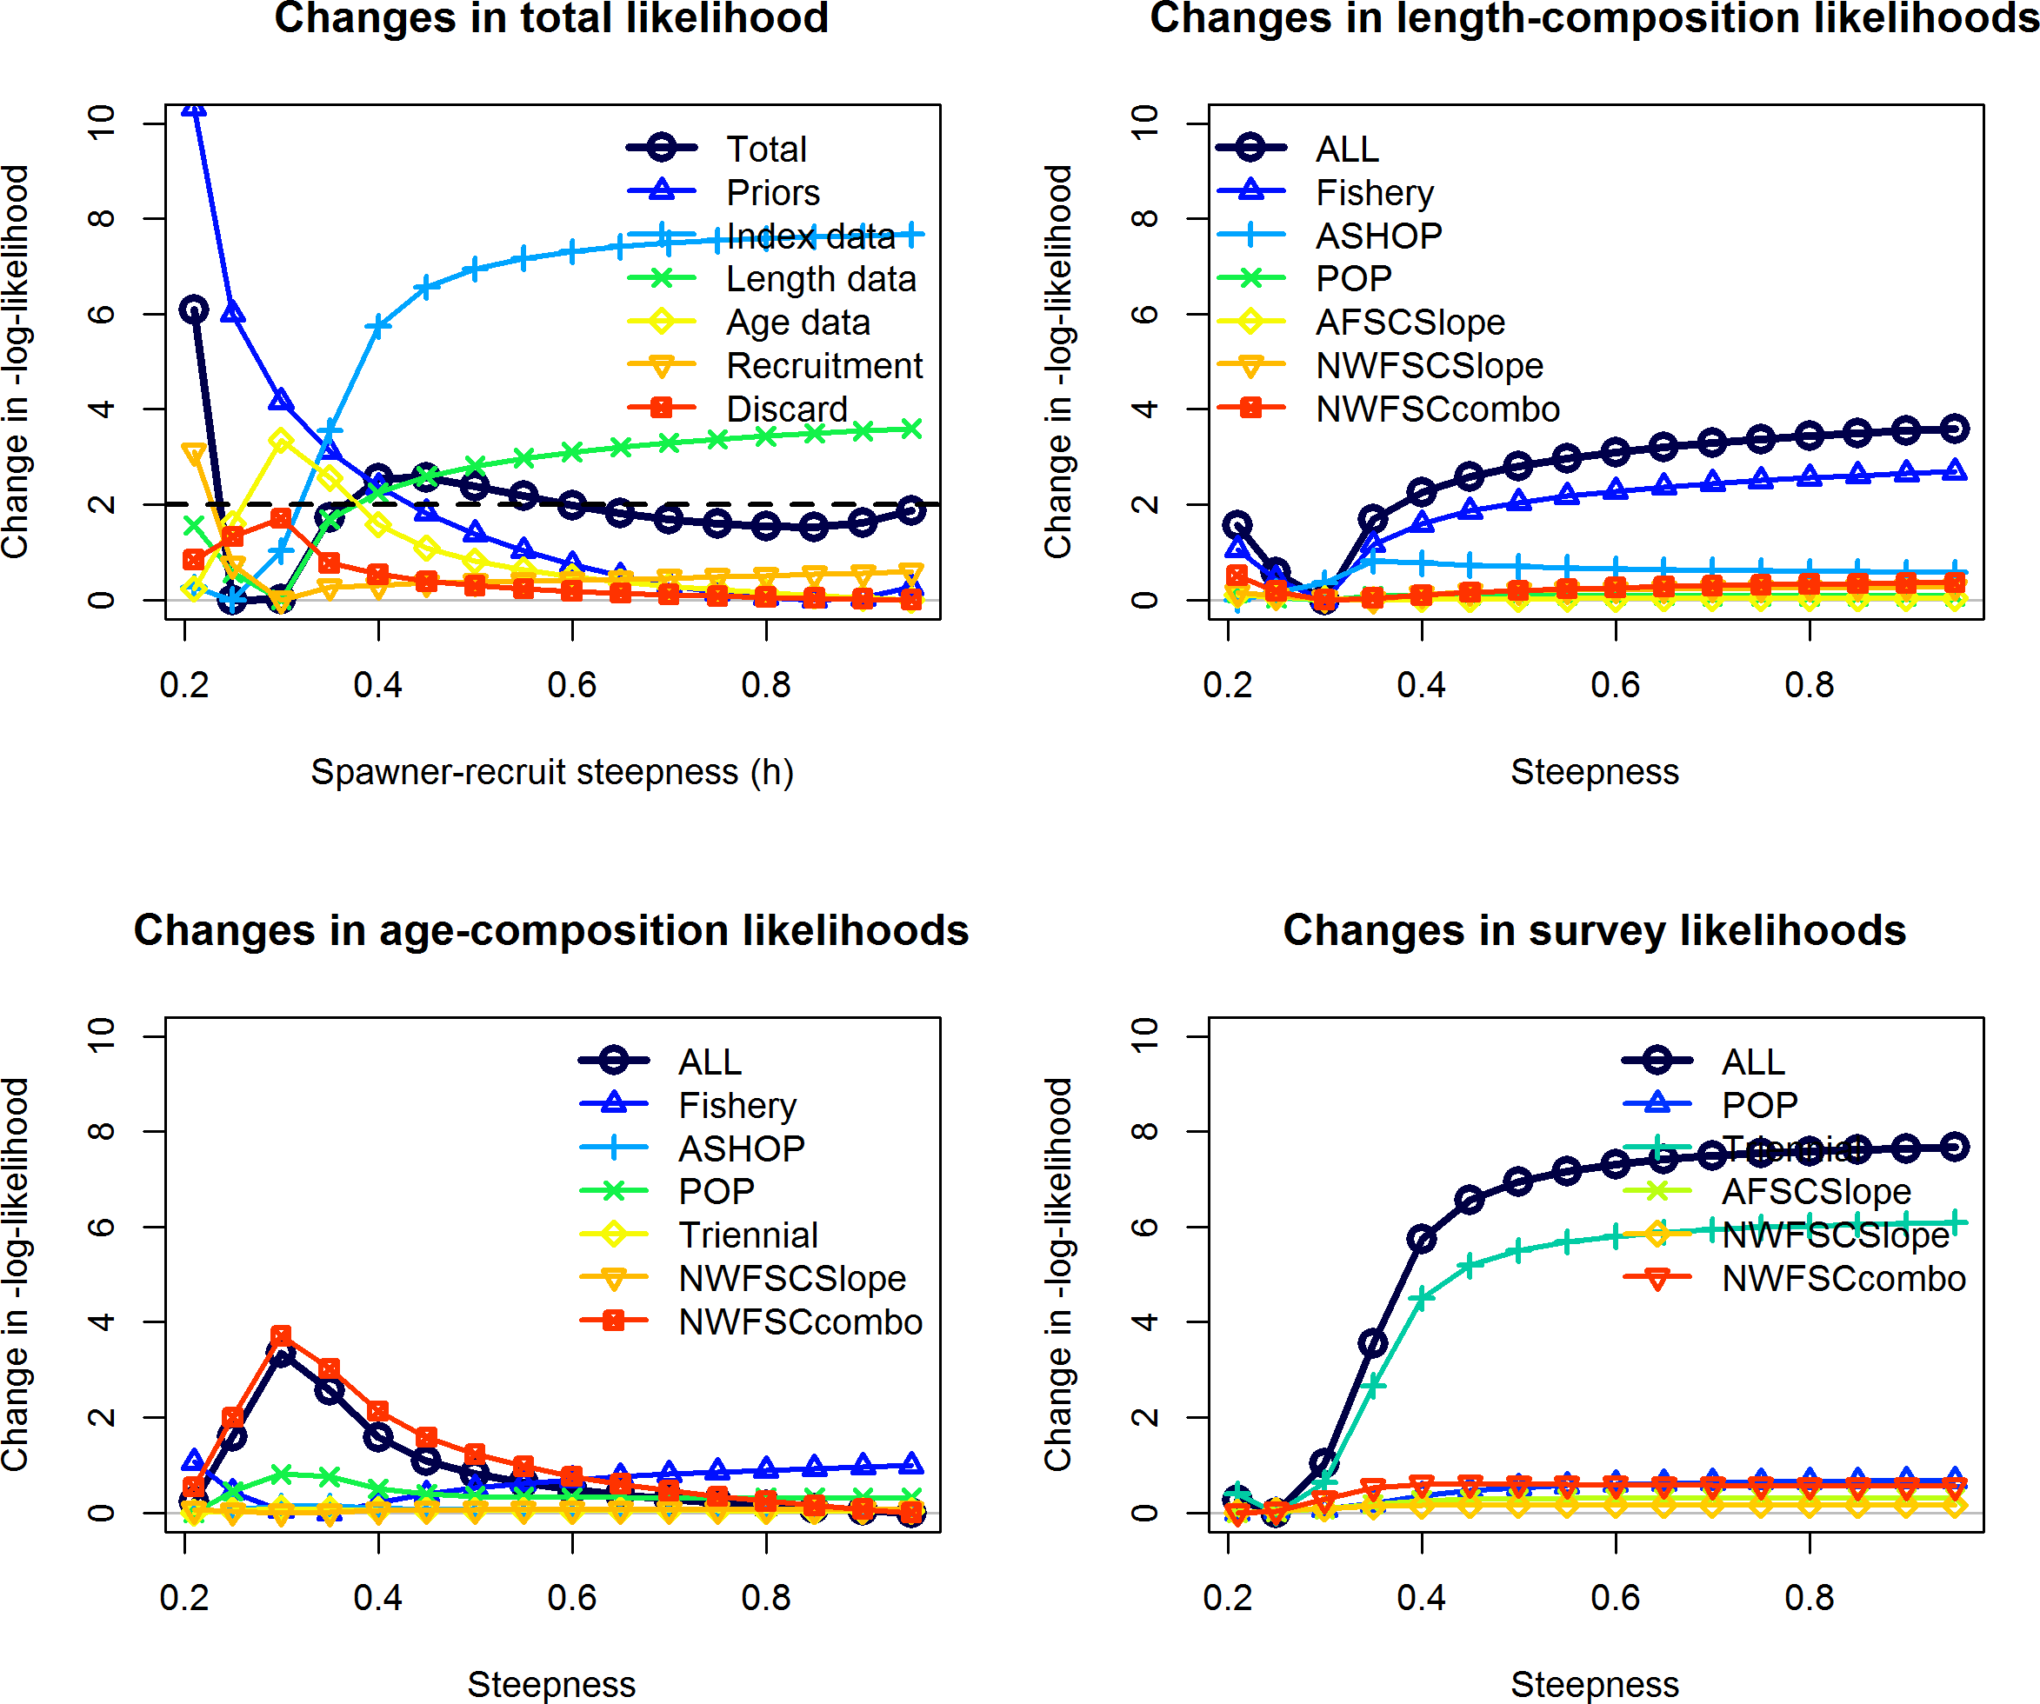

Figure 109: Profile over steepness with the inclusion of the Triennial shelf survey when treated as a single time-series for Pacific ocean perch.

1. **Appendix E. List of Auxiliary Files Available**

The listed files are also available as auxiliary files to accompany the assessment document:

1. Numbers at age for female and male Pacific ocean perch (POPnatagef.csv and POP- natagem.csv)
2. The Pacific ocean perch Stock Synthesis 3.30 model files
   1. 2017pop.dat
   2. 2017pop.ctl
   3. forecast.ss
   4. starter.ss

–*>*

1. **References**

Bradburn, M., Keller, A., and Horness, B. 2011. The 2003 to 2008 US West Coast bottom trawl surveys of groundfish resources off Washington, Oregon, and California: Estimates of distribution, abundance, length, and age composition. US Department of Commerce, National Oceanic; Atmospheric Administration, National Marine Fisheries Service.

Chilton, D.E., and Beamish, R.J. 1982. Age determination methods for fishes studied by the Groundfish Program at the Pacific Biological Station. [Ottawa:] Minister of Supply; Services Canada.

Dick, E., Beyer, S., Mangel, M., and Ralston, S. 2017. A meta-analysis of fecundity in rockfishes (genus *Sebastes*). Fisheries Research **187**: 73–85. doi: [10.1016/j.fishres.2016.11.009](https://doi.org/10.1016/j.fishres.2016.11.009).

Dick, E.J. 2009. Modeling the Reproductive Potential of Rockfishes (*Sebastes* Spp.). PhD Thesis, University of Californai at Santa Cruz.

Edwards, A., Haigh, R., and Starr, P.J. 2014. Pacific Ocean Perch ( *Sebastes alutus*) stock assessment for the west coast of Vancouver Island, British Columbia. DFO Can. Sci. Advis. Sec. Res. Doc. 2013/093.

Field, J.C. 2007. Status of the Chilipepper rockfish, *Sebastes goodei*, in 2007. Pacific Fishery Management Council, 7700 Ambassador Place NE, Suite 200, Portland, OR 97220.

Francis, R.C., and Hilborn, R. 2011. Data weighting in statistical fisheries stock assess- ment models. Canadian Journal of Fisheries and Aquatic Sciences **68**(6): 1124–1138. doi: [10.1139/f2011-025](https://doi.org/10.1139/f2011-025).

Gertseva, V., Matson, S., and Councill, E. 2015. Status of the darkblotched rockfish resource off the continental U.S. Pacific Coast in 2015. Pacific Fishery Management Council, 7700 Ambassador Place NE, Suite 200, Portland, OR 97220.

Gunderson, D.R. 1977. Population biology of Pacific ocean perch, *Sebastes alutus*, stocks in the WashingtonQueen Charlotte Sound region and their response to fishing. Fishery Bulletin **75**: 369–403.

Gunderson, D.R. 1978. Results of cohort analysis for Pacific ocean perch stocks off British Columbia, Washington, and Oregon and an evaluation of alternative rebuilding strategies for

these stocks. Pacific Fishery Management Council, 7700 Ambassador Place NE, Suite 200, Portland, OR 97220.

Gunderson, D.R. 1981. An updated cohort analysis for Pacific ocean perch stocks off Washington and Oregon. Unpublished report, Pacific Fishery Management Council, 7700 Ambassador Place NE, Suite 200, Portland, OR 97220.

Gunderson, D.R. 1997. Trade-off between reproductive effort and adult survival in oviparous and viviparous fishes. Canadian Journal of Fisheries and Aquatic Sciences **54**(5): 990–998.

Gunderson, D.R., and Sample, T.M. 1980. Distribution and abundance of rockfish off Washington, Oregon and California during 1977. Northwest; Alaska Fisheries Center, National Marine Fisheries Service.

Gunderson, D.R., Westrheim, S., Demory, R., and Fraidenburg, M. 1977. The status of Pacific ocean perch (*Sebastes alutus*) stocks off British Columbia, Washington, and Oregon in 1974.

Hamel, O.S. 2015. A method for calculating a meta-analytical prior for the natural mortality rate using multiple life history correlates. ICES Journal of Marine Science: Journal du Conseil **72**(1): 62–69. doi: [10.1093/icesjms/fsu131](https://doi.org/10.1093/icesjms/fsu131).

Hamel, O.S., and Ono, K. 2011. Stock Assessment of Pacific Ocean Perch in Waters off of the U.S. West Coast in 2011. Pacific Fishery Management Council, 7700 Ambassador Place NE, Suite 200, Portland, OR 97220.

Hannah, R., and Parker, S. 2007. Age-modulated variation in reproductive development of female Pacific Ocean perch (*Sebastes alutus*) in waters off Oregon. Alaska Sea Grant, University of Alaska Fairbanks. pp. 1–20. doi: [10.4027/bamnpr.2007.01](https://doi.org/10.4027/bamnpr.2007.01).

Helser, T., Punt, A.E., and Methot, R.D. 2004. A generalized linear mixed model analysis of a multi-vessel fishery resouce survey. **70**: 251–264.

Hicks, A.C., and Wetzel, C.R. 2015. The status of Widow Rockfish (*Sebastes entomelas*) along the U.S. west coast in 2015. Pacific Fishery Management Council, 7700 Ambassador Place NE, Suite 200, Portland, OR 97220.

Hicks, A.C., Haltuch, M.A., and Wetzel, C.R. 2009. Status of greenstriped rockfish (*Sebastes elongatus*) along the outer coast of California, Oregon, and Washington. Pacific Fishery Management Council, 7700 Ambassador Place NE, Suite 200, Portland, OR 97220.

Hoenig, J.M. 1983. Empirical use of longevity data to estimate mortality rates. Fishery Bulletin **82**: 898–903.

Ianelli, J.N., and Zimmermann, M. 1998. Status and future prospects for the Pacific ocean

perch resource in waters off Washington and Oregon as assessed in 1998. Pacific Fishery Management Council, 7700 Ambassador Place NE, Suite 200, Portland, OR 97220.

Ianelli, J.N., Ito, D.H., and Wilkins, M. 1992. Status and future prospects for the Pacific ocean perch resource in waters off Washington and Oregon as assessed in 1992. Pacific Fishery Management Council, 7700 Ambassador Place NE, Suite 200, Portland, OR 97220.

Karnowski, M., Gertseva, V., and Stephens, A. 2014. Historical Reconstruction of Oregon’s Commercial Fisheries Landings. Oregon Department of Fish; Wildlife, Salem, OR.

Kristensen, K., Nielsen, A., Berg, C.W., Skaug, H.J., and Bell, B. 2016. TMB: Automatic Differentiation and Laplace Approximation. Journal of Statistical Software **70**: 1–21.

McAllister, M.K., and Ianelli, J.N. 1997. Bayesian stock assessment using catch-age data and the sampling - importance resampling algorithm. Canadian Journal of Fisheries and Aquatic Sciences **54**: 284–300.

McCoy, M.W., and Gillooly, J.F. 2008. Predicting natural mortality rates of plants and animals. Ecology Letters **11**(7): 710–716. doi: [10.1111/j.1461-0248.2008.01190.x](https://doi.org/10.1111/j.1461-0248.2008.01190.x).

Methot, R.D., and Wetzel, C.R. 2013. Stock synthesis: A biological and statistical framework for fish stock assessment and fishery management. Fisheries Research **142**: 86–99. doi: [10.1016/j.fishres.2012.10.012](https://doi.org/10.1016/j.fishres.2012.10.012).

Methot, R.D., Taylor, I.G., and Chen, Y. 2011. Adjusting for bias due to variability of estimated recruitments in fishery assessment models. Canadian Journal of Fisheries and Aquatic Sciences **68**(10): 1744–1760. doi: [10.1139/f2011-092](https://doi.org/10.1139/f2011-092).

Pikitch, E.K., Erickson, D.L., and Wallace, J.R. 1988. An evaluation of the effectiveness of trip limits as a management tool. Northwest; Alaska Fisheries Center, National Marine Fisheries Service NWAFC Processed Report. Available from [https://www.afsc.noaa.gov/](https://www.afsc.noaa.gov/Publications/ProcRpt/PR1988-27.pdf) [Publications/ProcRpt/PR1988-27.pdf](https://www.afsc.noaa.gov/Publications/ProcRpt/PR1988-27.pdf) [accessed 28 February 2017].

Punt, A.E., Smith, D.C., KrusicGolub, K., and Robertson, S. 2008. Quantifying age-reading error for use in fisheries stock assessments, with application to species in Australia’s southern and eastern scalefish and shark fishery. Canadian Journal of Fisheries and Aquatic Sciences **65**(9): 1991–2005. doi: [10.1139/F08-111](https://doi.org/10.1139/F08-111).

Ralston, S., Pearson, D.E., Field, J.C., and Key, M. 2010. Documentation of the California catch reconstruction project. US Department of Commerce, National Oceanic; Atmospheric Adminstration, National Marine.

Rogers, J. 2003. Species allocation of *Sebastes* and *Sebastolobus* species caught by for- eign countries off Washington, Oregon, and California, U.S.A. in 1965-1976. Unpublished

document.

Rogers, J.B., and Pikitch, E.K. 1992. Numerical definition of groundfish assemblages caught off the coasts of Oregon and Washington using commercial fishing strategies. Canadian Journal of Fisheries and Aquatic Sciences **49**(12): 2648–2656.

Seeb, L.W., and Gunderson, D.R. 1988. Genetic variation and population structure of Pacific ocean perch (*Sebastes alutus*). Canadian Journal of Fisheries and Aquatic Sciences **45**(1): 78–88.

Stewart, I.J., and Hamel, O.S. 2014. Bootstrapping of sample sizes for length- or age- composition data used in stock assessments. Canadian Journal of Fisheries and Aquatic Sciences **71**(4): 581–588. doi: [10.1139/cjfas-2013-0289](https://doi.org/10.1139/cjfas-2013-0289).

Then, A.Y., Hoenig, J.M., Hall, N.G., and Hewitt, D.A. 2015. Evaluating the predictive performance of empirical estimators of natural mortality rate using information on over 200 fish species. ICES Journal of Marine Science **72**(1): 82–92. doi: [10.1093/icesjms/fsu136](https://doi.org/10.1093/icesjms/fsu136).

Thorson, J.T., and Barnett, L.A.K. 2017. Comparing estimates of abundance trends and distribution shifts using single- and multispecies models of fishes and biogenic habitat. ICES Journal of Marine Science: Journal du Conseil: fsw193. doi: [10.1093/icesjms/fsw193](https://doi.org/10.1093/icesjms/fsw193).

Thorson, J.T., and Kristensen, K. 2016. Implementing a generic method for bias correction in statistical models using random effects, with spatial and population dynamics examples. Fisheries Research **175**: 66–74. doi: [10.1016/j.fishres.2015.11.016](https://doi.org/10.1016/j.fishres.2015.11.016).

Thorson, J.T., and Ward, E.J. 2014. Accounting for vessel effects when standard- izing catch rates from cooperative surveys. Fisheries Research **155**: 168–176. doi: [10.1016/j.fishres.2014.02.036](https://doi.org/10.1016/j.fishres.2014.02.036).

Thorson, J.T., Shelton, A.O., Ward, E.J., and Skaug, H.J. 2015. Geostatistical delta- generalized linear mixed models improve precision for estimated abundance indices for West Coast groundfishes. ICES Journal of Marine Science **72**(5): 1297–1310. doi: [10.1093/icesjms/fsu243](https://doi.org/10.1093/icesjms/fsu243).

Thorson, J.T., Stewart, I.J., and Punt, A.E. 2012. nwfscAgeingError: A user interface in R for the Punt et al. (2008) method for calculating ageing error and imprecision. Available from: [http://github.com/nwfsc-assess/nwfscAgeingError/.](http://github.com/nwfsc-assess/nwfscAgeingError/)

Weinberg, J.R., Rago, P.J., Wakefield, W.W., and Keith, C. 2002. Estimation of tow distance and spatial heterogeneity using data from inclinometer sensors: An example using a clam survey dredge. Fisheries Research **55**(1–3): 49–61. doi: [10.1016/S0165-7836(01)00292-2](https://doi.org/10.1016/S0165-7836(01)00292-2).

Wilkins, M., and Golden, J. 1983. Condition of the Pacific ocean perch resource off Washington and Oregon during 1979: Results of a cooperative trawl survey. North American Journal of

Fisheries Management **3**: 103–122.

Withler, R., Beacham, T., Schulze, A., Richards, L., and Miller, K. 2001. Co-existing populations of Pacific ocean perch, *Sebastes alutus* , in Queen Charlotte Sound, British Columbia. Marine Biology **139**(1): 1–12. doi: [10.1007/s002270100560](https://doi.org/10.1007/s002270100560).